1. EMPIRICAL MODEL

In this section, we propose a novel system for classifying tweets related to ‘Zika’. The system architecture is shown in Figure 1.

Figure 1. System Architecture

Tweet Pre-processor

Tweet Scraper

Streaming API Raw Tweets

Twitter Server

Processed Tweets

Classifier Model

Classified Tweets

Prediction and Analysis

As mentioned, we decided to use the Support Vector Machine (SVM) algorithm and Naïve Bayes Algorithm for our classification as it has been seen earlier that both SVM and Naïve Bayes Algorithm are suitable algorithms for text classification.

The Support Vector Machine (SVM) algorithm is a non-probabilistic binary linear classifier. The model represents data entities as points on a sample coordinate plane in such a way that there is a clear gap between the groups of entities of different classes. The reason SVM work very well for text categorization is that text categorization involves many features (sometimes more than 5000) and SVM handles large feature space.

If there *n* points of the form (x1, y1), … , (xn, yn) where yi is the class for xi  , then it is possible to draw a maximum margin hyperplane between groups having yi =1 and yi =-1 and the hyperplane can be expressed in the following form:

*w.x – b = 1 and w.x – b = -1*

where w is the vector normal to the hyperplane.

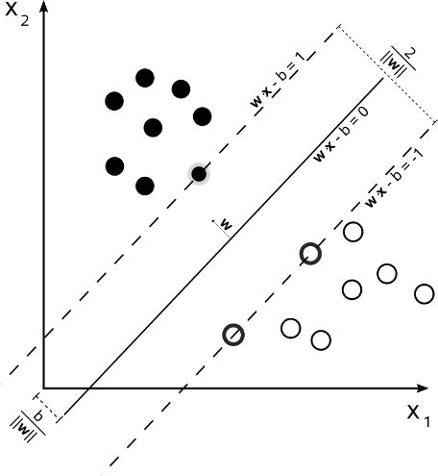

*Figure 2.*

Naïve Bayes’ classifiers are simple probabilistic linear classifiers and is based on the Bayes’ theorem. All Naïve Bayes’ classifiers assume that the features are independent of each other.

If there are n entities in the feature space represented by a vector x = (x1,… ,xn) , then using the Bayes’ theorem, the conditional probability can be expressed as:

*p(Ck | x) = p(Ck) p(x|Ck)*

*p(x)*