# Web server configuration

1. Download the latest tomcat.
   1. The version in this case is 9.0.6

<https://tomcat.apache.org/download-90.cgi>

1. Create the following directory –

D:\MyWebsites

1. Paste the tomcat package directory inside the MyWebsites directory
2. Rename the package to the directory name of the website

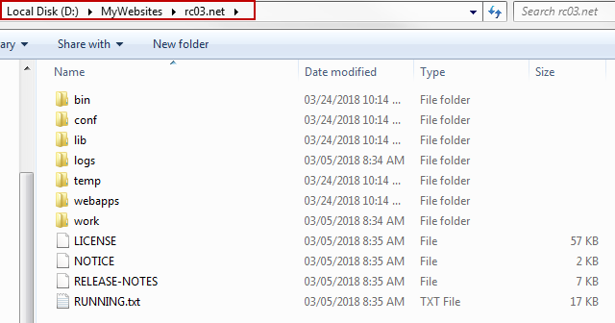

1. Deploy jdk in the following directory –

D:\java\jdk64-1.8.0_161

1. Create setenv.bat file and place it in the \bin directory

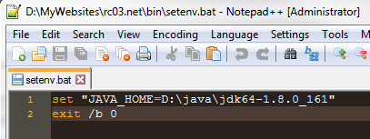

Specify the java home in the file

1. Create an index.html file and drop it in the following directory –

D:\MyWebsites\rc03.net\webapps\ROOT

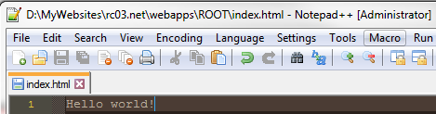

1. Run the startup.bat in the \bin directory

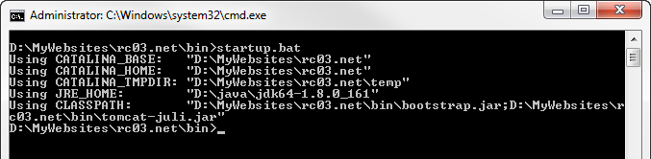

1. Access localhost:8080 in the browser

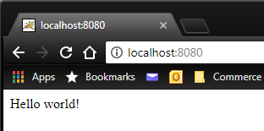

# Router configuration

1. Gather the internal IP address of the machine that is running the tomcat server –

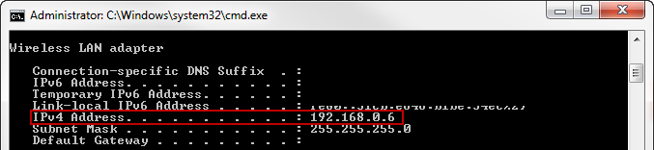

1. Open the router configuration page and find the port forwarding settings
2. Add a new rule for forwarding http traffic to port 8080

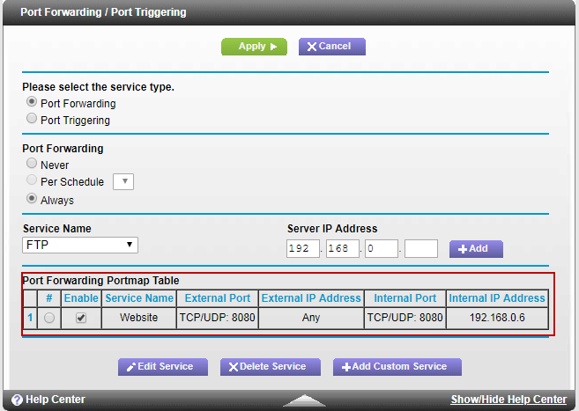

1. Go to <http://canyouseeme.org/>
2. Type in the port and click on the Check Port button

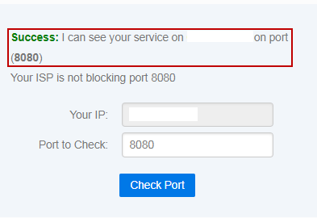

This shows that the port is accessible externally.

# Namecheap host record configuration

1. Go to <http://whatismyip.com> and take note of the external IP address (also known as the WAN IP)
2. Go to Advanced DNS configuration
3. In the host records section, and create the following:
   1. Type: A record; Host: @; Value: <external-ip>; TTL: Automatic
   2. Type: URL Redirect Record; Host: www; Value: http://<domain>:8080 Masked META (We use this record because [www.domain-name.com](http://www.domain-name.com) will be redirected, and “work” in the browser)

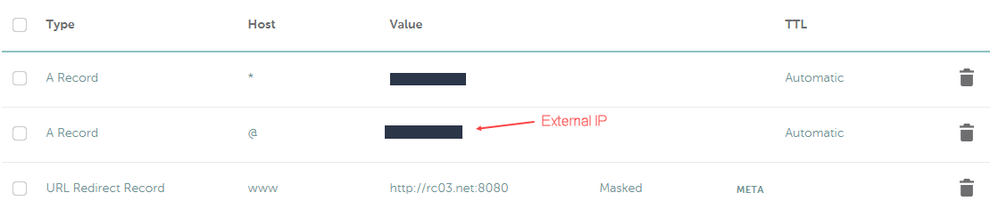

The record for the wildcard exists for creating virtual hosts in Tomcat, which I will cover in a later document.

# Problems I encountered

I have a Netgear C6300BD, and the router is running Firmware Version V2.05.18

It turns out that this particular router does not support loopback functionality, therefore when you have port forwarding setup, accessing http://<external-ip>:8080 does not work from within the network.

The best to test if the setup is working is by accessing your website from outside the network, and the most convenient way to do this is through a mobile device with