University of Hertfordshire
School of Engineering and Computer Science

MSc Data Science and Analytics with research paper

Module: 7COM1039-0206-2025 Advanced Computer Science Masters Project.

Detailed Project Proposal

Project title –Impact of Explainable AI Models on Credit Scoring Decision-Making

Student Name: R. Clement Mariya Dyriam
Student ID: 24084053

Table of Contents
1. Project Introduction 3
2. Aim of the Project 3
3. Objectives 3
4. Research Questions 4
5. Literature Review 4
6. Primary Research 4
7. Project Resources 5
8. Project Plan 6
9. Project Outcomes and Lessons to Be Learned 6
10. References 7

Chapeter 1

1.1 Introduction
The banking industry is also adopting artificial intelligence and machine learning to undertake banking activities that include credit ratings and loan issuance. Conventional credit scoring was based on statistical analysis and fastidious analysis. However, modern models of machine learning are capable of handling extensive financial and demographic information to enhance the accuracy of a prediction. Most of these models are black boxes despite their advantages as their decision-making process cannot be easily interpreted (Farishy, 2023).
Transparency and fairness play a critical role in financial systems. Banks should be capable of explaining their decisions to the customers and the regulatory authorities. Some problems associated with automated decision systems with no explanation are biased decision-making, diminished customer trust, and lack of adherence to laws. It has resulted in an increased attention towards Explainable Artificial Intelligence (XAI) which seeks to make machine learning models more understandable and explainable (Oyasiji et al., 2023).
The present project is devoted to the investigation of how the use of Explainable AI techniques influences the credit scoring decision. To develop and assess several machine learning models, the Statlog German credit dataset will be utilised. The techniques to explain the models and analyse the decision-making process will be applied after measuring their predictive performance. The findings will be useful in explaining the trade-off between model accuracy and interpretability in credit scoring systems.

1.2. Aim of the Project
This project seeks to examine the effect that Explainable Artificial Intelligence techniques have on credit scoring decisions made by machine learning models. In this study, the authors will concentrate on the performance of predictive models in terms of predictive performance and interpretability so as to identify the most appropriate model to use in the process of clear and credible credit risk estimation.

1.3. Objectives
- To develop and evaluate multiple machine learning models for credit risk classification using the Statlog German Credit dataset.
- To apply Explainable Artificial Intelligence techniques such as SHAP and LIME to interpret model predictions and identify key factors influencing credit decisions.
- To analyse the trade-off between predictive performance and interpretability, and recommend the most suitable model for transparent and reliable credit scoring in banking.

1.4. Research Questions
What is the impact of Explainable Artificial Intelligence techniques on the accuracy, interpretability, and reliability of machine learning–based credit scoring decisions in banking?.

1.5 Expected Outcomes

2 Literature Review

2.1 Survey
The available literature on machine learning-based credit scoring and Explainable AI has conflicting and occasionally opposite perspectives. As per Ayari, Guetari and Kraïem (2025), it is noted that models like the Logistic Regression, Rand Forest and Gradient Boosting attain high predictive accuracy in credit risk classification. These authors suggest that the enhanced accuracy provides the enhancement of the quality of financial decisions and minimisation of the default rates. However, according to Hassija et al. (2023), the fact that complex models, especially ensemble ones, act as black boxes and are not transparent, which makes them question the fairness, bias and compliance to regulations in banking systems.
there is a divided opinion in relation to Explainable AI methods. According to Hermosilla, Berríos and Allende-Cid (2025) statement, the other methods like…….. SHAP and LIME offer a lot of transparency and user confidence to model users since they can identify important features and can justify individual predictions (cite). Hooshyar and Yang (2024) have shown the these methods are merely approximate explanations and can make complex model behaviour appear simple and so misguide decision-makers (cite..). …….Thus, the debate in the literature is whether high predictive performance is necessary or a reliable and meaningful explanation is demanded in the credit scoring systems.

2.2 Comparision Between Literatures

paper | dataset | Classfier/model | accuracy | precision
Deepak [1] | Iris data[3]
Panday [2]

2.3 Literature Gap

3. Ethics ……..

4. Methodology

5. Implementation

6. Discussion and Conclusion

6. Primary Research
The main study will consist of working with machine learning models and methods of explainability in relation to the Statlog German Credit dataset. The data set has financial and demographic characteristics of loan applicants, which are classified as bad credit risk or good credit risk.Preprocessing will involve the encoding of categorical variables, normalisation of the numerical variables and the division of the data into the training and the testing data sets. Three machine learning models will be deployed after the preprocessing, which are Logistic Regression, Random Forest and Gradient Boosting. The training dataset will be used to train each model and the testing dataset will be used to evaluate the model.
Accuracy, precision, recall, and F1-score will be used as the measure of model performance. Furthermore, a cost sensitive analysis will be done to indicate actual banking risks. Once the most performing model has been identified, Explainable AI methods will be used. The global and local feature importance will be analysed by SHAP and the individual predictions explained by LIME. It will be analysed to understand the effect of explainability on credit decision reliability and transparency.

7. Project Resources
The development and experimentation of the project will be done using a personal computer or a laptop. The software environment will consist of python, Jupyter Notebook or Visual Code, machine learning libraries that include Scikit-learn, Pandas, and NumPy. SHAP and LIME will be used to implement explainability and Matplotlib and Seaborn will be used to create visualisations.
Risk Description | Probability | Possible Effects | Mitigation
Dataset imbalance or quality issues | Medium | Reduced model performance | Apply preprocessing and balancing techniques
Model overfitting | Medium | Poor generalisation | Use cross-validation and tuning
Difficulty implementing XAI tools | Medium | Delays in analysis | Use documentation and tutorials
Time management issues | Medium | Incomplete project | Follow structured schedule
Technical or software errors | Low | Project delays | Maintain backups and version control

8. Project Plan
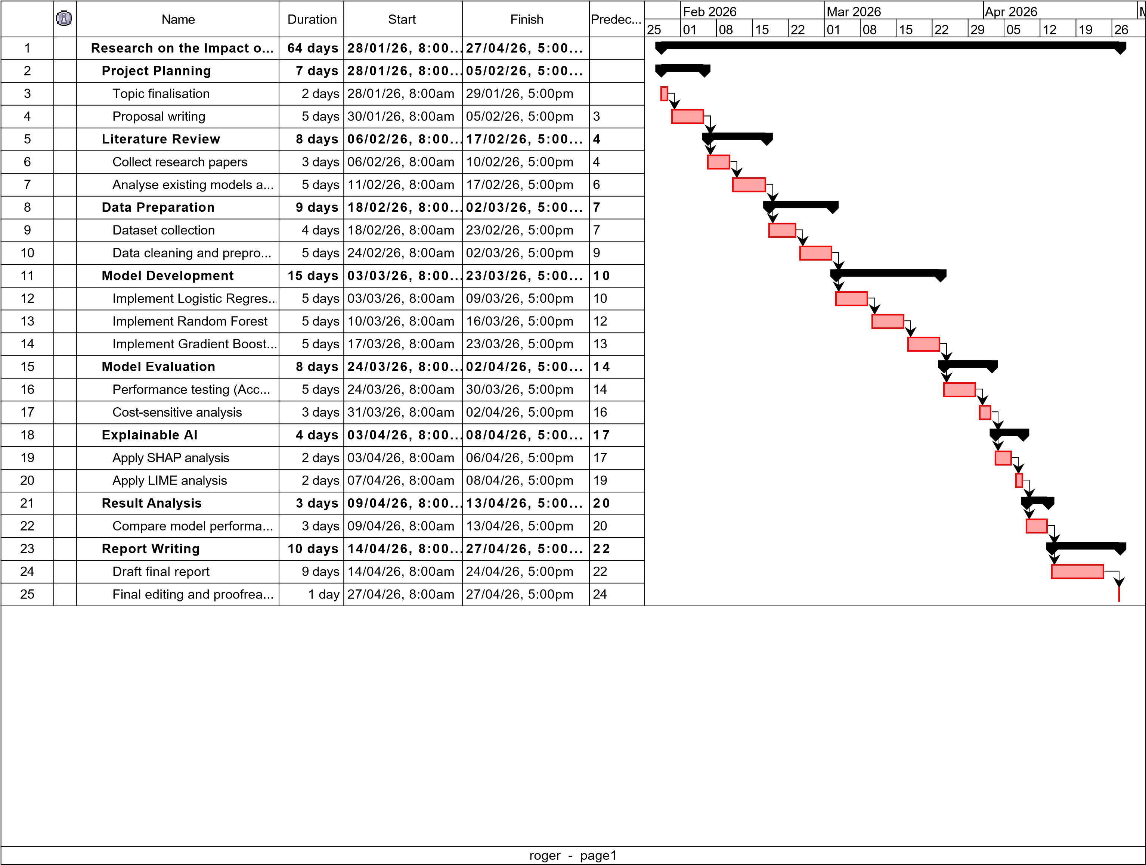

9. Project Outcomes and Lessons to Be Learned
- Comparison of several machine learning models with an aim of establishing their efficiency in credit risk categorisation.
- An in-depth interpretability study with SHAP and LIME, with emphasis on those features that have the most significant impact on credit decisions.
- A scientific evaluation of the trade-off between predictive accuracy and transparency of the models in credit scoring systems.
- A suggestion of the best machine learning system that has adequate performance, interpretability, and practical banking needs.
- Practical knowledge and technical skills in machine learning, Explainable AI techniques, and data-driven decision-making in financial applications.

10. References
Ayari, H., Guetari, Pr.R. and Kraïem, Pr.N. (2025). Machine learning powered financial credit scoring: a systematic literature review. Artificial Intelligence Review, [online] 59(1). doi: https://doi.org/10.1007/s10462-025-11416-2.
Farishy, R. (2023). The Use of Artificial Intelligence in Banking Industry. International Journal of Social Service and Research, [online] 3(7), pp.1724–1731. doi: https://doi.org/10.46799/ijssr.v3i7.447.
Hassija, V., Chamola, V., Mahapatra, A., Singal, A., Goel, D., Huang, K., Scardapane, S., Spinelli, I., Mahmud, M. and Hussain, A. (2023). Interpreting Black-Box Models: A Review on Explainable Artificial Intelligence. Cognitive Computation, [online] 16(1), pp.45–74. doi: https://doi.org/10.1007/s12559-023-10179-8.
Hermosilla, P., Berríos, S. and Allende-Cid, H. (2025). Explainable AI for Forensic Analysis: A Comparative Study of SHAP and LIME in Intrusion Detection Models. Applied Sciences, [online] 15(13), p.7329. doi: https://doi.org/10.3390/app15137329 .
Hooshyar, D. and Yang, Y. (2024). Problems With SHAP and LIME in Interpretable AI for Education: A Comparative Study of Post-Hoc Explanations and Neural-Symbolic Rule Extraction. IEEE Access, [online] 12, pp.137472–137490. doi: https://doi.org/10.1109/access.2024.3463948.
Oyasiji, O., Okesiji, A., Imediegwu, C. and Filani, O.M. (2023). Ethical AI in Financial Decision-Making : Transparency, Bias, and Regulation. International Journal of Scientific Research in Computer Science Engineering and Information Technology, [online] 9(5), pp.453–471. Available at: https://www.researchgate.net/publication/395771497_Ethical_AI_in_Financial_Decision-Making_Transparency_Bias_and_Regulation [Accessed 11 Feb. 2026].

Appendix
‌

‌

