SIMU: Data Analysis with Simulated Data

1. Learning Goals
In this exercise, you will learn (or remember) how to:
- develop and refine a mathematical model to describe a set of experimental measurements;
- use order of magnitude and other estimation techniques to formulate applicable models with increasing complexity and guide curve fitting procedures;
- perform a weighted curve fit of model (weighted to include uncertainties of the dependent variable);
- examine the residuals from your curve fitting to judge validity of model;
- properly report the parameter(s) from the curve fit of your final model with a 1σ and 3σ confidence interval;
- become familiar with research lab notebook procedures;
- get used to working with Discourse

2. Procedures and Deliverables
You can get started on this task in Week 1. For Week 2 you are expected to work during lab/class time on this assignment. Working with fellow students is encouraged, but you MUST submit your own individual work as defined by the courses academic misconduct policy found on the Course Admin page. You are welcome to use Discourse to ask questions and interact with your classmates. A Tech Comm is due before the start of the first experiment in Week 3.
There are a total of 3 deliverables for this assignment:
- a final lab notebook that covers the learning goals above and described in Sec. 3.1
- analysis and plotting code should be included in the logbook.
- Tech Comms (upload/append at the end of the SIMU logbook before the start of the first experiment module (EX1)). Detailed instructions and background information for Tech Comms are in Section 4.

3. Instructions

3.1. Logbook
By definition, it should NOT be polished but should have enough comments such that future you (or your colleagues or the TA) can follow it. This is the procedure you will use for the experimental portions of the course as well.
You must follow the (Lab Notebook Guideline) and (Logbook Server Instructions)

3.2. Task
Using a monochromatic laser light source, your co-worker has measured the diffraction pattern from a 2-slit pattern using a CCD camera (Figure 1).
Determine a model that best represents the data set and perform a nonlinear curve fit to the entirety of your data set with appropriate parameter(s).
Make sure you evaluate the quality of your curve fit using residual analysis and add refinements to your model when appropriate. Note that the model doesn’t have to be in closed form: it can be a numerical model and indeed at least one of the refined model will likely be easiest to implement with a numerical approach. At a minimum, you should develop (and compare) at least two different models and evaluate their quality with appropriate metrics (including examining curve fitting residuals).
Don’t forget to use the experimental conditions of your setup to guide your efforts both in development of the models and curve fitting mechanics (i.e. starting values for fitting parameters, etc.).
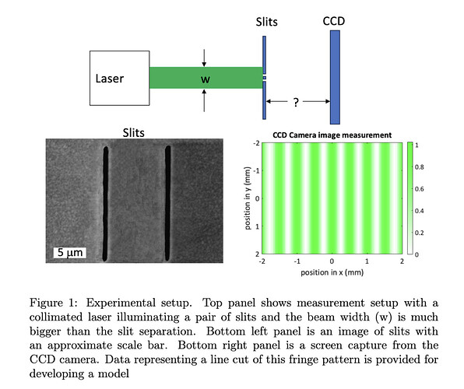
Linked data: TwoSlitData.csv
Linked background reading: Curve fitting Taylor-An Introduction to Error Analysis-1.pdf

4. Tech Comm (SIMU)

4.1. Learning Goals
In this technical communication exercise, you will learn how to summarize your
results from the simulation lab with a publication-grade figure and figure caption
describing and interpreting the results presented in the figure.

4.2. Background
When communicating data and/or results in a figure within a report, publication, and sometimes even in a slide deck, it is highly desirable to produce a figure that clearly presents your results. Moreover, this figure should often have a caption that concisely but completely describes the message(s) you wish to get communicate with the figure. In other words, a reader should be able to understand your results from just the figure and figure caption.

4.3. Figure Considerations
When designing a figure to effectively communicate your message it is useful to
keep in mind the following rules.
- Identify your message: what are you trying to express?
- Captions are not optional: see below.
- Tweak default options of plotting software/libraries: to better express
- your message.
- Use color effectively: improve message delivery without distractions .
- Avoid “chartjunk”: do not saddle the reader unnecessary information
- These rules (along with a few others) are discussed here in more detail with
- great examples.

4.4. Caption Considerations
In constructing a caption it is useful to parse up a proper figure caption by
considering what it should contain. All captions should contain an orientation
phrase/sentence to introduce the figure to the reader that is descriptive enough
to understand the main point of the figure without having to referring to any-
thing else. If the figure is presenting data/results at a minimum it should also
have an observation sentence (or two or more) that discusses trends or results
presented within the figure. And finally depending on context the cation could
have a discussion of what these trends/results mean. Please see Section 4.6 for more in-depth explanation and examples.

4.5. Deliverables
Using the above explanation, cited references and examples as a guide (and
help from TAs and profs) , generate a figure and caption that presents your
modelling efforts from your the simulation lab.

4.6 Background Reading
SIMU_Tech_Comm_captions-1.pdf (490.9 KB)
Techcom SIMU example 1.pdf (296.6 KB)
TenSimpleRulesforBetterFigures.pdf (3.7 MB)

