Affymetrix

DMET3 APT Translation Design and Implementation

Technical Specification
Document Title
DMET3 APT Translation Design and Implementation
Project Name
DMET3
Revision 1.0 | Last saved: 1/30/2009 07:15:00 PM
Created by: Mybrid Spalding | Last saved by: Mybrid Spalding

Table of content
1. Document Overview 5
1.1. Document Organization 5
1.1.1. Document Review Team 5
1.1.1.1. Core Team 5
1.1.1.2. Review Team 5
1.1.2. Review Routing 5
1.2. Document Change Control 5
2. Overview 6
2.1. Goal 6
2.1.1. High-level Design Specification 6
2.1.2. Translation Algorithm 6
2.1.3. Key Functional Decisions 6
2.1.4. Gotchas 6
2.1.5. Inputs/Outputs 6
2.1.6. Testing 6
2.2. Audience 6
2.3. Scope 7
2.3.1. affy/adk/translation 7
2.4. Exclusions 7
2.4.1. calvin_files/utils/src/GenoCallCoder.[h,cpp] 7
2.4.2. DMET Console 7
3. Glossary 8
3.1. DMET3 8
3.1.1. Wildcard Allele (No Call, Possible Rare Allele and Not Available) 8
3.1.2. Assay ID, synonym for Probe Set 8
3.1.3. Defining Marker, Haplotype Group 8
3.1.4. Haplotype Group 8
3.1.5. Marker, synonym for Probe Set 8
3.1.6. Probe Set 8
3.1.7. Genotype Override Report, Genotype Override File 9
3.1.8. Uncalled Report, synonym for Genotype Override File 9
3.1.9. Uncalled, synonym for wildcard 9
3.1.10. Comprehensive Report 9
3.1.11. Summary Report 9
3.1.12. GSR, Genotype Short Report 9
3.2. Software 9
3.2.1. MVC, Model View Controller 9
3.2.2. DC, DMET Console 10
3.2.3. CLI, command line interface 10
3.2.4. Base, synonym for allele 10
3.2.5. Hard Constraint 10
3.2.6. Soft Constraint 10
3.2.7. Verbose/Err class; as a controller 10
3.2.8. Heterozygous Call, Het Call 10
3.2.9. Homozygous Call 10
4. Design Specification 11
4.1. MVC Architecture 11
4.1.1. Interactive View 11
4.1.1.1. C_CONSOLE 11
4.1.1.2. C_CMDLINE 11
4.1.2. Report View 11
4.1.3. Control and View Objects 12
4.1.3.1. CO, controller object 12
4.1.3.2. SITMV, single instance table model view 12
4.2. Controller/View Implementation Discussion 14
4.2.1. Figure 1. Controller Paths 14
4.2.2. Figure 1. The Verbose Controller 14
4.2.2.1. Verbose/Err, pure static classes 14
4.2.2.2. Verbose Exception Crashes DC 15
4.2.2.3. Figure 2. Functional Specification: only one try/catch block 15
4.2.3. Figure 1: Progress Path 16
4.2.4. Figure 1: Cancel/Exception Path 16
4.2.5. Figure 1: Report Finish Path 17
4.3. Model Design 20
4.3.1. Translation File Models 20
4.3.1.1. SITM, Single Instance Table Model 20
4.3.1.2. SITMV, Single Instance Table Model View 20
4.3.1.3. MITM, Multiple Instance Table Model 20
4.3.2. File Models Design Choice, Raw Table vs Setter/Getter 20
4.3.3. TsvFile Table Model: TranslationInputTsvTableModel 21
4.3.3.1. Override file 23
4.3.3.2. Override file, validation and user generated 23
4.3.3.3. Override file, copy number 23
4.3.3.4. Override file, report aliases 23
4.3.3.5. Override file, current state 24
4.3.3.6. Mapping CHP data to Genotype Short Report format 24
4.3.4. Algorithm Business Object Models 26
4.3.5. CallResults/Future Work Model 26
4.4. MVC Flow Charts 28
4.4.1. Object Flow Chart 28
4.4.1.1. Object Flow Chart: Experiment Unit of Work 28
4.4.1.2. Object Flow Chart: CHP consumed 28
4.4.1.3. Object Flow Chart: Annotation File 28
5. Translation Table 31
5.1. Introduction 31
5.2. DMET2 Schema 31
5.2.1. Column Schema 31
5.2.2. Column order 33
5.2.3. Analysis Columns: Gene, AssayID, Haplotype, Reference, Variant, A1, A2…AN 33
5.2.4. Gene Header Row 34
5.2.5. Schema Rules, Three Places 34
5.2.5.1. TranslationInputTsvTableModel, Parent Constructor 34
5.2.5.2. TranslationTableModel, Model Constructor 35
5.2.5.3. TranslationTable, Business Object Constructor 35
5.2.6. Column Specification 35
5.2.7. A1, A2..AN Column Specification 37
5.2.7.1. Haplotype Call 37
5.2.7.2. Empty Value 37
5.2.7.3. Non-haplotype columns 37
5.2.7.4. Commented Out 37
5.2.7.5. Duplicate Allele Sets 37
5.3. DMET3 Translation Table Schema 40
5.3.1. DMET3 Column Schema Table 40
5.3.2. DMET3 to DMET2 column map 41
5.3.3. DMET3 Column Specification 42
5.3.3.1. Switch Design Strand to Report 42
5.3.4. A1, A2..AN Column Specification 44
5.3.4.1. Report Alias 44
5.3.4.2. Copy Number 45
5.4. Marker List 47
5.4.1. Header 47
5.4.2. Validation 47
5.4.2.1. Missing Header, Invalid Header, Hard Constraint 47
5.4.2.2. Invalid Probe Set Id, Hard Constraint 47
5.4.2.3. Unrecognized Probe Set Id, Soft Constraint 47
5.4.3. Filter, Translation Table Projection 48
5.4.3.1. First Allele Name 48
5.4.3.2. Collapse Allele Names 48
5.4.4. DC Implementation 48
5.5. Uncalled Report (Genotype Override File) 48
6. Translation Algorithm 50
6.1. Introduction 50
6.2. Translation Algorithm Preamble 50
6.2.1. DMET2, Genotype Short Report Experiment Sorting 50
6.2.2. Gene grouping 51
6.2.3. Loop on gene call marker sets. 51
6.3. Translation Algorithm, Schematic Overview 52
6.4. Translation Algorithm: Take One, Theory 54
6.4.1.1. Copy Number Zero 54
6.4.1.2. Copy Number One (Not Supported) 54
6.4.1.3. No Call, Possible Rare Allele and Not Available 54
6.4.1.4. Marker Translation 54
6.4.1.5. Haplotype Type Base Case Examples 55
6.4.1.6. Base Case 1: Haplotype Call Exact Match 55
6.4.1.7. Base Case 2: Haplotype Wildcard Match 58
6.4.1.8. Translation Algorithm. Calculating Total Results 59
6.4.1.9. Translation Algorithm, Matching (copied from code, edit for copy number and logging) 61
6.4.1.10. Translation Algorithm Discussion 63
6.5. Translation Algorithm: Take Two, Implementation 64
6.5.1. Validation 64
6.5.2. Complete Set Containment 64
6.5.3. Size Validation 65
6.5.4. Wildcard Validation 65
6.5.5. DMET2 Copy Number Zero 65
6.5.6. DMET3 Copy Number Zero 65
6.5.7. Theory Translation 66
6.5.8. Result Accumulation 66
6.5.9. Interrupts 66
6.5.10. Interpretation Code 66
7. Reporting 67
7.1. Three reports, one file 67
7.2. Reporting Flow Charts 68
7.2.1. Translation Table Reporting 68
7.2.2. Multi-allelic 68
7.2.3. Uncalled Report 68
7.2.4. Reporting Main Generate Loop Flow Chart 69
7.2.5. Reporting Set Translation Table Row Data Flow Chart 70
7.2.6. Reporting Set Relevant Alleles Flow Chart 71
7.2.7. Reporting Set Translation Row Data From Experiment Data Flow Chart 72
7.2.8. Reporting Generate Basecall Flow Chart 74
7.2.9. Reporting Generate Interpretation Code Flow Chart 75

Document Overview

Document Organization

Document Review Team

Core Team
Members of the core team:
Mybrid Spalding mybrid_spalding@affymetrix.com
Krzysztof Olszewski krzysztof_olszewski@affymetrix.com
Ray Wheeler ray_wheeler@affymetrix.com

Review Team
Members of the core team:
Ray Wheeler ray_wheeler@affymetrix.com
Alan Williams alan_williams@affymetrix.com
Harley Gorrel harley_gorrel@affymetrix.com

Review Routing
The core team will approve a complete draft before distribution to the actual project review team.

Document Change Control

Revision Information
Version | Date | Reviser | Summary of Changes
0.1 | 12/11/2008 9:16:00 AM | Mybrid Spalding | Initial Document for direction discussion. MVC, Controller and View design.
0.2 | 11/7/2026 | Mybrid Spalding | Changed name to “Design and Implementation.” MVC, Model design
1.0 | 11/7/2026 | Mybrid Spalding | First complete draft.

Overview

Goal
This document is being written after the fact. As such the code itself represents the best functional specification and this document focuses on the design and implementation. As such the objective is not to specify in full detail, but rather to specify what was implemented for posterity. In particular what is specified is:

High-level Design Specification
Object modeling and program flow charts.

Translation Algorithm
The algorithm behind translation is described in English.

Key Functional Decisions
For example, why there is only one try/catch block allowed within the program.

Gotchas
This document describes common problems typically encountered when fixing bugs and tweaking the code.

Inputs/Outputs
How the translation table, annotation table, marker list and override file interact with input data. DMET2 Genotype Short Report input vs. DMET3 CHP file input.

Testing
Test cases and methods beyond “make check” and “make regression”. Instructions are provided for how to add further cases to the report regression without updating the code.

The goal of this document then is to facilitate any developer who should happen to be given the task of fixing a bug or adding a feature to this software. A quick read of this document should be helpful and a good introduction to jumping into the code itself.
Another goal of this document is give the Bioinformatics team a solid starting point for a complete rewrite of a next generation of this project.

Audience
The objective of any writing should always be tailored to its audience. The audience in this case is the Bioinformatics team and QA partners.

Scope
This document is limited to the source code found in the following directory:

affy/adk/translation

Exclusions
This document does not cover code written specifically for translation but not found in the ‘affy/sdk/translation’ directory: Specifically this requirement does not cover:

calvin_files/utils/src/GenoCallCoder.[h,cpp]

DMET Console
In addition this document does not cover the DMET3 Console except with respect to invoking and run-time interaction with the translation code.

Glossary

DMET3

Wildcard Allele (No Call, Possible Rare Allele and Not Available)
If the input experiment data contains any of the following values for a probe set then it is referred too as a wildcard:
- No Call, a.k.a. NC
- Possible Rare Allele, a.k.a. PRA
- Not Available, a.k.a. NA or non-consented marker data

Assay ID, synonym for Probe Set

Defining Marker, Haplotype Group
A defining marker refers to the translation table specifically. When an allele column in the A1, A2…AN columns specifies a value for a marker then that marker is said to be a defining marker. Allele calls defined by the allele columns A1, A2…AN are typically blank except for one or two values. The blank values are in fact not black but infer the reference value in the Reference column of the translation table. The variant values appear in the allele columns. When they do they are referred to as a defining marker as this marker helps distinguish the allele call from the reference call.

Haplotype Group
Haplotype group refers to a set of markers in the translation table file. Each gene may have at most one haplotype group defined in the translation table. This group is defined by the set of markers that have a “Y” for yes in the haplotype column of the translation table. The set of markers for a gene with this designation is called the haplotype group.

Marker, synonym for Probe Set
Marker is often used to distinguish between haplotype and non-haplotype group allele probe sets, or SNPs. We say a probe set is either of type marker or haplotype. However, haplotype allele group probe sets can be referred to as marker when used in general. The input marker list file shown in Table 1, for example, may contain probe sets of both haplotype and non-haplotype group alleles. The marker list name of this file should not be construed to mean only non-haplotype group probe sets are allowed.

Probe Set
A probe set is an alpha-numeric identifier of the Affymetrix gene chip. Probe sets are created by agreement between the chip designers and the annotation file curators. The translation table must use the probe sets laid out by the experiment annotation file, even in the case of DMET2 calling where the annotation file is not input into translation.

Genotype Override Report, Genotype Override File
The one file used in translation which acts as both an input and an output file. When referred too as an output file it is most often referred too as the uncalled report. When this file is referred too as an input file it is most often referred to as an override file. Note that an override file doesn’t have to originate as an uncalled report as users are free to create stand-alone hand-crafted override files.

Uncalled Report, synonym for Genotype Override File
This file is always generated as a result of running the translation program. The file is generated with only wildcard results found in the comprehensive report. The common used case use of this file is for users to run experiments using a different product then DMET3 and then to supply the missing, wildcard data values is concrete values from said product.

Uncalled, synonym for wildcard
The uncalled report could just as easily be called the wildcard report, see wildcard allele.

Comprehensive Report
This report is the definitive translation result report. All probe sets in the translation file are reported on, even if they were not found in the input experiment data. The probe sets are reported on in precisely the same order as the input translation file. The one exception is when a marker list input file is used, in which case only those probe sets specified in the marker list appear in the comprehensive report.

Summary Report
This report is an abbreviated version of the comprehensive report and contains the same fields. Uninteresting gene call results are collapsed into one report row per gene. The summary report is always an abbreviated version of the corresponding comprehensive report. Therefore if the comprehensive report is modified in output by use of an input marker list then the summary report represents a summary of the modified comprehensive report.

GSR, Genotype Short Report
The GSR is called a report but in fact is input experiment data for the DMET2 and DMET3 translation tool. Note that only the CLI can take advantage of the GSR for DMET3. The DC always requires CHP files for input experiment data.

Software

MVC, Model View Controller
This is meant both as the classic architecture implementation (view selects a controller, model updates the view) in addition to an architecture design pattern (separation of presentation, business logic and control objects).

DC, DMET Console
The Microsoft Windows, C# program that invokes the translation code documented herein.

CLI, command line interface
The translation shell software can be invoked form a Linux bash shell using various command line options without the benefit of the DMET Console.

Base, synonym for allele
In DMET2 alleles were referred too as bases. DMET3 as a rewrite of DMET2 carried over this nomenclature. In particular alleles in the “CallElement” object are referred to as “bases”.

Hard Constraint
A validation or edit performed by the translation tool that results in program execution stopping upon failure, . i.e. a fatal error.

Soft Constraint
A validation or edit performed that does not stop program execution upon failure. Typically an error is written to log as well as the data involved in the failure is ignored.

Verbose/Err class; as a controller
The Err and Verbose classes are implemented as two separate static classes but for brevity are referred as the same class. Both classes are single instance classes that are not instantiated via a call to new but are rather static classes that are decorated with Verbose message handlers allocated on the heap at run time.

Heterozygous Call, Het Call
Experiment data contains a pair of call values that differ. For example, if a probe set id had values “A” and “C” for chromatid 1 and chromatid 2 respectiively.

Homozygous Call
Experiment data contains a pair of call values that are the same. For example, if a probe set id had values “A” and “A”: for chromatid 1 and chromatid 2 respectively.

Design Specification
This section specifies the architecture, design patterns and object models used for development. As stated in the glossary, MVC refers to both the architecture design used for DC and the translation tool interoperability as well as a design pattern specifying separation of presentation from data and program flow.

MVC Architecture
The project uses a simple Model View Controller [MVC] architecture.
The view for this project is taken to mean two types of views where the traditional notion is an interactive view that includes the DMET Console [DC] written in C# on Windows in addition to the command line interface [CLI].

Interactive View
The interactive view includes the DMET Console [DC] written in C# on Windows in addition to the command line interface [CLI]. In both cases the view chooses a controller type by specifying a mask passed into the “TranslationEngine” constructor:

C_CONSOLE
This mask option specifies controller behavior and translation engine options specific to the DC. The DC may not specify any other mask option.

C_CMDLINE
This mask option specifies controller behavior and translation options specific to the CLI. This mask may be combined with the C_CONSOLE mask to afford testing console behavior without using the DC. The CLI may also specify the C_CONSOLE option without the C_CMDLINE option. One of the unit test cases in the “CPPTest” directly specifies only the C_CONSOLE mask so as to insure the console controller behavior works correctly without the need to test on Windows to the extent possible.

Report View
The report view object is responsible for calling a controller but only one controller was implemented, the TsvFile output controller. This controller streams data output to temporary report files named with “.tmp” extensions.
The specification for the report model contains more data than required for the TsvFile controller and view. The report view is designed so as in the future to interact with the DC where the “CallResults” model will be passed to the DMET Console view object with the intention of having the DC display translation report results with a more user friendly interface than the simple spreadsheet files represented by the TsvFile object. For example, the DC might allow different sort orders than the order that currently output by the reports.
However, given a DC view of the reports directly has yet to be implemented than the report view object has no interaction with the user and is currently simply a design in-waiting. The reports are simply viewed using Excel or some other external program.

Control and View Objects
The controller and view objects are presented in Table 1.The reports are considered both view objects and models (representing the output files) and their ID designations reflect this.
Table 1 displays and “ID” column encoded with the following codes:

CO, controller object

SITMV, single instance table model view
The report view objects are coupled with the underlying models because the reports do not have any user interaction. See the following section for a discussion on the table model.

Table 1: Controller View Objects
# | Name | ID | DMET2 | DMET3 | Description
1. | ADTOptions | CO_1 | X | X | PGOptions and derivatives.
2. | Profile | CO_2 | X | X | Timing object that collects
3. | RunTimeEnvironment | CO_3 | X | X | Run time environment controller data. Has ADTOptions (CO_1).
4. | TranslationCommonControl | CO_4 | X | X | Common DC and CLI control code.
5. | TranslationEngine | CO_5 | X | X | APT BaseEngine Factory Controller, DC and CLI specific control code
6. | Override (uncalled) Report | SITMV_1 |  | X | Experiment Call Data Override
7. | Comprehensive Report | SITMV_2 |  | X | Translation Results Report
8 | Summary Report | SITMV_3 |  | X | Translation Results Report
9. | Marker Report | SITMV_4 | X |  | Translation Results Report
10. | Regression Report | SITMV_5 | X |  | Regression Testing Report

Controller/View Implementation Discussion
As stated in the goals section, the purpose here is not to restate what can be ascertained by reading the code, but rather to identify gaps, specify why decisions were made and to point out where the gotchas lie.
This section primarily documents a gap. That gap is the missing specification of the interoperability between the DC and the translation DLL that is not documented in either the DC or translation tool code base. This is the only place where the interoperability between the DC and the translation DLL is documented and so the topic is given a lengthy discussion. In addition, using the Verbose/Err classes as a controller represented challenges that had to be designed around and those decisions are document here as well
The controller design discussion is presented with reference to Figure 1. and Figure 2.; depicting the three controller paths available to the DC and the main run loop flow respectively.
The biggest interoperability challenge in developing this project was using the Verbose/Err classes as the controller. Unfortunately the problems encountered were not discovered until late in the project schedule, just a couple of weeks prior to the first code freeze. Therefore the design reflects choices were made due to expediency rather than an arguable appropriate design.

Figure 1. Controller Paths
The translation program is a batch program and as such the interaction between the view and the model is limited to a cancel message sent by the DC and corresponding return cancel reply message; along with two other messages of progress and report finish

Figure 1. The Verbose Controller
The motivation behind Figure 1 is the Verbose Controller. A lot of accommodation on account of the Verbose object as well as time was wasted on this Verbose object. Hopefully the discussion below can prevent a repeat of both by you, the reader.
As depicted in Figure 1., the utility of the Microsoft COM interface is limited to the creation of the TransltionEngine object and the subsequent “run” invocation required to start the batch processing of translation.
At the heart of the matter is that the message handlers attached to the Verbose/Err static classes originates in the unmanaged address spaced of the DC but are used by the translation DLL. Improper invocation of the DC message handlers by the translation DLL crashes the DC. The message handlers will be invoked by the translation code in the translation DLL, but these handlers are created by the DC and reside in the DC address space.

Verbose/Err, pure static classes
Careful examination of the Verbose/Err classes reveals they are pure static classes. One cannot create a new Verbose/Err object. This property allows the DC and the translation library to communicate via the Verbose/Err object and bypass COM. The Verbose/Err classes become the controller that arbitrates between the two code bases.
The static property provides a convenient communication interface, but also a fragile one.

Verbose Exception Crashes DC
The translation library will crash the DC if Err::errAbort is invoked by the translation library after the DC has issued an Err::errAbort to signal a cancel message to the translation library. The crash happens if any attempt to use Verbose is made within the translation DLL after receiving a DC cancel.

Figure 2. Functional Specification: only one try/catch block
The implication of 4.2.2.2 where the translation library can crash the DC if Err::errAbort is invoked after the DC does was not easy to track down. Craig and I spent the better part of a week working this out.
The original design of the translation library used a generous helping of try/catch blocks as is common to object oriented design. As such when a cancel message was sent to the translation DLL via the verbose handler in the Err object the translation code would necessary and consequently catch the DC cancel exception message within some arbitrary try/catch block of the translation library. As is common practice these try/catch blocks should re-throw exceptions not intended for them. However, doing so would require an appropriate exception type. However, Err::errAbort only throws one exception type and therefore try/catch blocks could not differentiate between exceptions.
In other words, the translation library could indeed throw exceptions internally using Err::errAbort with impunity until the moment the DC invoked the cancel and then the exception would be misinterpreted.
Further, once the DC sends a cancel message to the translation library using Err::errAbort, the translation library may not invoke any of the various the Verbose object methods or the DC will crash. Craig and I thought about extending Err::errAbort to differentiate exception types but once it became clear that Verbose could not invoked once the DC called Err::errAbort, that design thought was abandoned.
As a consequence of the above discussion it is a functional specification that no try/catch blocks exist except the top level try/catch in TranslationEngine::run. The translation code was refactored to use exactly one try/catch block at the top level of run and this is illustrated in Figure 2. This design has two benefits:
- Insures that only the TranslationEngine::run method will catch the cancel.
- Limits the exposure of the cancel operation vagaries to those methods necessary for cleanup due to the cancel.
In addition, within the file “TranslationEngine.cpp” the following warning appears:

// !!! WARNING !!!
// Beyond here no calls to Verbose::out or Verbose::warn can be
// made if okToExit is false and C_CMDLINE is false.
// This is because Vebose::out will
// throw an exception in Windows. All messaging beyond this
// point must be conditioned upon okToExit being true
// if C_CMDLINE is false;
It is a functional specification that all code implemented after this point in TranslationEngine::run be passed the “okToExit” condition variable and all logging via Verbose be conditioned on “okToExit” being true. This primarily applies to the various close methods found in TranslationExperimentReport.
To recap, it is a functional specification that the only try/catch block used within the translation code be the top level try/catch in TranslationEngine::run. Further, any clean up code required for cancel needs to be passed the “okToExit” condition variable and any messages logged via the Verbose object be conditioned upon “okToExit” being true.

Figure 1: Progress Path
Figure 1. has the progress message path denoted with an encircled number 1. (see legend).
When DC invokes the TranslationEngine::run method it is required that a progress handler built into the Verbose controller updates the view periodically. In this case the DC is messaged once per CHP file processed. The percentage progress bar in the DC is a calculation of the total CHP files divided by the number of CHP files already processed. If there is only a single CHP file being processed then there will only be one progress message sent.

Figure 1: Cancel/Exception Path
Figure 1 has the cancel message path denoted with various encircled number 2s placed throughout. Not depicted in Figure 1. is the exception path is the same as that of the cancel message path. While uncommon, the translation batch processing may need to initiate a cancel message on its own behalf. In that case the path is identical to sending a cancel reply message.
Note that while try/catch blocks are not allowed in the translation code, exceptions that abort the program are common and the result is the same as if the DC sent a cancel message, viz-a-viz the try/catch block in TranslationEngine::run catches the abort, cleans up after itself and sends the cancel message to the DC. Also, various system and APT libraries will also throw exceptions and cancel message path is used in exactly the same manner.

Figure 1: Report Finish Path
The translation batch process creates report files. Once the batch processing is done the translation process sends a message to the DC indicating translation completed successfully by “exiting” with status of ‘0’.
The “exiting” is in quotes because in fact the translation code resides in a DLL and as such never truly “exits”. This is why great care is taken at the end of Translation::run to free all dynamically allocated memory so as to not create memory leaks.
It is a functional specification that all heap memory be deallocated before the translation process “exits” so as to avoid memory leaks.

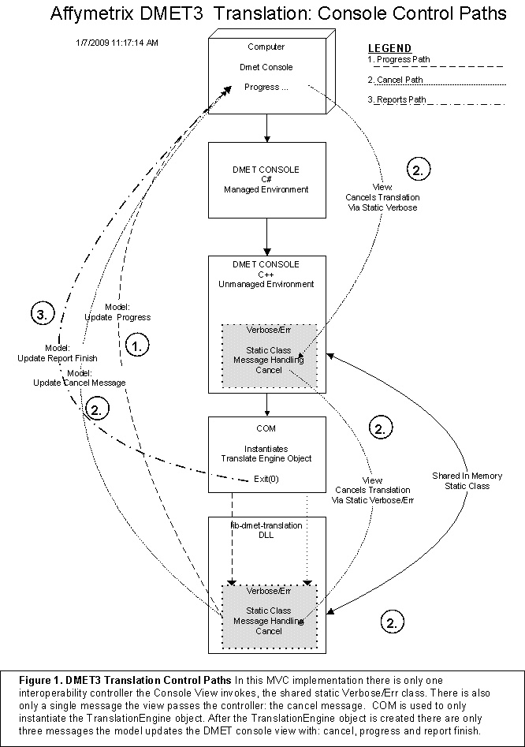
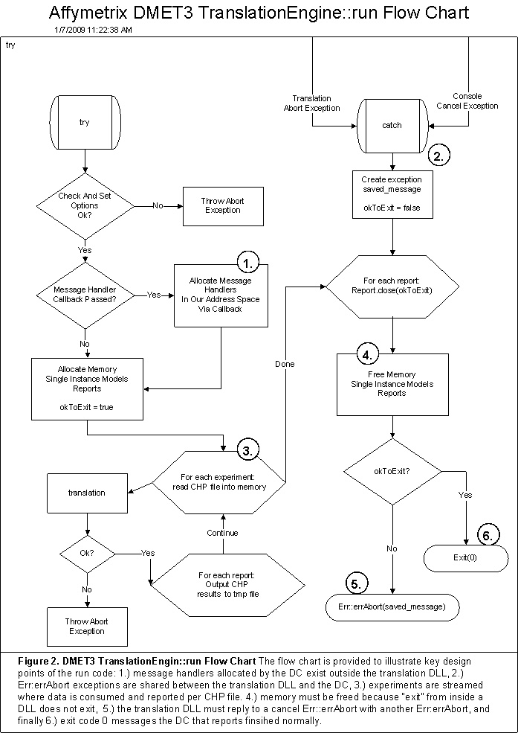

Model Design
Modeling of the translation code is primarily concerned with the input and output files. This is discussed in Section 4.3.1.
Modeling of the translation code also requires those business objects required to perform translation and these models are discussed in Section 4.3.2.
One particular model, CallResults, is a future work model designed for a future DC that displays translation results independent of the reports generated by this code and this discussion is presented in Section 4.3.3.

Translation File Models
Table 2: Translation File Models shows the various kinds of input and output files used by the translation code. All files are created by Affymetrix and required to be tab delimted, TsvFile object format. The one exception is the experiment data input files, which are of CHP format.
The table contains a coded “ID” column where the “ID” codes mean the following:

SITM, Single Instance Table Model
A design pattern exists called the single instance pattern. Most of the data models used for the translation tool are single instances models. These are global models that represent either an input or output file

SITMV, Single Instance Table Model View
This model is a combined model and view report object and is the same as the SITM where the models also have view methods. During translation the She reports

MITM, Multiple Instance Table Model
A multiple-instance table model is a design pattern designation created here to mean a stream model. Multiple experiment files or single experiment files are streamed in memory one experiment-at-a-time. At any given time there is only one experiment model instance to conserve memory. When the data for the one experiment is consumed, the model is destroyed and another created to represent the next experiment.

File Models Design Choice, Raw Table vs Setter/Getter
DMET3 was a rewrite of DMET2. DMET2 was written in Perl. As such in the DMET2 Perl code the input files were slurped into in memory hashes as is common practice with small files in Perl.
When DMET3 was being designed analysis was done as to whether a complete redesign was warranted. In Perl it is simple enough to split tab delimited lines into fields, records, and then hash them on some unique identifier, in this case the probe set id.
The observation was made that most of the report data was simply copied or passed through from the translation file. Only the gene call itself and corresponding analysis fields like interpretation code represent data not taken from the translation table.
To be precise, the comprehensive report is a copy of the translation file per experiment with additional columnss. One could say that the process reads in the translation file per experiment and then writes it back out again with the call data. Since most of the data in the translation table is “pass through” annotation data, it was decided that creating a collection of setter/getter objects to represent the various columns of the translation file was unwarranted. Instead, the translation file, and the various experiment data input files, would be treated as simple tables that are accessed directly via row, column look up. Indexes would be built for fast access of the table data for sort order, etc.
Each file then is represented as a table in memory using the simplest structure: a C++ STL “vector of vector of strings”. Most data is unanalyzed and unparsed, but simply copied from the translation file or other various input files to the various reports.

TsvFile Table Model: TranslationInputTsvTableModel
All input files are put in the same object model: TranslationInputTsvTableModel where the primary objective is to provide access to the data using a data table, columns and rows of strings. The principal attribute of the TranslationInputTsv
TableModel is the “rows” attribute, implemente as a table using the C++ STL vector template, “vector of vector of strings”. Each input file is represented by this simple wrapper class that also includes various indices and other required meta data attributes.
Note that the TsvFile object itself was not used directly as a simplification: accessing the columns and rows of the data is far more involved then simply row, column indexing of a table. To wit, the TranslationInputTsvTableModel is a gross simplification of the full capabilities of the TsvFile object itself.

Table 2. Translation File Models
# | Name | ID | DMET2 | DMET3 | Description | Input | Output | Format
1. | Translation | SITM_1 | X | X | Translation Map | X |  | TsvFile
2. | Annotation | SITM_2 |  | X | Call Map from CHP to Allele | X |  | TsvFile
3. | CHP | MITM_1 |  | X | Experiment Call Data, One Experiment per File | X |  | CHP
4. | Genotype Short Report | MITM_2 | X | X | Experiment Call Data, unlimited Experiments | X |  | TsvFile
5. | Marker List | SITM_3 |  | X | Probe Set Subset applied to Translation File | X |  | TsvFile
6. | Override (uncalled) Report | SITMV_1 |  | X | Experiment Call Data Override | X | X | TsvFile
7 | Summary Info | SITM_4 |  | X | Summary Annotation Data | X |  | TsvFile
8. | Comprehensive Report | SITMV_2 |  | X | Translation Results Report |  | X | TsvFile
9. | Summary Report | SITMV_3 |  | X | Translation Results Report |  | X | TsvFile
10. | Marker Report | SITMV_4 | X |  | Translation Results Report |  | X | TsvFile
11. | Regression Report | SITMV_5 | X |  | Regression Testing Report |  | X | TsvFile

Override file
Most files are either input or output only except one, the override file. File 6 denoted in Table 1 shows this file is both an input and an output file. As such business requirements regarding this file are somewhat ambiguous because on one hand the file is generated by the program itself, on the other hand users can create an override file independent of the one recreated from a previous run of the translation program. For this reason a detailed discussion of the override file is presented in the following sections.
The original design of this file called for simply reporting on so called wildcard values, i.e. no call, possible rare allele and not available. Currently this is still the case where the only the wildcard probe set data values are written to the uncalled report. However, overriding these values is no longer the only use case for this file.
There are three issues regarding the dual nature of the uncalled report.

Override file, validation and user generated
Business has requested that when users generate the override file they only be required to provide the probe set and override call value. However, this conflicts with requirements where if users are using an uncalled report that was previously generated then that report must be validated against the input translation table. Early on it was discovered that uncalled reports used for override may not match the translation table. Therefore the override file “Reference” and “Variant” columns are validated twice: once intra-file against the override base call and then again against the translation table variant and reference values for the probe set in question. If the override base call does not jive with the variant and reference columns within the uncalled report the row is rejected. If the variant and reference columns do not jive with the translation table the reference and variant columns the row is rejected.

Override file, copy number
Business has repeatedly requested that the override file be allowed to override the copy number, either zero or one, of the experiment data using the override file. However, the uncalled report will only contain uncalled data and copy number applies to an entire gene. The uncalled report would necessarily need to have all probe sets for an experiment gene in order to override copy number correctly with the entire set of gene probes. This is not a requirement for the uncalled report. These conflicting requirements result in confusion for users when trying to use the uncalled report to override copy number but having only an incomplete set of markers generated in the uncalled report.

Override file, report aliases
The final issue regarding the override file has to do with report aliases. Presume for a moment that the use case is the user sees something in the comprehensive report that they want to override. The expected process would be to take values from the comprehensive report and plop them into a hand-crafted override file. At issue with this presumed process is that the comprehensive report contains report aliases for some markers where as the translation file and override file must use actual allele names, not the alias. If the user were to make the incorrect conclusion that data from the comprehensive report, i.e. the report alias, can be used to specify the base call in the override file the row would be rejected because the alias cannot be mapped back to the translation file.

Override file, current state
The current state of the override file is that copy number override is not supported for all the issues noted above. However business is constantly asking for the override file to support copy number override and hence this discussion is presented. Each of the issues presented in previous sections would need to be addressed in order to enable copy number override.

Mapping CHP data to Genotype Short Report format
The Genotype Short Report format has five fields: “Sample”, “Experiment Name”, “External ID”, “Probe Set Id”, “Allele 1” and “Allele2”. The DMET3 experiment data in the CHP file is recast into the DMET2 experiment data format, the Genotype Short Report format. This design was chosen primarily because it is a requirement that DMET3 also support the Genotype Short Report format. Since the Genotype Short Report format was the simpler of the two and met all DMET3 requirements then the Genotype Short Report format became the internal representation standard for both CHP and GSR.

Figure 3. shows the mapping of the CHP file to the TsvFile. Most important is that even though the CHP file contains many fields in the bi-allelic and multi-allelic record format, there are only two fields used: the probe set id and the call byte. The call byte is split into two data elements: Allele1 and Allele 2. The CHP file name is the experiment name.

The Genotype Short Report format of DMET2 requires the fields “Experiment Name”, “Probe Set Id”, “Allele 1” and “Allele2.”. The “Sample” field in the Genotype Short Report format is annotation data that is obtained from Given the CHP file name is the experiment name then the DMET3 CHP file can be mapped to the DMET2 Genotype Short Report TsvFile format.

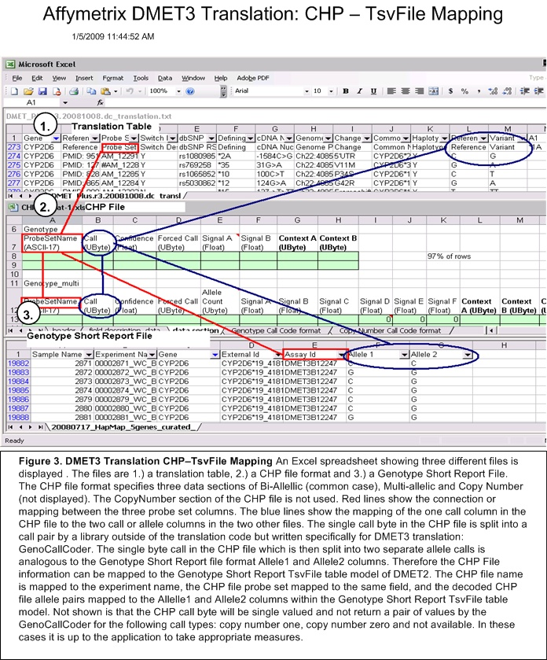

Algorithm Business Object Models
Table 3: Algorithm Business Object Models shows the objects used to actually perform the analysis that is the point of the program. In a good design, the design of the business objects as models within the MVC that are specific to processing data. If the design of the Input data models are changed, or the design of the view objects changed then ideally the business objects would need little modification.
Table 3: Algorithm Business Object Models
# | Name | ID | Description
1. | TranslationTable | BOM_1 | Container for GeneCalls (BOTM_2) and CallSets (BOTM3) of reference marker data. A business logic representation of the translation table (SITM_1)
2. | GeneCall | BOM_2 | Container for CallSets (BOTM_3) that represent columns of the Translation Table Model (SITM_1). Each Allele column represents a Gene Call, the output of the translation algorithm.
3. | CallSet | BOM_3 | Either a reference list of marker data as represented in the translation table (SITM1) or the experiment data (MITM_1, MITM_2). CallSets can be compared for match. The translation tool matches CallSets nested in the GeneCall to CallSets representing experiment data.
4. | CallElement | BOM_4 | A probe set id and corresponding allele list. Multi-allelic probe sets have a list with more than one allele.
5. | ExperimentResults | BOM_5 | Simple ExperimentGeneResults container with a couple of summary statistic attributes.
6. | ExperimentGeneResults | BOM_6 | CallResults container with indices representing one experiment’s set of translation results.
7 | CallResults | BOM_7 | A single haplotype marker group, or single non-haplotype marker translation result for an experiment. Contains the all the CallSets (BOM_3) of experiment data used during analysis. When wildcards are present multiple calls apply.

CallResults/Future Work Model
All business objects called out in Table 3 are involved with processing except the CallResults object. This object contains all the data used during translation in addition to the results. This business object is a future work object that is intended to be passed to some future view object within the DC. Originally the results from translation was a simple array of the calls, i.e *4/*1, Reference/Variant, etc. However, it was decided that the results should contain all the data used to create the translation call. This business object would be the go-between object for the DC and translation DLL. The CallResults object contains all information required to display a view of the translation process without marrying the results with the input files as is done during translation reporting.

MVC Flow Charts
This section contains flow charts and discussion with the goal of providing a clear understanding of the flow of the translation tool program.

Object Flow Chart
The object flow chart is intended for use as a high level discussion vehicle for the overall flow of the program.

Object Flow Chart: Experiment Unit of Work
At the center of the flow is a simple loop over each experiment. The experiment is the unit of work. This loop is where the analysis is performed. This implies that any future addition to the DC to display real-time results would be necessarily be limited to per-experiment results display. In fact, the current progress bar of the DC is simply a factor of the progress of each experiment analyzed as a unit of the total number of experiments. In the future the CallResults object would be passed to the DC instead of just a progress handler.
On the current Linux and Windows systems an experiment with on the order of one thousand markers takes approximately one second to finish. For this reason the experiment as the unit of work was designated appropriate.

Object Flow Chart: CHP consumed
The object flow chart also shows that the CHP input experiment data file is consumed and all date lost. It is important to realize that NO annotation data is taken from this file, only analysis data. Further, the CHP file contains three sections, Bi-Allelic, Multi-Allelic and Copy Number of which only the first two are processed. The Copy Number section is ignored completely. Copy number state is encoded in the other sections. Most of the columns in the Bi-Alllelic and Multi-Allelic CHP file data sections are ignored. Only the “Probe Set Id” and “Call Byte” columns are used and subsequently passed along in the analysis results.
Note that even though CHP data is consumed, if in the future the DC were to implement a real-time analysis view the CHP is available to the DC for view presentation. At one point during development in a design meeting with the DC developer the point was made that the DC already uses a CHP parser and that there would be no benefit of having the translation tool pass along all the CHP data in the analysis results for benefit of the DC.

Object Flow Chart: Annotation File
The annotation file has ID SITM_2 in Table 1, but is not displayed in the object flow chart. This is because the SITM_2 annotation file object is not used during translation. The SITM_2 is only used by an audit feature of the translation tool that is separate from analysis. This audit feature audits the annotation file and translation table file for consistency of annotation data.
The reason for the annotation file is that it is required for the GenoCallCoder object in the APT library used during translation. The translation tool never parses then the annotation file during translation. Further, this also implies that annotation data referred too in the various output reports does not come from the annotation file, even though one would naturally jump to this conclusion. The translation table file contains all the necessary annotation data required for reporting; ergo the purpose of the audit feature of the translation tool is to audit that the annotation data within the annotation file as consistent with the same annotation data in the translation table file.
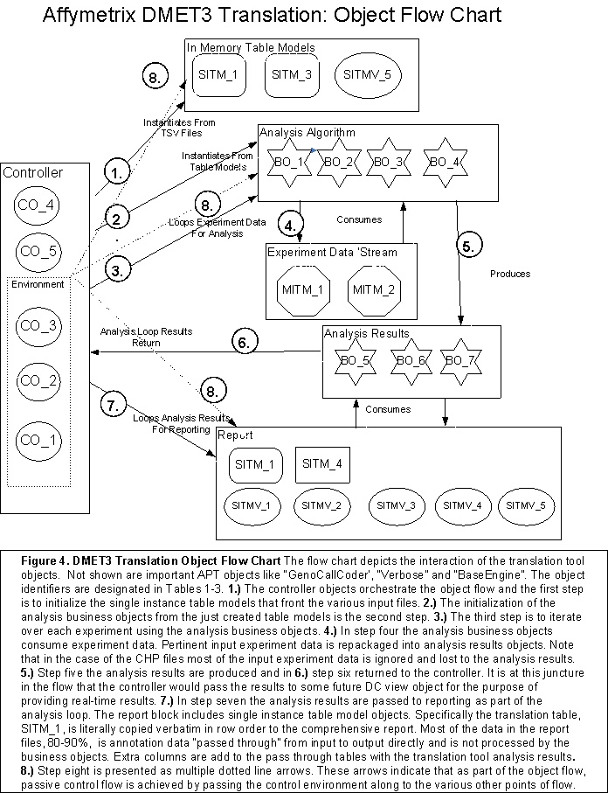
I

Translation Table

Introduction
The single instance table models that were discussed in Section 3 generally represent a verbatim, in memory copy of the TsvFile object on disk; the data from the file is simply copied into the simpler TranslationInputTsvTableModel’s “rows” attribute of a simple “vector of vector of strings” that can be easily referenced through row, column lookup using C++ column enums.
This verbatim copy, however, is not the case with respect to translation table file and the in memory single instance table model. By contrast the translation table is extensively processed as it is read in. This section spells out how the translation table single instance table model differs from what one would see if the translation table file were opened in an Excel Spreadsheet.
Another complication for the translation table is that the schema for DMET2 is different from DMET3 and the program needed to be able to be backwards compatible with respect to DMET2 translation table format. For this reason the translation table is not accessed directly via row, column lookup as with the other single instance table models, but rather accessors were implemented that mapped between the two schemas of DMET2 and DMET3.
Finally, not only does this discussion cover the processing that takes place when the translation table is read into the single instance model, it also covers the vagaries of unconventional, unique format of the file itself. In a modern computer system data either typically comes from a database and specification from the table schema. Some XML file would be used to create a basis for a clean object layout. This is not the case with the translation file. The schema of the file is unique, not formally documented anywhere and as such the first section details how to interpret the latest version of the translation table and tries to provide a thorough specification from the technical side.
To the best of my knowledge, the following sections represent the only detailed technical schema of this file

DMET2 Schema
The schema for the translation table file goes beyond a simple specification of the columns and their types. Data such as haplotype allele groups are specified by columns in the table that specify inclusion in the group via yes/no indicators. Data elements can be ignored by being commented out and entire rows and columns may also be ignore as being commented out as well.\

Column Schema
The constructor of the TranslationInputTsvTableModel takes a structure as input to the constructor of all the column names and a regular expression of allowed values. The regular expression per column is applied to all the data read from the TsvFile for said column and if the data fails to match the regular expression then the program stops. Thus the regular expressions represent hard constraints. Soft constraints that would not cause the translation program to stop cannot be passed at this point. Instead, the sub-class constructor may be used to parse the data a second time when needed, iterating over all table rows, and soft constraint exceptions then written to log.

Table 5: DMET2 Translation Table File Column Schema
Name | NULL | # | Valid RE | Ignore RE
Gene | N | 0 | ^[A-Z\\d]+$ | NULL
Reference Link | Y | 1 | .* | NULL
AssayID | Y | 2 | ^(?:AssayID)|(?:[\\w\\d]+)|(?:\\#.*)$ | NULL
dbSNP | Y | 3 | ^(?:(?:rs\\d+[|;\\s]*)+|(?:N/?A)|(?:refSNP\\sID)|(?:dbSNP))$ | NULL
Defining | Y | 4 | ^(?:(?:N)|(?:Defining)|(?:\\*?[>A-Za-z\\d\\-\\s\\+]+))$" | NULL
CDNA | Y | 5 | .* | NULL
Genomic | Y | 6 | .* | NULL
Change | Y | 7 | .* | NULL
External ID | Y | 8 | .* | NULL
Validated | Y | 9 | ^(?:Validated)|(?:[YN])$ | NULL
Haplotype | Y | 10 | ^(?:Haplotype)|(?:[YN])$ | NULL
Reference | Y | 11 | ^(?:Reference)|(?:Minor Allele)|(?:Major Allele)|(?:[ACGT0]+)|(?:INS)|(?:DEL)|(?:-)$ | NULL
Variant | Y | 12 | ^(?:Variant)|(?:Minor Allele)|(?:Major Allele)|(?:[ACGT0]+)|(?:INS)|(?:DEL)|(?:-)$ | NULL
A1, A2..AN | Y | 13, 14, … N | .* | NULL

Table 5 shows the translation table column schema passed into the TranslationInputTsvModel constructor. Only Columns 0, 2, 3, 4, 9, 10, 11 and 12 have valid regular expressions. This is indicative of the fact that the translation table is in fact the defacto report format as well as serving as analysis input data. This unspecified, unparsed data is simply copied verbatim to the output reports.
Columns with wild card regular expressions that allow for any characters are simply representing annotation, report data that is passed through to the output reporting. However, this is not the case with the A1, A2…AN column specifying the haplotype allele groups. Business rules for these columns are enforced further downstream, including hard constraints that may force the program to stop processing data.
Table 5 also includes a column with an ignore regular expression. This feature is not used in favor of more sophisticated ignore logic employed in the sub-class constructor.

Column order
The translation table does not require strict column order for the static columns, or the first twelve columns in Table 7. However, the translation table does require that all static columns be accounted for.
The allele columns A1, A2…AN must be in consecutive order without blanks. The columns are considered dynamic in that the number of allele columns is not fixed, but rather is determined by the first empty or blank table header column at the end of the sequence of consecutive A1, A2…AN allele columns.

The TranslationTsvInputTableModel takes a condition variable as input to the constructor an indicator as to whether the schema should enforce strict column order. This requirement is not part of the TsvFile dynamic column order feature. The TsvFile APT object can dynamically access columns based on the column header name independent of column order. The TsvFile does not require that all the columns be specified. In other words the TsvFile allows for partial schemas to be specified. Columns not specified are ignored.

The column order enforcement is accomplished entirely within a callback function, convertTCDArrayToVector, passed into the TranslationInputTsvTableModel constructor.

Analysis Columns: Gene, AssayID, Haplotype, Reference, Variant, A1, A2…AN
Only five of the first twelve columns are used for translation analysis: Gene, AssayID, Haplotype, Reference and Variant. The other columns are annotation data passed through to reporting. However, looking at the schema in Table 5 there are two columns, dbSNP and Defining, that have regular expressions even though they are just annotation columns. Why? The answer is simple enough: business required that these columns be parsed and the translation table be rejected if the valid regular expressions failed to match. These requirements illustrate an important point about the translation table and the translation tool program in general: many business requirements exist that have nothing to do with analysis and reporting per se. These arbitrary requirements exist throughout the code. Not all of these arbitrary requirements are specified in this document, though many of the important ones are. The upshot then is to ask the business before removing what looks like superfluous requirements in the code when implementing new features or making bug fixes.

Gene Header Row
When the gene value changes between translation table rows, then It is required that the column names, or header columns, are to be repeated at the start of each Gene in the translation table. This is true for the first gene as well.
The gene header row differs from the schema header row specified in Table 5. The name “Gene” is replaced by the actual gene value. Also, the A1, A2…AN allele names are replaced with the actual allele name that is the resulting “call” determined during translation. See Table 6. This implies then that all gene rows in the translation table must be grouped together. Inspection of the valid regular expressions in Table 5 shows that the column name is included where the regular expression is not the wild card. Also, the case of the “dbSNP” column, the column name changes to “refSNP” in the gene header row, this is shown in Table 6.
Table 6 shows the first two rows of a DMET2 translation table file. The first row, as expected, shows the schema represented in Table 5. The second row appears to repeat the schema, but is really the gene header row.The column name “Gene” has been replaced with the actual gene value of “ABCB1”. Also depicted is that “A1’ as been replaced with “WT”. The “dbSNP” column name has been replaced with “refSNP”.
Table 6: Gene Header Row
It is a fatal error if a group of gene markers does not start with the header columns as shown in Table 6. However, this logic is not part of the TranslationTableModel constructor, but rather part of the TranslationTable business object constructor.

Schema Rules, Three Places
The previous paragraph illustrates another important point. The schema for the translation table file is enforced in three separate places, and not the usual two places as with all other single instance table models: The multiple places where the schema is enforced is indicative of the dual purpose of the translation table as both the output, report data and then again the input specifying translation results. During processing the data required in the translation table for the translation algorithm is not taken from the single instance, in memory table, but rather the data is encapsulated in business objects created by the TranslationTable constructor.
The three places are:

TranslationInputTsvTableModel, Parent Constructor
This level of schema parsing primarily represents just the schema definition determined by both the “valid” and “ignore” regular expressions. There is also a filter callback function that can be passed in addition to a dynamic column parser callback function. The translation table does not use the filter callback function but does take advantage of the dynamic column callback to create the A1, A2…AN column schemas. This is required because the number of A1, A2…AN columns is not fixed. Different valid DMET2 translation table files can vary the number of allele columns, however the first twelve columns are fixed.

TranslationTableModel, Model Constructor
This level of schema definition for all TranslationInputTsvModels incorporates business logic corresponding to row and columns only, not for objects created from these rows and columns. In addition this is where indices are built for faster access during processing. This is also where rows and columns are marked as ignored when they are commented out, rather than using the ignore valid regular expression of the parent constructor.
IMPORTANT NOTE: because indices into the translation table are built before further processing by downstream processing, it is important that rows not be deleted by downstream processing. Indexing is accomplished by mapping various column data values to table row numbers. Deleting any rows in the in memory table would require rebuilding all the indices. To avoid this then deleted rows are to be marked as ignored. This is realized by commenting out “AssayID” column, pre-pending the pound sign “#” to the assay id value. There is a method in the TranslationTableModel class that takes a row number as input and marks that row as “ignored”.

TranslationTable, Business Object Constructor
This level of schema definition represents just the data and the business logic required for analysis. The TranslationTable constructor does not transform the translation table rows, but rather creates new sophisticated business objects. For example, gene haplotype groups are created from the set of markers for a gene where there is a ‘Y’ designated in the Haplotype column.

Column Specification
Table 7 contains the name of each column as it appears in either the table schema or the gene header row and any specification for the data not captured in the regular expression of Table 5.
Table 7: Translation Table Column Specification
Column Name | Gene Row Header | Specification
Gene | ABCB1 | A gene header row is required whenever the gene column value changes. The allele names (calls) specified in the A1, A2…AN columns of this gene header row are to be associated with this gene.
Reference Link | Reference Link | Report, pass through data.
AssayID | AssayID | Unique identifier within the table. However, multi-allelic assay ids will have multiple rows in the translation table to facilitate having multiple variant alleles. If an assay id repeats in the translation table then the marker is considered “multi-allelic”. For multi-allelic markers the rows will have identical column data (copied data) up to the Variant column. The multi-allelic row specifies a new Variant and for haplotype markers these rows may also define different allele calls.
dbSNP | refSNP ID | Report, pass through data.
Defining | Defining | Report, pass through data.
CDNA | cDNA Nucleotide Position | Report, pass through data.
Genomic | Genomic Nucleotide Position | Report, pass through data.
Change | Change | Report, pass through data.
External ID | External ID | Report, pass through data.
Validated | Validated | Report, pass through data.
Haplotype | Haplotype | If yes and in addition this marker has a designation in the various A1, A2…AN columns then this marker is considered a haplotype group marker. Note that it is possible for a marker to be specified as a haplotype marker in this column but not have a designation in the various A1, A2…AN columns. When this happens then the marker is effectively treated as a non-haplotype marker. It is worth repeating that a marker as designated haplotype “Y” is not treated as a haplotype mark if in fact there is no designation of the marker participating in the A1, A2…AN allele call columns. There is no business logic in the code to enforce that a haplotype “Y” marker has a designation in the A1, A2…AN columns.
Reference | Reference | A, C, T, G, DEL, INS. (Note for DMET3 the allele sequences for INS replace INS and the “-“ replaces DEL.
Variant | Variant | Same as Reference.  In addition it is a hard constraint that the variant must be different from the row’s reference value. It is also a hard constraint that the set of multi-allelic rows have differing variant values. Hard constraints mean the program stops when violated.
A1, A2..AN | WT, K27, *1, *9 | See Section 5.2.6

A1, A2..AN Column Specification
The allele name, or allele call, specification is lengthy and therefore specified here and not in Table 7. This discussion also refers to Figure 5.

Haplotype Call
The purpose of the allele columns A1, A2…AN is to define the translation call for a haplotype group. The end result of the analysis algorithm in translation is to produce one of these column name calls per chromatid pair. This call pair will look like “*3/*3”. Such a call means that the marker values in the “*3” named column were matched against both chromatid sequences of the experiment input data.

Empty Value
Figure 5 shows two versions of the DMET2 table values for gene TBXAS1. Most important is that an empty value in an allele column is not empty at all, but instead infers a reference value from the Reference column. The second version of the table at the bottom of Figure 5 shows what this would look like if the reference values were filled in.

Non-haplotype columns
The haplotype columns are A1 – A9. The non-haplotype columns are A10-A21. The non-haplotype allele columns are not used in translation. They are only used for “pass through’ reporting purposes only. These column names appear in the relevant alleles column of the output reports.
However, the non-haplotype columns A10-A21 shown in Figure 5 are not used during processing and allele calls are not created using the column names, as with the haplotype columns.
A non-haplotype column can be determined by looking at the row of the defining markers. If a row is designated as Haplotype column “N” then the column is non-haplotype, else haplotype..

Commented Out
If the column name begins with a pound sign “#” then the column is ignored.

Duplicate Allele Sets
Looking at Figure 5 one can see that each column A1-A9 has a different defining marker. However, this is not always the case. If two sets of allele columns have the same defining marker then the program stops. It is a hard constraint that each allele set is to have a differing set of defining markers.
Duplicate allele sets are allowed when marker lists are provided. See the section on marker lists for further details.
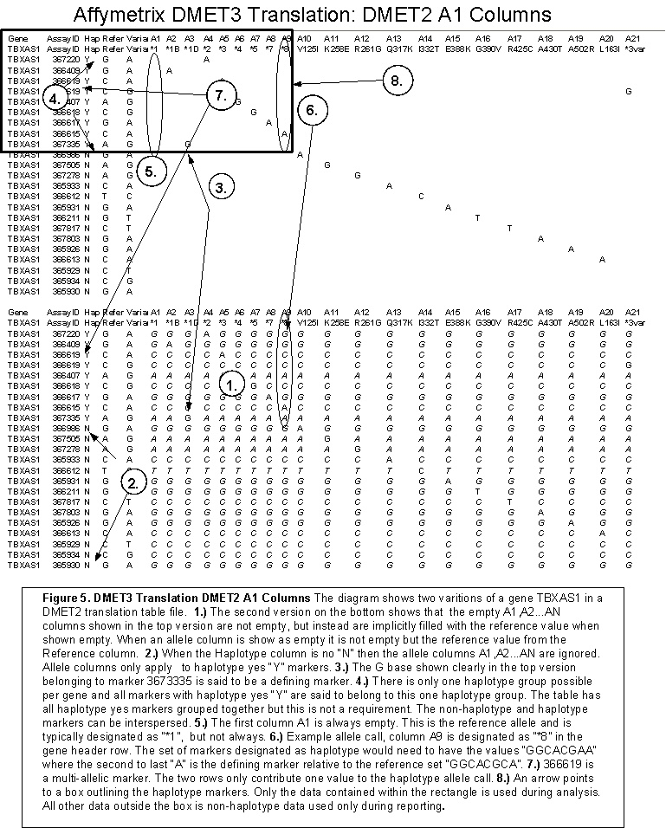

DMET3 Translation Table Schema
All of the discussion in section 5.2 about the DMET2 schema applies to the DMET3 schema and this section assumes section 5.2 has been properly read.
The DMET3 table can be said to be a super-set of the DMET2 requirements.

DMET3 Column Schema Table
Table 8: DMET3 Translation Table Column Schema
Name | NULL | # | Valid RE | Ignore RE
Gene | N | 0 | ^[A-Z\\d]+$ | NULL
Reference Link | Y | 1 | .* | NULL
Probe Set Id | Y | 2 | ^(?:Probe\\sSet\\sID)|(?:[_\\-\\w\\d]*\\d+)|(?:\\#.*)$ | NULL
Switch Design Strand to Report | Y | 3 | ^(?:Switch.Design.Strand.to.Report)|(?:[YN])|(?:\\#.*)$
dbSNP RS ID | Y | 4 | ^(?:(?:rs\\d+[|;\\s]*)+|(?:N/?A)|(?:refSNP\\sID)|(?:dbSNP.RS.ID))$ | NULL
Defining | Y | 5 | ^(?:(?:N)|(?:Defining)|(?:\\*?[>A-Za-z\\d\\-\\s\\+]+))$ | NULL
cDNA Nucleotide Position | Y | 6 | .* | NULL
Genome Position | Y | 7 | .* | NULL
Change | Y | 8 | .* | NULL
Common Name | Y | 9 | .* | NULL
Validated | Y | 10 | ^(?:Validated)|(?:[YN])$ | NULL
Haplotype | Y | 11 | ^(?:Haplotype)|(?:[YN])$ | NULL
Reference | Y | 12 | ^(?:Reference)|(?:Minor Allele)|(?:Major Allele)|(?:[ACGT0]+)|(?:INS)|(?:DEL)|(?:-)$ | NULL
Variant | Y | 13 | "^(?:Variant)|(?:Minor Allele)|(?:Major Allele)|(?:[ACGT0]+)|(?:INS)|(?:DEL)|(?:-)$ | NULL
A1, A2..AN | Y | 14, 15, … N | .* | NULL

DMET3 to DMET2 column map
The translation table is not accessed directly via row,column lookup in the rows. Instead an API is used that takes as input the DMET3 column name, or the DMET2 column name if no corresponding DMET3 column name exists.
The following table maps the two columns per the API.
Table 9: DMET3 to DMET2 Column Map
DMET3 Name | DMET2 Name | Comment
Gene | Gene
Reference Link | Reference Link
Probe Set ID | AssayID | Names changed between DMET2 and DMET3. Probe Set ID ids for DMET3 must match the Annonation File, Probe Set Id. No such restriction exists for DMET2. DMET2 names cannot be used with DMET3 algorithm, but DMET3 names can be used with DMET2 logic.
Switch Design Strand to Report | N/A | Identical to a column in the annotation file. Used as GenoCallCoder API parameter qualifier. DMET2 logic does not use the GenoCallCoder or the corrresponding annotation file.
dbSNP RS ID | dbSNP
Defining | Defining
cDNA Nucleotide Position | CDNA
Genome Position | Genomic
Change | Change
Common Name | External ID
Validated | Validated
Haplotype | Haplotype
Reference | Reference
Variant | Variant
A1, A2..AN | A1, A2..AN

DMET3 Column Specification
The DMET2 column specifications apply with the following additions and changes.

Switch Design Strand to Report
The Switch Design Strand to Report column is a Boolean indicator. This indicator mirrors an identically named column in the annotation file passed to the GenoCallCoder. If this indicator is true then the allele must pass a reverse complement value to the GenoCallCoder report allele API, when checking for report allele values to use in the reports.
This column then only effects reporting and not translation.

The reverse complement algorithm is shown in Figure 6. for clarity.

The switch design strand then is used to make the determination when to call the reverse complement algorithm in Figure 6 as input into a GenCallCoder API that determines a report allele. Translation is always performed using the alleles in the translsation table. The report allele determination requires use of the reverse complement as needed when indicated by this column. The report allele is calculated by the GenoCallCoder object. The GenoCallCoder object cannot be instantiated without an experiment CHP file. Therefore, the report allele data structure for the translation table cannot be created in the constructor but rather the report allele data structure is instantiated when the first CHP file is read in during translation.

When an allele has been switched to the report allele using a possible reverse complement indicated by the Switch Design Strand To Report column, then the allele is called the report allele. A separate data structure of report alleles is kept in the TranslationTableModel.
Figure 6: Reverse Complement Algorithm
/*****************************************************************************/
/**
* CallElement::reverseComplement
* Synopsis:
* Switch to the other strand by taking the reverse complement.
*
* @param seq - the base (allele) sequence to take the complement of.
*
* @return rev - the reverse complement
*/
/*****************************************************************************/
std::string CallElement::reverseComplement(const std::string seq)
{

std::string rev;

rev.clear();

if (CallElement::isWildCardBase(seq)) {
return seq;
}

for (int i = seq.size() - 1; i >= 0; i--) {
switch (seq[i]) {
case '-':
rev.append("-");
break;
case 'a':
rev.append("t");
break;
case 'c':
rev.append("g");
break;
case 'g':
rev.append("c");
break;
case 't':
rev.append("a");
break;
case 'A':
rev.append("T");
break;
case 'C':
rev.append("G");
break;
case 'G':
rev.append("C");
break;
case 'T':
rev.append("A");
break;
case '0': // Copy Number 0
rev.append("0");
break;
default:
std::string temp(seq[i], 1);
rev.append(temp);
}
}
return rev;

}
// end CallElement::reverseComplement
/*****************************************************************************/

A1, A2..AN Column Specification
Figure 6 illustrates the some of the points of this discussion.

Report Alias
The translation table for DMET3 changed the way inserts were designated from using a fixed designation “INS” to the use of the actual allele base sequences. Figure 7 shows an insert sequence of “TTTCGCCCCTTTCGCCCC” for marker “AM_12272”.
This long sequence brings up another irregularity with the DMET3 table that does not exist with DMET2. The string of long sequence was considered unacceptablely long to display in reports. Recall the comprehensive report is little more than a couple of additional columns added to a complete copy of the translation table per experiment. The business decided to use a shorter version of the insert sequence. This shorter version is called the report alias and, unfortunately, was not copied from the annotation file to the translation table along with the other annotation data.
Most of the annotation data found in annotation file is copied to the translation table. That is not the case with the report alias. This difference has become a source of much confusion and many hacks in the translation code and therefore if this program is changed much in the future is recommended that the translation table be given an addition “alias” column to avoid this confusion.
The DMET translation code does not directly parse the annotation file used in DMET3 calling. Therefore, during run-time the translation program uses a special purpse API in the GenoCallCoder , APT library to get report aliases that exist. Very few markers have report aliases. On those markers which represent inserts and then only if the base sequence is of sufficient length.
The GenoCallCoder requires and experiment CHP file in order to be instantiated. For this reason the report alias map in the TranlationTableModel is not built until the first run of experiment is translated. In the event multiple experiments are processed the report alias API is not called except for the very first experiment.
It is important to note that while reporting uses the report alias, translation does not. Therefore the alias cannot be used in the allele columns A1, A2…AN as they would never match the CHP file data. The GenoCallCoder always returns the actual insert base sequence.
This disconnect between translation and reporting with respect to the report alias has a large impact on the uncalled report. Since the uncalled report is both an input and output file for the translation program, then the uncalled report cannot use the report alias because translation process cannot use the alias. This means the comprehensive and summary reports will display the report alias and the uncalled report the translation table insert base sequence. This can be a source of confusion in both interpreting the uncalled report when compared to the other reports as well as modifying the uncalled report. The uncalled report only contains wildcard markers. Users are free to add other markers as they see fit. If the user makes the mistake of attempting to use a report alias from a comprehensive report as the insert sequence for the uncalled report override then the row will be rejected as invalid since only translation table sequences can be used.
Note that there was a discussion about allowing the uncalled report to contain report aliases. The translation program could then match on alias and not just the translation table entry. However, this notion was rejected by the bioinformatics technical team.

Copy Number
Copy number is probably the number one vote getter for cause of bugs in the translation tool. In part this is due to the way copy number information is handled. Namely the GenoCallCoder and the translation table treat the copy number zero designation as just another allele to match during translation. However, copy number designation by the allele is at the gene level and not at the marker level or haplotype group level, the designation applies to all markers, haplotype and non-haplotype alike. This means that the code has to special case this “allele call” to apply to non-haplotype markers.
For example, in Figure 7 the copy number zero designation is on column A65. This is the last allele column. This is a business rule. The copy number designation needs to be the last allele column if it exists.
Further more there is no encoding in the copy number zero, allele call name of “*5” in column A65 that indicates the column is in fact copy number zero designation and not just an allele name. Since the name is not encoded then the decision was made by the business to fill a ‘0’ in the data field for the column as copy number zero indicator for all markers. Therefore the translation code must inspect a subsequent row in the translation table in order to make a copy number zero designation determination for the last column. If the row subsequent to the gene header row contains a “0” in the last allele column then the last allele name is copy number and not an allele call.

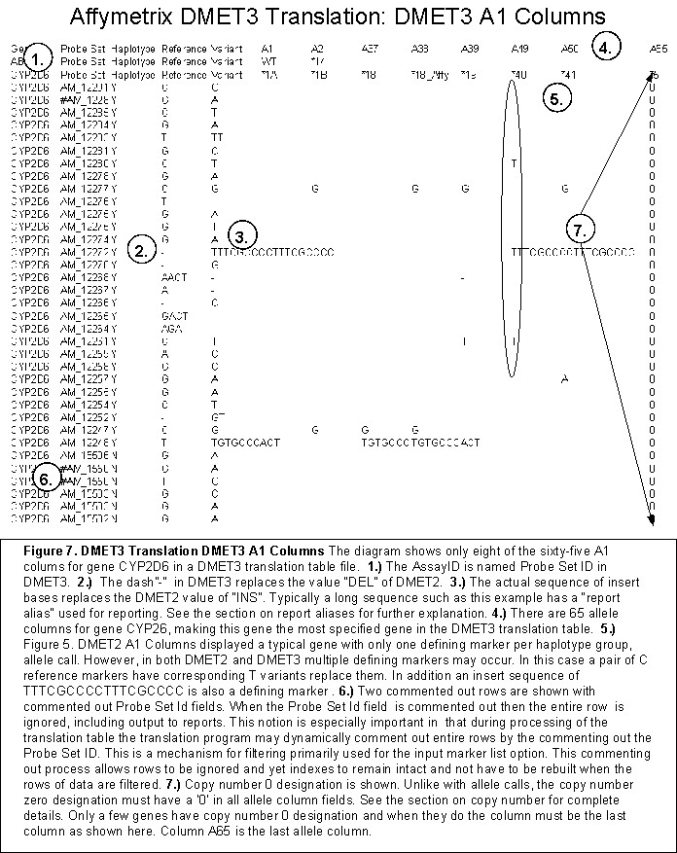

Marker List
The translation table input file is effectively modified by the marker list option. The marker list is an input TsvFile, csv file with just one column. That column contains a listing of markers in the translation table to use. This list filters the rows of the translation table. However, the list is not exclusionary the way one thinks typically of a filter. The marker is inclusionary, only those markers that appear in the input marker list file are to be used.
The marker list requirements exclusively impact the translation table and below are the requirements.

Header
Since the marker list file is considered a csv file even though there is only one column. The file is parsed with the TsvFile object and it still must have a header row. The header is must be “probe-set”. Strict column ordering is not enforced and the file may have more than one column. All columns are ignored except the marker list column.
A listing of a sample marker file”No_ABCB1_partial_CYP2A6_GSTM1.txt” is shown:
2009-01-14 08:34:21 % head No_ABCB1_partial_CYP2A6_GSTM1.txt
probe-set
AM_11327
AM_11330
AM_11334
AM_11336
AM_11337
AM_11341
AM_11342
AM_11343
AM_11344

Validation
Parsing of the marker list will cause a fatal error and stop translation under the following conditions:

Missing Header, Invalid Header, Hard Constraint
The header “probe-set” must be the first line.

Invalid Probe Set Id, Hard Constraint
The probe set ids must conform to the regular expression "^[\\w\\d]+$". This regular expression precludes DMET2 ids. This expression also precludes commenting out the id.

Unrecognized Probe Set Id, Soft Constraint
If the probe set id passes the regular expression validation but is not found in the translation table being used, the probe set id is ignored.

Filter, Translation Table Projection
The implementation of the marker list filter is to mark the translation table rows to be ignored. More than one row may be impacted if the probe set id is multi-allelic. Ignored rows (rows that are commented out in the translation table) are not written to the output reports.
The filter is said to cause a projection of the underlying table where columns are filtered out as well. The columns filtered out are the allele name columns A1, A2…AN. How the column filtering happens can be controlled with a DC or command line option where projection can take place in one of two fashions:

First Allele Name
In the event that ignoring a probe set id effectively removes a defining marker for an allele name column such that the set of remaining probe set ids is identical to a previous allele name set, then that column is marked as ignored by commenting out the allele name value. The first allele name with the set of defining markers is used during translation.
There is a special case where all defining markers are effectively removed. This is just a degenerate reference allele name case, the first allele name in the A1 column.

Collapse Allele Names
In the event that ignoring a probe set id effectively removes a defining marker for an allele name column such that the set of remaining probe set ids is identical to a previous allele name set, then that column is marked as ignored by commenting out the allele name value and the allele name is appended as a list to the corresponding, identical previous allele name column. Most allele name columns have just one defining marker. When that marker is ignored then the allele name column set is the same as the reference set and the reference set will have a potentially long list of similar allele names.

DC Implementation
The DC has the capability to pass in a vector of probe set ids to use as the marker list.
In this case the vector must still begin with a first entry of “probe-set”, but otherwise the marker rows are unparsed. The translation tool assumes the DC is passing in validated data. However, any probe set id that is not found in the translation table is ignored, effectively ignoring all erroneous markers passed in by the DC. Invalid markers are not logged.

Uncalled Report (Genotype Override File)
The marker list in the previous section is not the only input file (or vector in the case of the DC) that can impact translation by supplanting data. One additional file can be used, the uncalled report, a.k.a. Genotype Override file.
However, unlike the marker list, the genotype override file does not supplant the translation-table data; instead the actual translation results are supplanted. See the section on the translation algorithm.

Translation Algorithm

Introduction
The translation algorithm has three parts.
- Preamble: A preamble where one experiment set of data is read in, validated, sussed into two chromatid CallSets
- Algorithm: CallSets are simply matched for equivalence; no algorithm is required except when wildcards exist and then an algorithm is used to generate results rather than direct matching. Copy number zero is also accounted for.
- Results: Results are accumulated in special business object.
The unit of work during translation is the CallSet. Even markers are encapsulated in CallSets of one CallElement. The reason being is that multiallelic markers contain multiple variant values. The CallSet with a single CallElement have equivalence operators “==” overloaded to handle multiple variant matching.
A gene will have at most one CallSet haplotype group. The set of markers for this haplotype group is the only experiment CallSet instance with more than one CallElement.. The Algorithm Matching Diagram in Figure 8 shows that all markers have CallSets but only one CallSet exists for the haplotype group. Most of the translation process then is concerned with matching individual markers to the respective reference or variant call.

Translation Algorithm Preamble
The preamble is mostly concerned with marshalling the experiment data into gene marker sets.
However, while the CHP files represent one complete set of experiment data, the Genotype Short Report input file is contains all experiment data in file and is typically sorted by probe set id and not experiment id. Therefore there is a special handling of Genotype Short Reports input experiment data files where the translation tool rejects the Genotype Short Report file and creates a new Genotype Short Report file that is sorted by experiment.

DMET2, Genotype Short Report Experiment Sorting
It is a hard edit if the input Genotype Short Report is not sorted by experiment. However, before the fatal error is given the Genotype Short Report is sorted by experiment id a new Genotype Short report created. A new file of the same input name as the original Genotype Short Report is created with an additional extension of “.sorted.txt”.
The reason for creating the new file is that sorted file is expected as part of the results. Business requested that the sorted file be included with the reports.

Gene grouping
Each gene is translated individually within a loop using the GeneCall business object. However, the various input file types of CHP and Genotype Short Report do not group experiments by gene probe sets. Therefore the GenotypeTableModel builds an index that groups probe set ids by gene whenever an entire experiment is read in. Further the GenotypeTableModel has a logical selector, or cursor, API that can then can be used to iterate over the experiment probe sets by gene set.

Figure 8 depicts the process of how an experiment is broken down into specific gene objects, or gene CallSets.
The diagram in Figure 8 shows that all probe set ids per experiment are filtered for every experiment gene iterated. This is accomplished via the business object, GeneCall. The set of all possible haplotype and marker gene calls is contained in the GeneCall. The diagrams shows two separate gene call lists, a haplotype list and a marker list. Further the haplotype markers are actually filtered twice, once as a haplotype marker and second as a marker.
Not shown in Figure 8 is that not only will the set of all probe set ids for all genes be much greater than the set of probe set ids for a specific gene, but also the set of unknown probe set ids (those not specified in the translation table model) will be much larger than the set of probe set ids in the translation table.

Loop on gene call marker sets.
Looking at Figure 8 there are two sets of translation gene call marker sets: haplotype and marker. Each set of haplotype gene call, marker sets of A1…AN in addition to marker gene call, marker sets of M1…MN is iterated over. An API called “translateExperimentCall” is invoked and at the point the translation algorithm begins and the preamble ends.

Translation Algorithm

Translation Algorithm, Schematic Overview
Figure 8 shows a schematic overview of how translation works.
Each experiment has two columns of experiment data called, chromatids. It is important to note that the two columns do not signify which chromosome the allele data came from. A chromatid contains a random mixture of data from either chromatid.
Figure 8 shows that the pair of chromatid columns contains not only probe set ids from found in the translation table, but “unkown” probe set ids. However, the unknown designation does not imply that the probe set ids are not important to other aspects of DMET3, only that such a probe set id is not available for translation.
Translation can be concisely described as the process of matching all possible translation results as described by the translation table file with input experiment data.
The diagram in Figure 8 shows that the first step taken is to filter the input experiment data using a complete call set for a given gene. A complete call set contains every possible probe set id for the gene. Once the input experiment data is filtered for known probe set ids of a given gene, then the haplotype set is created. Recall that each gene has at most one haplotype group. Therefore all filtered haplotype gene markers are compiled into one haplotype call set.
Besides the filter process creating the haplotype group call set for a gene (if there is one), each marker is also added to a call set of one probe set id for the purpose of marker matching of reference or variant. This includes the haplotype group markers. All markers have a call set of one call element created. The reason for the call set for just one marker has to due with multi-allelic markers. The CallSet object has a list of bases associated with a probe set id. Of course for the experiment data there is only one base (of sequence of bases for inserts), but the experiment data is to be matched with the corresponding translation table probe set id, CallSet of one marker. The translation table CallSet will have multiple bases if the probe set id is multi-allelic and the CallSet comparison operative is overloaded to match when the experiment is one of the multi-allelic possibilities.
Not shown in Figure 8 is that each translation result CallSet, whether haplotype or marker, is given a name. That name is the translation result. Marker CallSets have exactly two possible translation result possibilities, reference or variant. For haplotype groups that name is designated in the table under the appropriate A1, A2…AN column.
Figure 8 shows the output translation results. A translation result is a simple string of the format “A/B” where A and B are each a chromatid result separated by a “/” slash.
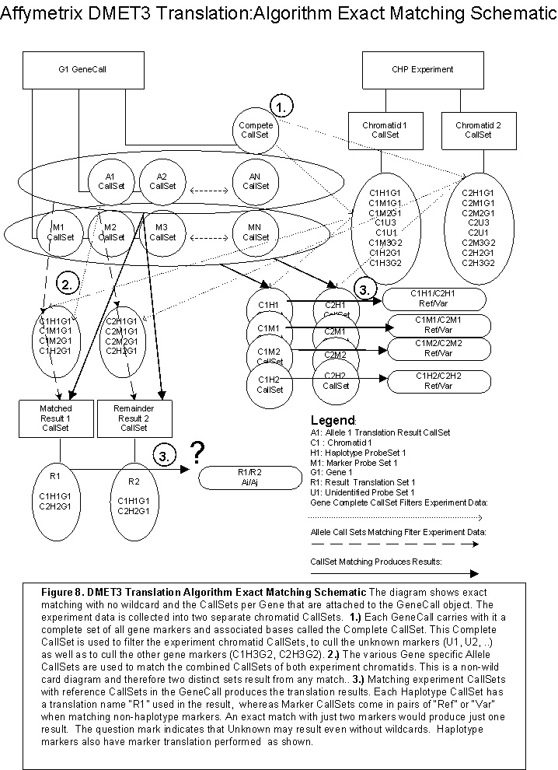

Translation Algorithm: Take One, Theory
This section presents the English and Mathematical requirements for the translation. Translation is defined to mean a match between a haplotype group in the translation table with the experiment data. Mathematics is required for one reason, to avoid matching all permutations when wildcards are present.

Copy Number Zero
The theoretical requirements for copy number zero are simple. If any marker for a gene is designated as copy number zero, than all markers, either haplotype group or not, are considered copy number zero. It is a hard edit for experiment data to have varying copy number for a gene.

Copy Number One (Not Supported)
The theoretical requirements for copy number are similar to copy number zero. If any marker for a gene is designated as copy number one then all markers, either haplotype or not, are considered copy number one. It is a hard edit for experiment data to have varying copy number for a gene.
The translation result for a copy number one translation only contains the one result. There is no “/” slash followed by the second chromatid result in the copy number one translation result.
At one point copy number one was supported by translation. However, the code implemented as required was insufficient to the task. Business decided against completing copy number one requirements and copy number one input is now rejected by the translation tool. However, the copy number one code is still in the code in case there is ever a need to complete it.

No Call, Possible Rare Allele and Not Available
For the sake of translation the three types of unspecified allele values of No Call, Possible Rare Allele and Not Available are equivalent and also considered to be wildcards. Wildcards are treated as any possible allele specified in translation table. Typically for a probe set this means two possibilities, the probe set id’s reference and variant, but for multi-allelic probe set ids, the number of variants is more than one.
Whenever one chromatid of experiment data is a wildcard then both are wildcards. It is not possible for one chromatid to be specified and the other chromatid to not be specified.

Marker Translation
All experiment probe set ids designated in the translation table are to be translated independently as markers, whether part of a haplotype group or not,.
The translation algorithm requirements are simple: compare each chromatid pair of experiment probe set id to the translation table reference and variant columns. It is a hard edit that every experiment allele value must be in the translation table if the probe set id is designated in the translation table. If the reference allele is matched to the reference value then the chromatid call is “Ref”, and likewise “Var” is used for the variant. The two chromatid call values are combined into a single string of both values separated by a slash “/”. This string is called the translation call, and is referred to as marker translation. Markers not designated as haplotype will only have marker translation.
The marker translation algorithm produces one of the following possibilities, discounting copy number,
- Ref/Ref
- Ref/Var
- Var/Var
- (Empty)
The value “Var/Ref” is not shown and not produced because “Var/Ref” is considered a duplicate of “Ref/Var”. Whenever there is a reference and variant detected in the experiment chromatid pair, “Ref/Var” is always the result regardless if the variant was in the Allele1 or Allele2 column. This is true for haplotype calls as well where translation calls are independent of the experiment, chromatid column order. Another way to say this is that the pair of individual chromatid translation results separated by the slash “/”, resulting from the translation algorithm, are interchangeable, unordered and do not reflect the order of the experiment chromatid pair that produced the translation call.

Haplotype Type Base Case Examples
The base cases referred to in this section refer to illustrative examples in Figure 9, base cases are simple examples that do not need a mathematical formula to compute the solution space.

Figure 9 shows data from a translation table, some experiment CHP data file, and then the resulting haplotype translation calls. The figure shows that some set of unspecified gene, probe set ids has three probe set ids comprising the haplotype group.
Each probe set id in Figure 9 has the same reference allele value of “A”. (spread sheet cells A3, A4 and A5). Each probe set id in Figure 9 also has the same variant allele value of “C” (spread sheet cells B3, B4 and B5).

Base Case 1: Haplotype Call Exact Match
The haplotype group experiment alleles for the two chromatids 1 & 2 are AAC and CAA respectively for Case 1, the exact match.
An exact match is defined to be a match that contains no wildcards. However, as Figure 9 shows, an exact match does not yield a unique result. Instead an exact match will yield the set of all possible matches based on the permutations of rearranging the chromatid pairs as shown in Figure 9.
The translation algorithm is required to combine the 2 chromatid allele in all possible combinations of haplotype group sequences. Looking at Case1 in Figure 9, both chromatids share the same value “A” for the second value: AAC and CAA. Therefore the total number permutations possible are 4 as is shown.
Figure 9 also shows that the permutations results in half the resulting set being duplicates. This is true because results are unordered with respect to call sequence pairing, i.e. *2/*5 is equivalent to *5/*2.

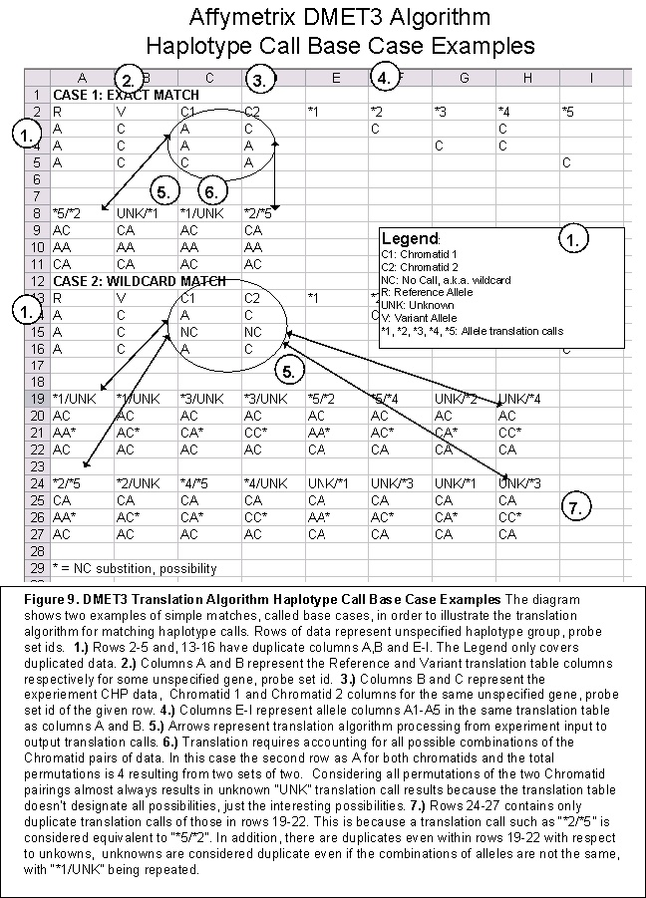
Case 1 also demonstrates that even though there are no wildcards the results commonly contain at least one unknown, or “UNK”, call. This is related to the fact that there is no business requirement that the translation table specifify all possible permutations. In fact, generally only a handful of possibilities are laid out in the translation table and hence unknown calls are very common.
The final resulting translation call set then for base case 1 is comprised of “*2/*5” and “*1/UNK”. The results are sorted in alpha-numeric order. Therefore “*5/*2” is sorted as “*2/*5”. If only one chromatid is unknown then the unknown value “UNK” is always reported second.

Base Case 2: Haplotype Wildcard Match
The haplotype group experiment alleles for the two chromatids 1 & 2 are A[NC]C and C[NC]A respectively for Case 2, the wildcard match. Looking at Figure 9, the second row of Case 1 has had the A replaced with a no call “NC” wildcard value.
Translation with wildcards present requires additional permutations beyond just rearranging the chromatid values for a given probe set id. For the wildcard probe set ids there is also a requirement to permutate through all combination of reference and variant values. For multi-allelic probe set ids within a haplotype group there will be multiple variant values required for permutation. However, this example is a simple case of a bi-allelic where only the bi-allelic reference and variant pair require permutation.
Translation requirements with respect to wildcards are identical to the exact match translation requirements stated in the previous section with the one exception: more permutations.
One final note is that Figure 9 shows that more than one duplicate translation call can happen due to the additional permutations relative to exact matching. In this case *1/UNK and *3/UNK both have four matches given all permutations. However, each result would still only be reported once. Regardless of the number of duplicates a translation call has due to permutations of wildcards, the translation call is only ever reported once in the resulting call set.
The resulting translation call set then for Base Case 2 in Figure 9 after removing duplicates and then sorting is:
- *1/UNK
- *2/*5
- *2/UNK
- *3/UNK
- *4/UNK
- *4/*5

Translation Algorithm. Calculating Total Results
The translation algorithm calculates the total number or translation calls for efficiency reasons. Calculating the translation results required eliminates the inefficiency for iterating through a for loop through all possible permutations of matches. It should be noted that the translation algorithm is not required for deriving the correct answer. The formulas presented here are all concerned with calculating total translation calls required, or haplotype pairs.
Looking at Figure 9, one can imagine a large set of permutations for long sequences of say thirty or forty probe set ids could have upwards of ten-to-fifteen wildcard probe set ids no calls for an experiment. Further this large set of permutations would be inefficient in compute time. For this reason translation uses an algorithm to compute the translation call result in addition to performing simple matching as is indicated in Figure 9.
Definitions:
0 = No Het calls seen
1 = Het calls seen
AHPS = Allele Haplotype Pairs Seen
THP0 = Total Hap Pairs, No Het calls seen
THP1 = Total Hap Pairs, Het calls seen
THPR = Total Haplotype Pairs Required, THP0 + THP1 = Final count of total resulting possible pairs
THPS = Total Haplotype Pairs Seen, related to THPR. If the total haplotype pairs seen is does not equal the THPR at the end of matching than an “UNK/UNK” call is added to “make up the difference”.
HPPA = Haplotype Pairs Per Allele, Haplotype Pairs Seen
i = the current haplotype pair count. If a haplotype group is comprised of three probe set ids then i will range from 0 to 3.
Ni = number of alleles for marker I (i.e. for bi-allelic Ni = 2)
(Ni / 2 ) = Ni choose 2 AND NOT Ni divided by 2. The formula for Ni choose 2 is (Ni * (Ni – 1)) / 2. In this case the slash “/” does mean division. Note that when Ni is 2 then Ni choose 2 equals 1. This is reflected in that the bi-allelic formulas are a simple case of the tri-allelic where the Ni term has been reduced to 1.
Initial Conditions:
THP0 = 1
THP1 = 0
HPPA = 1
Bi-Allelic Formulas
THP0(i + 1) =
{i + 1 is homozygous? => THP0(i)
{i + 1 is heterozygous? => 0
{i + 1 is wildcard? => 2 * THP0(i)
THP1(i + 1) =
{i + 1 is homozygous? => THP1(i)
{i+ 1 is heterozygous? => 2* THP1(i) + THP0(i)
{i + 1 is wildcard? => 2*THP1(i) + 2*THP1(i) + THP0(i)
Note that there is a duplicate terms in the last line of the calculation of THP1(i+1). This is deliberate. The first term represents the count when the wild card is homozygous and a het call has been seen already. The second, duplicate term represents the count when the wild card is heterozygous and a het call has been seen already. The final term is the count when the wild card is a het call and is the first het call seen.
Tri-Allelic Formulas
The Tri-allelic are similar to the bi-allelic excepting an Ni term is used to account for the number of alleles per marker.
THP0(i + 1) =
{i + 1 is homozygous? => THP0(i)
{i + 1 is heterozygous? => 0
{i + 1 is wildcard? => 2 * THP0(i) * Ni
THP1(i + 1) =
{i + 1 is homozygous? => THP1(i)
{i+ 1 is heterozygous? => 2* THP1(i) + THP0(i)
{i + 1 is wildcard? => (Ni / 2) 2*THP1(i) + (Ni / 2) 2*THP1(i) + (Ni / 2 ) THP0(i)

Total Possible Pairs Loop (_calculateTHPR copied from code)
for (int i = 0; i < chromatid1.size(); i++, iCEit++) {

bool isHet = _isHeteroZygousPair(chromatid1, chromatid2, i);
int Ni = _getProbeSetBaseCount(chromatid1, completeSet, i);

if (iCEit->second.hasWildCards()) {
// HPPA
HPPA *= Ni;
// THP1
THP1 = Ni * THP1 + (Ni) * (Ni - 1) * THP1 + ((Ni) * (Ni - 1) / 2) * THP0;
// THP0
THP0 = THP0 * Ni;
} else if (isHet) {
// THP1
THP1 = 2 * THP1 + THP0;
// THP0
THP0 = 0;
} else { // is homozygous
// THP1 = THP1;
// THP0 = THP0;
}

}
THPR = THP0 + THP1;

Translation Algorithm, Matching (copied from code, edit for copy number and logging)
int HPPA = 1; // Haplotype Pairs per allele
int THPS = 0; // Total Haplotype pairs seen
std::map< std::string, int > AHPS; // Allele haplotype pairs seen.

int THPR = 0; // Total Haplotype pairs required.
// THPR is a complex calculation broken out into another routine.
THPR = _calculateTHPR(chromatid1, chromatid2, completeSet, HPPA);

for (std::vector<CallSet>::const_iterator iCSit = m_alleleSet.begin();
iCSit != m_alleleSet.end(); iCSit++) {
AHPS[iCSit->m_name] = 0;
}

// The marker reference and variant sets are always the first two
// sets, skip over them for haplotype groups;
int offset = isHaplotypeGroup ? 2 : 0;

for (std::vector<CallSet>::const_iterator iCSit = m_alleleSet.begin() + offset;
iCSit != m_alleleSet.end() && (THPS < THPR); ++iCSit) {

// The following condition is possible if the allele name was
// added as the second half of the call. If the number possible pairs
// has already been seen for this allele then just optimize
// by continuing.
if (!(AHPS[iCSit->m_name] < HPPA)) continue;

const CallSet & firstSet = *iCSit;

// Check if any combination of the two chromsomes match each
// element. If so we have a match and the second match
// will be a result of the remaining bases not used to make the first
// match.

if (! firstSet.match(chromatid1, chromatid2)) {
continue;
}

// Build the second set from the difference between the
// the test set and the inputs.

CallSet secondSet = firstSet.buildSecondSet(rte, chromatid1, chromatid2);

for (std::vector<CallSet>::const_iterator jCSit = iCSit;
(jCSit != m_alleleSet.end()) && (results.size() < THPR) &&
(AHPS[firstSet.m_name] < HPPA); ++jCSit) {
if (secondSet == *jCSit) {

if (jCSit->m_name != firstSet.m_name) {
AHPS[jCSit->m_name]++;
}
AHPS[firstSet.m_name]++;

std::string alleleCall = firstSet.m_name + "/" + jCSit->m_name;
results.appendAlleleCall(alleleCall, geneCopyNumber, firstSet, *jCSit);

} // for each allele in the translation table get a second match.

if (AHPS[firstSet.m_name] < HPPA) {
std::string alleleCall = firstSet.m_name + "/UNK" ;
results.appendAlleleCall(alleleCall, geneCopyNumber, firstSet);
}
THPS += HPPA;

} // For each allele in the translation table, check for a match.

// If the number of allele pairs seen is less than the total required
// then we add "UNK/UNK" to represent the difference.
if (THPS < THPR) {
results.appendAlleleCall("UNK/UNK", geneCopyNumber);
}

results.orderCalls();

return results;

Translation Algorithm Discussion
The objective of the translation matching algorithm is to efficiently generate the translation result set with minimal time spent matching. Primarily this accomplished by pre-calculating the required permutations as outlined in the previous sections. The total permutations do not need to be iterated through in a for loop for a three reasons.
- The matching in the main translation for loop always produces allele name combinations without unknowns. An example of an allele name combination is “*2/*6”. This limits the matching permutations for loop to the combinations of the allele columns A1, A2…AN in the translation table. Further, since “*2/*4” is the same as “*4/*2” then each subsequent comparison left-to-right requires one less match. For example, given there are 50 allele name columns, A1…A50 there will be 49 matches for the first column A1 if all chromatid pairs are heterozygous. Since A1 and A2 will have already been compared then for the column A2 there are only 48 matches. Then for A3 there are only 47 matches until for the final column there are no match possibilities because the final column has already been compared to all columns. This means that the maximum total matches for 50 columns is 50*50/2, or 1250. However, this number is rarely reached because the number of het calls limits the HPPA, or het pairs possible per allele. A HPPA of just two is very common and the for loop will quit matching when the number of pairs equals the total possible.
- Unknowns are generated with HPPS, or het pairs seen total is less than the HPPA after allele column matching has been exhausted. an unknown call can be added. This will almost always be the case for large haplotype groups. This is because the HPPA represents the permutations possible for an allele for the second chromatid and the translation table rarely has all possible second chromatid sequences enumerated.
- The total haplotype pairs seen count is kept for the express purpose of creating the “UNK/UNK” call. If this count at the end of match is less than the total haplotype pairs required than the “UNK/UNK” result is added. This calculation is easiest to understand by example using Figure 9. Looking at the alleles in Figure 9 notice that none of the *1 to *5 alleles would match a sequence of experiment data “CCC”. In other words, if the experiment data resulted in all variants there is no allele to match. If both chromatids had sequences of “CCC” then no allele would match. The THPS would be 0. However, the THPR has to be greater than 0 and so THPS would be less than THPR and “UNK/UNK” would be the only translation call for both chromatids having sequence of “CCC” in Figure 9.

Translation Algorithm: Take Two, Implementation
The previous section delt with the ideal nature of translation: matching to produce results and calculating results based on the total number of calls expected. This section deals with copy number zero and other vagaries not covered by the theory.

Validation
Ideally the translation algorithm would only be passed data ready for translation. However, experience testing of the tool has made lead to essentially double validation. Objects are validated upon creation and doubly validated in the translation algorithm.
The reason for this is that input data requirements change frequently and often but the algorithm does not. Algorithm validation catches validation lapses as input models change. Bugs often creep into input code newly written to handle changing probe set id requirements, etc. However, the algorithm has essentially remained in tact since its finalization in May of 2008. Further, input needs to shift sands between DMET2 and DMET3. However, translation does not. By the time the data reaches the translation algorithm the input has been standardized to a universal format. For these reasons validation is part of the translation implementation. The strategy has proven itself out as most of the bugs logged are either input or reporting bugs, but not translation.

Complete Set Containment
The most important validation is containment. Approximately seventy-five percent of the probe sets in a CHP do not have enteries in the translation table. The CallSet constructor for the experiment chromatids is supposed to use the Complete CallSet to filter the experiment probe sets and hence only valid probe sets should be in the chromatid pair of CallSets. It could be argue that double checking again that the experiment chromatid CallSet again is a waste of time.
However, time-and-time again this has proven to not be the case. This is especially true with customer created data in the form of override data. A customer can change a NoCall wildcard in the override report to an insert sequence that may be off by just one base. Validation of the override customer data does happen at load time for the override file and will catch this, but that validation has failed oft times, sometimes due to a requirements miss-understanding between the proper use of report alleles, aliases and complements.
The complete CallSet for a gene contains one CallElement per probe set. Each CallElement has a list of bases, or alleles, valid for that probe set. The list will only ever have more than one item in the list when that probe set is multi-allelic, represented by multiple rows for the probe set in the translation table.
The “contains” operator for a CallSet A being checked for containment against CallSet B checks the probe set existence as well as the base, or allele, existence. Both experiment chromatid CallSets are checked for containment within the gene Complete CallSet.

Size Validation
If a chromatid CallSet represents all the probe sets for a haplotype group, then the size or number of probe sets is checked against the reference haplotype set for the gene. If the experiment size is not the same then a fatal error occurs. There is a command line option which can be used to turn off throwing a fatal error. The command line switch indicates to simply log an exception and not process the haplotype group translation for the gene.

Wildcard Validation
If a chromatid CallSet represents all the probe sets for a haplotype group and in addition all the base values for these probe sets are wildcards, or NoCalls, then the empty result is returned for the haplotype group translation. No translation is performed.

DMET2 Copy Number Zero
If DMET2 calling is being used via Genotype Short Report experiment input files then a copy number detection happens first thing. If copy number zero is detected then the passed in copy number zero results are returned without translation.
DMET2 Copy Number Translation does not involve the translation table, but rather a special copy number zero file. The result of a copy number zero detection is passed into the translation algorithm for the gene.

DMET3 Copy Number Zero
Copy number zero detection happens before translation for DMET3 CHP input as well. However, unlike with DMET2 translation, the copy number zero designation, or result, is part of the translation table, or a pseudo allele. Therefore the result of a copy number zero detection is part of the haplotype allele set for the gene. This pseudo allele set is used to create the copy number translation result. As with DMET2, copy number zero results are returned immediately without further translation.

Theory Translation
Once the implementation validation and copy number detection as outlined previous is run then the theory code detailed in the theory section runs without exception and results are returned.

Result Accumulation
The CallResults returned with each translation are accumulated in various objects to be saved for eventually consumption by reporting. Each experiment is translated, results collected, and then reporting consumes the experiment results.

Interrupts
The DMET Console may interrupt translation at any time. Are there any concerns? The answer is no. The translation algorithm uses no temporary files and there are no requirements to complete a translation in process. Translation can be interrupted with impunity and at any time without harm.
Note that reporting keeps a running output for each experiment in all report files. The translation tool does not clean up the temporary these report files. However, the DMET Console does. If the translation tool is interrupted at the command line the temporary files will be available for analysis if desired. All results are final.

Interpretation Code
The interpretation code in the comprehensive and summary reports is not generated by the translation algorithm, but instead is calculated from the translation algorithm result within the reporting code.

Reporting
If you are a developer and there is a bug that needs a fixin’, most likely this is the place you need to look. The other most likely place would be in the input file parsers.
Most of the object files in DMET3 are less than one thousand lines. They are clean, small, “easy to digest quickly” files as any good design should. However, two object files are not. One is the input file TranslationInputStreamTableModel.cpp at 1,400 lines. The other is the TranslationExperimentReportModel.cpp at 2,000 lines.
These two files are both relatively large for the same reason. They are dealing with a lot of details that do not lend themselves to easy encapsulation. Breaking these files into smaller files would not lead to better code, just having lots of files open simultaneously trying to deal with cross referencing the details. The way I see it, having the onerous code in one file makes cross-referencing details, searching text and details easier. Besides, purging the tool of these poorly implemented code pieces can be easily done with one press of a delete key if they are only in one file. ☺

Three reports, one file
There are three reports resulting from translation, the comprehensive report, the summary report and the uncalled report. The reports all contain the same data, just formatted differently. Therefore the reports are all contained in one object. The only deviation between the three reports is the data picked off for output. Only the summary report contains a small amount of data not common to all three.

Reporting Flow Charts
The objective with this section is to expose the reporting tool in such away that test cases can be generated without having to understand the actual C++ code. These flow charts should be suitable for working with QA partners.

Key points to keep in mind when reading the flow charts are:

Translation Table Reporting
The main reporting loop iterates over each row of translation table and copies the requisite columns to the various reports. Experiment data fills in the few experiment columns of reporting. The implication is that every probe set in the translation table is reported independent of existence within the experiment data. Default values for the experiment columns are provided.

Multi-allelic
A multi-allelic probe set in the translation table is denoted using a condition variable “IsProbeSetFirstRow”. The subsequent rows beyond the first row only contribute variant base data, all other data is repeated from the first row and hence ignored during reporting.

Uncalled Report
The uncalled report as explained in previous sections is both an input and an output file.

Reporting Main Generate Loop Flow Chart
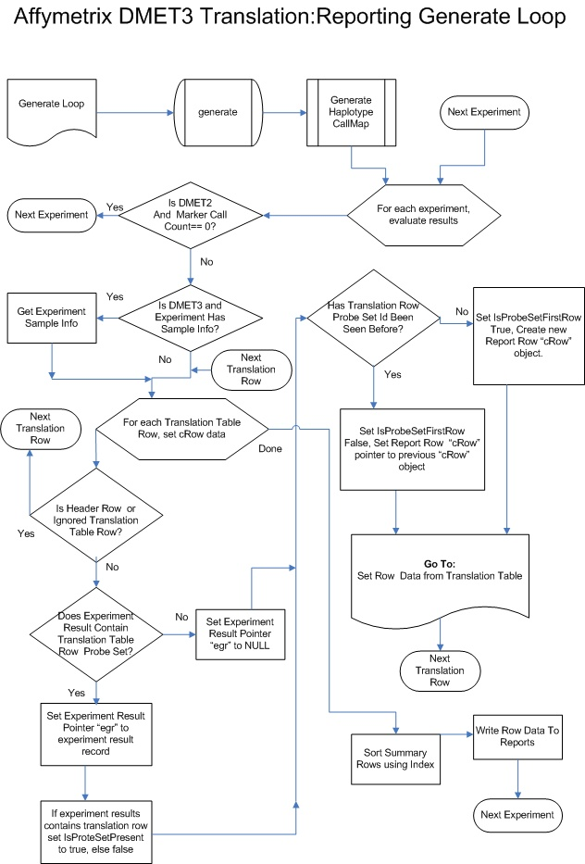

Reporting Set Translation Table Row Data Flow Chart
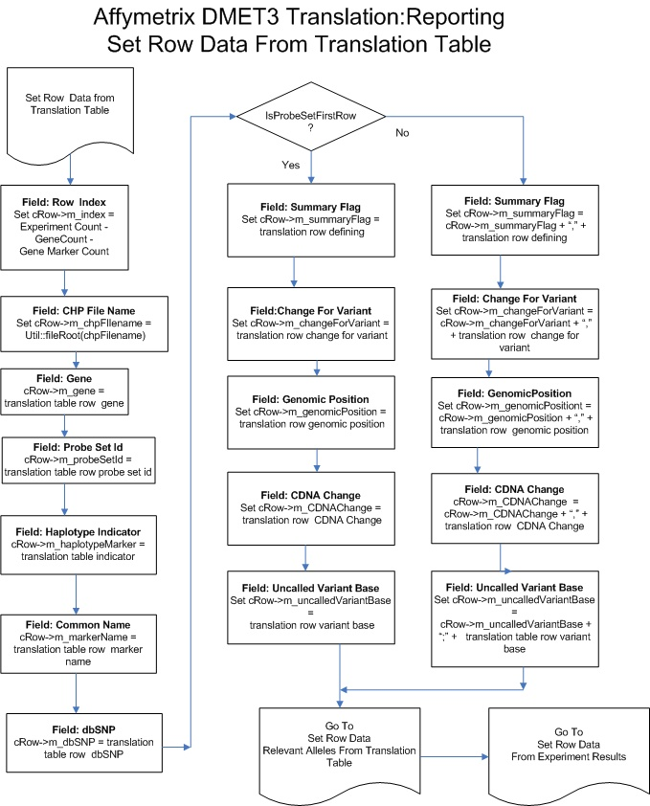

Reporting Set Relevant Alleles Flow Chart
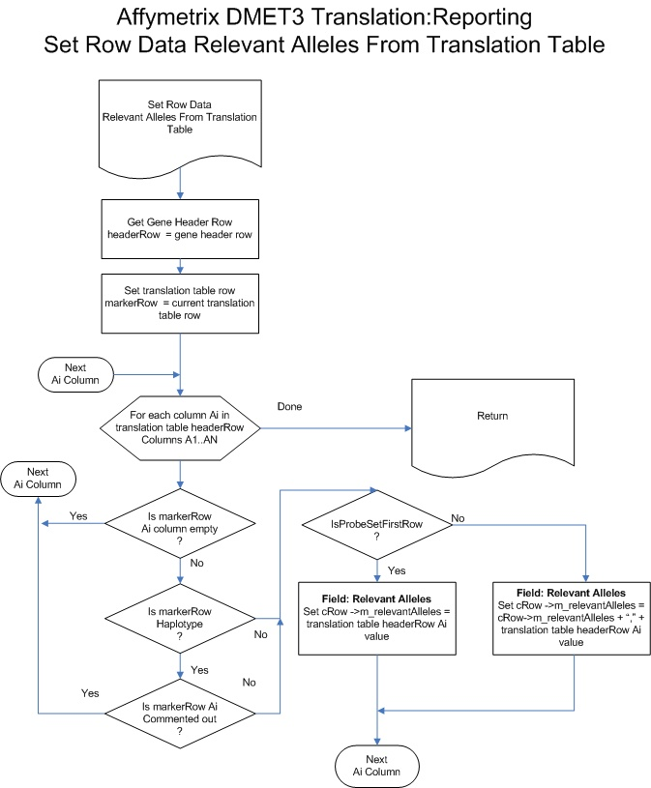

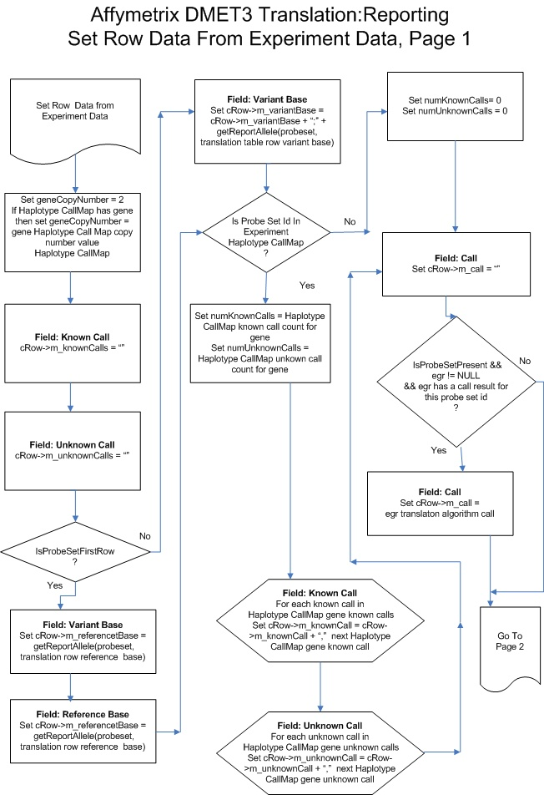
Reporting Set Translation Row Data From Experiment Data Flow Chart
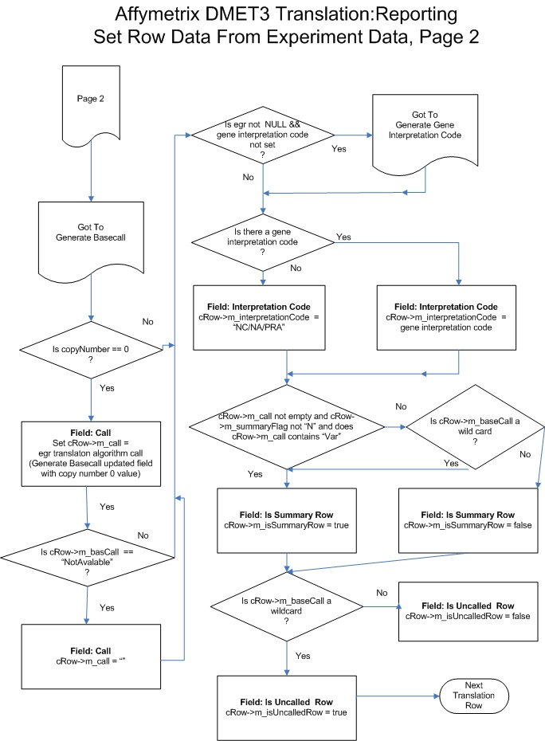

Reporting Generate Basecall Flow Chart
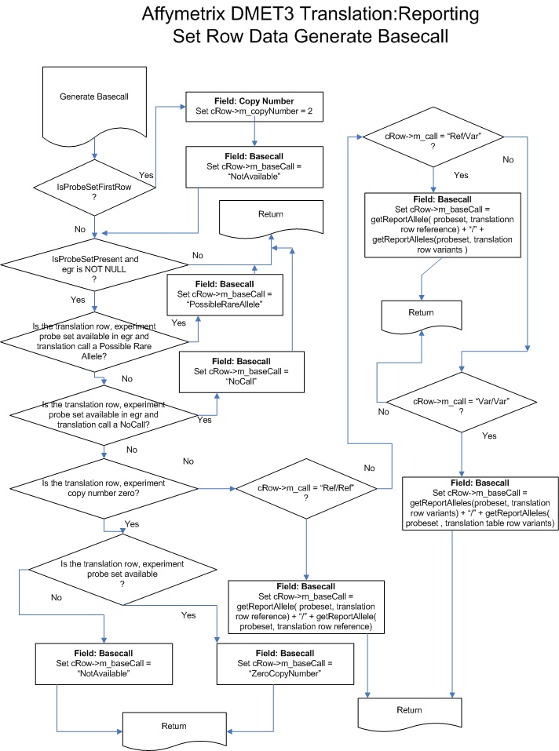

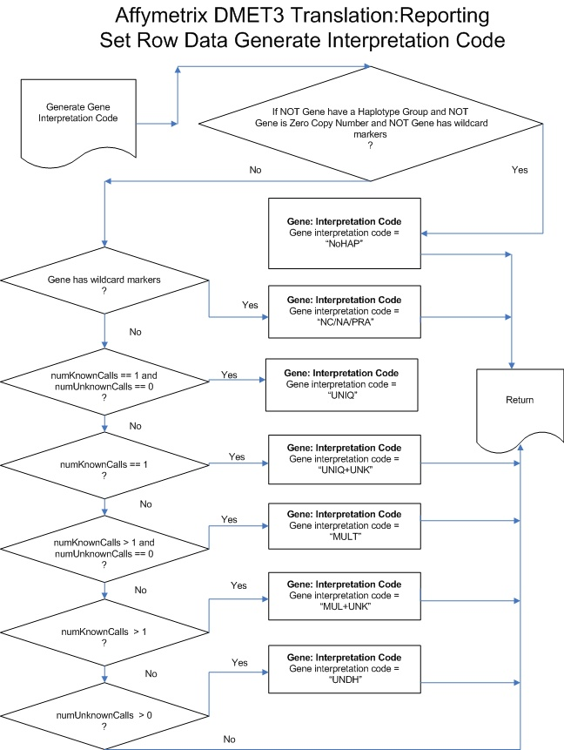
Reporting Generate Interpretation Code Flow Chart

