Module 1
Pass Task 1

Please find all source code and original image files in the Git repository: https://github.com/rcallow/SIT315

Figure 1: Schematic Diagram
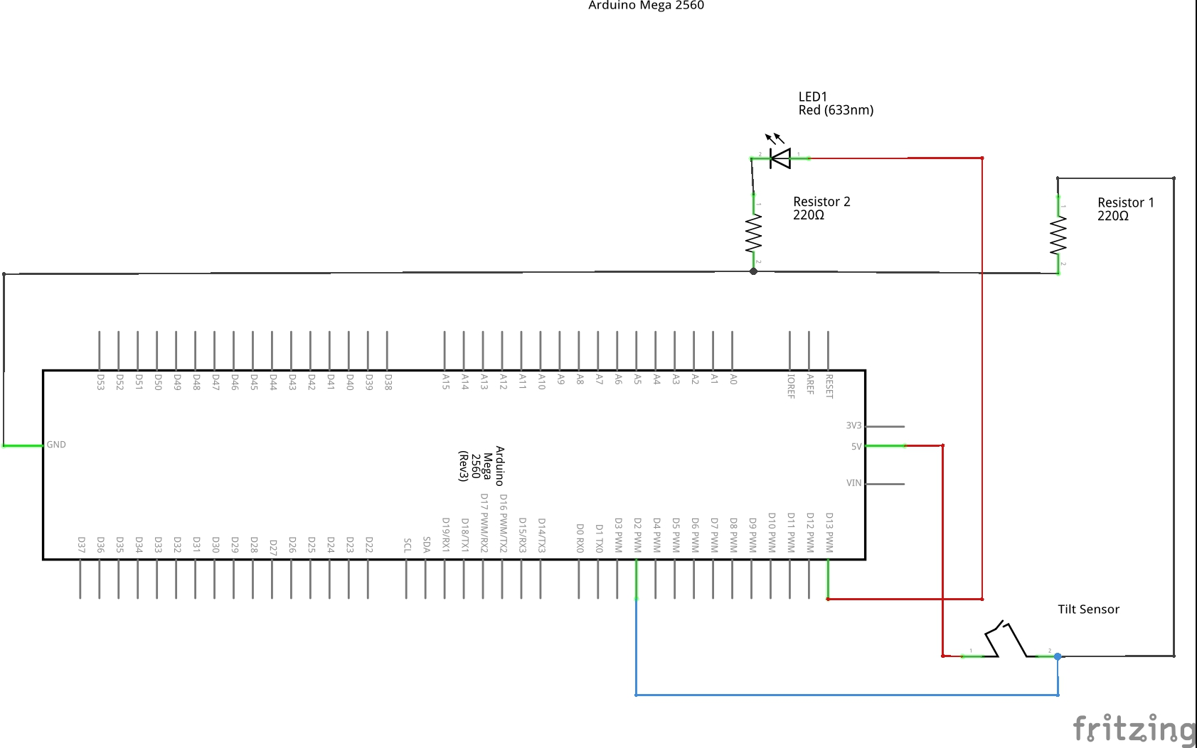

Figure 2: Assembled Hardware

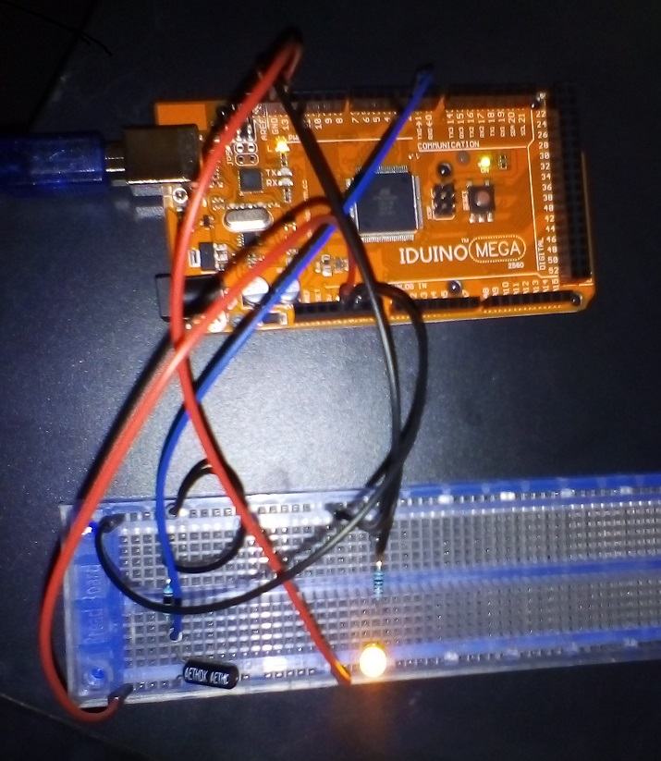

Source Code:
Task1.1P.ino file contents:

uint8_t inputPin = 2;
uint8_t outputPin = 13;
bool changeDetected = 0;
bool isLevel = 1;

void setup()
{
pinMode(outputPin, OUTPUT);
pinMode(inputPin, INPUT);

// Start serial output
Serial.begin(9600);
Serial.println("Arduino tilt sensing started");
}

void loop()
{
// Test whether the tilt sensor has detected a change
if(isLevel != digitalRead(inputPin))
{
// Record change in tilt status
changeDetected = 1;
isLevel = digitalRead(inputPin);
}

if(changeDetected)
{
if(isLevel)
{
// Turn on LED at pin 13
digitalWrite(13, HIGH);
Serial.println("LED on");
Serial.println("Arduino is not tilted");
}
else
{
// Turn off LED at pin 13
digitalWrite(13, LOW);
Serial.println("LED off");
Serial.println("Arduino is tilted");
}
// Reset change monitor
changeDetected = 0;
}

// Delay to reduce false readings
delay(200);
}

Figure 3: Serial Output (Screenshot)

