A unique item has fallen into my possession. I fear that I will not be able to keep it safe. You know too well the many who pursue my knowledge. I am giving it to you in the hopes that you will be able to keep it secret.

You should already have everything you need to unlock the secrets within. I trust in your skill - and your discretion.

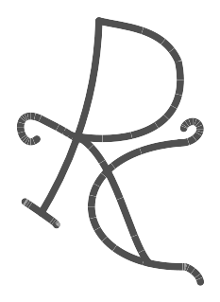
Our curiosity has brought us here. Only our wits can save us now.

