Performance Estimation, Testing, and Control of Cyber-Physical Systems Employing Non-Ideal Communications Networks

**Student: Richard Candell, Université de Bourgogne, France & NIST, USA.  
Supervisor: Sebti Foufou, Université de Bourgogne, France**

**Abstract**

Wireless technology is a key enabler of the promises of Industry 4.0 (Smart Manufacturing). As such, wireless technology will be adopted as a principal mode of communication within the factory beginning with the factory enterprise and eventually being adopted for use within the factory workcell. Factory workcell communication has particular requirements on latency, reliability, scale, and security that must first be met by the wireless communication technology used. Wireless is considered a non-ideal form of communication in that when compared to its wired counterparts, it is considered less reliable (lossy) and less secure. These possible impairments lead to delay and loss of data in industrial automation system where determinism, security, and safety is considered paramount. This thesis investigates the wireless requirements of the factory workcell and applicability of existing wireless technology, it presents a modeling approach to discovery of architecture and data flows using SysML, it provides a method for the use of graph databases to the organization and analysis of performance data collected from a testbed environment, and finally provides an approach to using machine learning in the evaluation of cyberphysical system performance.

# Introduction

Smart Manufacturing provides a vision of future manufacturing systems that incorporate highly dynamic physical systems, robust and responsive communications systems, and computing paradigms to maximize efficiency, enable mobility, and realize the promises of the digital factory. Wireless technology is a key enabler of that vision. Wireless communication is inherently more prone to latency and delay than wired counterparts. In addition, wireless communication implies the utilization of the electromagnetic spectrum which is a publicly accessible medium with constrained capacity and more prone to cyber-attack. While transmitted data can by digitally protected through authentication and encryption, wireless devices are prone to interference and jamming by both rogue and friendly emitters exacerbating the reliability and latency concern impacting factory performance without compromising data security. Wireless communication in factories is often constrained by battery life and most certainly constrained by the availability of the electromagnetic spectrum. As the reliance on wireless devices within the factory continues, steps toward developing a more robust wireless factory communications network must be developed. These steps include:

* The automation system must become situationally aware and adaptive to knowledge of the trends in electromagnetic spectrum occupancy and acute events; and
* Intelligence of the automation system must move closer to the physical system. This means moving the intelligence for control to the actuator; and
* Performance test methods must be developed and incorporated into the industrial fringe devices. The test methods must be dependable and at the same time easy to use by factory personal not trained in the technicalities of wireless communication; and
* Existing Wireless communications protocols must be analyzed and adapted, and new protocols must be developed to balance reliability, latency, and scalability; and
* Security of the network must be maintained and must include availability as a paramount characteristic.

This thesis includes development of test approaches for measuring the performance of industrial wireless networks deployed within smart manufacturing work-cells. Thus, the primary goal of this thesis is the discovery of methods and approaches to the evaluation of industrial uses cases performance for those use case in which wireless communication technology is used as the principal mode of communication. The primary motivation of the research is to discover practical test and evaluation methods for assessing performance of an industrial workcell thereby improving security, safety, and reliability in general. Findings and results of the thesis work are included within the thesis and published as journal articles and conference proceedings. Resulting data is also made available.

# Contributions and Organization

This thesis is presented in three major parts. In Part I, the thesis provides a historical introduction to the context of smart manufacturing. It presents the premises of industrial wireless technology, key challenges to using wireless within a factory environment, and the accepted indicators that are currently used in the application of wireless within factory environments. Then, the existing state of the art is presented to orient the reader for the thesis contribution. This state of the art includes a discussion of the industrial wireless technology landscape, standards, and a tentative mapping of those technologies to application domains. A discussion of the systems modeling approaches is then provided with a focus on the Systems Markup Language. Then a discussion of approaches to the use of databases follows. In Part II, *Thesis Contributions*, the technical contributions of this thesis are presented. Finally, in Part III, the thesis provides a detailed discussion of the four major contributions of this thesis work. Concluding remarks and future direction are provided as an opinion of the thesis candidate. The thesis contributions are presented as follows:

**Requirements** [1]–[4] An examination of the wireless technology landscape is conducted. Existing and future wireless technologies are assessed for their appropriate applicability to industrial use cases.

**Modeling** [5], [6] In an effort to better understand the architectural composition of the workcell using industrial wireless communication, modeling techniques are used to identify and decomposed the parts, interfaces, and data flows. SysML is adopted for this process and a proposed modeling library is created and presented. The model with conceptual diagram is made publicly available independent of the tool that was used to create the model.

**Application of Graph Databases** [7], [8] A method is developed for collecting, cleaning, organizing, and presenting the cyberphysical performance indicators of experiments run within the NIST Industrial Wireless Testbed. The method developed utilizes the Neo4j graph database and is presented as a novel approach as compared to traditional approaches using relational database, spreadsheets, and raw file processing.

**Machine Learning** [9], [10] A machine learning technique is developed and applied to the prediction of signal-to-interference levels within a wireless factory workcell network employing a robot arm within a force-seeking apparatus. The machine learning method allows a trained network to accurately determine the signal-to-interference level using the physical state of the robot arm rather than the state of the wireless link itself.

The author also cites his paper [11] accepted to the conference on product life-cycle management. The author presents a new industrial wireless testbed design that motivates academic research and is relevant to the needs of industry. The testbed is designed to serve as both a demonstration and research platform for the wireless workcell. The work leverages lessons learned from past incarnations that included a dual robot machine tending scenario and a force-torque seeking robot arm apparatus. This version of the testbed includes computational and communication elements such that the operation of the physical system is noticeably degraded under the influence of radio interference, competing network traffic, and radio propagation effects applied within the lab. Key performance indicators of the testbed are selected and presented which include communication, computational, and physical systems indicators. This new testbed will be used to perform future research motivated by this thesis.

An additional contribution by the author for which he was not primary author but took a substantial role is cited here [12]. In this work, the author designed, constructed, and executed an experiment in collaboration with the main author in which a typical two-dimensional gantry apparatus was controlled by a local controller which received G-code commands wirelessly over a Wi-Fi network. The industrial wireless channel was replicated using a radio frequency (RF) channel emulator where various scenarios were considered, and various wireless channel parameters were studied. The movement of the gantry system tool was tracked using a vision tracking system to quantify the impact of the wireless channel on the system performance. Numerical results were presented including the total run time of an industrial process and the dwell times at various positions through the process. This contribution is not discussed within the thesis.

# Wireless Workcell Modeling Using SysML

The second contribution was an abstraction of the industrial cyberphysical system that is the factory work using SysML. In this work, a model was constructed using primitives representing each major architectural component of the workcell and interfaces within the workcell and to systems outside the workcell. These interfaces are used to represent elements of information flow. The information flows represented represent the performance of the supporting network. Subsequently, the physical system that operates using that network has its own performance that is directly connected to the performance of the network. Each information flow identified using the SysML model represents an opportunity of study. For example, the system elaborated by the internal block diagram shown in Figure 1, each of the main actors (Robot Controller 1, Robot Controller 2, and Supervisor) are all connected to an 802.11ax network.

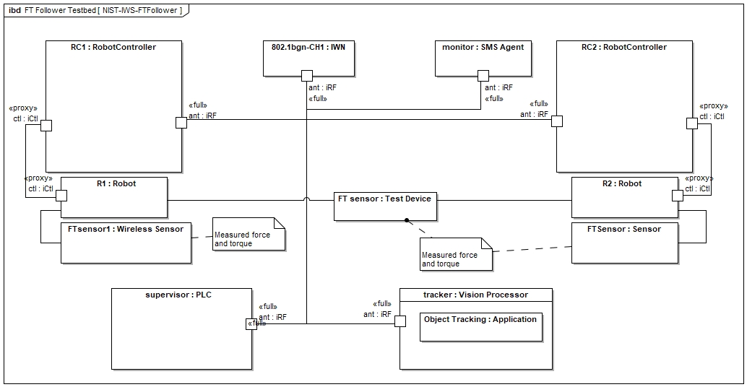

Figure 1. Internal block diagram of a wireless leader-follower testbed apparatus.

The developed model is constructed of the elements necessary to construct useful representations of factory work-cells in which wireless networks are used to transport information necessary for automated control system operation. Reusable, derivable elements are developed and then extended to represent the constructs of the work-cell such as robot control, supervisory control, vision, safety, and spectrum monitoring. An industrial wireless network is then developed, and constraints of the radio channel and network services are formalized. Using the architectural model, information flows are explored and incorporated within. Main building blocks of the conceptual model are shown in Figure 2. Included but not shown are the intricate SysML specifications of the constraints of the radio channel and networking components which are used to model concepts of trustworthiness such as information delay and loss.

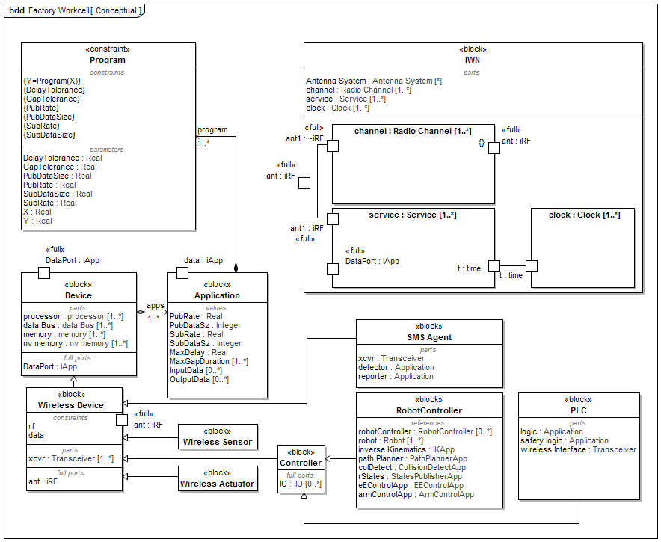

Figure 2. Conceptual SysML block diagram of the wireless workcell.

# Application of Graph Databases

Graph databases are designed to provide a powerful modeling framework for the storage and visualization of data in which relationships and connections between data could be significant but difficult to detect or visualize in the real world. When one hears the word "database," typically one envisions a relational database such as MySQL or Oracle in which the database itself stores information in a highly structured manner in which tables are constructed in a predetermined way with columns, rows, and rigidly defined data types. In contrast, graph databases are not rigid in their structure and organization. Data is graph databases are natively stored within nodes and vertices (connections). Each node and vertex can have associated properties and thus store data as shown in Figure 1 which illustrates the common notion of a graph database. In the graph units of information (nodes) exist with relationships lines between those units of information depicted as lines. The connecting lines represent relationships which are the essential building block used within the contribution presented in the thesis.

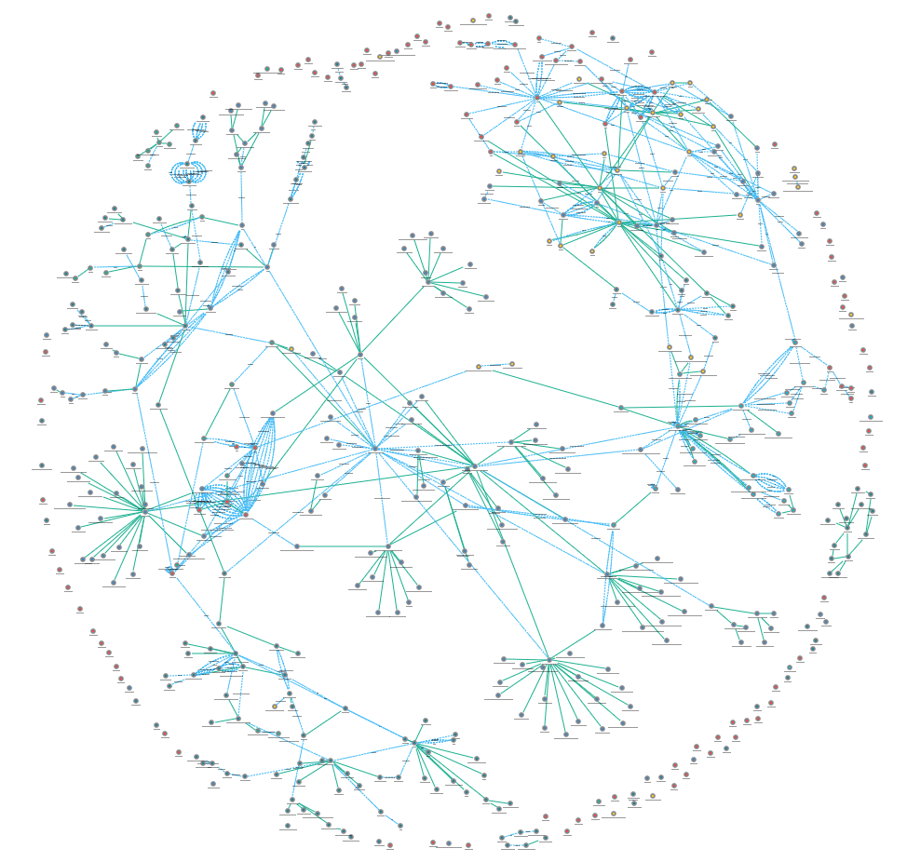

Figure 3. A notional spherical graph depicting nodes and vertices.

The graph database was employed within the work of this thesis. It was demonstrated as an effective tool to model and capture performance information for research and possibly for situational awareness of factory operation. The objective of using a graph database was essentially to 1) leverage the inherent connectedness of the data resulting from the experiments being performed within the NIST Industrial Wireless Laboratory, and 2) demonstrate that wireless networks could be used for a significant class of use case without impacting physical system performance. To support the research performed for this contribution, a testbed was constructed. In the testbed, two robot arms were used to move and inspect parts through a series of four (4) computer numerically controlled (CNC) machines. Each robot is equipped with a 6-DOF force torque sensor in its wrist. Joint control of each robots is conducted through a separate robot controller computer assembly. A programmable logic controller (PLC) was used to supervise activity within the workcell and was called the Supervisor. The network and physical performance of the simulated workcell was captured completely agnostic of the type of communication network being used. Through the use of adapter and network tap devices shown in the diagram, it was possible to capture packet flight data in a way such that the type of technology used for communication did not alter routing of information. By doing this, the schema of the graph databased was left relatively unchanged across experiments while different wired and wireless protocols were investigated. Many instantiations of graph databases were produced for each experiment conducted using the testbed.

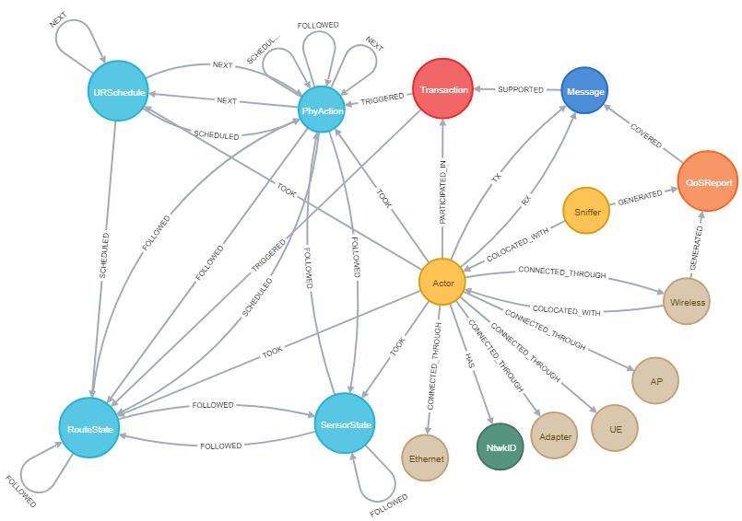

Figure 4. Graph database schema used for the thesis research of CPS performance capture

This reveals what is important: the connection between physical actions and the transactions that support them. Transactions are grouping of information transmissions (i.e., packets) that traverse the wireless network. Factors that impact reliability of transaction such as message (i.e. packet) loss or message (i.e. packet) delay indirectly impact start and stop times of physical actions. These relationships are directly captured within a graph and thus the applicability of a graph database to the investigation of cyberphysical system performance becomes evident. Ultimately, one could argue that the primary contribution of this component of the thesis is the demonstration of interconnectedness between the industrial (wireless) network and physical operations through the modeling and capture of the performance data, the data relationships, and the analysis of physical action performance when network performance is degraded. The use of the graph database makes that possible. As an example, the schema shown in Figure 2 was produced by querying the schema of a single database with hundreds of physical actions and hundreds of thousands of supporting transactions. By querying the data represented by this structure, it was demonstrated that the wireless network employed did not prohibitively impact operation. It was also demonstrated that through querying of the performance outliers that network events such as loss in signal strength or an increase in interference could be linked to a delay in the actuation of a robot action. This type of event discovery and correlation to the physical world is particularly advantageous to facilitating the adoption of wireless in smart manufacturing.

# Application of Machine Learning

Machine learning (ML) is a large field of science and engineering that deals with the application of computing algorithms to perform actions without being explicitly programmed to do so. In general applications, ML is used from applications ranging from voice recognition in personal electronics, spam filtering in email, and performing traffic prediction for commuters to providing services such friend identification and face recognition in social media. In industrial applications, machine learning has the promise of a wide range of applications such as robot autonomy and detection of security anomalies. In this thesis, as machine learning framework was demonstrated for the prediction of the signal-to-interference ratio (SIR) within a communications link used for the control of a robot arm depressing a spring apparatus shown in Figure 3. The ML framework as shown to be useful and accurate in the prediction of link quality. Link quality estimation (LQE) is an important metric in wireless communication system. It is a general term used to describe the level of quality of a communication link. The SIR metric is a ratio between the intended signal being transmitted and the level of interference competing with the intended signal. Interference, whether caused by malicious jamming or not, is an impeding factor in the adoption of wireless in smart manufacturing systems. Therefore, having a clear situational awareness picture of the level of interference and the quality of communication links being used is of clear interest. The contribution presented within this thesis addresses a clear need in improving the detection and estimation of signal quality events in the workcell.

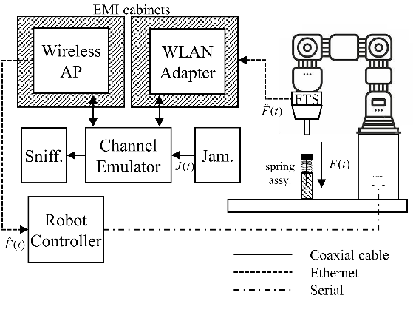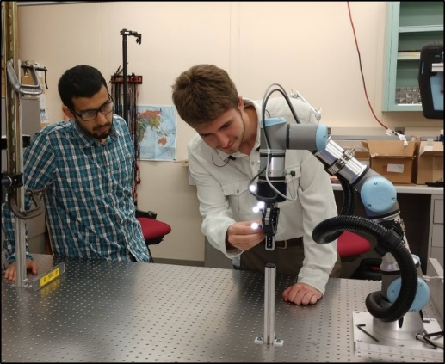

Figure 5. Robot force-seeking spring system with controlled wireless   
channel emulation and interference injection.

First, in this work, we present a method using random forest regression to estimate the SIR ratio of the communication channel within a robotic arm force-seeking scenario in which the force signal is transmitted over a wireless local area network (WLAN). Position data from a vision-based tracking system, a distant observer, is used to train a channel quality estimator to infer the SIR of the wireless channel. The experiment is designed so that the small perturbations in the wireless channel resulting from interference will present position uncertainty in the physical system. Next, the same testbed setup is deployed to explore, in more detail, the impact of machine learning on the performance of the detection algorithm. It is also endeavored to understand the impact of various features in the training data set. Hence, position data is used from a vision-based tracking system, a distant observer, to train a channel quality estimator to infer the SIR experienced by both the wireless access point and the wireless station used within the experiment. Five different features are extracted from the position data captured by the vision system. The contributions of this chapter are summarized as follows:

* The work explains in detail the proposed algorithm for SIR estimation, the testbed setup, and the features extracted from the position data. Results of the algorithm are presented demonstrating the effectiveness of the machine learning algorithm.
* Various machine learning regression schemes are compared for SIR estimation, thereby demonstrating the superior performance of various ensemble-based approaches.
* Impact of individual features are studied regarding the performance of the proposed algorithm to understand the correlation between the interference level to each of these features. Hence, the correlation between physical systems behavior and the underlying quality of the wireless communications channel is better understood.
* Finally, an analysis on the impacts of measurement interval and the training set size on the performance of the ML algorithms is provided.

The proposed machine learning approach is deployed for three values of SIR: -9, -8, and -7 dB. As shown in Figure 4, the predictive machine learning approach is relatively effective. The random forests predictor is accurate within roughly +/- 0.1 dB with some outliers having errors showing errors of less than 0.6 dB. This shows that machine learning techniques are effective at predicting SIR values by merely observing the physical apparatus once the predictor is trained.

Figure 6. Predicted SIR versus actual SIR.

Bibliography

[1] R. Candell and M. Kashef, “Industrial wireless: Problem space, success considerations, technologies, and future direction,” in *2017 Resilience Week (RWS)*, Sep. 2017, pp. 133–139, doi: 10.1109/RWEEK.2017.8088661.

[2] K. Montgomery, R. Candell, Y. Liu, and M. Hany, “Wireless User Requirements for the Factory Work-cell,” 2019. doi: https://doi.org/10.6028/NIST.AMS.300-8.

[3] R. Candell, M. Kashef, Y. Liu, K. B. Lee, and S. Foufou, “Industrial Wireless Systems Guidelines: Practical Considerations and Deployment Life Cycle,” *IEEE Ind. Electron. Mag.*, vol. 12, no. 4, pp. 6–17, 2018.

[4] R. Candell, M. Hany, K. B. Lee, Y. Liu, J. Quimby, and K. Remley, “Guide to industrial wireless systems deployments,” Gaithersburg, MD, Apr. 2018. doi: 10.6028/NIST.AMS.300-4.

[5] R. Candell, M. Kashef, Y. Liu, and S. Foufou, “A SysML representation of the wireless factory work cell,” *Int. J. Adv. Manuf. Technol.*, vol. 104, no. 1–4, pp. 119–140, Sep. 2019, doi: 10.1007/s00170-019-03629-x.

[6] R. Candell, “A Model of a Wireless Factory Work-Cell Using the Systems Modeling Language,” *J. Res. Natl. Inst. Stand. Technol.*, vol. 123, p. 123018, Oct. 2018, doi: 10.6028/jres.123.018.

[7] R. Candell, M. Kashef, Y. Liu, K. Montgomery, and S. Foufou, “A Graph Database Approach to Wireless IIoT Work-cell Performance Evaluation,” in *Proceedings of the 2020 IEEE International Conference on Industrial Technology*, Feb. 2020.

[8] M. Kashef, Y. Liu, K. Montgomery, and R. Candell, “Wireless Cyber-Physical Systems Performance Evaluation through a Graph Database Approach,” *J. Comput. Inf. Sci. Eng.*, pp. 1–19, 2020, doi: 10.1115/1.4048205.

[9] R. Candell, K. Montgomery, M. Kashef, Y. Liu, and S. Foufou, “Wireless Interference Estimation Using Machine Learning in a Robotic Force-Seeking Scenario,” in *2019 IEEE 28th International Symposium on Industrial Electronics (ISIE)*, Jun. 2019, pp. 1334–1341, doi: 10.1109/ISIE.2019.8781418.

[10] R. Candell, K. Montgomery, M. Kashef, Y. Liu, and S. Foufou, “Machine Learning Based Wireless Interference Estimation in a Robotic Force-Seeking Application,” *ISA Trans.*, 2020, doi: pending.

[11] R. Candell and S. Foufou, “Smart Manufacturing Testbed for the Advancement of Wireless Adoption in the Factory,” in *Proceedings of the 17th International Conference on Product Lifecycle*, 2020, [Online]. Available: https://www.plm-conference.org/.

[12] M. Kashef, R. Candell, and S. Foufou, “On the Impact of Wireless Communications on Controlling a Two-Dimensional Gantry System,” in *ASME 2019 14th International Manufacturing Science and Engineering Conference*, 2019, vol. Volume 1:, doi: 10.1115/MSEC2019-2896.