Electromagnetic Interference Measurements from Tungsten Inert Gas (TIG) Arc Welding

# Description

The 2.4 GHz ISM band is shared by Wi-Fi, Bluetooth, Wireless HART, ISA100.11a, and several other industrial wireless systems. Our dataset contains comprehensive electromagnetic interference (EMI) measurements from Tungsten Inert Gas (TIG) welding processes conducted in the NIST fabrication shop. The measurements were taken using a typical arc welding power source and recorded at three distinct frequencies: 900 MHz, 2.4 GHz, and 5.3 GHz. The data collection was performed with a bandwidth of 160 MHz and a sample rate of 625 MHz, providing high-resolution insights into the EMI characteristics during the welding operations. This dataset may be useful for understanding the EMI behavior in TIG welding and can be instrumental in developing interference mitigation strategies, aiding in RF band selection and frequency planning, and improving welding technology and regulations.

# Equipment and Configuration:

The following equipment was used to take these measurements:

**Antenna and Cabling**

* RF cables rated for up to 18 GHz
* Antenna was an TSA900 directional antenna
* Real-time Spectrum Analyzer (RTSA): Rohde & Schwarz FSW-B160R with FSW8

**RTSA Measurement Settings:**

* Recording Sample Rate: 625MHz
* Recording Bandwidth: 160 MHz
* Capture Time: 80ms per measurement
* Reference Power Level: 0 dBm

# Measurement Setup

Arc welding interference measurements were taken in the NIST Machine Shop. As shown in Figure 1, the measurement configuration consisted of a welding station producing an arc followed by a line-of-sight (LOS) path loss component, a high gain directional antenna, an RTSA, and a measurement computer (PC) for extracting the measurements.

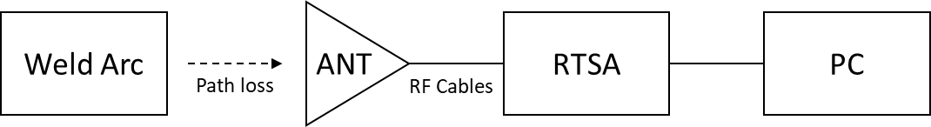

Figure 1. Conceptual Measurement Configuration

As shown in Figure 2, the measurement antenna was positioned a nominal distance of 4.0 meters from the welding arc. The antenna was mounted on a tripod with an RF test cable proceeding from the rear to the RTSA positioned away from the weld behind a concrete walls and metal door as shown in Figure 3. This was done in an attempt to minimize indirectly conducted emissions from the electromagnetic field produced by the arc. The RTSA was also powered by an isolated electrical circuit located on the opposite side of the shop over 20 meters away.

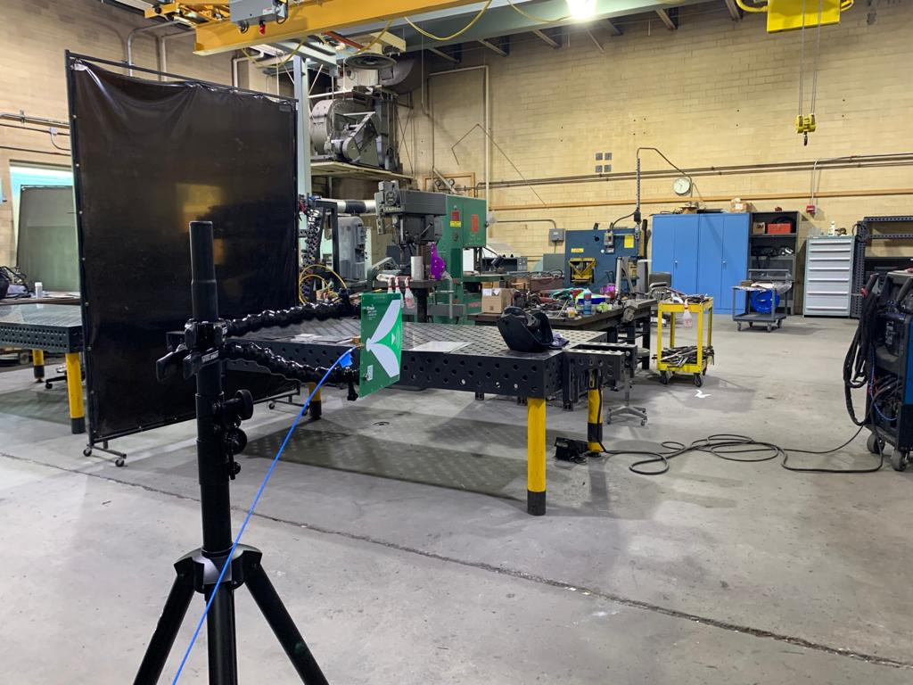

Figure 2. Measurement antenna directed toward the welding table

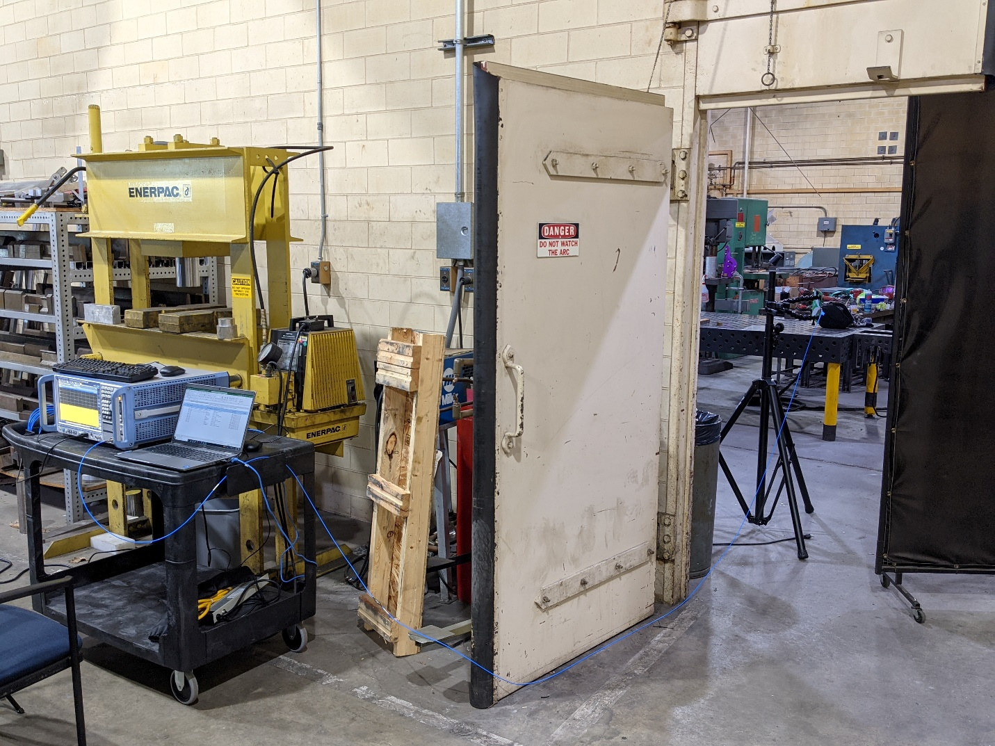

Figure 3. Measurement Station with RTSA and Measurement Capture Computer

# Data Organization

The measurement data and supporting documentation is organized as described below.

**Top level (folder)**

* *MeasurementParameters.xlsx*: Contains the measurement configuration parameters for each of the measurement taken.
* *analyze_measurements.m*: M-file script used to produce results in the dataset
* *tigwelding_power_results.txt*: Contains summary power metrics of each measurement

**data (folder)**

A folder exists for each measurement run named as *<measurement name>.iq. Within each folder*, the following files are provided:

* *<root_file_name>.float32*: measurement file containing interleaved formatted complex baseband amplitude samples of the measured interference across a 50 Ohm reference.
* *workspace.mat*: A MATLAB workspace file containing all of the variables that resulted from the NIST processing of the measurement files. Note: Only those measurements that exhibited notable interference will have this file.
* **Files not used but provided for informational purposes only:**
  + *<root_file_name>.float32.xml*: XML file of the measured power versus time, spectrum, and histogram formatted in accordance with the Rohde & Schwarz XML format. Refer to Rohde & Schwarz format specifications for details regarding this format specification.
  + *open_IqTar_xml_file_in_web_browser.xslt*: A style sheet for the XML measurement file.

**figs (folder)**

For each Measurement Folder, a plot of the following is provided in PNG format:

* Time series of the measured interference signal computed as the magnitude of each complex sample
* Estimated interference power at 1, 10, and 100 meters

**datasheets (folder)**

Contains the datasheets of the welding device that was used to produce the arc weld measurements.

**@tigwelding (folder)**

Contains the MATLAB code used to process the measurement files. MATLAB Version 2023 was used. This code may be incompatible with older versions of MATLAB.

**NIST Disclaimer**

Certain commercial equipment, instruments, or materials are identified in this publication in order to describe the experimental procedures and data adequately. Such identification is not intended to imply recommendation or endorsement by the National Institute of Standards and Technology, nor is it intended to imply that the materials or equipment identified are necessarily the best available for the purpose.