CIVE202 – Project #5: Initial Results
Course: CIVE 202 – Civil Engineering Analysis II
Project: Project #5 – TCR Violations Analysis
Group: ENVRN-02-06
Group Members: Dawa Lamu Tamang, Rebecca Carroll, Savanna Flores
Date: 3/30/2026

Initial Results:
Result 1: TCR Violations by State
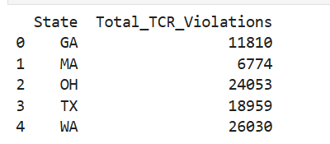
Figure 1 Total TCR Violations by State
The table above shows the preliminary total number of Total Coliform Rule (TCR) violations by state using the cleaned SDWIS dataset. This provides an initial comparison across the five selected states and highlights variation in violation counts between states.

Result 2: TCR Violations by System Size
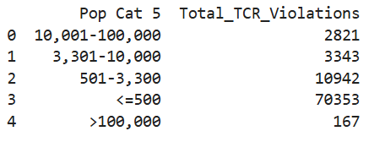
Figure 2 TCR Violations by Population Category
The table above shows the distribution of TCR violations by population size category. The results indicate that the smallest water systems (serving <=500 people) account for the highest number of violations, while larger systems have significantly fewer violations.

Result 3: TCR Violations Over Time
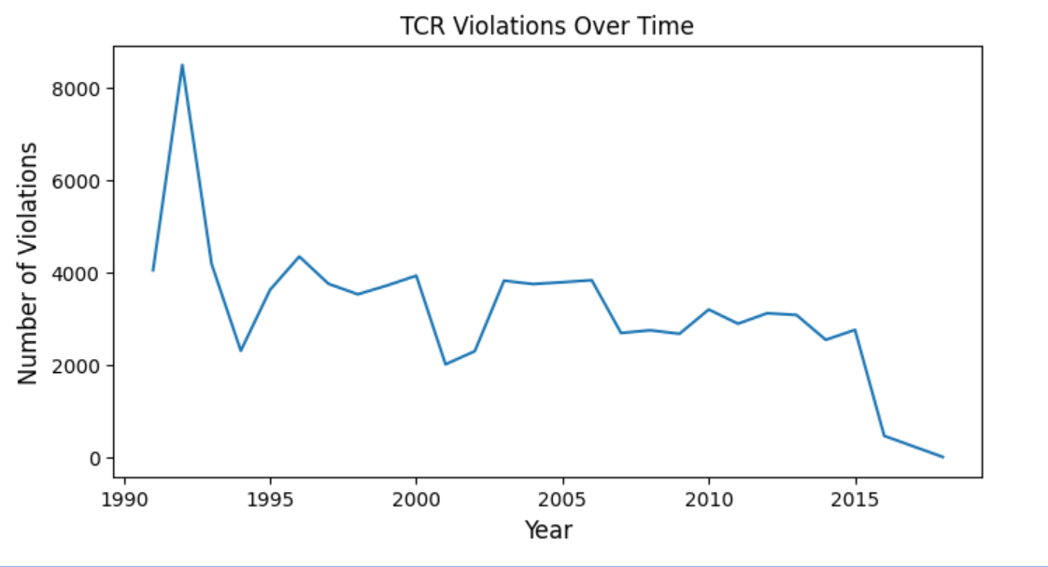
Figure 3 TCR Violations Over Time
The graph above shows the trend of Total Coliform Rule (TCR) violations over time using the cleaned SDWIS dataset. The results indicate that violation counts fluctuate across years, with higher values in earlier years and a general decline in more recent years.

