TCR Violations Analysis Technical Report – Project #5
Client: UMass Amherst Water Research Team

Group ENVRN-02-06
Dawa Lamu Tamang
Rebecca Carroll
Savanna Flores

CIVE 202: Civil Engineering Analysis II
Spring 2026

Table of Contents:
1. Introduction 3
2. Methods 3
2.1 Data sources and project workflow 3
2.2 Variable selection and rationale 3
2.3 Data preparation and visualization 4
2.4 Bias and ethical considerations in data analysis 4
3. Results and Discussion 5
3.1 TCR violations by state 5
3.2 TCR violations by system size 6
3.3 TCR violations over time 6
3.4 State-level trends over time 8
3.5 System size trends over time 8
4. Conclusion 9
5. References 10

1. Introduction
Drinking water quality is critical to public health, and monitoring microbial contamination is a key responsibility of water system operators. The Total Coliform Rule (TCR) established by the Environmental Protection Agency (EPA) ensures that public water systems are regularly tested for contamination. Violations of this rule may indicate issues in treatment, infrastructure, or monitoring practices.
The objective of this project is to analyse TCR violations using data from the Safe Drinking Water Information System (SDWIS). Specifically, this project aims to:
- Develop clear and meaningful visualizations of violation data
- Identify trends in violations across different states
- Analyse how system size affects compliance
- Evaluate how violations change over time

2. Methods

2.1 Data sources and project workflow
The dataset used in this project was obtained from the EPA Safe Drinking Water Information System (SDWIS). The data includes quarterly violation reports for five selected states: Georgia (GA), Texas (TX), Ohio (OH), Massachusetts (MA), and Washington (WA).
Because the SDWIS system provides data on a quarterly basis, all four quarters for each year from 2021 to 2025 were downloaded and combined into a single dataset. This allowed for a complete analysis of yearly trends.

2.2 Variable selection and rationale
The variables selected for this analysis were chosen to align with the project objective of understanding violation patterns.
- primacy_agency_code (State): Used to compare violations across states
- pop_cat_5 (System size): Used to analyze how population size affects violations
- submission_year_quarter / year: Used to track changes over time
- violation_type and rule_name: Confirmed focus on Total Coliform Rule violations

2.3 Data preparation and visualization
The analysis was conducted using Python with pandas and matplotlib.
The following steps were performed:
- Combined all quarterly CSV files into a single dataset
- Standardized column names to lowercase format
- Converted population values to numeric format
- Extracted year from the submission year-quarter field
- Grouped data using pandas to calculate total violations
The visualizations created include:
- Bar charts for violations by state and system size
- Line plots for trends over time
- Multi-line plots to compare trends across states and system sizes

2.4 Bias and ethical considerations in data analysis
All data-driven analyses are influenced by the decisions made during data collection, processing, and interpretation. In this project, several coding and methodological choices introduce potential sources of bias that should be considered when interpreting the results.
- Violations were aggregated by state and by time (year and quarter) to identify trends. This approach simplifies the dataset and allows for clear comparisons but may obscure important variability at the individual water system level. Differences between specific systems such as operational practices or local environment conditions are not captured in aggregated results.
- The analysis relied on total counts of Total Coliform Rule (TCR) violations rather than normalized metrics. This introduces bias because states with larger populations or a greater number of water systems may naturally report more violations, even if their overall compliance rate is comparable to or better than smaller states. A more comprehensive analysis would consider violations per system or per population served.
- Data cleaning decisions may influence results. During preprocessing, non-numeric values in key fields such as population served were converted using methods that may produce missing values when errors occur. These records may be excluded from certain calculations, which can bias results toward cleaner or more complete data entries. Additionally, encoding adjustments were applied to ensure compatibility with Python, which may alter or remove certain special characters.
- The transformation of the submission year and quarter field into a numeric or categorical format introduces assumptions about time. Converting quarterly data into a continuous or ordered variable assumes equal spacing between observations and may oversimplify temporal trends.
- The selection of only five states for analysis introduces selection bias. While the states were chosen to represent different EPA regions, they may not fully capture national trends in TCR violations. As a result, findings from this analysis may not be fully generalizable to all public water systems in the United States.
Conclusions should be considered in the context of the above limitations.

3. Results and Discussion

3.1 TCR violations by state
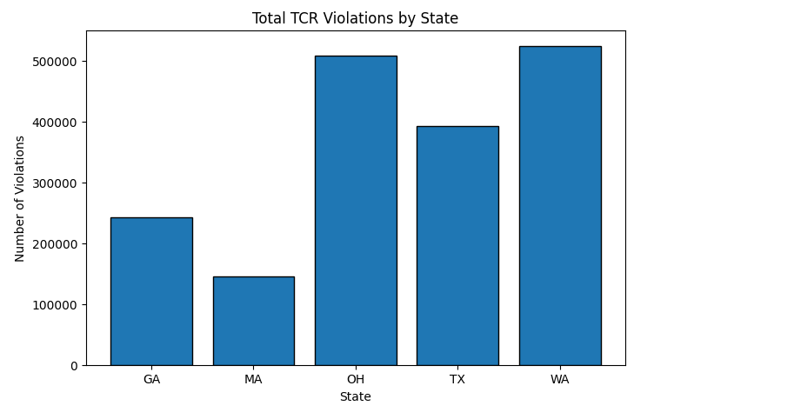
Figure 1 TCR violations by state
The bar chart shows clear differences in violation counts across the five states.
Washington (WA) and Ohio (OH) have the highest number of violations, while Massachusetts (MA) has the lowest. Texas (TX) and Georgia (GA) fall between these extremes.
This suggests that compliance levels vary significantly across states, potentially due to differences in infrastructure, regulatory enforcement, or system management practices.

3.2 TCR violations by system size
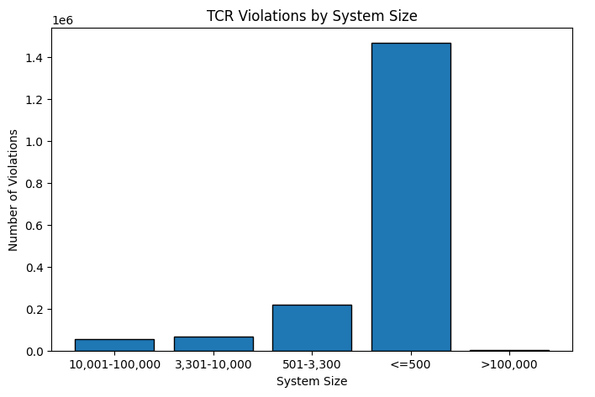
Figure 2 TCR violations by system size
The results show a strong relationship between system size and violations. Water systems serving 500 or fewer people account for the most violations. Medium-sized systems also contribute significantly, while large systems show very few violations. This indicates that smaller systems face greater challenges in maintaining compliance, likely due to limited resources, staffing, and technical capacity.

3.3 TCR violations over time
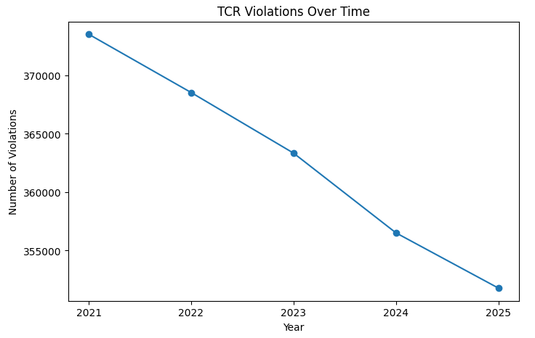
Figure 3 TCR violations over time (2021–2025)
The line plot shows a gradual decrease in violations from 2021 to 2025. This downward trend suggests improvements in compliance, monitoring practices, or infrastructure over time. However, the decrease is relatively steady rather than abrupt, indicating gradual progress rather than major policy shifts.
3.4 State-level trends over time
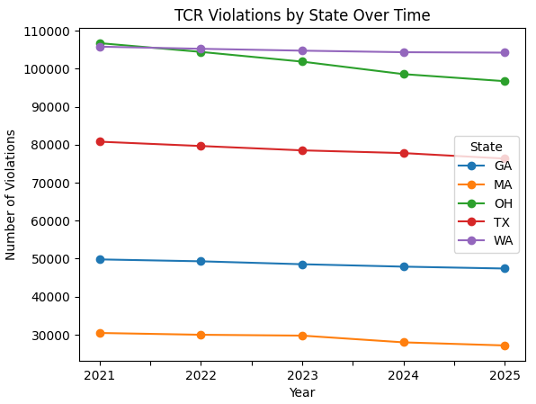
Figure 4 Line plot of TCR violations by state over time
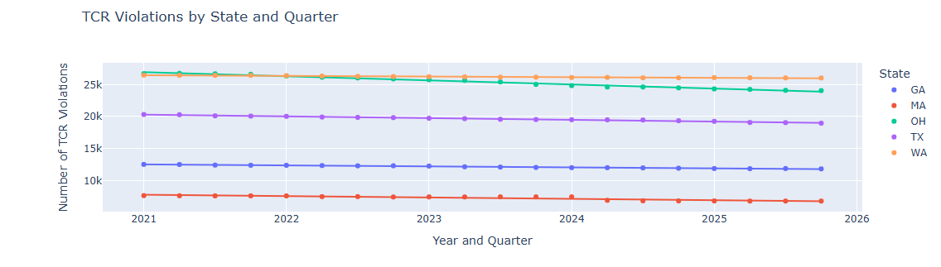
Figure 5 Scatter plot of TCR violations by state over time
When analysing each state individually:
- All states show a slight decrease in violations over time
- Washington and Ohio consistently remain the highest
- Massachusetts consistently remains the lowest
This indicates that while overall compliance is improving, differences between states persist.

3.5 System size trends over time
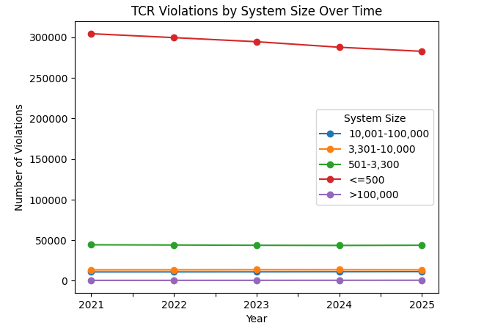
Figure 5 TCR violations by system size over time
The system size analysis over time shows that:
- Small systems (≤500) dominate violations every year
- All system sizes show slight decreases over time
- Larger systems consistently maintain low violation counts

4. Conclusion
This project analysed Total Coliform Rule violations across five states from 2021 to 2025. The results show that violations are strongly influenced by both system size and geographic location. Small water systems account for the majority of violations, highlighting the need for additional support and resources for these systems. While violations have decreased over time, differences between states remain significant.
Overall, this analysis demonstrates the importance of data-driven approaches in understanding water quality compliance and improving public health outcomes.

5. References
(N.d.). EPA, Environmental Protection Agency, <https://www.epa.gov/dwreginfo/revised-total-coliform-rule-and-total-coliform-rule> (Apr. 23, 2026).
(N.d.). EPA, Environmental Protection Agency, <https://sdwis.epa.gov/ords/sfdw_pub/r/sfdw/sdwis_fed_reports_public/200> (Apr. 23, 2026a).
(N.d.). EPA, Environmental Protection Agency, <https://www.epa.gov/dwreginfo> (Apr. 23, 2026a).
“Visualization with python.” (n.d.). Matplotlib, <https://matplotlib.org/> (Apr. 23, 2026a).
“Pandas.” (n.d.). pandas, <https://pandas.pydata.org/> (Apr. 23, 2026).

