

Human Rights Database Staff Manual

Topics covered:

1. Finding the database
2. Logging in
3. Navigating / logging out
4. Searching the database
5. Adding a case
6. Adding a client
7. Viewing Case Details / Adding File Note
8. Finding a stored file
9. Adding shared files
10. Managing your own account
11. Importing users
12. Adding users manually
13. Managing users
14. Viewing users activity

For the most part, the database is pretty self-explanitory, but just in case you cant figure something out lets start with the basics!

1. **Finding the Database**

The database is located online at <http://admin.pahro.org/> and is compatible with Firefox, Chrome and Internet Explorer 8.

1. **Logging In**

When you first load the database, you’ll be asked to login. Your login details should have been given by the staffmember who set up your account. Remember to change your password on first use – see section 10.

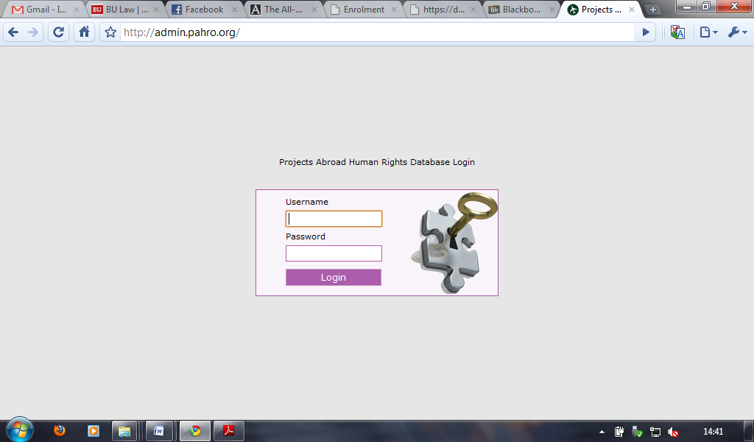

1. **Navigating**

Once logged in you’ll be presented with the home screen. On the left of this are the navigation links:

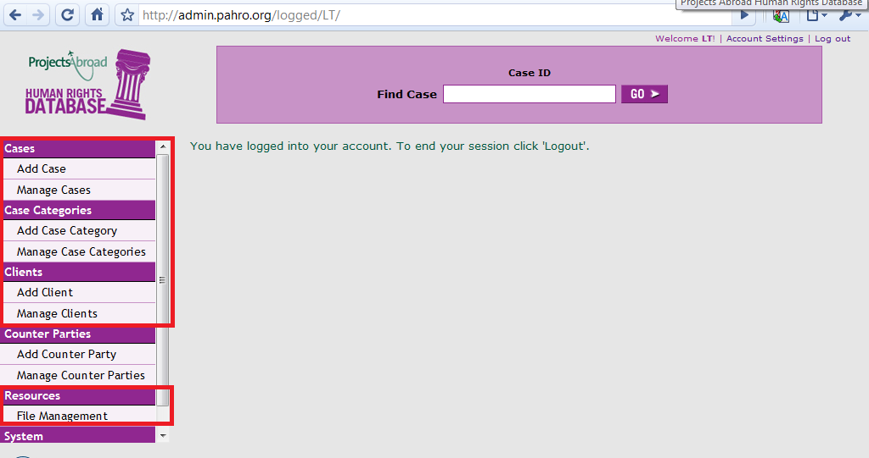

The main ones we’ll be using are under the headings ‘Cases’, ‘Case Categories’ and ‘Clients’.

1. **Searching the database**

The database allows you to conduct a search based on several criteria, however for most day-to-day tasks the important ones are searching by case number and client name.

The case number search can be carried out from either the home page or the manage cases page:

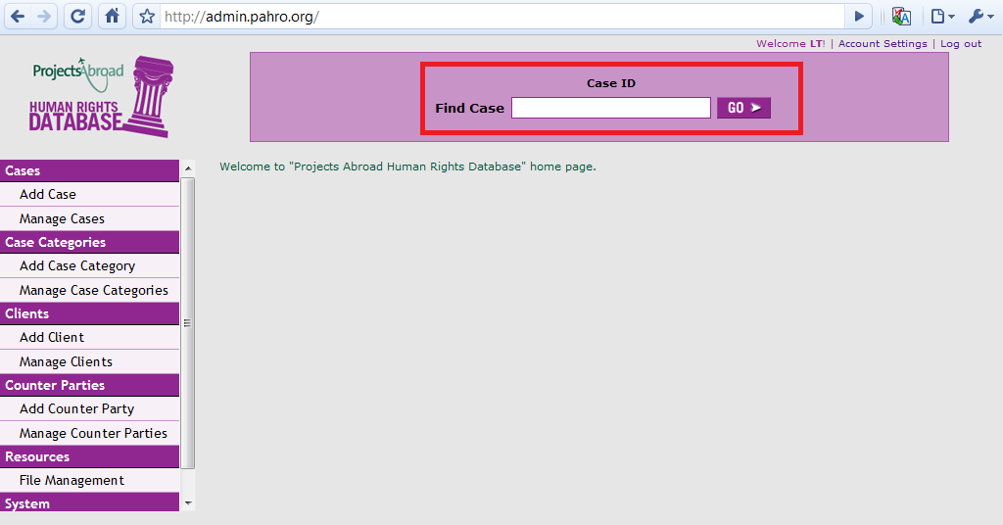

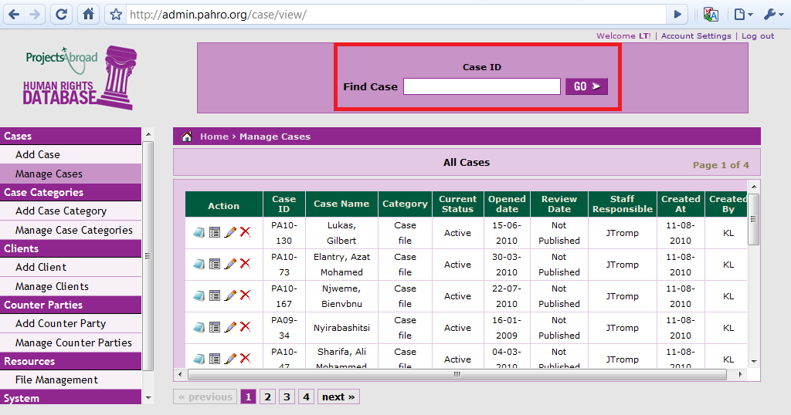

The client name search can be located on the 'manage clients' page:

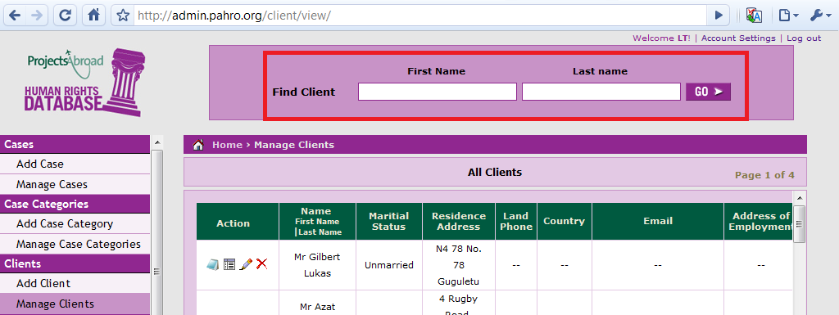

One useful feature the database includes is auto complete. To shorten the search process, relevant search results are displayed as you type:

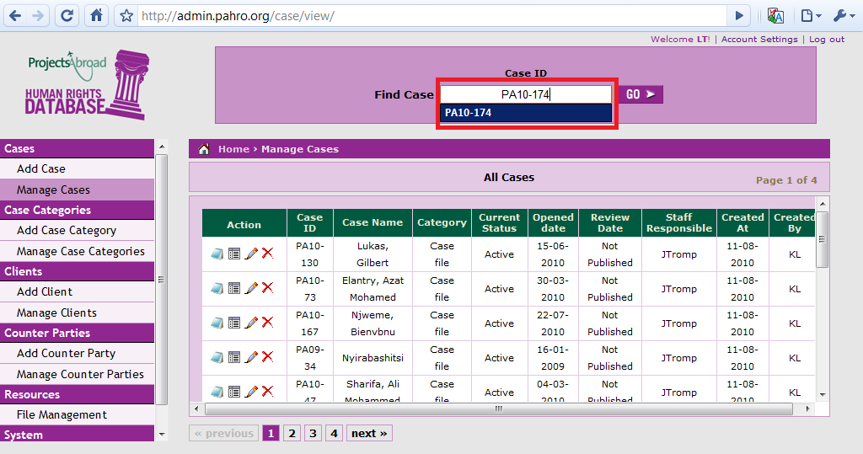

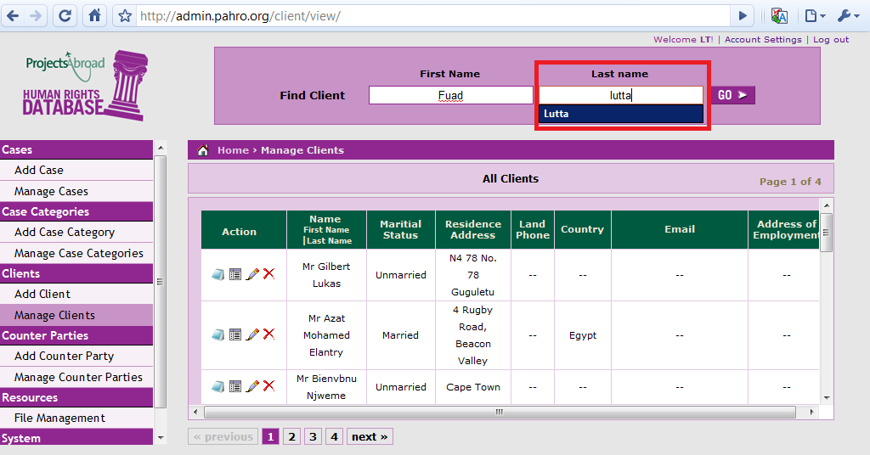

It’s a fairly good indicator that if the name or case number doesn’t appear as you’re typing, it’s not included in the database. This doesn’t mean to say it’s not worth running the search though – if something isn’t found the database should display a screen similar to:

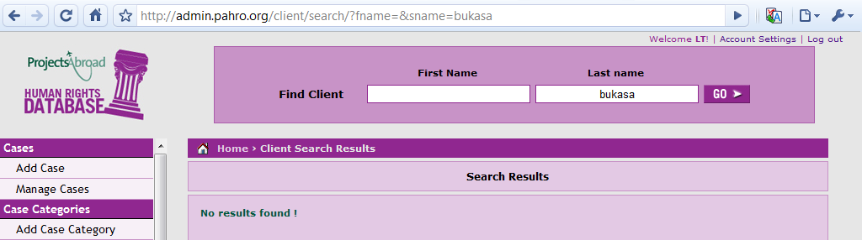

1. **Adding a Case**

This is probably the most important feature to learn. To begin, select the ‘add case’ link from the navigation panel and you will be presented with this screen:

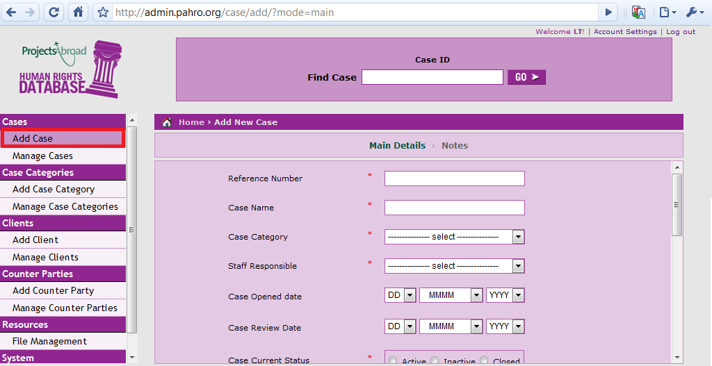

The first step in adding the case is determining if there is an appropriate category for it. We use the category feature to help produce statistics for the office and assist in grouping similar cases. To check the categories click on the drop down box labelled ‘case category’:

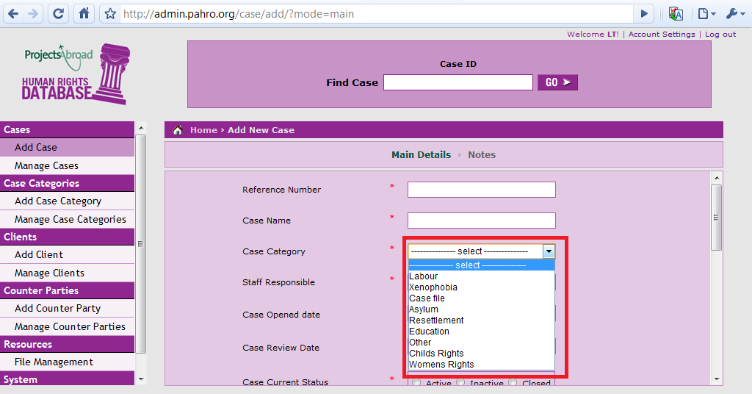

If the case category for your case isn’t displayed, you may need to have a new one created. It should also be noted that there is the ‘other’ category for unique case issues. If you feel that the problem highlighted by your client is not likely to be found in any other cases, use this category instead of have a new one made.

Once you have determined the category for your case, it’s time to fill out the case details. Let’s take a look at the example below:

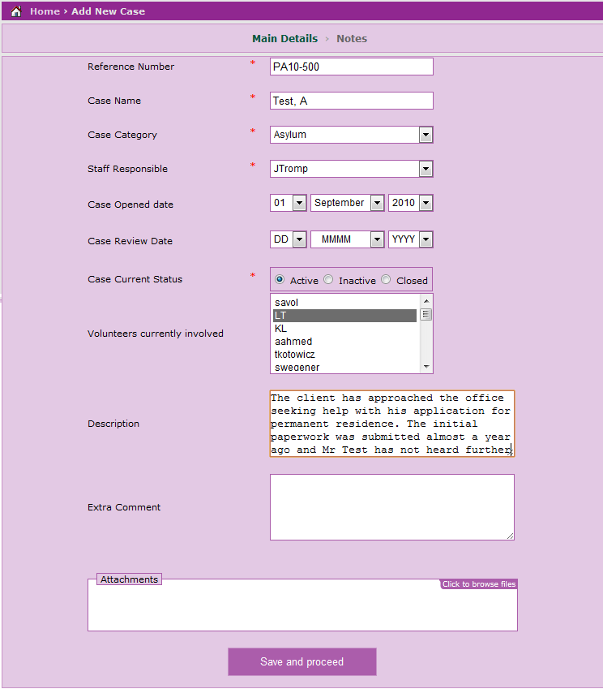

Probably the easiest way of getting to grips with this screen is to look at it field-by-field:

* **Case reference** – This should always be given in the format PAYY-REF.

For example, if the case was opened in 2009 with number 123 the reference for it would be PA09-123. You may find that some cases also have initials at the end of them. To enable the database to accurately search by case number, please ignore the initials and give the reference in the format above.

* **Case Name –** This is given in the format of last, first and middle names. To give another example Rubera Abdou would be given as Abdou, Rubera. At this stage we are not concerned about the client’s title as this information is stored on the ‘client’ page.
* **Case Category –** As already discussed, this needs to be selected based on the circumstances of the case. If there is any uncertainty please just talk to a member of staff.
* **Staff Responsible –** This is normally the legal services coordinator – in this case it’s Johnlyn Tromp.
* **Case Opened Date –** Fairly self explanatory – this is the date given on the paper file when the case was initially opened / received.
* **Case Review Date –** This allows you to specify a date that either you or another volunteer should look over the file. Use common sense when choosing this based on the position of the case – if the client has just submitted their papers for permanent residence to home affairs, it would be pointless to review the case in 5 days!
* **Volunteers currently involved –** This is to allow staff to track the number of people currently involved in the case.If there are multiple volunteers working on the same case hold down the CTRL key to select their logins.
* **Description –** Getting this field correct is vital. This field should contain an accurate summary of the case to date. Try not to précis the information too much – having the complete set of facts on the database enables us to rebuild a file if anything happens to the original paper copy. The easiest way to get this field correct is to ask each volunteer to produce a summary of their cases before they hand it to you. This therefore saves you having to read through each and every file.
* **Extra comment –**this field is largely superfluous, but if needs be can store extra thoughts etc that would not normally form part of the case description.
* **Attachments –** This field is used to attach scans of the paper file to the database record. You should have been shown by a staff member how to use the scanner.

Once you have the scanned documents, the ‘click to browse file’ button will let you select the saved files:

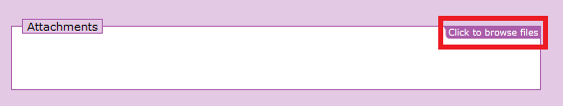

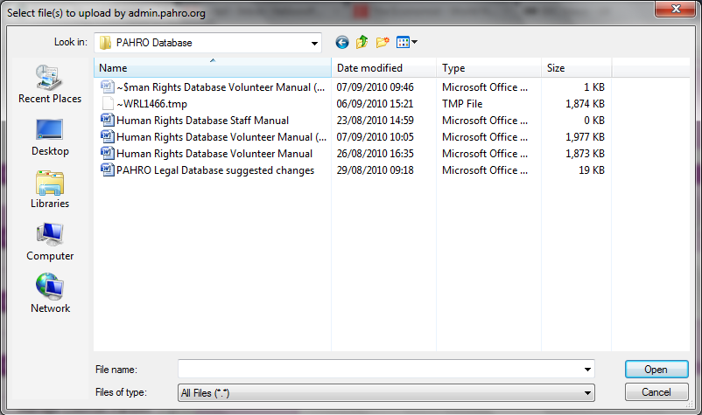

Once all the above fields have been completed, click the save and proceed button. You should then be shown this screen:

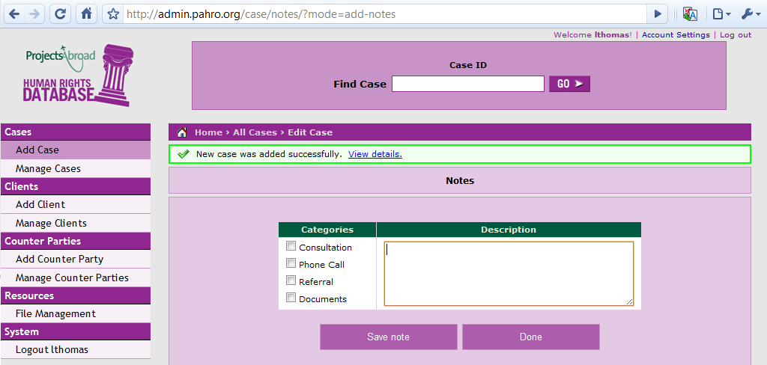

The notes screen allows you to go into more detail about the specifics of the case – be it a consultation, phone call etc. Ideally you should be creating a file note for the shared files and duplicating it on here every time there is activity on the case. This also means that the PAHRO staff can review the progress of the case without necessarily having to take the paper file off you.

If you have added any notes, click the ‘save note’ button to save it. Once you are completely finished adding the case click the ‘done’ button. **YOU MUST THEN REMEBER TO ADD A CLIENT FOR THE NEWLY CREATED CASE.**

**6. Adding a Client**

Adding a client allows us to keep track of specific individuals, as some clients hold more than one case with us. It’s therefore essential that once you have added a case you add the client straight after. To begin this process, click on the ‘Add client’. From here you’ll be shown a screen similar to the ‘add case’ page. Let’s look at an example:

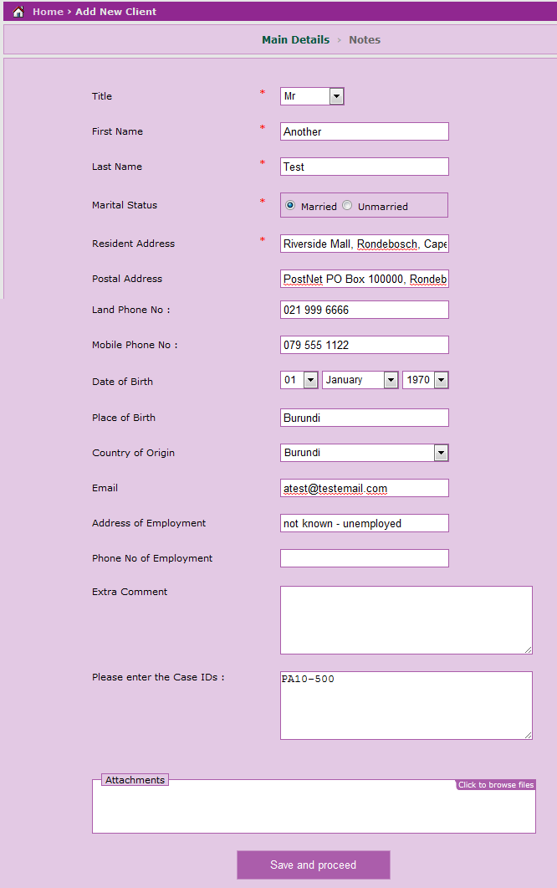

Whilst only some of the field on this page are actually required, you should try and complete as many as possible – it is better to say ‘unknown’ for something than leave it blank!

Also worth noting is the Case ID field. **IT IS ESSENTIAL** you fill this in correctly, as if you don’t the database won’t be able to match the client to their cases. The case numbers must be given exactly as they are stored in the database, and if there are multiple cases the numbers must be separated by commas. For example:

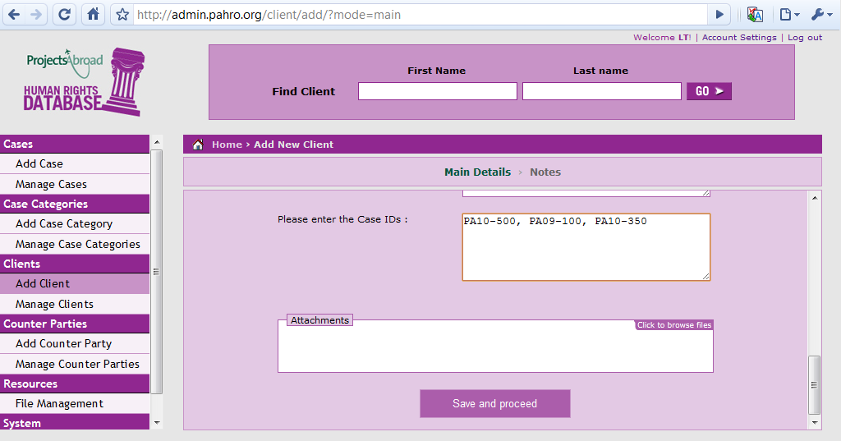

If for whatever reason you enter an invalid Case ID the database will not allow you to add the client and will instead show you:

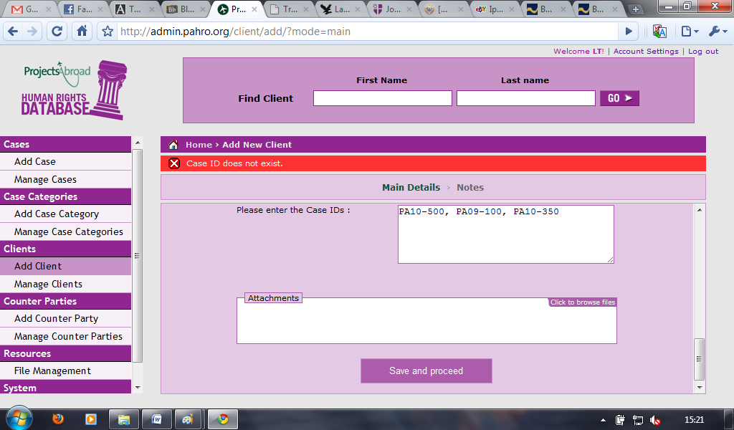

Once you have finished adding the details click on the ‘save and proceed’ button. The database will then take you to the notes page (just as with a new case) where you can add further information if necessary.

**7. Viewing Case Details / Adding Notes**

To view the specifics of a case or add a new note to it, click on the ‘manage cases’ link. This should then display a list of the most recently added cases. If the case you want to work on isn’t listed, use the search box at the top of the page to find it. For this example we’ll look at one of the test cases:

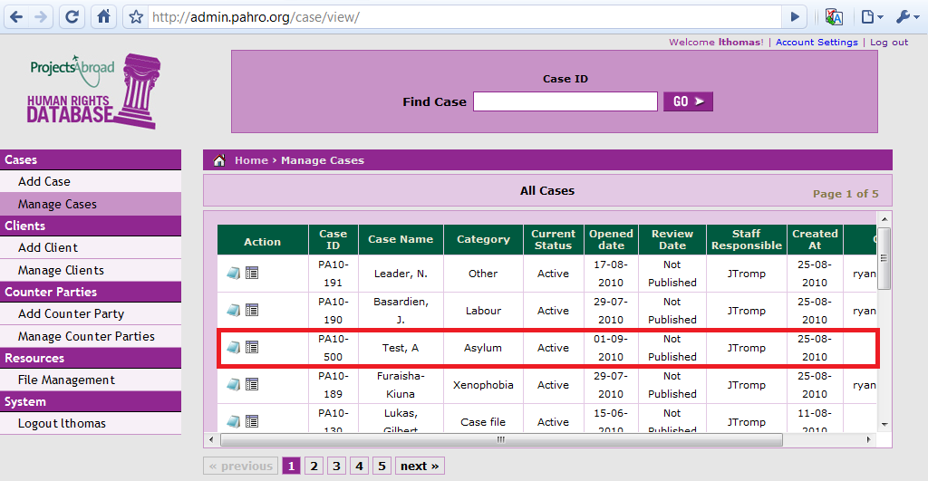

The two icons were interested in are:

- View / Add Notes



- Details



**View / Add Notes**

You’ve already seen how to add a note as part of setting up a case, and the procedure is largely the same once the case is established:

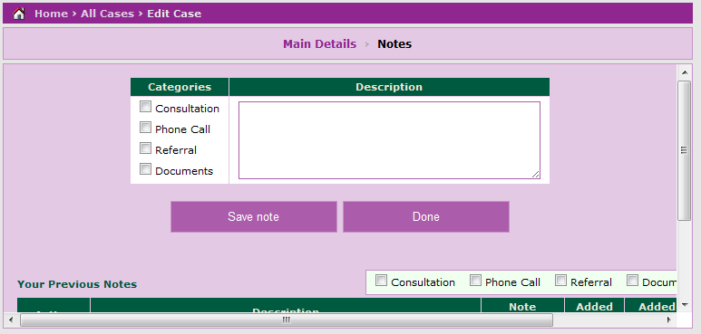

Once you have typed up the file note and selected its category, click on the ‘save note’ button to store it. The list of notes below will then be updated:

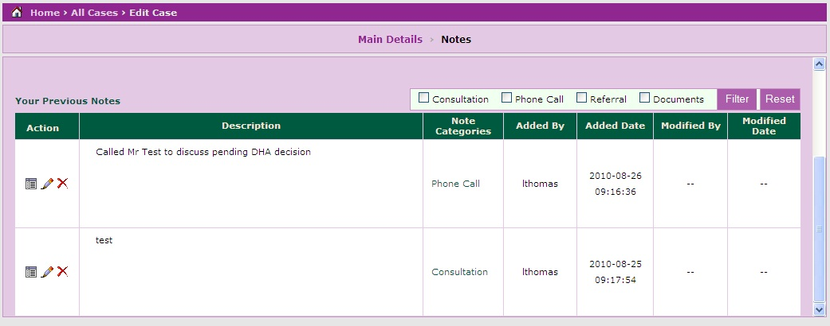

If there are a large number of notes for a particular case, you can specify which category to view by using the ‘filter’ function. Simply select the type of note you wish to view then click on the filter button:

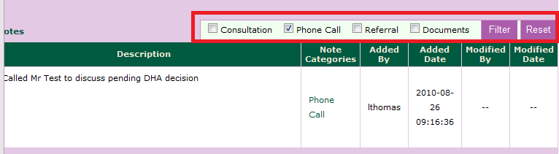

If you then wish to view the full list of notes click on the ‘reset’ button.

**Viewing Case Details**

To view the case specifics click the  icon next to the specific case. This will then take you to the following screen:

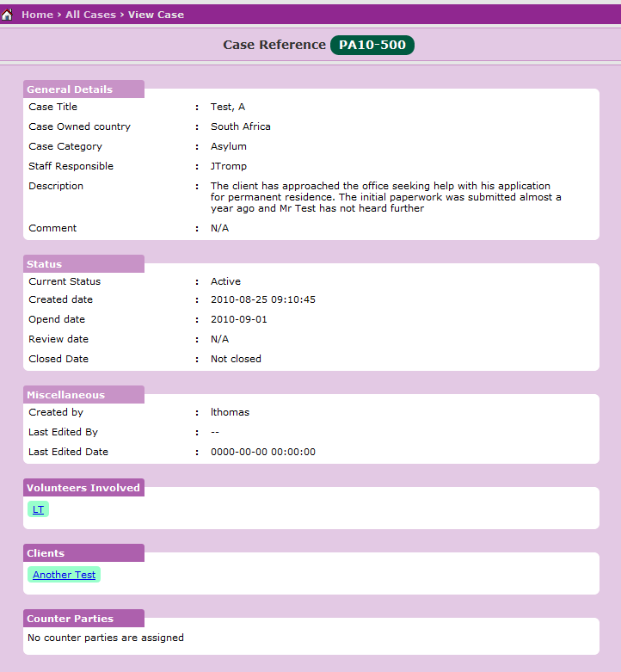

For the most part the screen should be self explanatory butlet’s look at some of the more obscure fields:

**Miscellaneous** – Contains basic information about the database record

**Volunteers Involved** – Lists all the volunteers currently listed as involved. Does not provide a complete history however as volunteers are deleted from the database after they leave PAHRO. Clicking on the volunteer name will direct you back to the homepage. This is because volunteers do not have permission on the database to view others personal information.

**Clients** – Provides a list of every client linked to the case. This is based on the case IDs given when each client is added.

**Counter Parties** – Gives the details of any partner / referral organisations involved in the case. This is particularly useful when determining if the case has been passed to another NGO to handle.

Clicking on the links given for volunteers involved, clients or counter parties brings up the same information as if you were to perform a client or volunteer search:

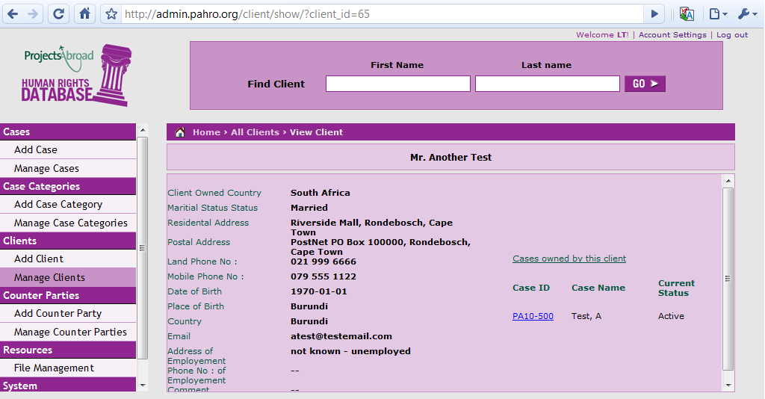

**8. Finding a stored file**

The PAHRO database also has a repository of frequently used files – much like the shared files stored on Theo’s PC. To get to this part of the database, click on the file management link:

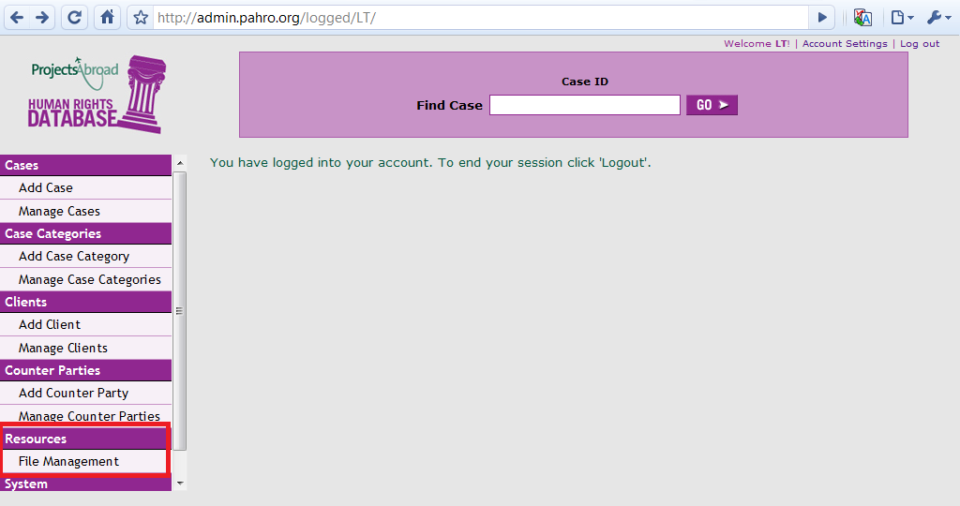

This should then present you with the list of folders. For this example we’ll be looking at the ‘handbooks’ file:

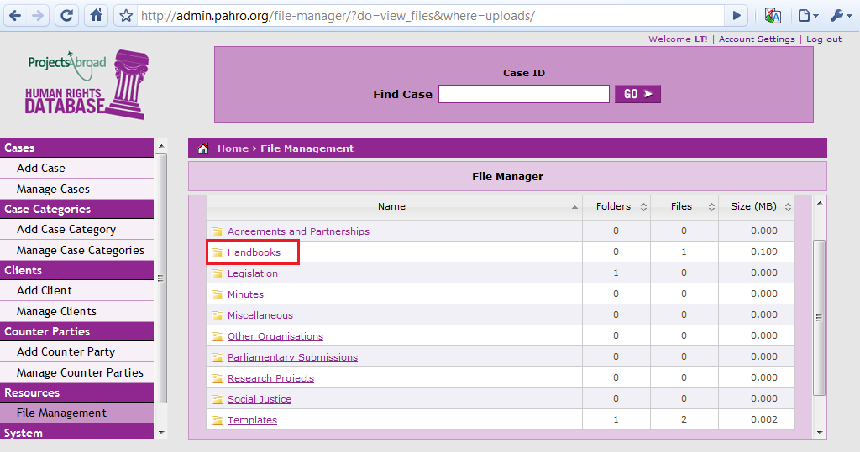

Once a folder has been selected, the database will list the files and folders within – just like windows explorer (or finder on a Mac). To open a file, click the download button on the right hand side:

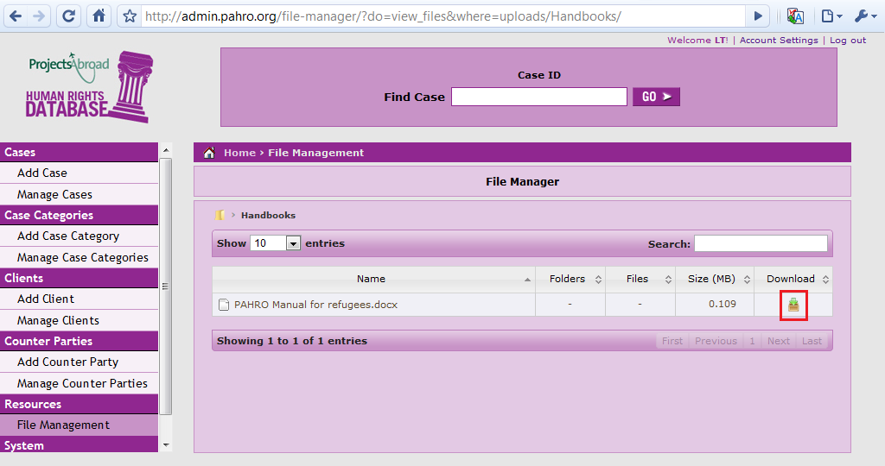

It’s also worth mentioning that volunteers can only view files stored on the database so if you want to make changes or upload a new file speak to a member of staff!

**9. Adding a Shared File**

The process for uploading a file onto the shared system is much the same as it is to view a file.

Start by going to the file management screen:

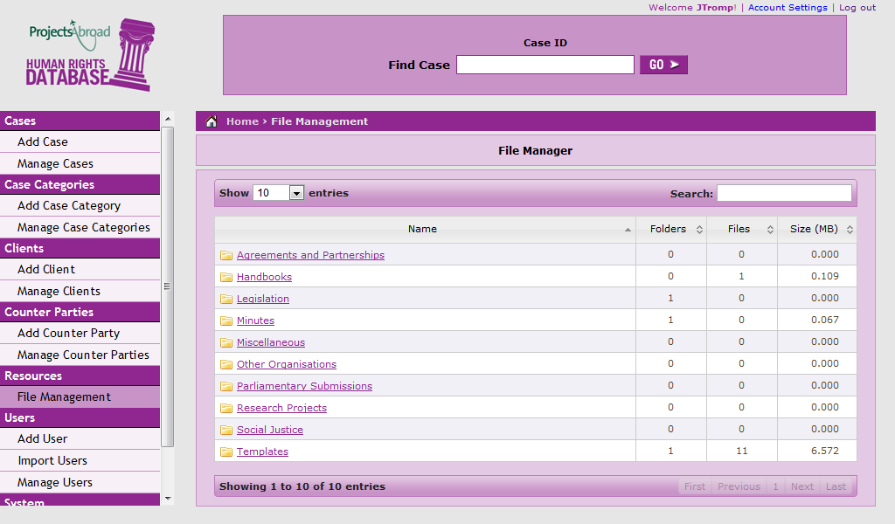

At this stage you won’t be able to upload files or create new folders – this is to prevent this section of the shared files from becoming too cluttered. Therefore select the folder that is the most appropriate for the file(s) you wish to upload. In this example, we’ll take the minutes folder:

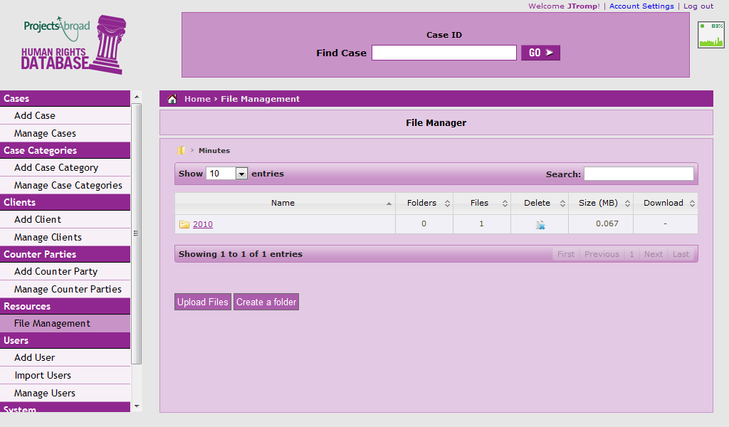

At this point two new buttons become visible – ‘upload files’ and ‘create a folder’



If you wish to put a file in the folder you’re currently looking at, click the upload files button. This will then display a new set of options:

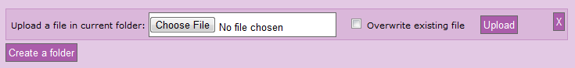

From here click the ‘choose file’ button. This will then display:

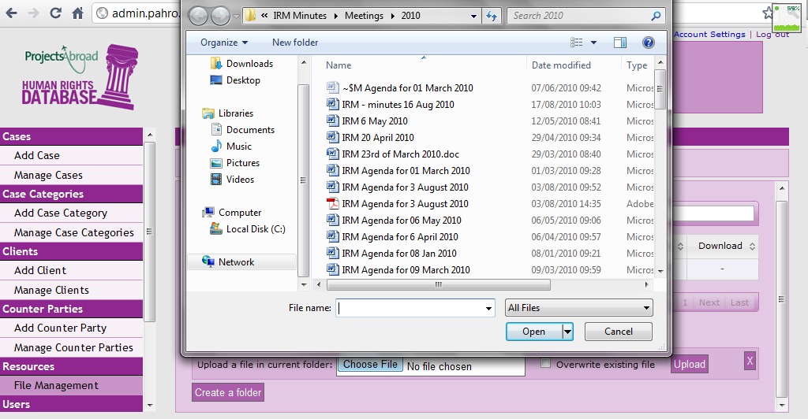

Use this dialog to find and select the file you want. When you have clicked the ‘open’ button the database will update and show you the name of the file you have selected:

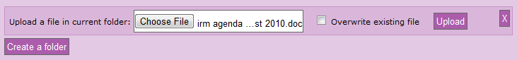

If you a replacing an existing file with a newer version, select the ‘overwrite existing file’ checkbox. If you selected the wrong file by mistake, the cross icon on the right hand side will remove it from your selection.

When you are happy with the file and options, click the upload button to save the file. The database will confirm if it saved successfully by showing:

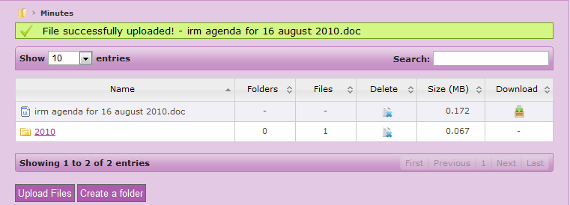

To create a folder simply click the create folder button, enter the desired name and either press enter or click the create folder button again:

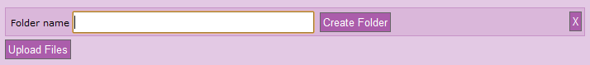

**10. Managing your account**

To change basic settings such as your password or email address click the ‘account settings’ link in the top right of the screen:

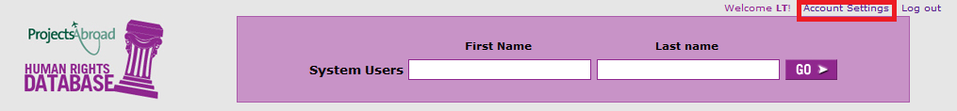

This will then take you to the account management page:

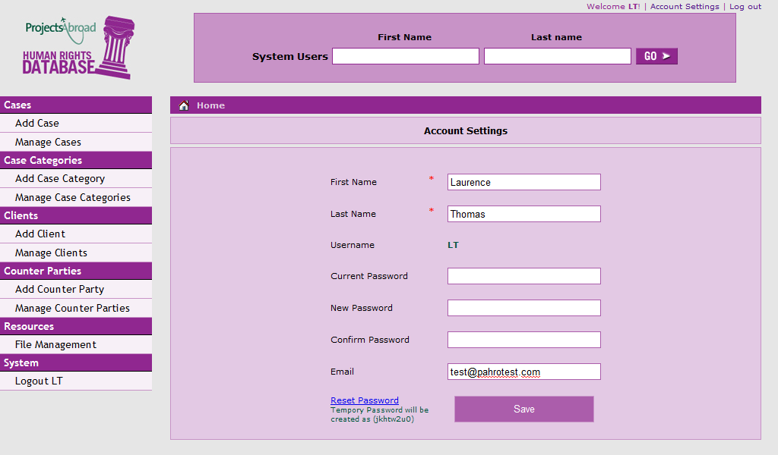

By default your password for the PAHRO database should be the same as that for your myprojectsabroad.net page.

If you wish to change your password simply enter your current password and the new password in both the ‘new password’ and ‘confirm password’ fields.

In the event that you have forgotten your password whilst logged in, the reset password link will give you a new password without the need to enter your existing password. **It is vital you write this password down before you click on the link.** If you do not, a staff member will have to reset your password for you.

When you are finished making changes, click the save button. The database should then inform you that the changes have been applied successfully.

**11. Importing Users**

The import users feature of the database connects with TAGOS and pulls the new volunteers details directly from that. To access this feature, select the ‘import users’ link from the left hand side of the screen. This should then display:

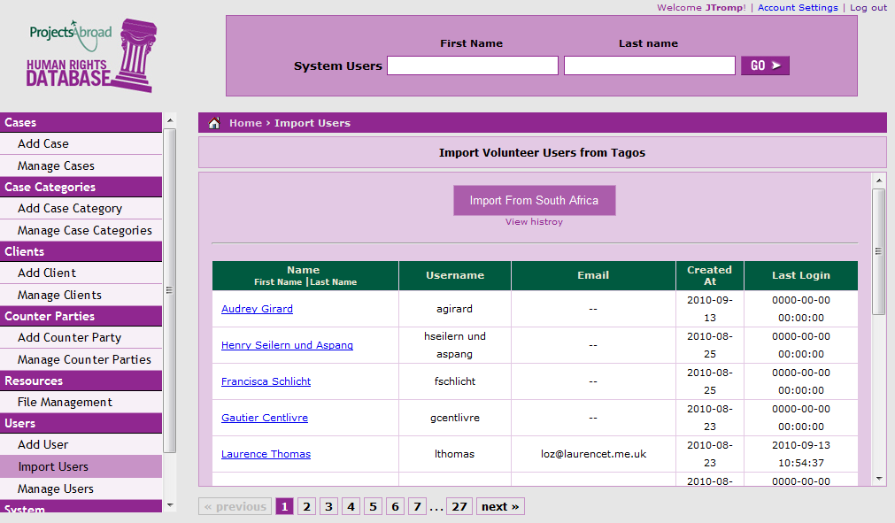

To import the new users it’s simply a matter of hitting the ‘Import From South Africa’ button. If new users are added, the database will display them at the top of the list and give a confirmation message.

If there are no new users to be imported, the database will give the message:

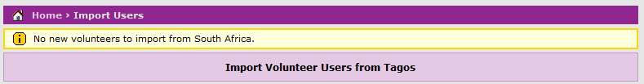

**12. Adding Users Manually**

In the event that a volunteers details are not imported from TAGOS (normally due to them transferring from another project), it’s necessary to create the user by hand. Similarly if a new staff member joins the office they may need an account created as well.

To do this start off by navigating to the ‘add users’ page:

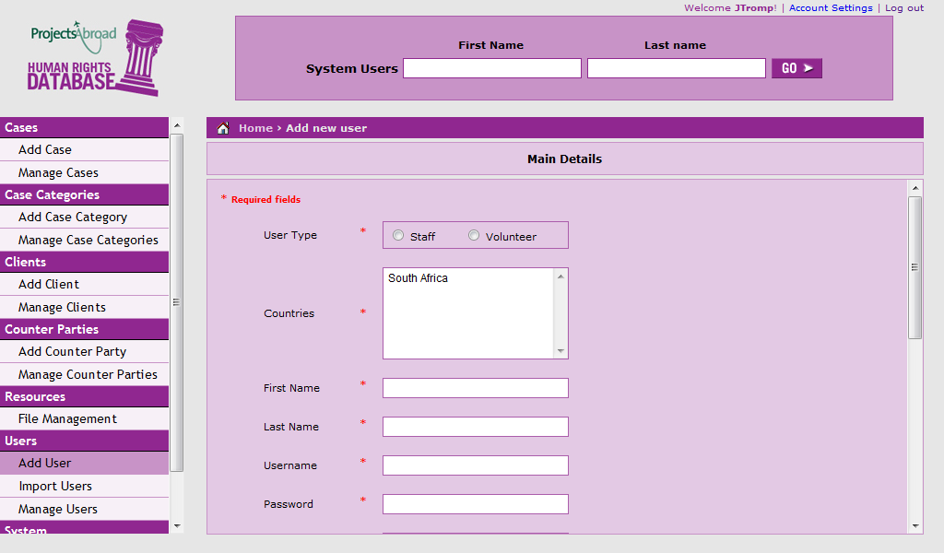

Unlike when adding a case or a client, all the fields on this form are required (apart from an email address, although this should be copied across from TAGOS). They are completely self-explanatory so we won’t focus on them individually.

Once you have selected the type of user [be it volunteer or staff], the database will display a whole new pane of check boxes. It’s very important that these are correct, so let’s look at an example:

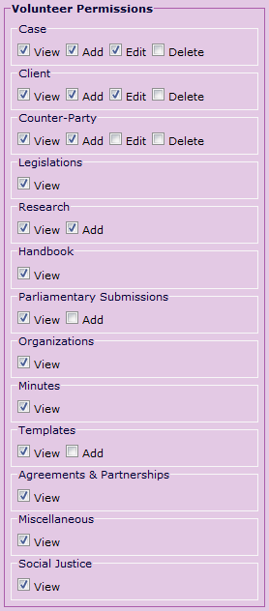

As you can see, volunteers **do not** need every permission available. This is mainly to ensure that data does not get accidentally or maliciously deleted from the database.

You must therefore un-tick the delete case, client and counter party options. Similarly, volunteers do not need to edit counter parties, so this needs to be unchecked.

The options below counter party relate to the file storage and what volunteers can see and modify. As a general rule, there is no need for them to add anything other than research, so the ‘add’ boxes under Parliamentary Submissions and Templates should be unchecked.

**For new staff**, the default permissions do not need to be changed unless there is a specific reason (e.g. short term contract or limited position).

**14. Viewing user’s activity.**

If for whatever reason you need to view the activity of a particular database user (if you believe them to be altering records, for example) the system keeps a searchable log allowing you to do this. It can be accessed from the ‘activity log’ link:

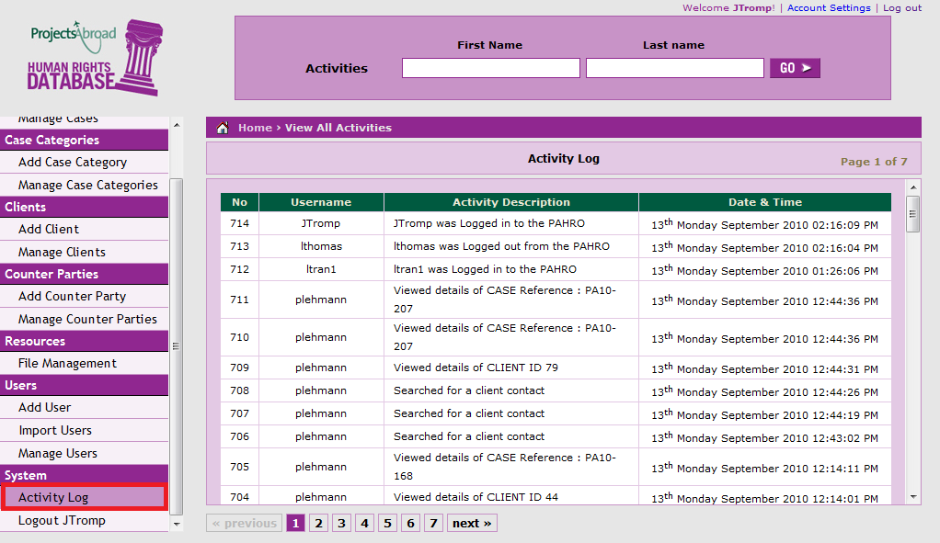

If the activity is within the last few minutes, it should be displayed in the list. If, however, you don’t know when the activity occurred, or you simply wish to focus on one person’s history, you can use the search feature provided.

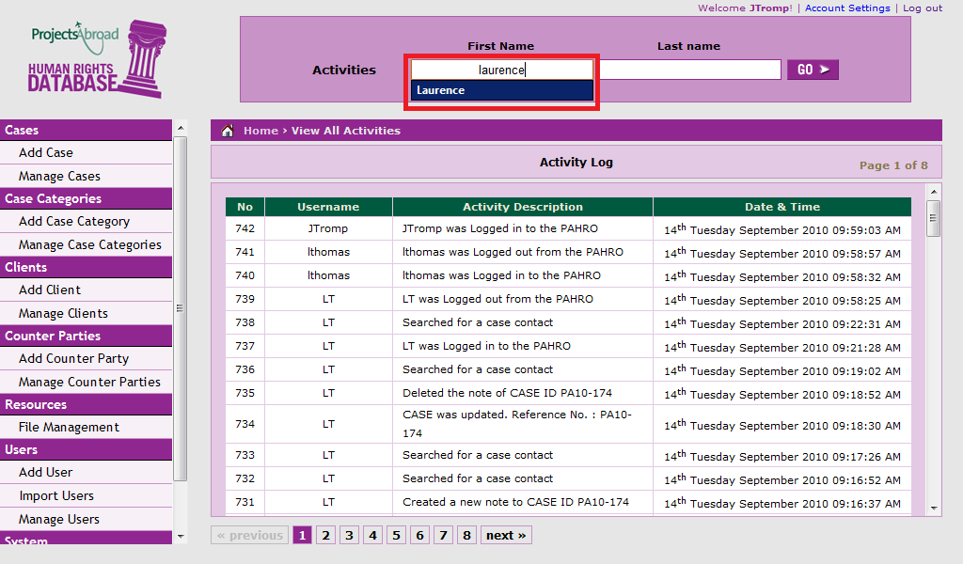

This feature performs in exactly the same way as the case and client searches and also incorporates the autocomplete function. Once you have entered the name of the volunteer in question, click the ‘go’ button and the database will display the results:

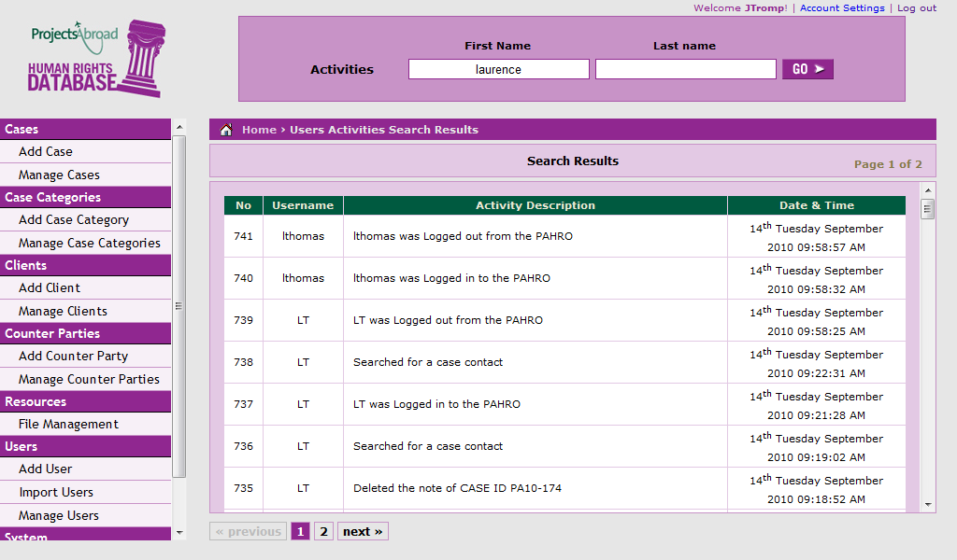

If the activity doesn’t appear in the list and it’s vital to find out who carried it out, contact the IT team or raise it as a helpdesk item to be looked into further.