

Human Rights Database Volunteer Manual

Topics covered:

1. Finding the database
2. Logging in
3. Navigating / logging out
4. Searching the database
5. Viewing Case Details / Adding File Note
6. Finding a stored file
7. Managing your account

For the most part, the database is pretty self-explanitory, but just in case you cant figure something out lets start with the basics!

1. **Finding the Database**

The database is located online at <http://admin.pahro.org/> and is compatible with Firefox, Chrome and Internet Explorer 8.

1. **Logging In**

When you first load the database, you’ll be asked to login. Your login details will have been given to you as part of your induction, but as a general rule they should be the same as those for your myprojectsabroad.net page.

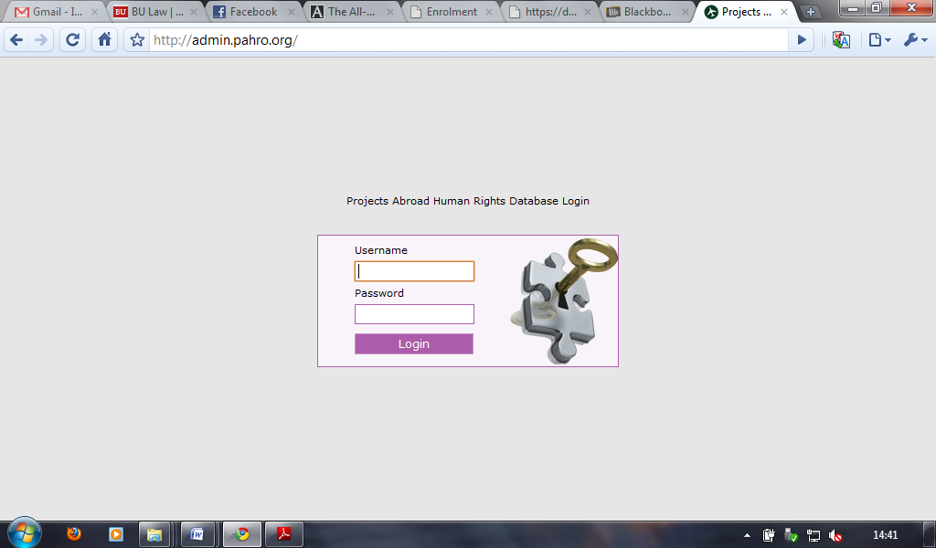

1. **Navigating**

Once logged in you’ll be presented with the home screen. On the left of this are the navigation links:

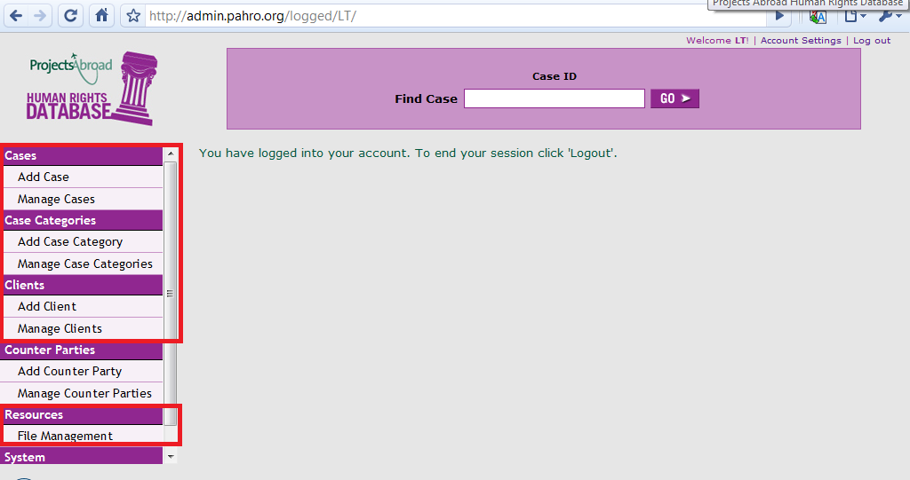

The main ones we’ll be using are under the headings ‘Cases’, ‘Case Categories’ and ‘Clients’.

1. **Searching the database**

The database allows you to conduct a search based on several criteria, however for most day-to-day tasks the important ones are searching by case number and client name.

The case number search can be carried out from either the home page or the manage cases page:

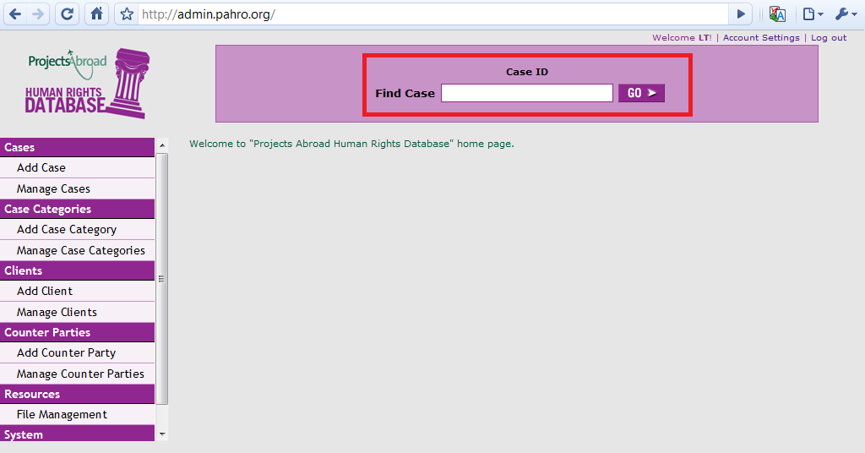

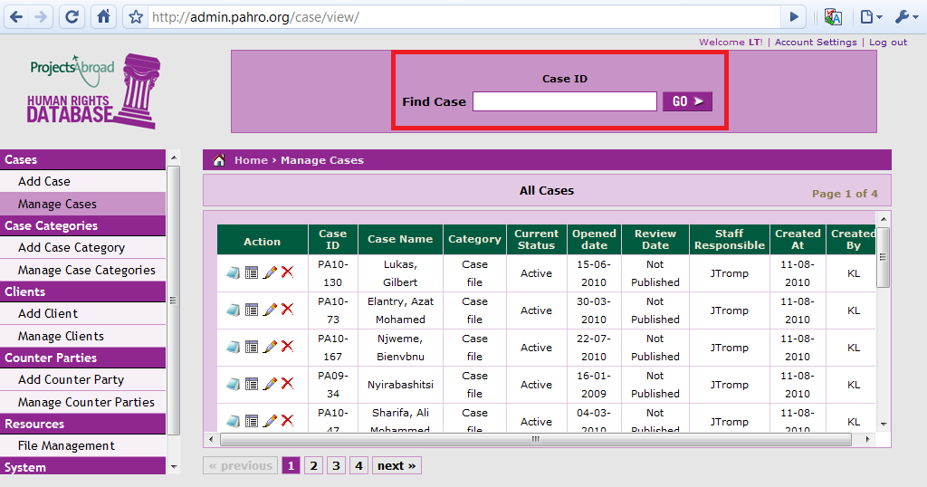

The client name search can be located on the 'manage clients' page:

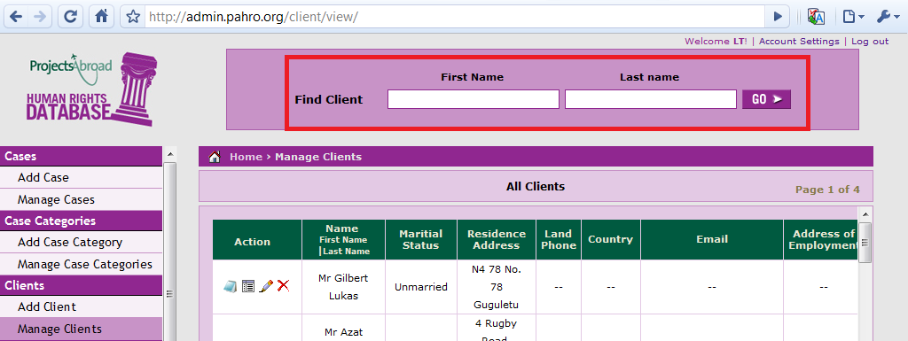

One useful feature the database includes is auto complete. To shorten the search process, relevant search results are displayed as you type:

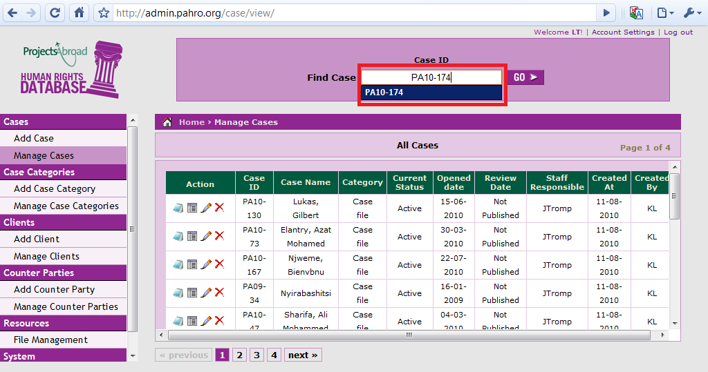

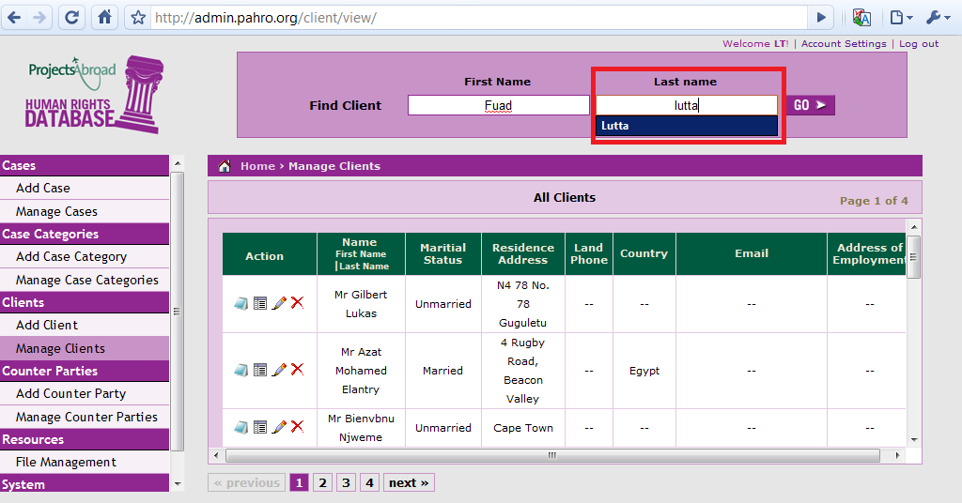

It’s a fairly good indicator that if the name or case number doesn’t appear as you’re typing, it’s not included in the database. This doesn’t mean to say it’s not worth running the search though – if something isn’t found the database should display a screen similar to:

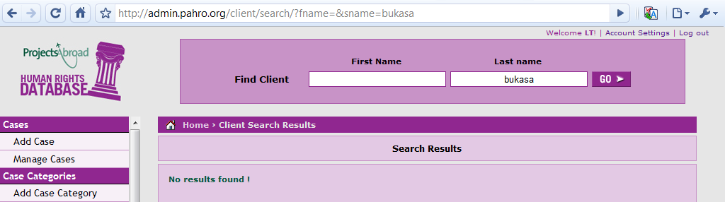

**5. Viewing Case Details / Adding Notes**

To view the specifics of a case or add a new note to it, click on the ‘manage cases’ link. This should then display a list of the most recently added cases. If the case you want to work on isn’t listed, use the search box at the top of the page to find it. For this example we’ll look at one of the test cases:

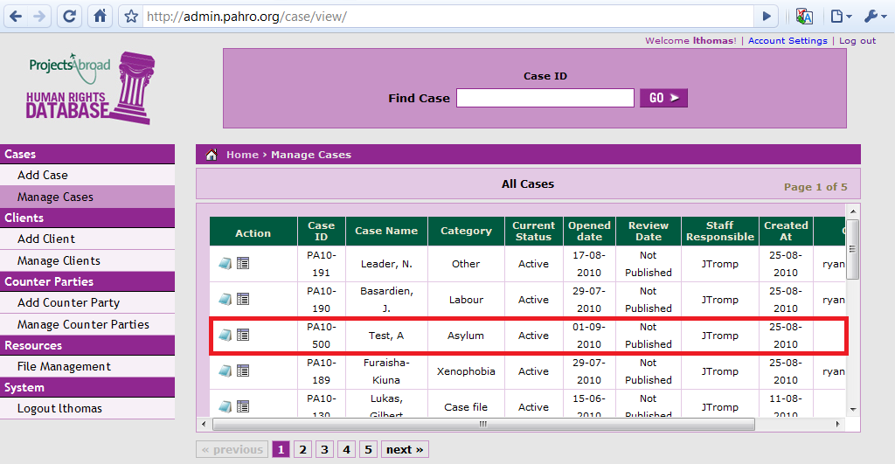

The two icons we’re interested in are:

 - View / Add Notes

 - Details

**View / Add Notes**

To reach the notes page, simply click the notepad icon . The database should then present you with:

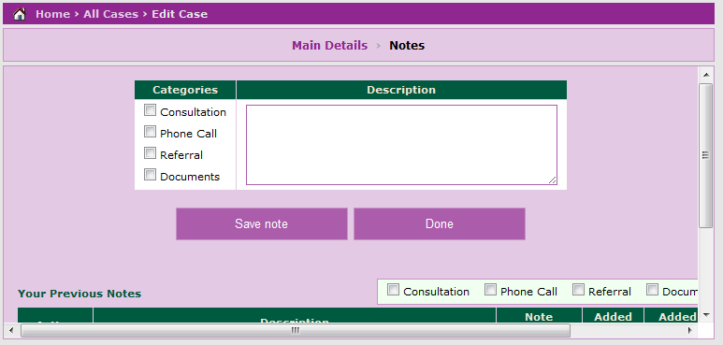

Once you have typed up the file note and selected its category, click on the ‘save note’ button to store it. The list of notes below will then be updated:

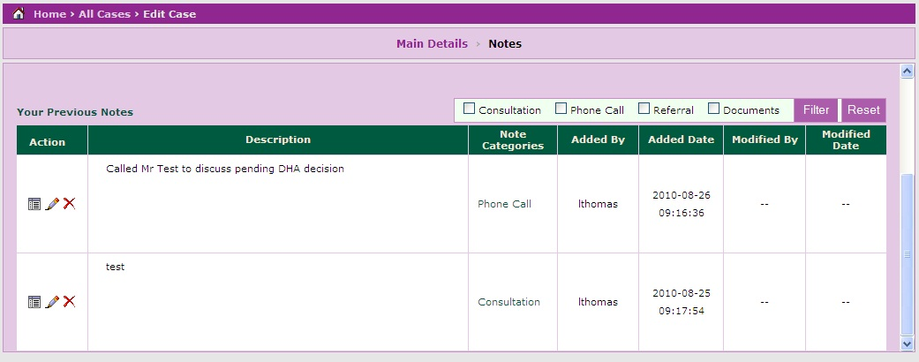

If there are a large number of notes for a particular case, you can specify which category to view by using the ‘filter’ function. Simply select the type of note you wish to view then click on the filter button:

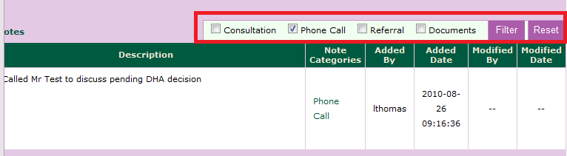

If you then wish to view the full list of notes click on the ‘reset’ button.

**Viewing Case Details**

To view the case specifics click the  icon next to the specific case. This will then take you to the following screen:

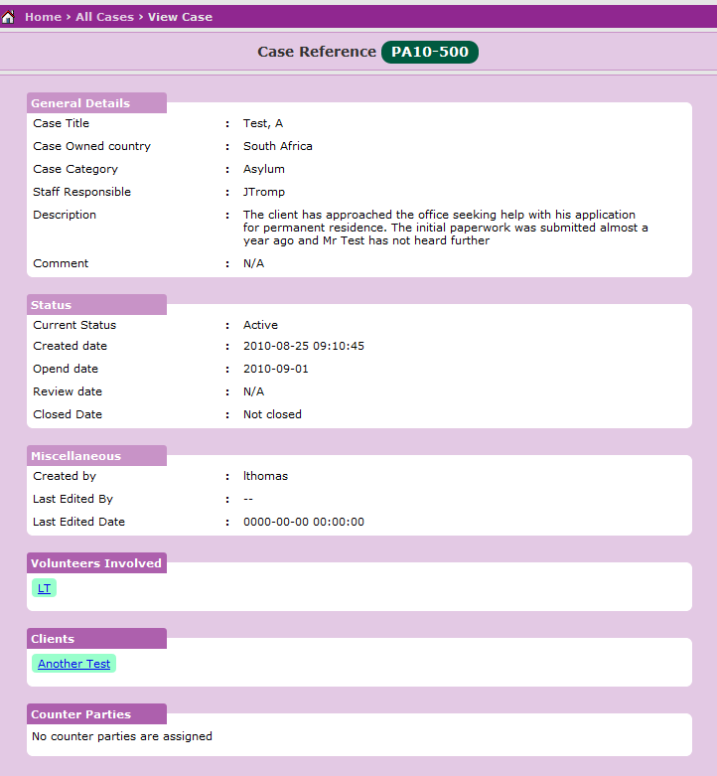

For the most part the screen should be self explanatory butlet’s look at some of the more obscure fields:

**Miscellaneous** – Contains basic information about the database record

**Volunteers Involved** – Lists all the volunteers currently listed as involved. Does not provide a complete history however as volunteers are deleted from the database after they leave PAHRO. Clicking on the volunteer name will direct you back to the homepage. This is because volunteers do not have permission on the database to view others personal information.

**Clients** – Provides a list of every client linked to the case. This is based on the case IDs given when each client is added.

**Counter Parties** – Gives the details of any partner / referral organisations involved in the case. This is particularly useful when determining if the case has been passed to another NGO to handle.

Clicking on the links given for volunteers involved, clients or counter parties brings up the same information as if you were to perform a client or volunteer search:

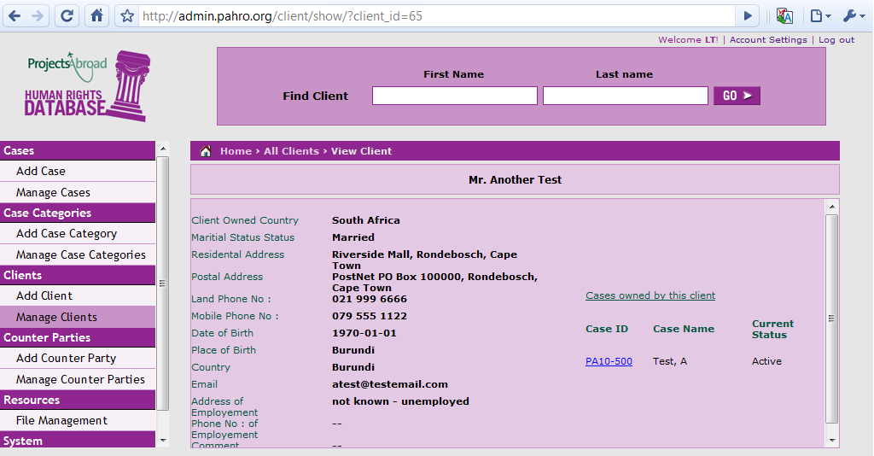

**6. Finding a stored file**

The PAHRO database also has a repository of frequently used files – much like the shared files stored on Theo’s PC. To get to this part of the database, click on the file management link:

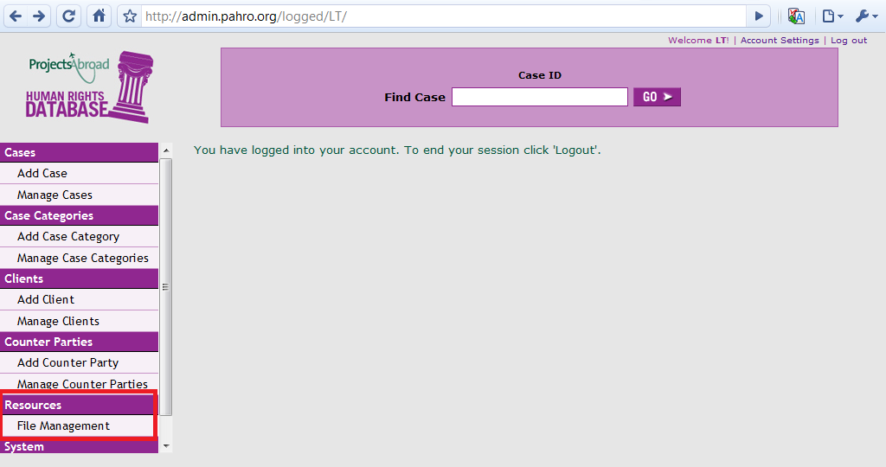

This should then present you with the list of folders. For this example we’ll be looking at the ‘handbooks’ file:

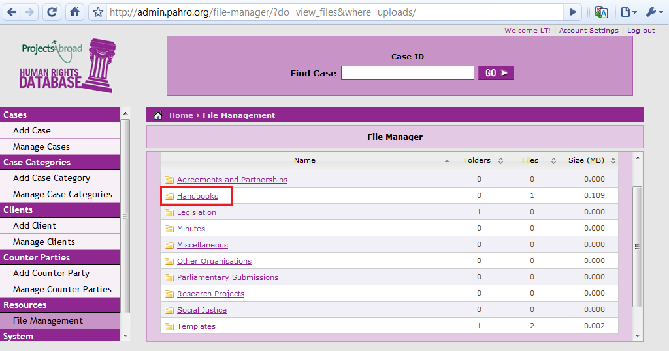

Once a folder has been selected, the database will list the files and folders within – just like windows explorer (or finder on a Mac). To open a file, click the download button on the right hand side:

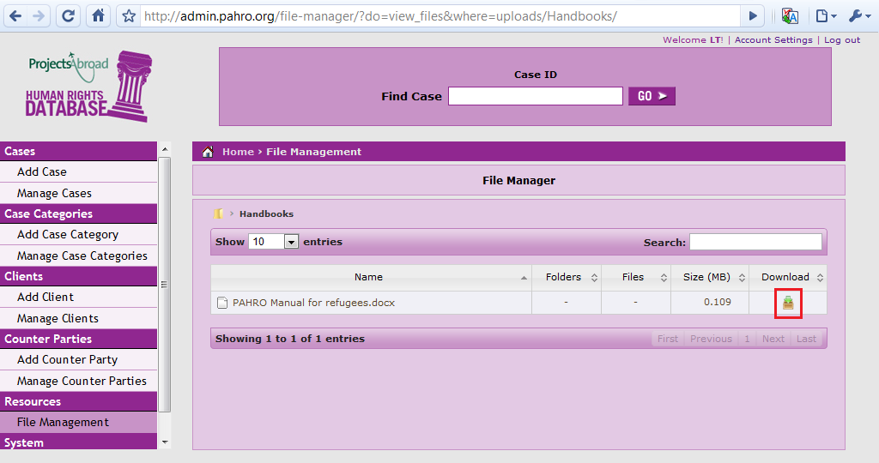

It’s also worth mentioning that volunteers can only view files stored on the database so if you want to make changes or upload a new file speak to a member of staff!

**7. Managing your account**

To change basic settings such as your password or email address click the ‘account settings’ link in the top right of the screen:

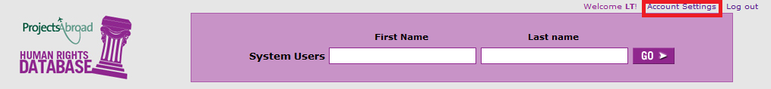

This will then take you to the account management page:

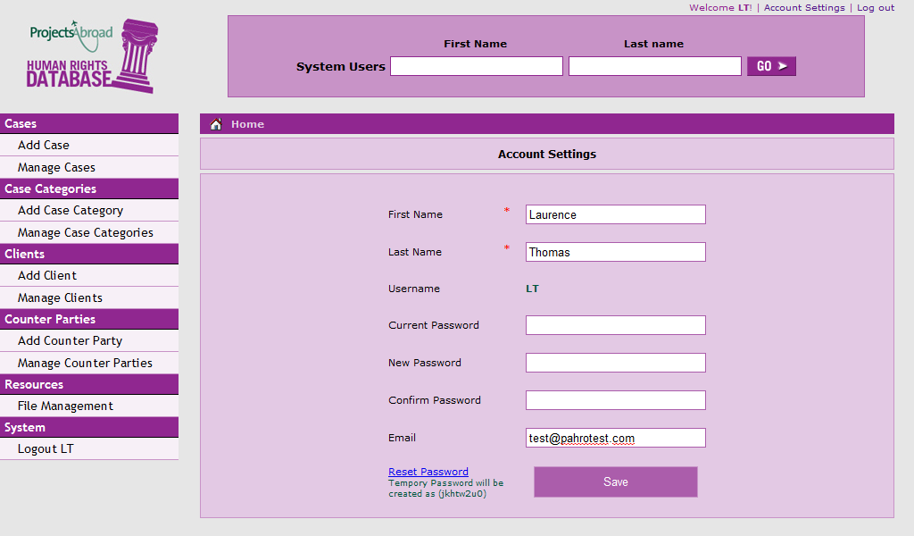

By default your password for the PAHRO database should be the same as that for your myprojectsabroad.net page.

If you wish to change your password simply enter your current password and the new password in both the ‘new password’ and ‘confirm password’ fields.

In the event that you have forgotten your password whilst logged in, the reset password link will give you a new password without the need to enter your existing password. **It is vital you write this password down before you click on the link.** If you do not, a staff member will have to reset your password for you.

When you are finished making changes, click the save button. The database should then inform you that the changes have been applied successfully.