*“Deep Learning Frameworks for Natural Language Processing: BERT and GPT-2”*

*Research Computing Center Workshop — Spring 2020*

*Jeffrey Tharsen tharsen@uchicago.edu*

***This Guide and ipynb files :***

<https://github.com/rcc-uchicago/BERT-ELMo_tutorial_Spring2020>

1. “This Grad Student Used a Neural Network to Write His Papers” (GPT-2) <https://futurism.com/grad-student-neural-network-write-papers>
2. **What are Transformers?**

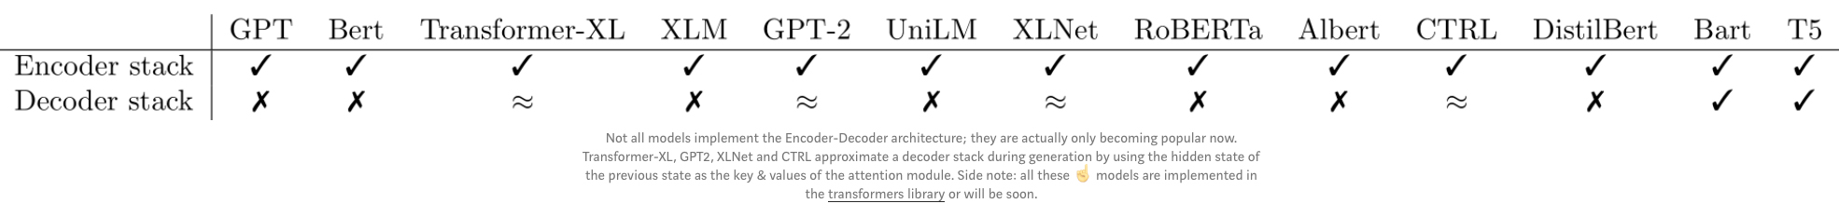

* [**https://github.com/google-research/bert**](https://github.com/google-research/bert) (official Google repository for BERT)
* [**https://medium.com/huggingface/encoder-decoders-in-transformers-a-hybrid-pre-trained-architecture-for-seq2seq-af4d7bf14bb8**](https://medium.com/huggingface/encoder-decoders-in-transformers-a-hybrid-pre-trained-architecture-for-seq2seq-af4d7bf14bb8)
* [**https://github.com/huggingface/transformers**](https://github.com/huggingface/transformers)

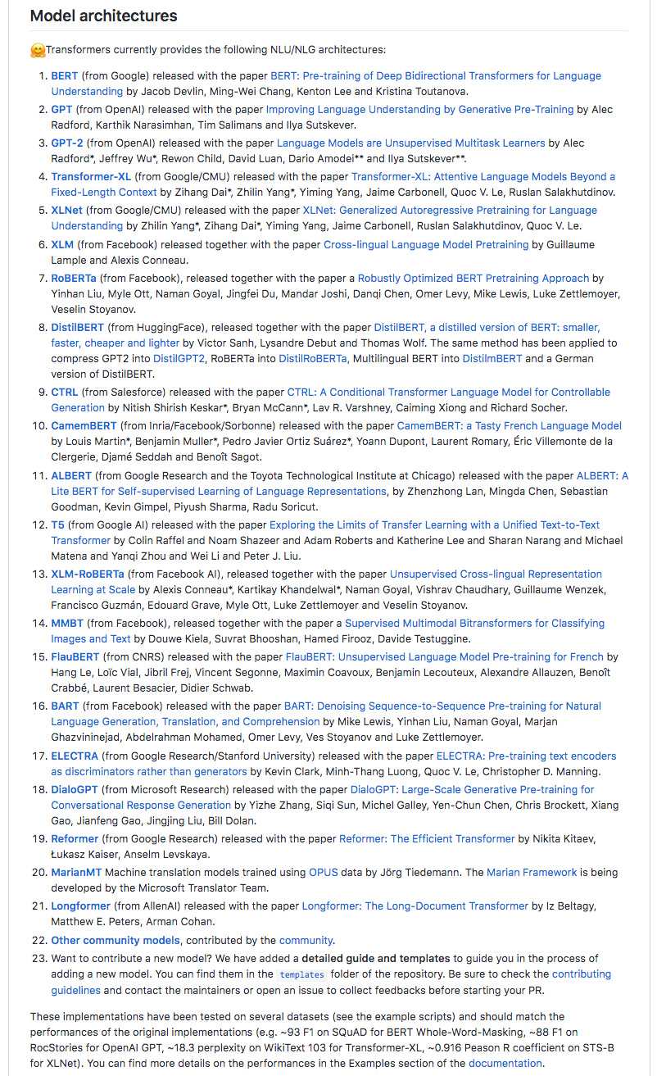

* <https://medium.com/@ngwaifoong92/beginners-guide-to-retrain-gpt-2-117m-to-generate-custom-text-content-8bb5363d8b7f>
* <http://jalammar.github.io/a-visual-guide-to-using-bert-for-the-first-time/> (DistilBert)

1. **What Tasks can Transformers be trained for?**

* <https://github.com/huggingface/transformers/blob/master/examples/README.md>   
  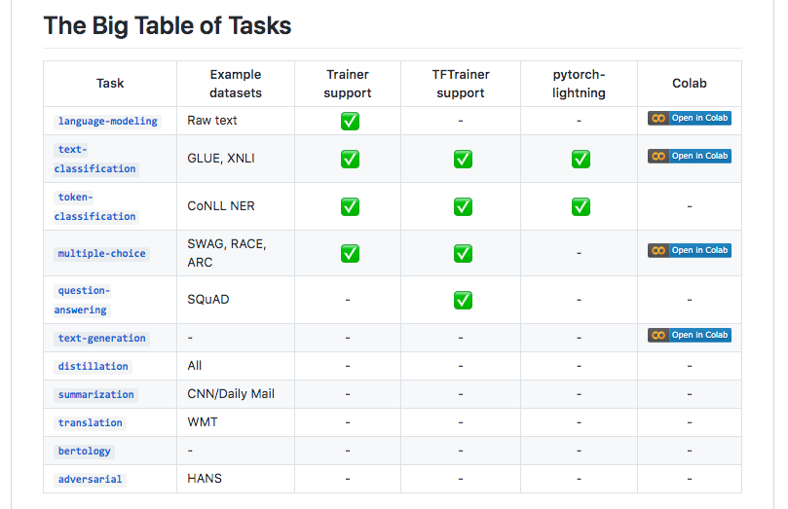
* <https://towardsdatascience.com/bert-for-dummies-step-by-step-tutorial-fb90890ffe03>
* <https://medium.com/@Moscow25/the-best-deep-natural-language-papers-you-should-read-bert-gpt-2-and-looking-forward-1647f4438797>
* <https://medium.com/@ranko.mosic/googles-bert-nlp-5b2bb1236d78>

1. **Jupyter Notebook : Single-token prediction with Google’s BERT (via Pytorch)**

BERT_Predict_masked_token.ipynb

1. **Jupyter Notebook: Next sentence predictiom with OpenAI’s GPT-2**

BERT+GPT2_sentence_prediction.ipynb  
  
[**https://openai.com/blog/better-language-models/**](https://openai.com/blog/better-language-models/)

*The code comes from this tutorial :* <https://colab.research.google.com/github/huggingface/blog/blob/master/notebooks/02_how_to_generate.ipynb>

1. **Training BERT for various tasks (on Google Cloud TPU via Colab)**

***Google Cloud TPU Quickstart:***[***https://cloud.google.com/tpu/docs/quickstart***](https://cloud.google.com/tpu/docs/quickstart)

[***https://cloud.google.com/tpu/docs/setup-gcp-account***](https://cloud.google.com/tpu/docs/setup-gcp-account)

***In Cloud Console (“Dashboard”)  
Create a cloud storage bucket; run the tutorial***

***Enable billing – you must put in a credit card number  
 “Start my free trial”***

***Create bucket (I used “bert_tutorial_12345”)***

**Colab : Predicting Movie Review Sentiment with BERT on TF Hub *(requires Tf 1.x, you may need to add* !pip install --upgrade --force-reinstall tensorflow-gpu==1.15.0 *at the beginning)***<https://colab.research.google.com/github/google-research/bert/blob/master/predicting_movie_reviews_with_bert_on_tf_hub.ipynb>

1. **Training BERT for various tasks on Midway using pre-built models**
2. **Classification : MRPC (Sentence Equivalence) via GLUE  
   See Appendix I below**
3. **Question & Answer via SquAD ( 1.1 / 2.0 )**

<https://github.com/google-research/bert#squad-11><https://github.com/google-research/bert#squad-20>

1. **How to build (“pre-train”) a BERT model from a custom source corpus on Midway**
2. **The basic procedure :**   
   [**https://github.com/google-research/bert#pre-training-with-bert**](https://github.com/google-research/bert#pre-training-with-bert)
3. Formatting the source corpus : *one line per sentence, one blank line between documents*
4. Creating vocab.txt ( WordPiece tokenization )  
   <https://github.com/kwonmha/bert-vocab-builder>
5. Setting up bert_config.json (make sure the vocab length is correct)

***Tips and best practices:*** [**https://ufal.mff.cuni.cz/pbml/110/art-popel-bojar.pdf**](https://ufal.mff.cuni.cz/pbml/110/art-popel-bojar.pdf)

1. **How to build a GPT-2 model from a custom corpus**

<https://medium.com/@ngwaifoong92/beginners-guide-to-retrain-gpt-2-117m-to-generate-custom-text-content-8bb5363d8b7f>

<https://towardsdatascience.com/train-a-gpt-2-transformer-to-write-harry-potter-books-edf8b2e3f3db>

1. **Retrieving and Visualizing the vectors from a BERT model (t-SNE with PCA)**
2. **Google’s method :**<https://github.com/google-research/bert#using-bert-to-extract-fixed-feature-vectors-like-elmo>
3. **The “bert-embedding” library on Github :**<https://github.com/negedng/bert-embedding>
4. **Colab (for Tf 2.x) :**

<https://colab.research.google.com/drive/1hMLd5-r82FrnFnBub-B-fVW78Px4KPX1#scrollTo=_Iwew0KP8vRM>

1. **Use Tensorflow’s Tensorboard Embeddings Projector (3 dimensions) :**

<https://towardsdatascience.com/bert-visualization-in-embedding-projector-dfe4c9e18ca9>

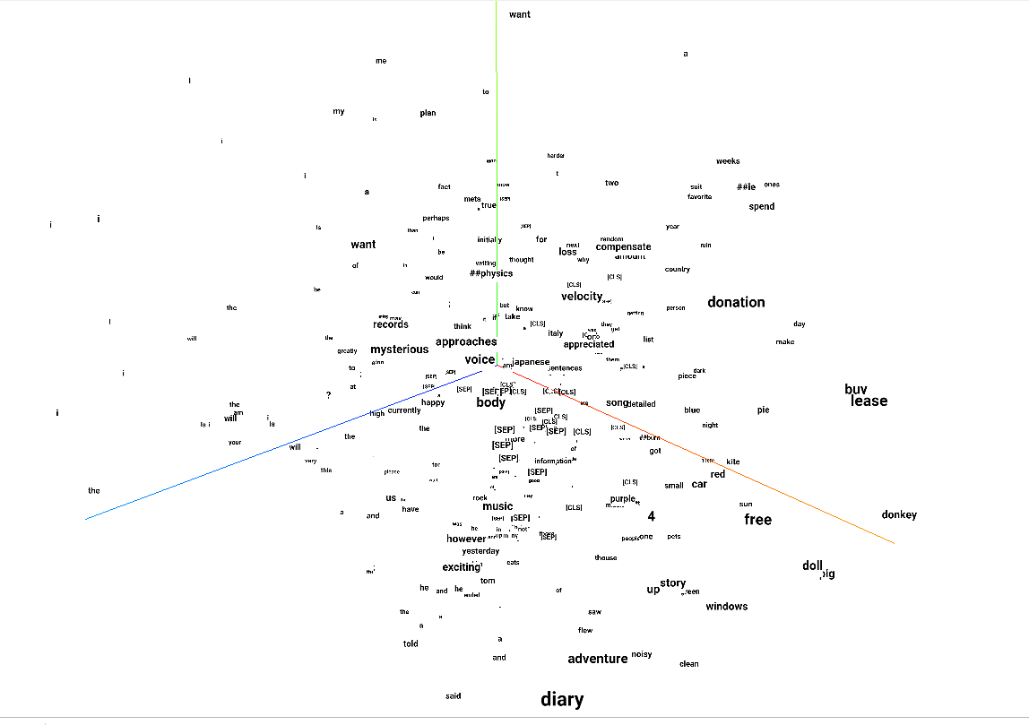

**Appendix I. Using Midway to train BERT for Classification :**

**MRPC (Sentence Equivalence) via GLUE**

1. Clone or download Google’s main BERT repository:  
   git clone <https://github.com/google-research/bert.git>
2. Download one of the pre-trained Google BERT models:  
   <https://github.com/google-research/bert#pre-trained-models>

e.g. **BERT-Base, Uncased** (recommended)  
 12-layer, 768-hidden, 12-heads, 110M parameters  
<https://storage.googleapis.com/bert_models/2018_10_18/uncased_L-12_H-768_A-12.zip>

*Open Firefox, download the zip file, then move it to your working directory and unzip it:*  
mv ~/Downloads/uncased_L-12_H-768_A-12.zip .  
unzip uncased_L-12_H-768_A-12.zip

1. **The model zip file will contain:**
   1. vocab.txt BERT-Base, Uncased = 30,522
   2. bert_config.json the all-important config file
   3. bert_model.ckpt.meta binary metadata file
   4. bert_model.ckpt.index binary index file
   5. bert_model.ckpt.data-00000-of-00001 the DATA, aka “the checkpoint file”
2. To run the GLUE test, first download: download_glue_data.py script

from [*https://gist.github.com/W4ngatang/*](https://gist.github.com/W4ngatang/)

module load Anaconda3/2018.12  
  
*Run :* python download_glue_data.py

cd bert

*Create an sinteractive session for yourself on Midway :*

**sinteractive –mem-per-cpu=24G   
(or : sinteractive –mem-per-cpu=24G –partition=gpu2 –gres=gpu:1 )**

*Load the modules and Tensorflow 1.13.1 environment :*

module load Anaconda3/2018.12

source activate tf-cpu-1.13.1 (or source activate tf-gpu-1.13.1 )

*Export these directories (makes it easier to run run_classifier.py ) :*

export BERT_BASE_DIR=/path/to/bert/uncased_L-12_H-768_A-12

export GLUE_DIR=/path/to/glue_data

*To train the classifier, run this:*

python run_classifier.py \

--task_name=MRPC \

--do_train=true \

--do_eval=true \

--data_dir=$GLUE_DIR/MRPC \

--vocab_file=$BERT_BASE_DIR/vocab.txt \

--bert_config_file=$BERT_BASE_DIR/bert_config.json \

--init_checkpoint=$BERT_BASE_DIR/bert_model.ckpt \

--max_seq_length=128 \

--train_batch_size=32 \

--learning_rate=2e-5 \

--num_train_epochs=3.0 \

--output_dir=/tmp/mrpc_output/ 🡪 *change this to somewhere useful*

*Then to run a test, create the file test.tsv in the /bert directory ;   
the process will create test_results.tsv in your output_dir.*

*Here are samples of both of these files:*