

**3rd Annual Econometrics Game**

**Connecting to Research Computing Center Resources**

**- part 1 -**

# **Accounts**

* Each team has associated a Research Computing Center (RCC) guest account
* Each member of the team will be able to connect to RCC resources using the account associated to its team.
* By using these guest accounts all team members agree to the RCC User Policy: <https://rcc.uchicago.edu/about-rcc/rcc-user-policy>
* ***Smile****, be patient - it is much easier to use supercomputers than it seems to be*.

|  |  |
| --- | --- |
| Team1 | rccguest2910 |
| Team2 | rccguest2911 |
| Team3 | rccguest2912 |
| Team4 | rccguest2913 |
| Team5 | rccguest6110 |
| Team6 | rccguest6111 |
| Team7 | rccguest6112 |
| Team8 | rccguest6113 |
| Team9 | rccguest6114 |
| Team10 | rccguest6115 |
| Team11 | rccguest6116 |
| Team12 | rccguest6117 |
| Team13 | rccguest6118 |
| Team14 | rccguest6119 |



**Getting started**

* Note that **‘XXXX’** represents the **code of the team** (**rccguestXXXX**).
* Note that **‘Y’** represents the **team number** (**TeamY**).
* You received a ‘TeamY’ zip file where you can find 2 subfolders, ‘Windows’ and ‘Linux\_MAC’. You will need to use one of the two subfolders, depending on the OS of your computer (Windows, Mac OS X, or Linux).
* Unzip the ‘TeamY’ folder.

**Information about accessing RCC resources**

Multiple members of the same team can connect to the RCC cluster and access computing resources simultaneously so long as the resources are available.

The typical workflow is:

1. Login to one of the two “login nodes” (e.g., via SSH);
2. Once you are in the login node, you can perform simple tasks (e.g., view and copy files);
3. Reserve a “compute node” on the cluster using the sinteractive command.

For Step 3, we have created a “reservation” on the RCC compute cluster which will allow you to quickly reserve a compute node for your team without having to wait for other users to complete their tasks. More details on how to use the sinteractive command, and how to request computing resources (CPUs, memory) will be given in a separate worksheet.

Once you have completed these steps, you have a shell environment on one of the cluster nodes which you can use for loading & running programs (see “modules” below), doing your data analyses, etc.

# RCC_logo_Large.png

# **Connecting to the login node**

## **Mac/Linux**

### Configuration of the ssh-key

* 1. The ssh-key associated to your team (id\_rsa.rccguestXXXX) is located inside the TeamY/Linux\_MAC/ folder, e.g., ~/Downloads/TeamY/Linux\_MAC/
  2. Change its permission:
     + Open a Terminal window
     + Use cd command to change the path to the location of the id\_rsa.rccguestXXXX file, e.g.,:

cd ~/Downloads/TeamY/Linux\_MAC/

* + - Change the file permission:

chmod 600 id\_rsa.rccguestXXXX

### Connecting

* 1. Open a Terminal window and run, e.g.,:

ssh -i ~/Downloads/TeamY/Linux\_MAC/id\_rsa.rccguestXX

**Windows**

### Download an SSH client, e.g., [Putty](http://www.putty.org/) (<http://www.putty.org/>)

### Location of the ssh-key

The ssh-key associated to your team (id\_rsa.rccguestXXXX) is located inside the TeamY/Windows/ folder, e.g., Downloads/TeamY/Windows/

### Connecting

* 1. Open Putty and set up the following:

Hostname: rccguestXXX@midway2.rcc.uchicago.edu

Port: 22



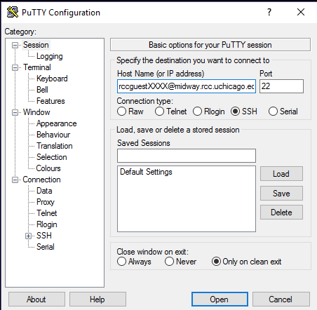

* 1. In the Category section, click on Connection->SSH->Auth and click on Browse. Search for the location of the ssh-key, e.g., Downloads/TeamY/Windows/

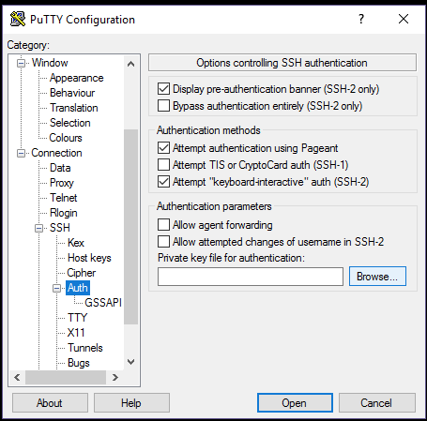

* 1. Click Open. You are now connected to the login node.



# **Accessing the team shared space**

* After connection, you should be able to access the team shared space, at the following location (use cd command to access it):

/scratch/midway2/rccguestXXXX

* You can add here any file that you would like to share with the team.
* Note: The shared space for the team is limited to 5TB.

# **Transferring files into the shared space**

On **MAC** or **Linux** computers using the terminal run the following commands:

To copy a file from your computer to RCC:

scp -i ~/Downloads/TeamY/Linux\_MAC/id\_rsa.rccguestXXXX local\_file rccguestXXXX@midway2.rcc.uchicago.edu:/scratch/midway2/rccguestXXXX/

To copy a directory from your computer to RCC:

scp -i ~/Downloads/TeamY/Linux\_MAC/id\_rsa.rccguestXXXX local\_folder -r rccguestXXXX@midway2.rcc.uchicago.edu:/scratch/midway2/rccguestXXXX/

To copy a file from RCC to your computer:

scp -i ~/Downloads/TeamY/Linux\_MAC/id\_rsa.rccguestXXXX rccguestXXXX@midway2.rcc.uchicago.edu:/scratch/midway2/rccguestXXXX/file /local\_directory\_location

To copy a folder from RCC to your computer:

scp -i ~/Downloads/TeamY/Linux\_MAC/id\_rsa.rccguestXXXX -r rccguestXXXX@midway2.rcc.uchicago.edu:/scratch/midway2/rccguestXXXX/file /local\_directory\_location

You can find some more documentation about scp command here: <https://kb.iu.edu/d/agye>

On **Windows**, **MAC**, or **Linux** you can use also a GUI-based client tool such as [FileZilla](https://filezilla-project.org/), [WinSCP](https://winscp.net/eng/download.php), or [Cyberduck](https://cyberduck.io/?l=en). Make sure when connecting, that you specify the location of the private ssh-key. [Here](https://winscp.net/eng/docs/ui_login_authentication) is an example on how to use WinSCP with ssh-key.

### RCC_logo_Large.png

### Example of configuration of FileZilla (available for MAC, Linux, and Windows)

* Host: midway2.rcc.uchicago.edu
* Username: rccguestXXXX
* Port: 22
* Go to FileZilla -> Settings -> SFTP -> Add key file...
* Browse for the ssh-key corresponding to your Team, e.g., for Team14:

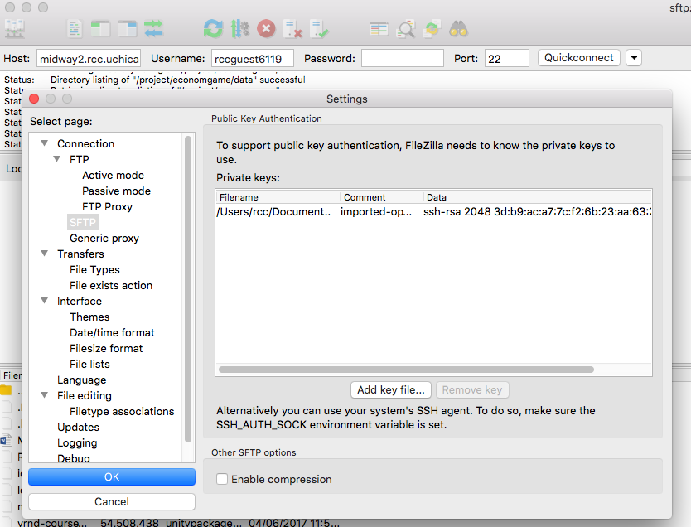

More information about data transfer on Midway2 can be found [here](https://rcc.uchicago.edu/docs/data-transfer/index.html).

**Finding software**

Software is available by loading the proper module. See [here](https://rcc.uchicago.edu/docs/software/modules) a full list of the software modules available on the RCC cluster (note that we are using Midway2).

Show the list of available modules:

* module avail

Show the list of available modules for a specific software you are interested (e.g., R, Python):

* module avail R
* module avail python

Show the list of currently loaded modules:

* module list

Load the R module

* module load R (loads the default module)
* module load R/3.1 (loads version 3.1)

Unload the R module

* module unload R

Unload all the currently loaded modules

* module purge

For testing that everything works well for you, we suggest you to upload/create a basic script in the location of your team and run it. If you encounter any problem, let us know and we will help you.

Other information about how to access the dataset and how to use interactive sessions will be provided on Saturday.