Mockups

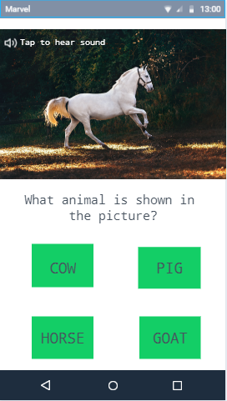

Describe each wireframe, mockup, and prototype image.

Describe your proposed application, the purpose of the application, and the objective to be accomplished by the application

My proposed application is called “Alamnimals”. Alamnimals is an educational application made for kids who is at their early years in school. The objective of this app is to educate the kids on different kinds of animals and familiarize them on the sound that the animal creates.