**Rhyss Brian C. Cadungan BSIT-MI182 Mobprog**

My proposed application is called “Alamnimals”. Alamnimals is an educational application made for kids who is at their early years in school. The users will guess what animal is shown in the picture and they will have to choose one correct answer from the four choices, if they got the correct answer, a message will appear in the screen saying that they have got the correct answer and if they chose a wrong answer they will have to guess again until they got the correct answer. The users can also tap the picture to hear the sound of the animal that was shown. The objective of this app is to educate the kids on different kinds of animals and familiarize them on the sound that the animal creates.

**Wireframe**

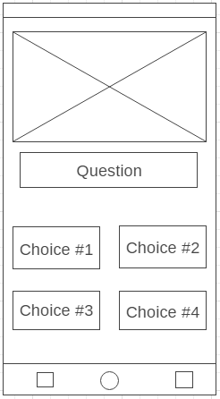 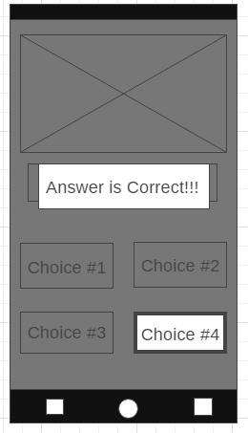

a. This wireframe design serves as the main screen. The round box at the uppermost screen will contain a photo and a question under it. The four small round boxes will be the button for the answer choices.

b. The second wireframe design is the screen that will pop up a message after the user got the correct answer.

**Mockups**

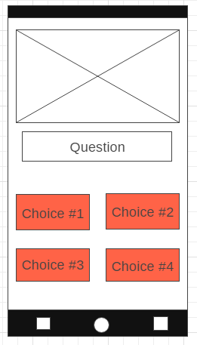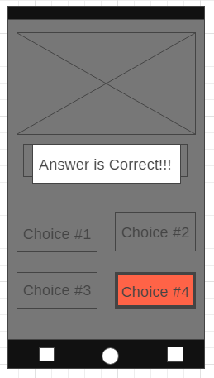

a. This wireframe design serves as the main screen. The round box at the uppermost screen will contain a photo and a question under it. The four small round boxes will be the button for the answer choices.

b. The second wireframe design is the screen that will pop up a message after the user got the correct answer.

**Prototype**

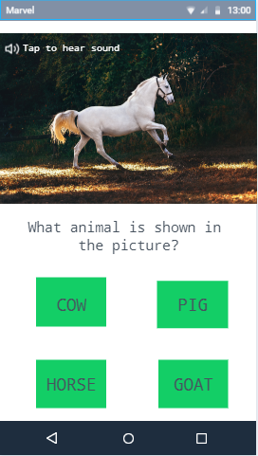

Answer is Correct!!!

a. This wireframe design serves as the main screen. The round box at the uppermost screen will contain a photo and a question under it. The four small round boxes will be the button for the answer choices. The user can tap the image to hear the sound of the animal that was shown in the picture.

b. The second wireframe design is the screen that will pop up a message after the user got the correct answer.