ISEGREGATE HOME SCREEN

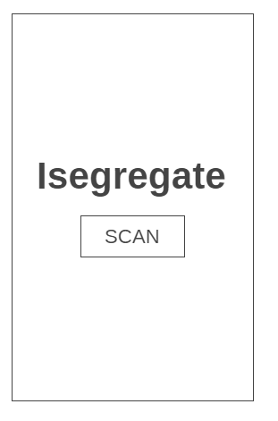

ISEGREGATE SCAN SCREEN

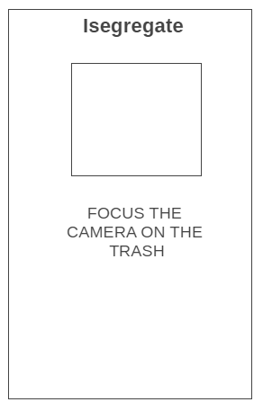

ISEGREGATE SCAN SCREEN

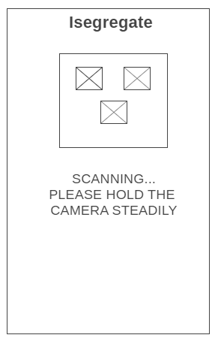

ISEGREGATE SCAN RESULTS SCREEN

