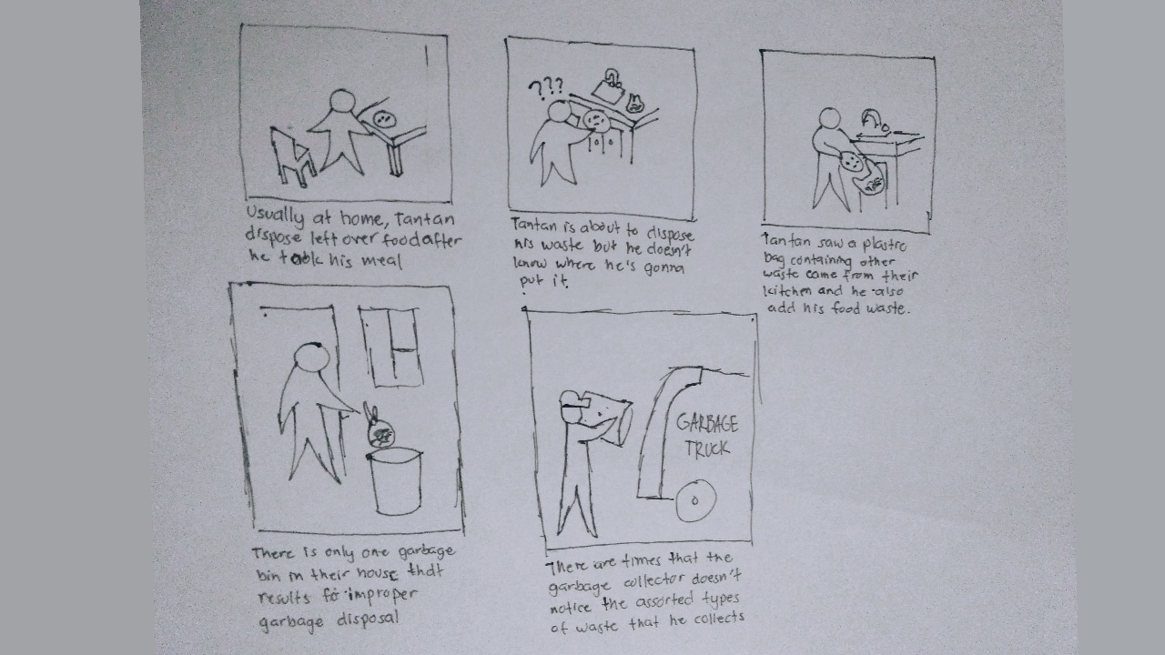**Storyboard**

**(problem)**









**Storyboard:**

**(Solution)** 







