ROLL NO 15
Prateek Maru
screenshots of Q2

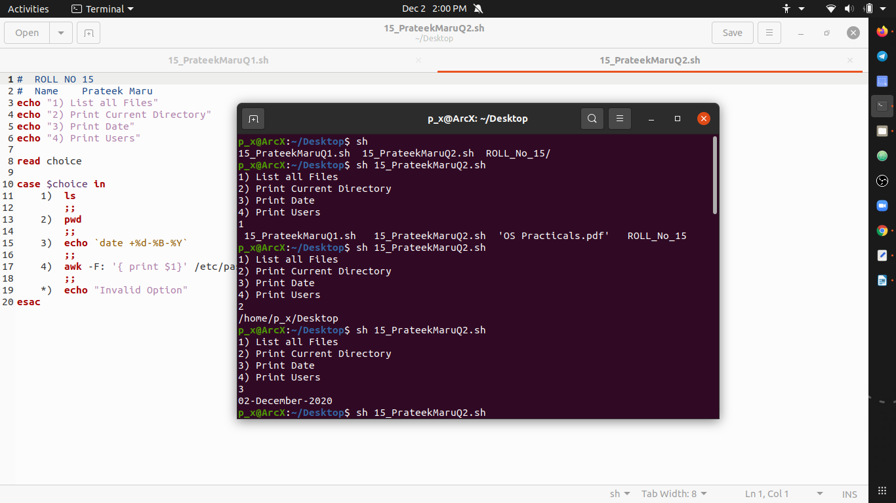

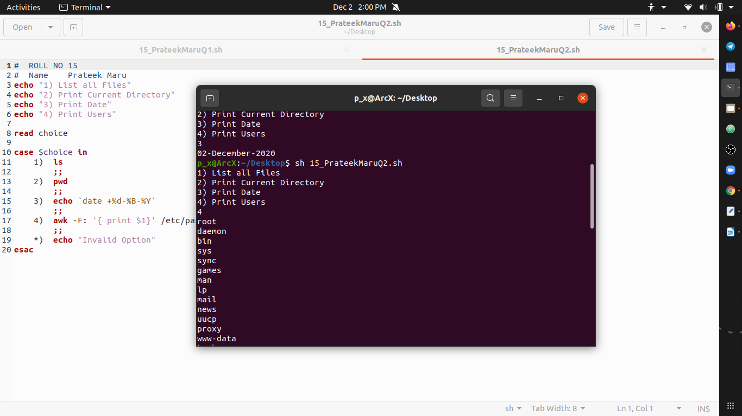
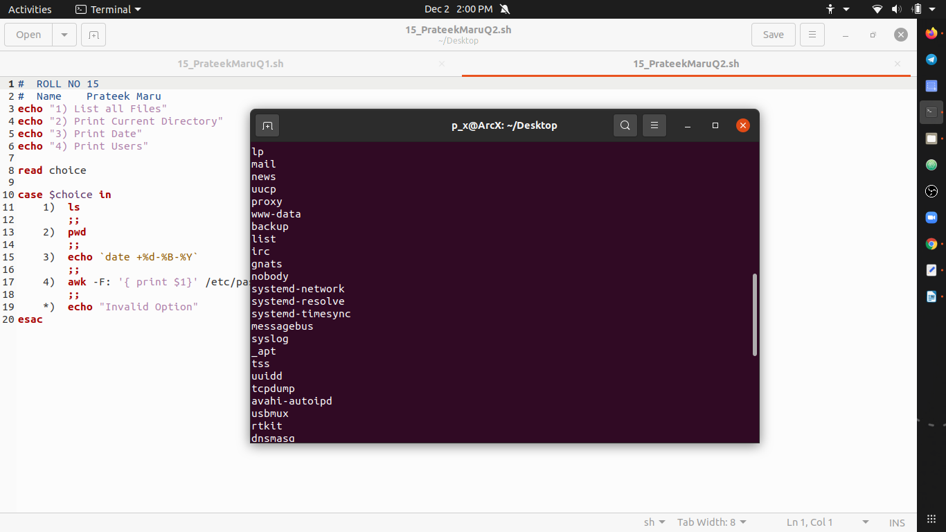

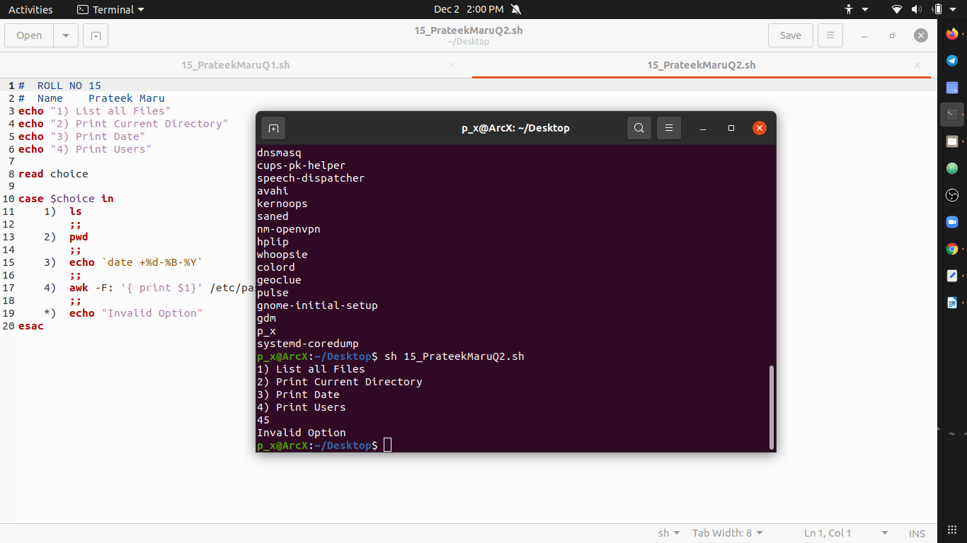

# ROLL NO 15
# Name Prateek Maru
echo "1) List all Files"
echo "2) Print Current Directory"
echo "3) Print Date"
echo "4) Print Users"

read choice

case $choice in
1) ls
;;
2) pwd
;;
3) echo `date +%d-%B-%Y`
;;
4) awk -F: '{ print $1}' /etc/passwd
;;
*) echo "Invalid Option"
esac

# using for loop
echo "1 to 10 product list"
for i in 1 2 3 4 5 6 7 8 9 10
do
echo -n "$i "
done
echo ""
