A Webpage
Robert C. Columbia
Walden University
A Webpage
The researcher set up a web server and a few pages.
Installation
The researcher downloaded XAMPP and attempted to install it. He noted a warning message. He clicked on some checkboxes and closed out the installer and restarted it. He noted that Walden University (n.d.) stated that one should “Install Apache as a server; otherwise, step through the installation and accept the default options.” (To prepare for this application section, Download XAMPP section, para. 3), but this did not seem to be an obvious option. Clicking the checkbox next to “Apache” did not seem to have any noticeable effect. He installed to the default location, which was c:\xampp. He went ahead with the BitNami installation checkbox and was directed to a website to download software. He did not download the software at that time. The installation of the primary software appeared to start. He attempted to access http://localhost but was given an error page. He viewed the XAMPP control panel and found several X’es. He clicked to start Apache and was given a firewall warning. He clicked to allow. He got an error message when he attempted to check the service box near Apache. He created a file, renamed it index.php, and entered content from Walden University (n.d.). He clicked the Explorer button in the XAMPP control panel and was shown this location. He created a folder under c:\xampp called hello and moved index.php there. He attempted to navigate to http://localhost/hello but was given an Error 404 page. He moved the hello folder to c:\localhost\htdocs as shown by Walden University (n.d.). He then attempted to access http://localhost/hello/ and was shown a welcome page. The researcher believes that Figure 1 shows this page. As suggested by Walden University (n.d.), the researcher renamed his file to world.php. He attempted to navigate to http://localhost/hello/ and was shown a directory listing in his browser that listed world.php and an option to go to up in the directory hierarchy. Clicking on world.php generated a welcome message.
Default Pages
According to Walden University (n.d.), Apache has a set of filenames that it looks for when a person makes a request that does not include a filename. One advantage to having this sort of processing is that it allows web designers to create a website and provide a simple URL to viewers. It is clearly less complex for a person to remember to go to http://www.coolsite.com/awesomestuff/ than to remember to go to http://www.coolsite.com/awesomestuff/asdpmo.eip. Another way this may help is by providing an incentive to designers to standardize on their naming practices. If one person is working on the content at http://www.coolsite.com/vacations/ and another is working on http://www.coolsite.com/movies/, one might expect there to be some sort of parallelism between them. If one designer puts their main page at http://www.coolsite.com/vacations/thisismymainwebpage.dee and the other puts theirs at http://www.coolsite.com/movies/welcometomyindex.bbt, that could look unprofessional or unnecessarily confusing. Displaying a listing of files to a user may also be unprofessional and confusing to a user and showing them a page rather than a directory listing may be a good practice.
Further Changes
The researcher made a copy of world.php and named it hello.php and made changes that were requested by Walden University (n.d.). See Figure 2 for the result. The researcher organized his site directory and will make an archive. Files may have been renamed or removed to better present the content.

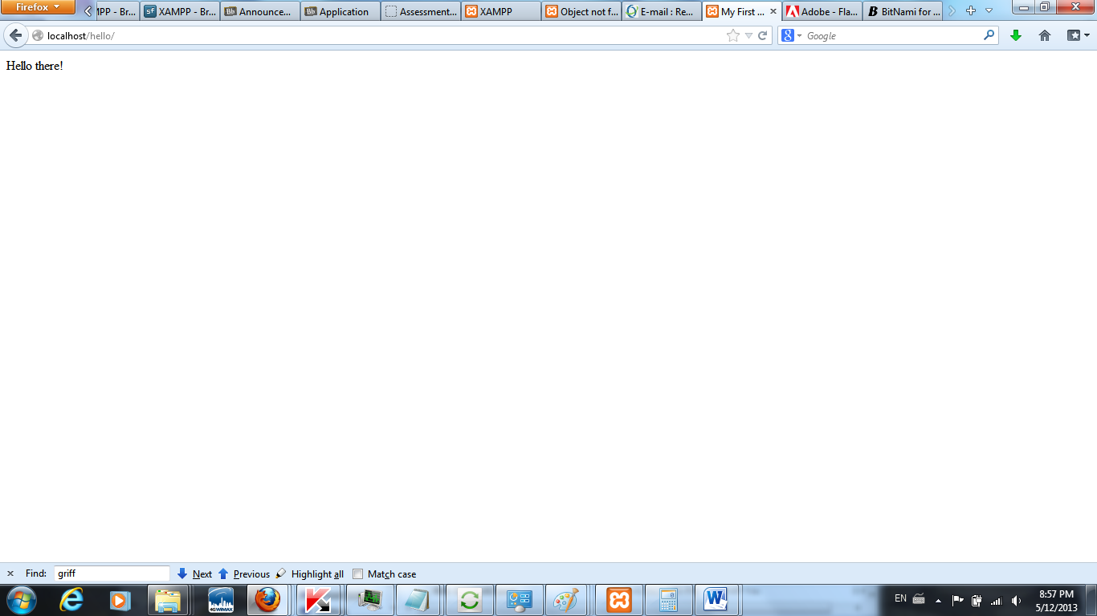

Figure 1. Initial Page. Shows a page built from content obtained from Walden University (n.d.). The researcher used Firefox 20.0.1 on Windows 7. Out of scope content such as icons and other tabs are not necessarily the work of the researcher.

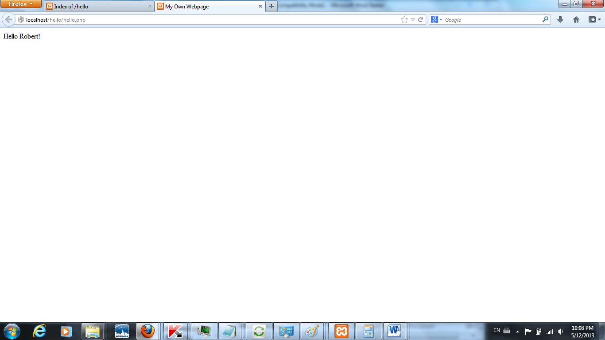

Figure 2. Modified Page. Shows a page edited by the researcher based on content from Walden University (n.d.). Out of scope content such as icons and other tabs are not necessarily the work of the researcher.

References
Walden University. (n.d.). ITEC-6020-1/ISYS-6020-1-Core web technologies2013 Summer sem 05/06-08/25-PT2: Unit 1: Application. Retrieved May 12, 2013 from https://class.waldenu.edu/webapps/blackboard/content/
listContent.jsp?course_id=_2821804_1&content_id=_10170931_1#_10170963_1.

