Sleep Apnea Risk Assessment – Detailed Report by WakeUpCall

This detailed report includes patient information, STOP-BANG scoring, Epworth Sleepiness Scale, risk assessment, lifestyle factors, medical history, and SHAP model explanation for physician review.

Assessment Result
Predicted Risk Level: | HIGH RISK
Model Confidence: | 92%
Recommendation: | Immediate consultation with a sleep specialist is advised

.

Patient Information

Name: | Jane Doe
Age: | 45
Sex: | Female
Height: | 162 cm
Weight: | 77 kg
BMI: | 31.5
Neck Circumference: | 42 cm

STOP-BANG Assessment

Snoring | Yes – Loud and frequent snoring reported
Tiredness | Yes – Daytime sleepiness present
Observed Apnea | Yes – Witnessed breathing pauses
High Blood Pressure | Yes – Hypertension diagnosed
BMI > 35 | No
Age > 50 | No
Neck ≥ 40 cm | Yes – Increased neck circumference
Gender Male | No
Total Score | 5 (High Risk)

Epworth Sleepiness Scale (ESS)
Sitting and reading | 2
Watching TV | 2
Public place sitting | 3
Passenger in car | 2
Lying down PM | 3
Talking | 1
After lunch | 2
Traffic stop | 0
Total ESS Score | 15 (Excessive Daytime Sleepine

ss)

Lifestyle & Medical History

Smoking | No – Patient does not smoke
Alcohol Intake | Yes – Occasional consumption
Exercise | Low – Sedentary lifestyle
Hypertension | Yes – Diagnosed condition
Diabetes | No

SHAP Model Explanation
SHAP values help quantify how much each feature contributed to the final sleep apnea risk prediction. Positive values increase risk, while lower values have less influence.

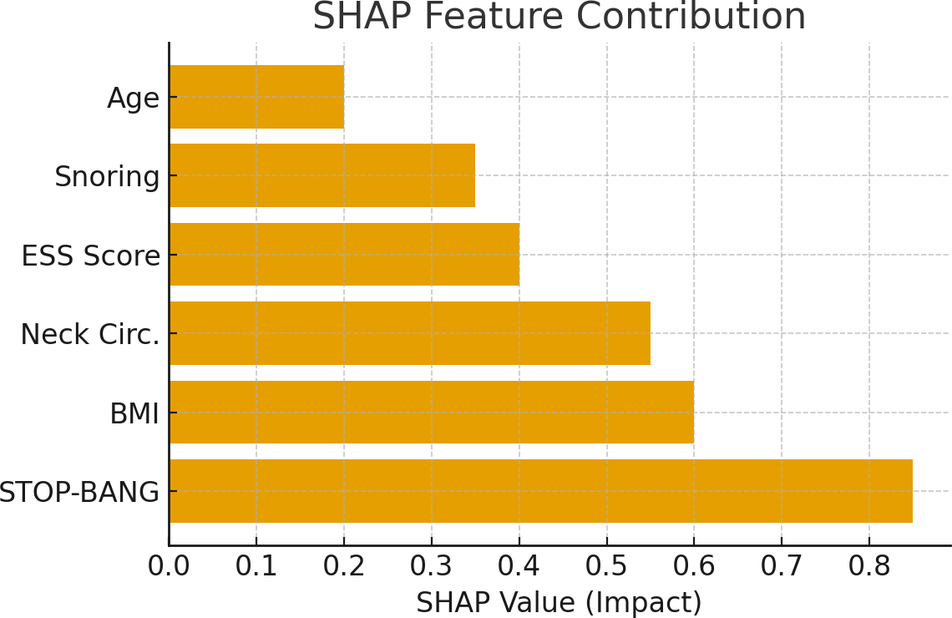

This report was automatically generated by the WakeUpCall Sleep Health System.

