Technologies of Text, Northeastern University

Spring 2019

**Lab #2: Into the Archive/Thinking with the Codex**

**Wednesday, January 16 2019**

*Whether thick, thin, brittle, smooth, dog-eared, or stained, every page discloses a unique identity that has been shaped by cultural forces over time. This identity is susceptible to change across different reading communities, but the material cues provided by the page perdure and are always present in the transmission of ideas. Designers make calculated decisions regarding the size, shape, colour, and quality of the material to suggest to readers what kind of page it is and how they wish it to be treated. Although a handwritten folio of animal skin in a medieval manuscript is as much a page as the leaf of a mass-produced paperback, the characteristics of each communicate vastly different messages about their respective manufacture, circulation, and cultural value.*

Bonnie Mak, "Architectures of the Page"

For this lab, I have selected books from Northeastern University's Archives and Special Collections for us to investigate. As when we looked at Harlequins on the first day, this lab is an exercise in close looking. I’ve arranged the books in pairs, each designed to illuminate a particular textual contrast: between time periods, technologies, or cultures.

You should choose one pair of books and compare two facing pages (one *opening*) from the first book with two facing pages from the second. You are not bound (pun *so very much* intended) to analyze pages I discuss in the guided part of the lab, and in fact I encourage you to find others. Feel free to browse, carefully, for two sets you find particularly interesting. And then you should *look* and *feel* and *smell* and *listen* (but **not** *taste*) closely! Consider returning to Special Collections to spend more time with your chosen books. You should also choose two facing pages from one of the digitized books listed at the end of this assignment and compare them with the physical books you studied, so that **in total you compare and contrast six pages from three books**.

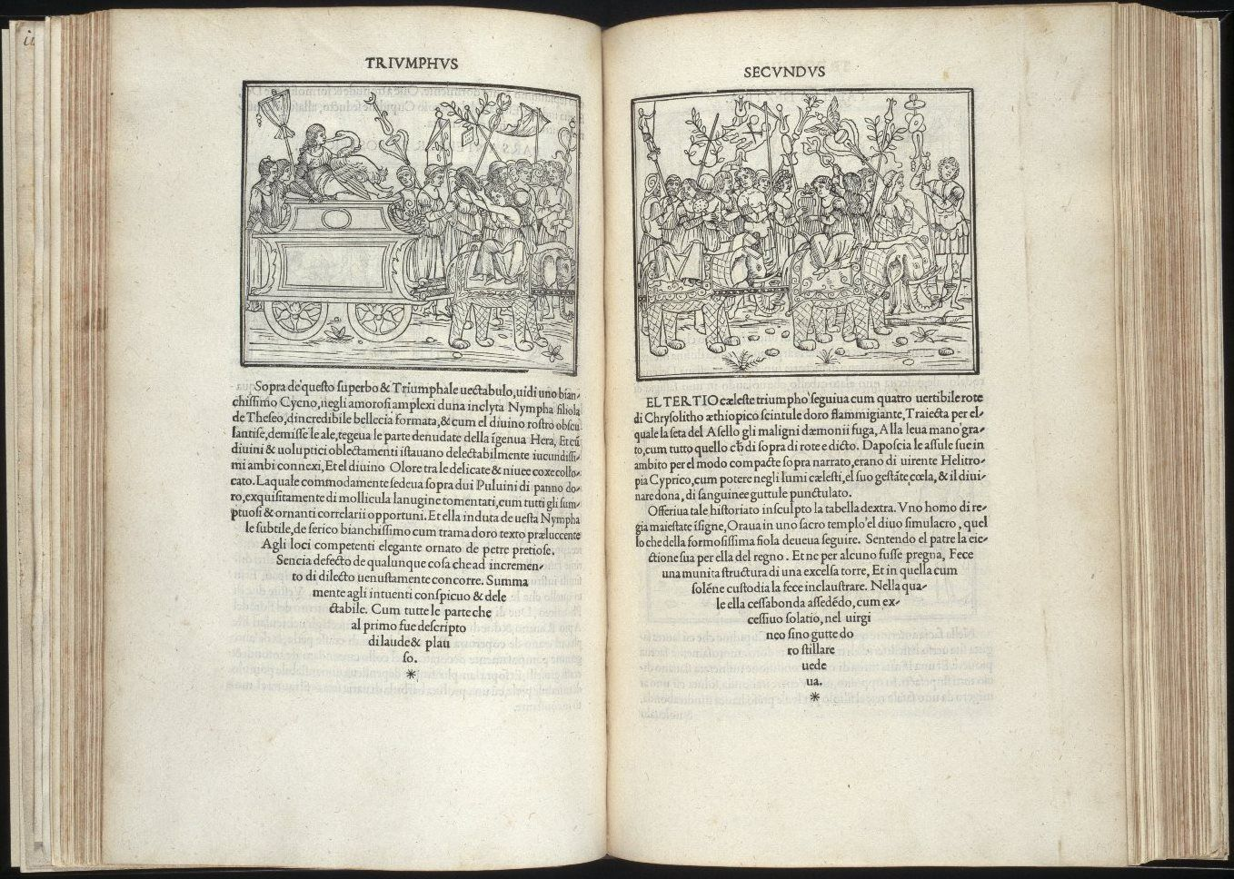

Your fieldbook entry should analyze salient similarities and differences among the pages in your three chosen books. Don’t simply list comparisons—though you might use bullet points to organize your thoughts—but work to understand significances. What can we learn from just a few page openings about relationships among technology, media, and culture during your texts’ periods? What do these books teach us about shifting reading, writing, and publishing practices? How does each set of pages signal what a book is, who a book is for, and what a book does during its historical period? What are the logics, codes, and protocols through which a "book" operates in each period? Can you trace an evolutionary path from earlier books in your set to latter ones?

In your lab report, you should link your thoughts and observations about these specific texts to our course readings, which can help you understand the features and effects I want you to attend to.

*A book is a machine to think with, but it need not, therefore, usurp the functions of either the bellows or the locomotive.*

1. A. Richards, *Principles of Literary Criticism*

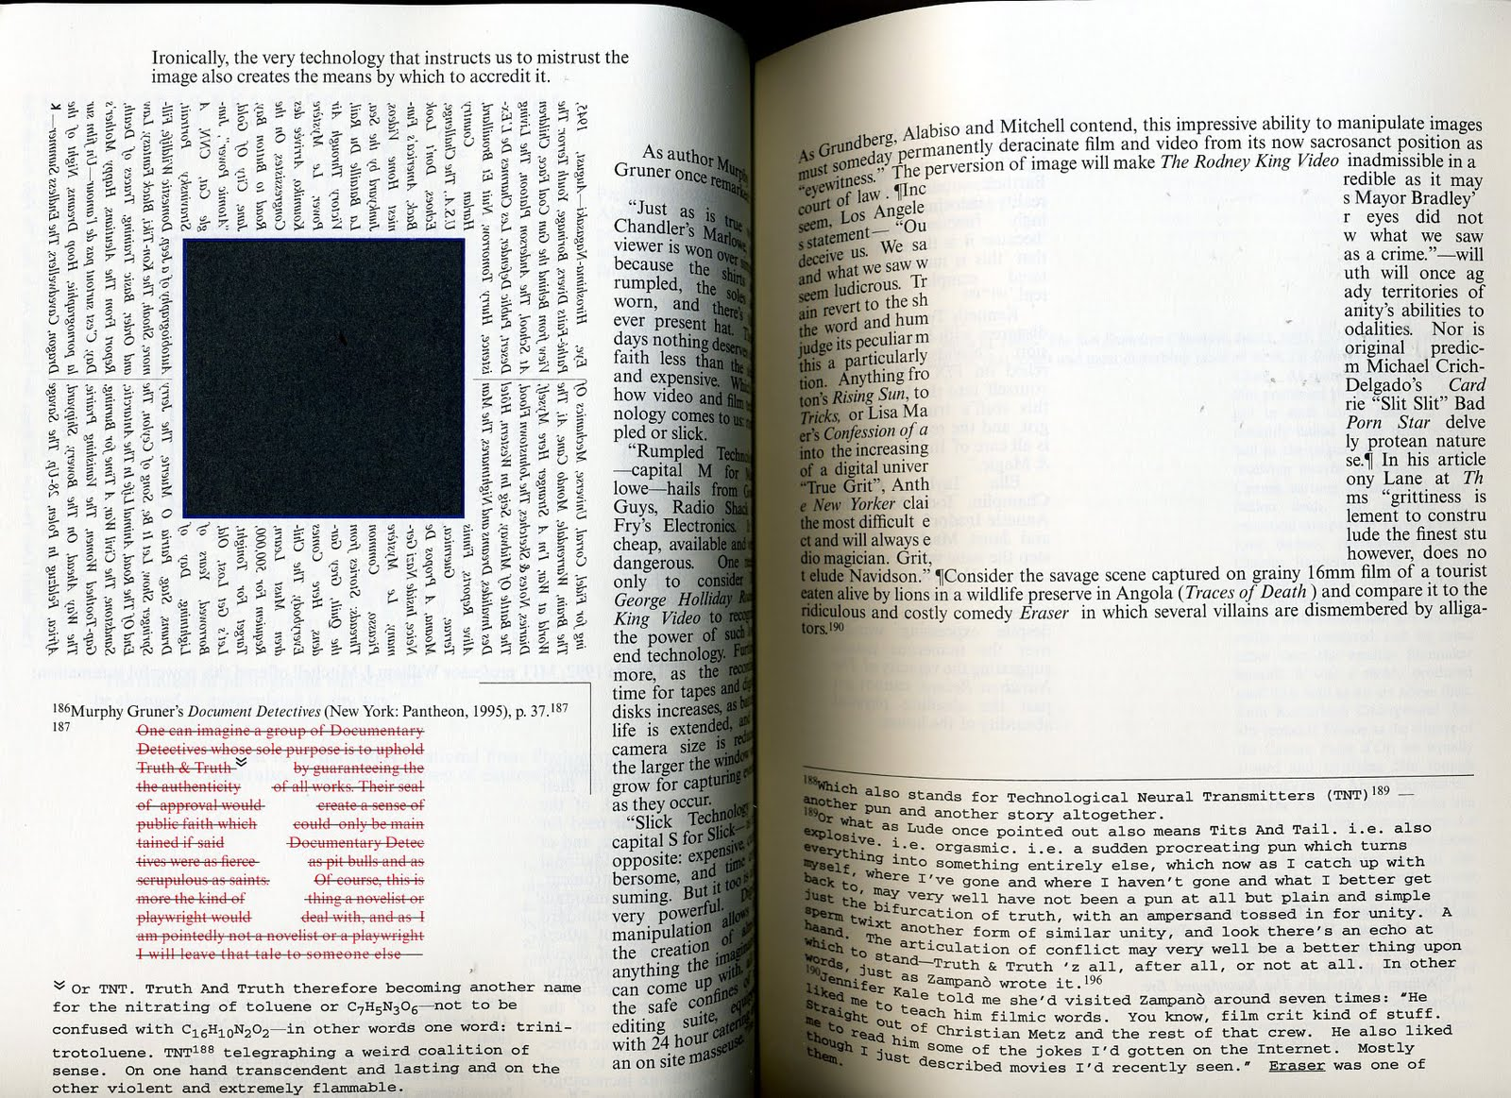

## Possible In-Archive Pairs

1. The "Dragon Prayer Book" (after 1461) and Ovid, *P. Ovidii Nasonis Amatoria* (1546)
2. Wynkin de Worde, *The History of Helyas* (1901; reproduction of 1512 edition) and Guido Bentivoglio, *Relationi fatte in tempo delle sue nuntiature di Fiandra e di Francia* (1629)
3. Buteo Delphinaticus, *Bvteonis Delphinatici Opera Geometrica* (1554) and Benjamin Franklin, *Briefe von der Elektricität* (1758)
4. William Maitland and Others, *The history and survey of London* (1756) and Karl Baedeker, *The Rhine from Rotterdam to Constance* (1900)
5. Charles Dickens, *Sketches of Young Couples* (1840) and Jacob A. Riis, *How the Other Half Lives* (1904)
6. Alexander Jones, *Historical Sketch of the Electric Telegraph* (1852) and George W. Pierce, *Principles of Wireless Telegraphy* (1910)
7. Alfred Koehn, *Japanese Tray Landscapes* (1937) and Amaranth Borsuk and Brad Bouse, *Between Page and Screen* (2012)

## Digital Books

* [Codex Sinaiticus](http://www.bl.uk/turning-the-pages/?id=b00f9a37-422c-4542-bfbd-b97bf3ce7d50&amp;type=book) (~350)
* [Lindisfarne Gospel](http://www.bl.uk/turning-the-pages/?id=fdbcc772-3e21-468d-8ca1-9c192f0f939c&type=book) (~700)
* [Book of Kells](http://digitalcollections.tcd.ie/home/index.php?DRIS_ID=MS58_003v) (~800)
* [Diamond Sutra](http://www.bl.uk/turning-the-pages/?id=1c92bc7e-8acc-49b3-9a27-b5ad8f44230a&amp;type=sd_planar) (868)
* [Medieval Bestiary](http://www.bl.uk/turning-the-pages/?id=181afc99-df1f-4951-8981-df7e26625850&amp;type=book) (~1200)
* [Sultan Baybars' Qur'an](http://www.bl.uk/turning-the-pages/?id=0354faf0-a67a-11db-87d3-0050c2490048&amp;type=book) (1306)
* [The Golden Haggadah](http://www.bl.uk/turning-the-pages/?id=47111807-4e9a-43de-be65-96f49c3d623c&amp;type=book) (~1320)
* [The Sherborne Missal](http://www.bl.uk/turning-the-pages/?id=181afc99-df1f-4951-8981-df7e26625850&amp;type=book) (~1400)
* [The Gutenberg Bible](https://www.bl.uk/treasures/gutenberg/search.asp) (~1454)
* [The Nuremburg Chronicle](https://cudl.lib.cam.ac.uk/view/PR-INC-00000-A-00007-00002-00888/1) (1493)
* [Hypnerotomachia Poliphili : ubi humana omnia non nisisomnium esse docet atque obiter plurima scitu sane quam digna commemorat](http://diglib.hab.de/wdb.php?dir=inkunabeln/13-1-eth-2f) (1499)
* [Codex Arundel](http://www.bl.uk/turning-the-pages/?id=758caef0-a664-11db-8b3a-0050c2490048&amp;type=book) (~1500)
* [*De Humani Corporis Fabrica*](https://cudl.lib.cam.ac.uk/view/PR-CCF-00046-00036/1) (1543)
* [Shakespeare First Folio](https://cudl.lib.cam.ac.uk/view/PR-SSS-00010-00006/1) (1623)
* [Mamusse wunneetupanatamwe Up-Biblium God naneeswe Nukkone Testament kah wonk VVusku Testament](https://archive.org/details/mamussewunneetup00elio) (1663)
* [The Mercator Atlas of Europe](http://www.bl.uk/turning-the-pages/?id=223c7af8-bad6-4282-a684-17bf45bd0311&amp;type=book) (~1570)
* [Nature Printing](https://cudl.lib.cam.ac.uk/view/MS-ADD-10141/1) (1774)
* [*Birds of America*](http://www.bl.uk/turning-the-pages/?id=6bf88002-53a1-41e2-bfc6-de66c674355a&amp;type=book) (1838)