Go to market strategy

2022-10-19

Table of Contents

# The market

## All main battery chemistries

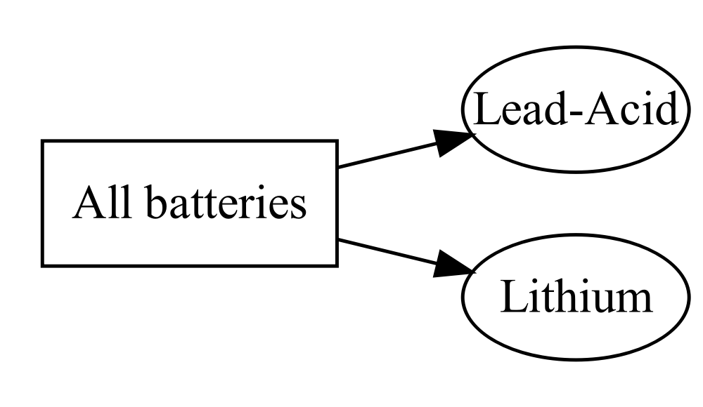

cxccx Lorem ipsum dolor sit amet, consectetur adipiscing elit. Nulla eu pulvinar arcu, quis aliquam dui. In at cursus ante. Vestibulum non sagittis lacus. Duis vitae iaculis dui. Vivamus tempor, nibh ut pretium tempus, enim lorem dignissim quam, at euismod massa magna at magna.

## The market size

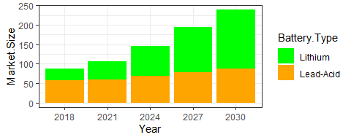

cars

| Battery.Type | 2018 | 2021 | 2024 | 2027 | 2030 |
| --- | --- | --- | --- | --- | --- |
| Lead-Acid | 57 | 59 | 69 | 78 | 87 |
| Lithium | 30 | 47 | 76 | 116 | 152 |

# Lead-acid batteries

## Basic classifictaion by use

