Untitled

2022-08-19

## R Markdown

This is an R Markdown document. Markdown is a simple formatting syntax for authoring HTML, PDF, and MS Word documents. For more details on using R Markdown see <http://rmarkdown.rstudio.com>.

When you click the **Knit** button a document will be generated that includes both content as well as the output of any embedded R code chunks within the document. You can embed an R code chunk like this:

summary(cars)

## speed dist   
## Min. : 4.0 Min. : 2.00   
## 1st Qu.:12.0 1st Qu.: 26.00   
## Median :15.0 Median : 36.00   
## Mean :15.4 Mean : 42.98   
## 3rd Qu.:19.0 3rd Qu.: 56.00   
## Max. :25.0 Max. :120.00

## Including Plots

You can also embed plots, for example:



Note that the echo = FALSE parameter was added to the code chunk to prevent printing of the R code that generated the plot.

# ddsddds

## Basic market

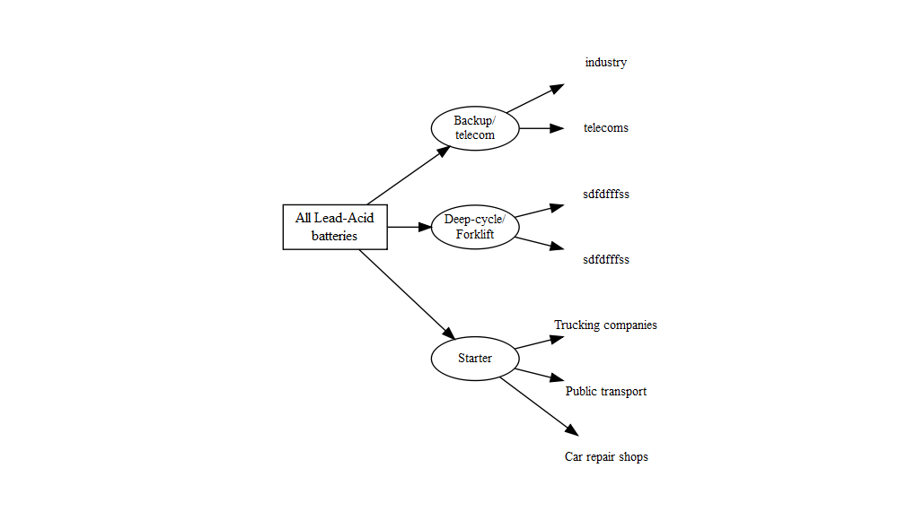

## Warning: package 'flextable' was built under R version 4.1.3

## ! Using an auto-discovered, cached token.

## To suppress this message, modify your code or options to clearly consent to  
## the use of a cached token.

## See gargle's "Non-interactive auth" vignette for more details:

## <https://gargle.r-lib.org/articles/non-interactive-auth.html>

## i The googlesheets4 package is using a cached token for 'rcepka@gmail.com'.

## v Reading from "Untitled spreadsheet".

## v Range ''Sheet1'!B11:D17'.

| from | to | average |
| --- | --- | --- |
| 1 | [[numeric]] | 3.5 |
| 7 | [[numeric]] | 13.0 |
| 20 | [[numeric]] | 60.0 |
| 101 | [[numeric]] | 1,050.5 |
| 2,001 | [[numeric]] | 3,500.5 |
| 5,000 | [[character]] | 5,000.0 |