SUMMARY:

The purpose of this document is to give an overview and show the data validation of the SQL stored procedure before and after optimization.

The Problem:

By talking to few jurisdictions, we were informed that sometimes the overall ETL process takes more than 24 hours to complete. We took a step to identify one stored procedure which is widely used for the reporting purposes and tried to optimize it to reduce the overall processing time.

The Solution:

By implementing one simple step (Introducing flags for couple of queries), we can reduce the overall processing time significantly (less than 50% of the current processing time on a full load). Below are the steps.
- To better understand the problem, we removed the delta/Incremental date filters so we can run a full load and identify where the bottlenecks are.
- Based on the execution, we found that there are couple of places where procedure is taking almost 30 mins out of overall processing time (90 mins)
- After reviewing, we found that the queries have multiple update statements and all of them are using very expensive operations. Please see the below example.
  - The ‘NOT LIKE’ and ‘or’ here in this update statement is very expensive 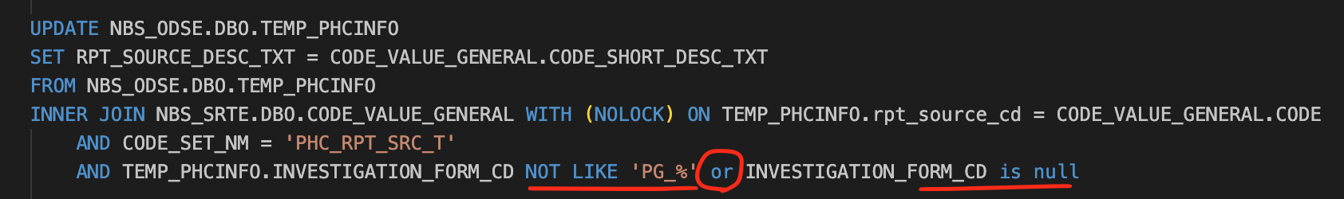
  - To address this issue, we can just add the last line from above screenshot as a column in the prior insert statement i.e., inside ‘TEMP_PHCINFO’ table. This table now has a flag, and we can just use that flag for all the 10 update statements.
    - Flag:
    - Update statement: 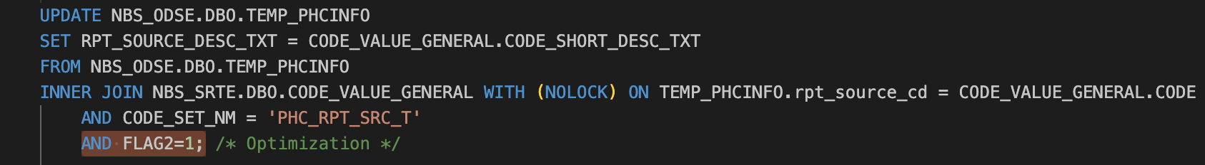
  - Each update statement was taking about 3 mins previously, by implementing these flags, it only takes 2-3 secs to run all the updates. This is a drastic improvement.
- We also had other enhancements related to case statements and CTE’s (Common table expression), but we removed them to make it simple for comparing the original vs optimized procedure.

The Opportunity:

There is still lot of opportunity to improve the query performance, but the overall processing time may just remain the same. Some of them are listed below.
- Using case statements instead of update statements.
- Using ROW_NUMBER function instead of deleting statements when removing the duplicates.
- Remove unnecessary order by statements.
- Combining multiple queries together and reduce the number of queries where needed.

Data Validation:

We were able to perform the below tasks related to Data Validation of this store procedure.
- Counts check.
- Data check (row by row & column by column).
- Code check.
- Uniqueness of data

Process followed for Data Validation:

Please find the below list of data validation steps that were performed.

  - First Iteration (last sprint)
    - Compared results of original and optimized versions of the stored procedure with all the optimization attributes.
    - Initially, data validation failed for couple of tables, I had to fix and then match them to move on to next step. This is a step-by-step execution of the SPROC.
    - Please find the ‘phcf_datavalidation’ documentation on GIT for more details
    - Stats: 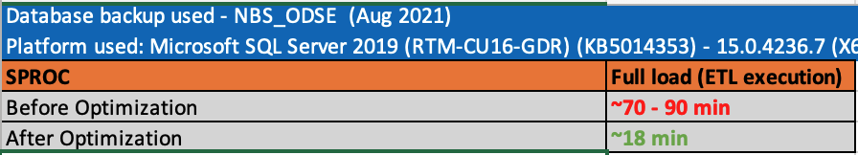

  - Second Iteration
    - We found that we need to ‘ORDER BY’ few columns to really compare both Original and Optimized version. So, we added order by on both the original and optimized versions and ran them step by step.
    - The results are matching after the ordering by the columns when removing duplicates and when using STUFF function.
    - Stats: 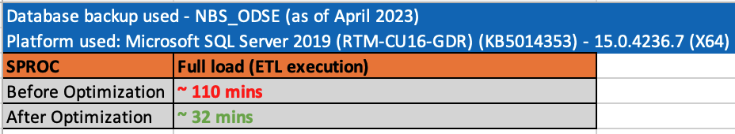

  - Third Iteration
    - The first and second Iterations are older DB backups and only had one million records to deal with. The Third iteration is the most recent Alabama DB backup (as of April 2023)
    - The overall data volume has doubled from previous iterations. We were dealing with 2 million records going forward.
    - We performed data validations considering two approaches 1. flags & CTE’s and 2. using only flags to really understand the impact of these on the overall counts between original and optimized results. The results are not much different in the processing time and data quality. Please find the ‘phcf_datavalidation’ spreadsheet for more details.
    - Stats:
    - 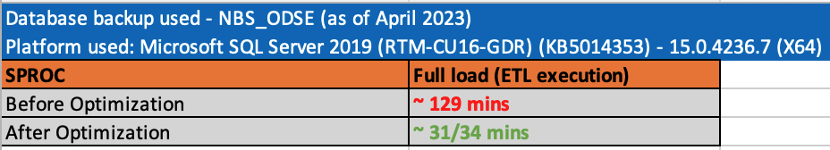

  - Fourth Iteration:
    - After reviewing with our team, we concluded that if we don’t do the order by on specific columns, we will not be able to perform end to testing at any given point of time when comparing these both SPROC’s(original & optimized). So, we decided to just run the Original sproc multiple times to see what happens.
    - The result of running original sproc multiple times helped us confirm that the record counts will never be the same when we run the same procedure multiple times. That means, there is no specific rule to pick ‘PERSON_UID’ or ‘PUBLIC_HEALTH_CASE_UID’ when removing the duplicates.
    - We took a backup of the below two tables and truncated and reran the original sproc multiple times to see if the counts match.
        - PublicHealthCaseFact
        - SubjectRaceInfo
    - Even that turned out to be mismatching. The results of truncating the data and refreshing the target tables with the same sproc(original stored procedure) also explains that the picking of records is happening vaguely.
    - Please refer to ‘multiple executions of orignal’ on the ‘phcf_datavalidation’ spreadsheet for more details.

  - Delta runs:
    - After all the above iterations, We decided to just run the incremental load consider ‘2023-01-01’ as start date and ‘getdate()’ as the end date. The overall processing time of optimized version is 5 mins less than original sproc’s run time.
    - The discrepancy between the data continues because there is no specific rule for removing the duplicates.
    - Similarly, there is no specific order by before executing STUFF command.

