CS-E4840 - Information Visualization, 2020
Name: Peter Jiang
ID: 784902

Exercise 1

a)
Problems with the visualization include
- Representation of numbers should match the true proportions. There is no consistent distance used between the data points, on both x and y axis. Also, sometimes the year has been specified, sometimes not.
- The number of dimensions represented should be the same as the number of dimensions in the data. This is violated by pressing all data into one graph.
- Clear, detailed and thorough labeling should be used to defeat graphical distortion and ambiguity. Explanations should be written at the data on the graph itself. However, labeling is in the bottom left corner, which leads to unnecessary eye movements.
- Poor Data Ink-Ratio: Flag is completely unnecessary and only serves to show off the designer’s design skills

b) Why the graphic below is better:
- Splitting unrelated data into distinct graphs
- Making it clear what each graph is for by moving description directly to the graph
- Consistent use of units
- Maximize data-ink ratio
- No unnecessary graphics
- Empty bars
- Constrict scale domain to the results

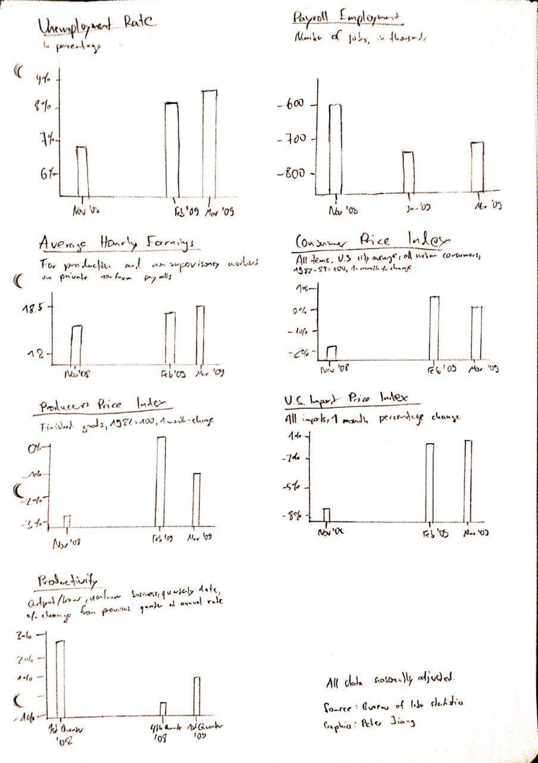
Exercise 2

I chose the graphic from https://graphics.reuters.com/CHINA-HEALTH-SOUTHKOREA-CLUSTERS/0100B5G33SB/index.html:

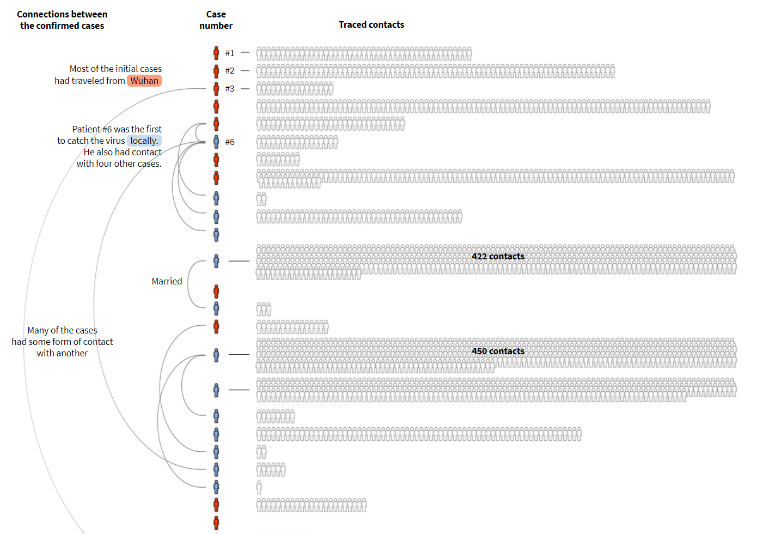
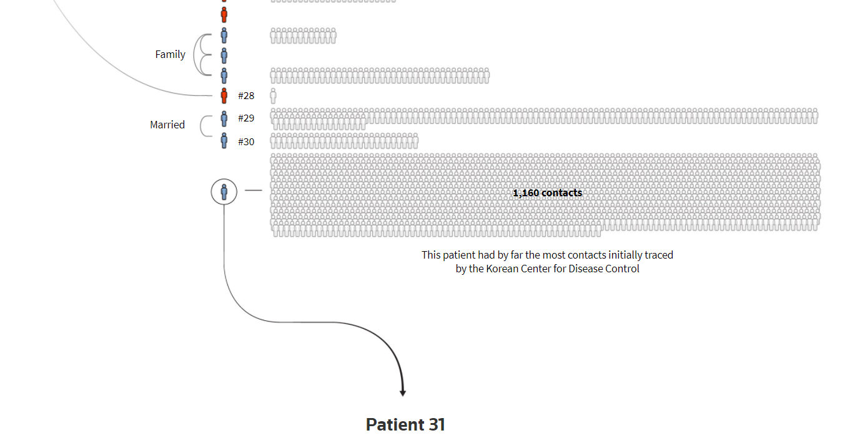

What I found appealing about this graphic, was that it managed to visualize a) a chronological listing of patients, b) the number of their traced contacts, c) relationships between the confirmed cases, and d) indication whether it was an imported infection or not. Displaying a human icon for each traced contact made it more imaginable with what amount of cases we are dealing with. It highlights the importance of Patient 31, which the rest of the article focuses on.

Exercise 3
a)

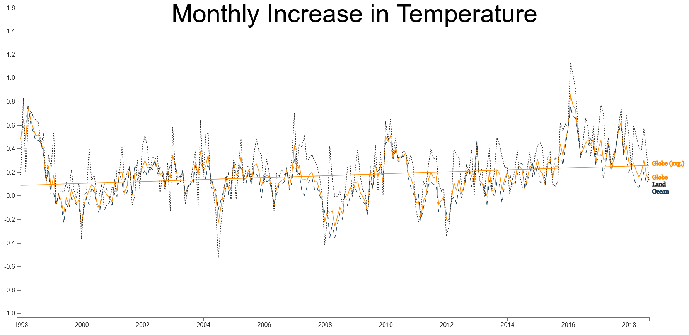
“It’s clear that there has been no significant increase in temperature. Climate change is FAKE!”

b)

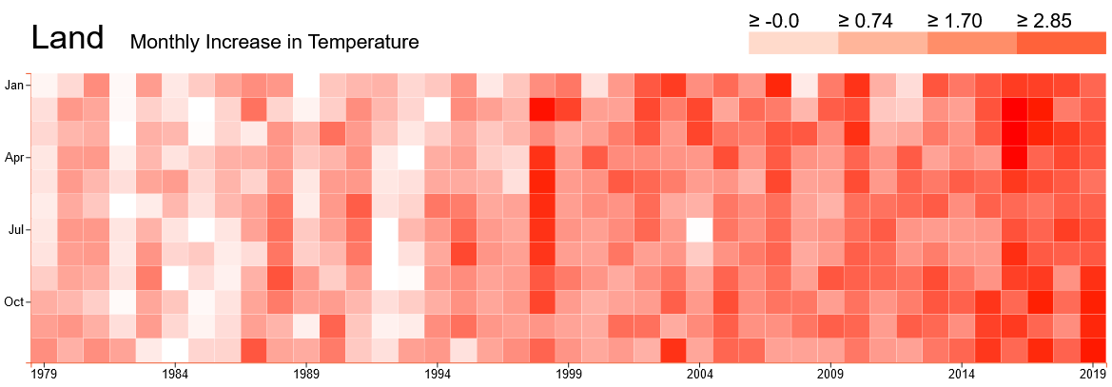
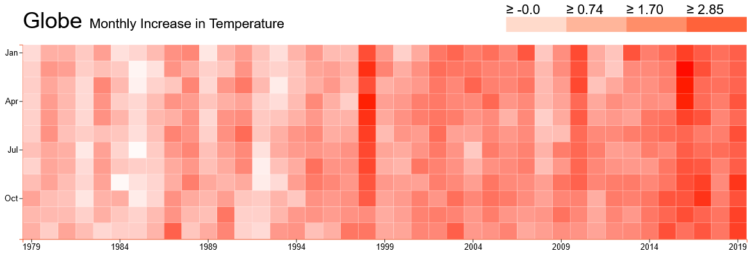

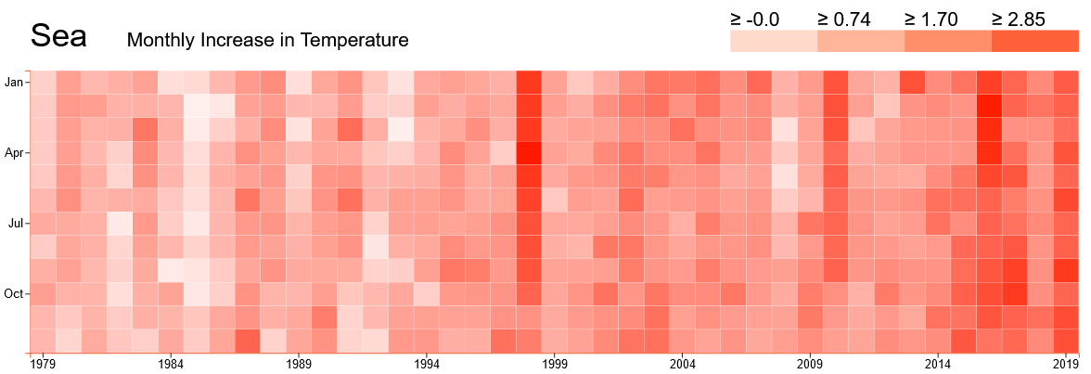
“The earth is heating up!!!”

c)

Data has not been distorted in a), only the date range has been constricted.
The lie factor in b) is 1.5, as color values have been distorted by a factor of 1.5.

d)

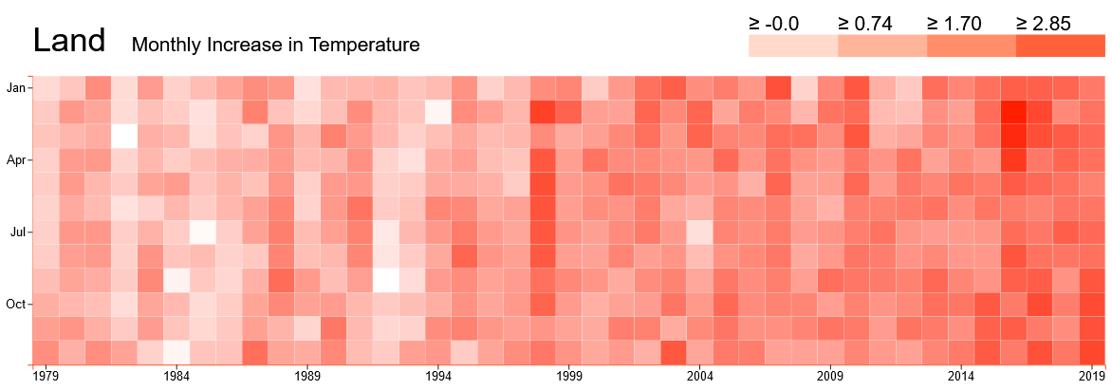
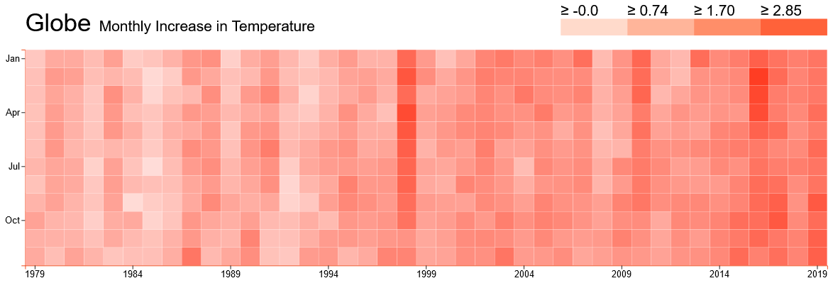

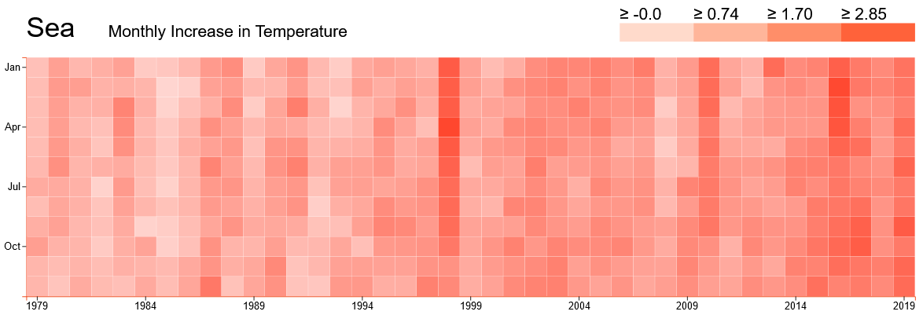
The chart is good, because
- Data Ink Ratio is optimized
- Representation of numbers matches the proportions, color intensity has not been distorted
- Clear labeling of the Data
- Usage of data of all years where all months have a value
- Data is split into several graphs for readability
- Heatmap Layout is intuitive.

Exercise 4
