Path Analysis

*Lab Exercise 1, Part b*

2.5. Properly report the results

Predicted career: Fireman

The hypothesized model was tested with path analysis and the estimated model is

depicted in Figure 1. The model appeared to have mediocre fit, SRMR = .04, p =0.13, RMSEA = .06, 90% CI [0, 0.13], TLI = 0.94.

Impulsivity was predicted by age, β = -0.12, Z = -2.26, p = 0.02, and thrill seeking, β = 0.49, Z = 8.88, p < .001. Impulsivity significantly predicting the career choice of a fireman, β = 0.18, Z = 2.96, p = .003, and so did sex, β = -0.25, Z = -4.20, p < .001.

*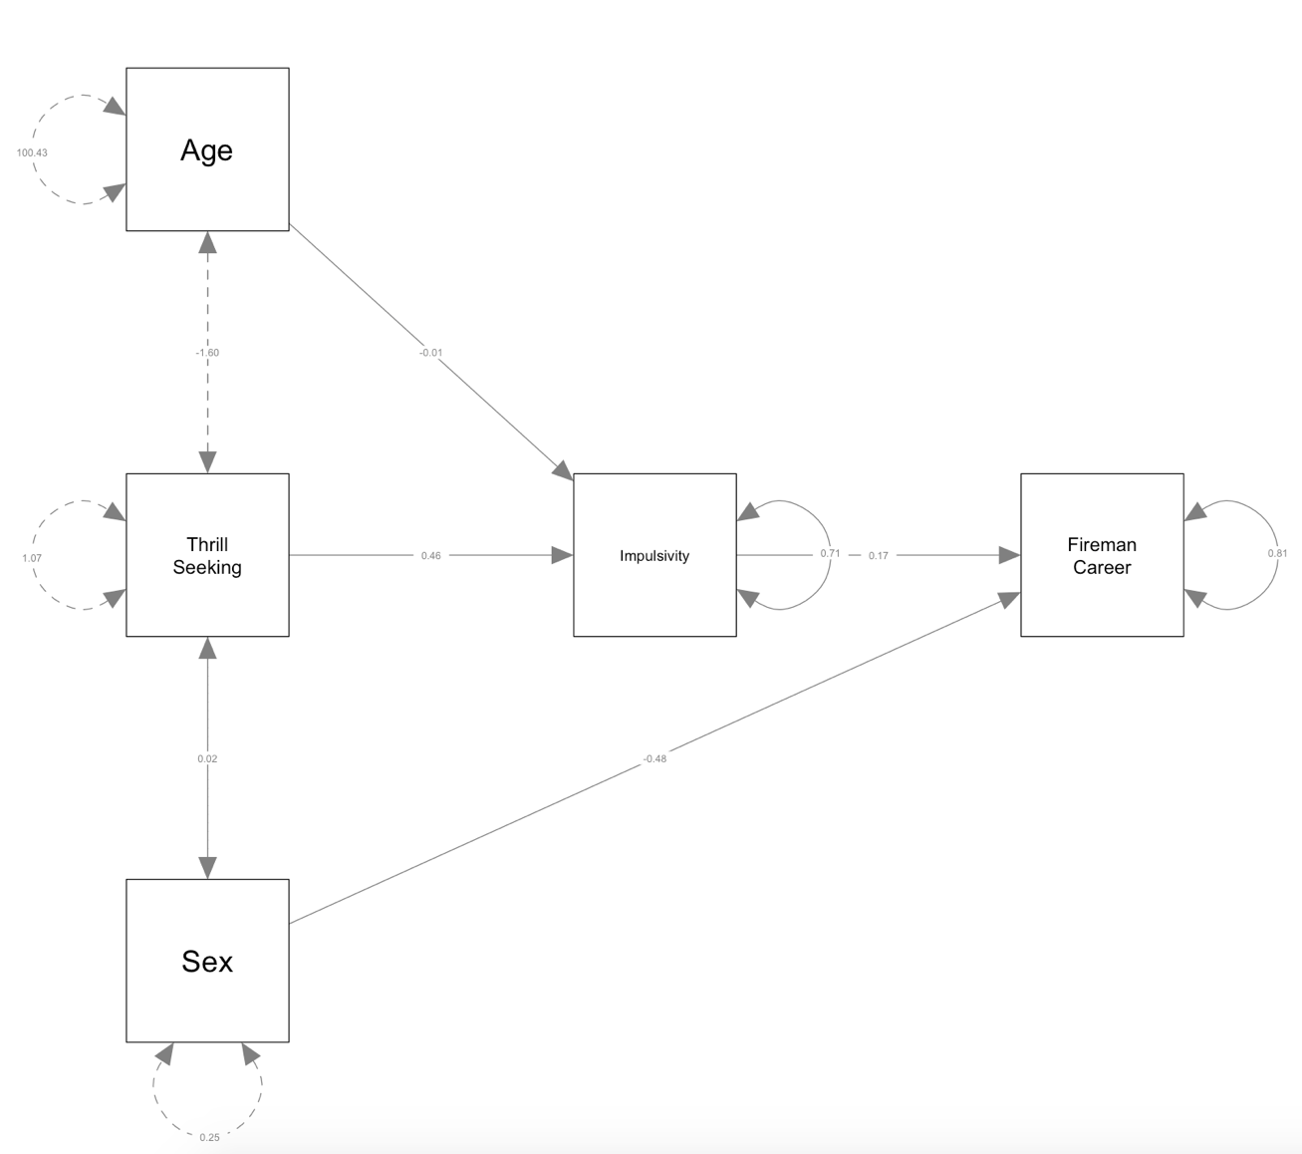*

*Figure 1.* Unconstrained model

3.3. Properly report the results

I wanted to see if the data fit an “Unconstrained Model” (Figure 1) better than a constrained model that posits no relationship age and impulsivity (“Constrained Model,” Figure 2). The constrained model appeared to have a poor fit, SRMR = .05, p =0.03, RMSEA = .08, 90% CI [0, 0.13], TLI = 0.89, AIC = 1297.2, BIC =1314.8. Impulsivity was predicted by thrill seeking, β = 0.51, Z = 9.24, p < .001. Impulsivity significantly predicting the career choice of a fireman, β = 0.18, Z = 2.96, p = .003, and so did sex, β = -0.25, Z = -4.20, p < .001.

A Likelihood Ratio test of the two models suggested that the models did not fit the data equally well, 𝝌2(1) = 5.04, p = 0.02. Thus, the unconstrained model was chosen.

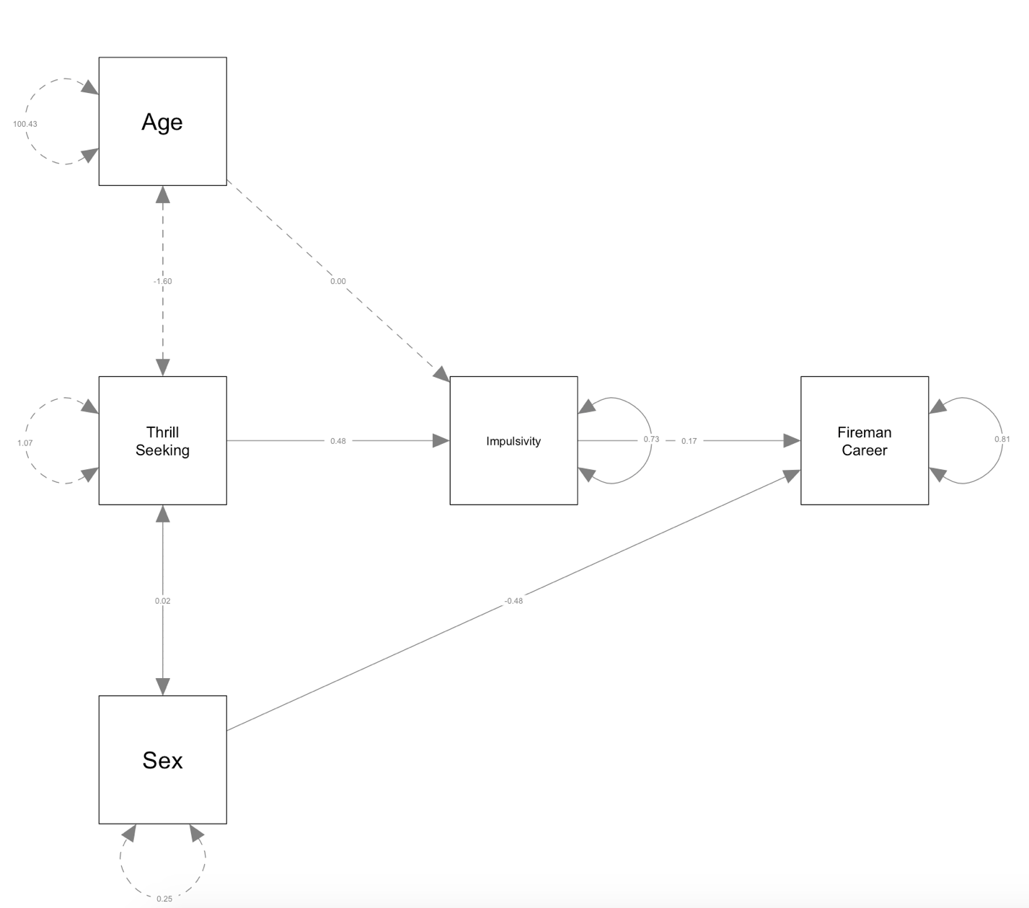

*Figure 2:* Constrained model

4.3. Report the results

I wanted to see if the data fit an alternative theoretical model (“Non-nested Model”, Figure 3) better than an unconstrained model (“Unconstrained Model,” Figure 1). The alternative non-nested model appeared to have a poor fit, SRMR = .003, p <.001, RMSEA < .001, 90% CI [0, 0.10], TLI = 1, AIC = 1314.75, BIC = 1335.88. Impulsivity was predicted by thrill seeking, β = 0.51, Z = 9.24, p < .001. Thrill seeking significantly predicting the career choice of a fireman, β = 0.13, Z = 2.14, p = .003 but stress reactivity did not, β = -0.05, Z = -0.78, p < 0.44.

The alternative theoretical model did not have a good fit, and therefore the unconstrained model should be chosen. When comparing model AIC, the absolute difference was greater than 10, therefore the model with the higher AIC (alternative theoretical model) was not supported by the data. The calculated difference between model BIC was greater than 10, illustrating that the models fit differently. Again, this supports the choosing the unconstrained model.

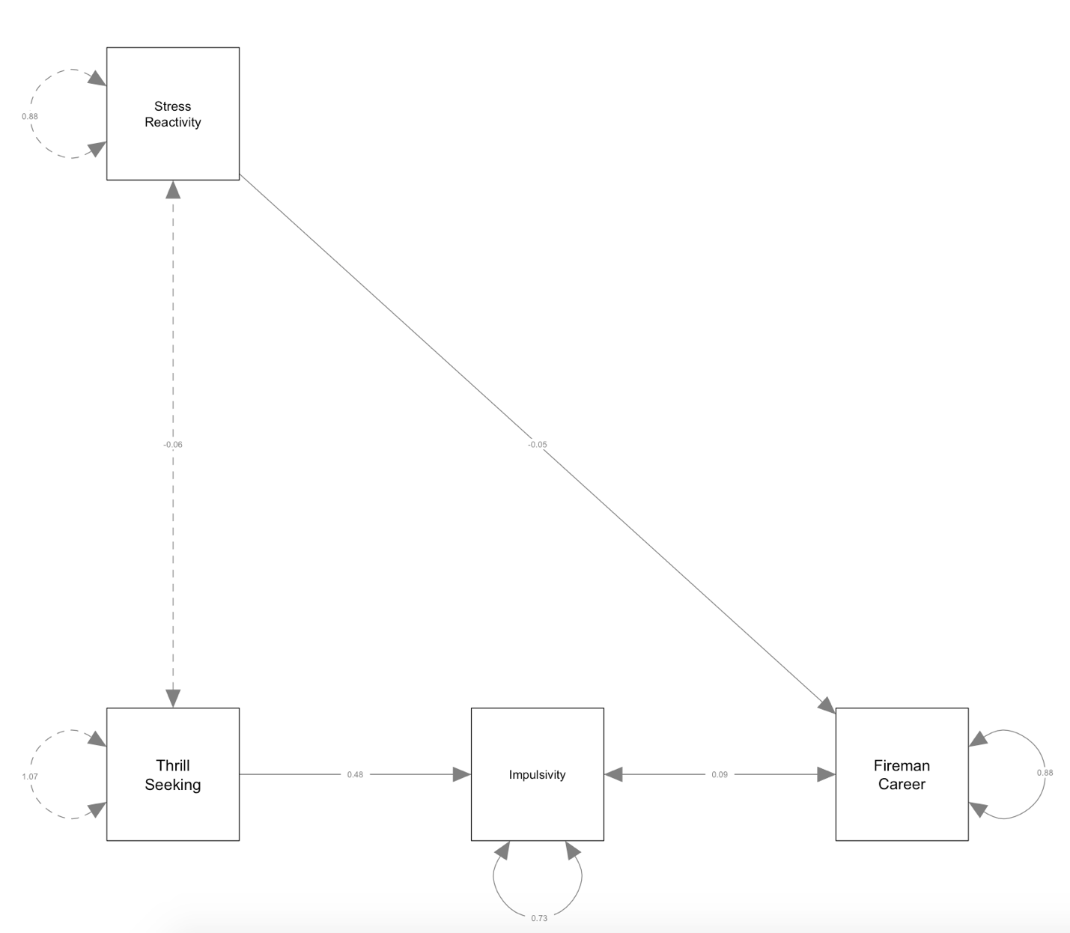

5. Make up a purely hypothetical research question that is relevant to your specific program of research that could be tested with a path analysis. You may either describe this research question in words or specify the model by drawing it.

Moral

Outrage

Blame

Intentionality

Agency

Harm