Symbolic Material Culture within an Ancient Catastrophic Temple Complex

Dr. Henry Walton Jones Jr.

1984-01-01

## Introduction

This is a totally made-up study on a completely fictional archaeological site, but the data are very real.  
Blah, blah, blah.

It is **very** important to state that *any* ***conclusions*** reached in this report are the ramblings of a *fictional* character.

## Materials

Here is a list of materials used during excavation:

* whip
  + for carefully excavating ancient materials
    - something else
* hat
  + for protection form the hot sun
    - something else
* gun
  + to keep away dig-site cats

In order of importance

1. gun
2. hat
3. whip

## Methods

I recently learned how to use R and couldn’t wait to use it in this study! I am using R version 4.4.3 (2025-02-28) Trophy Case.

## Results

|  |  |  |  |  |  |  |  |  |  |  |  |  |  |  |  |  |  |  |  |  |  |
| --- | --- | --- | --- | --- | --- | --- | --- | --- | --- | --- | --- | --- | --- | --- | --- | --- | --- | --- | --- | --- | --- |
| Table 1: This is a useful caption.   | Phase | Mean (cm^2) | SD | | --- | --- | --- | | post | 6820.000 | 2335.2195 | | disturbed | 6656.333 | 923.3474 | | pre | 6383.346 | 1624.9737 | | euro | 6288.071 | 2053.0179 | | NA | 4666.281 | 2564.9596 | | chi | 3772.500 | 1238.9613 | |

Here’s a figure

|  |
| --- |
| Figure 1 |

This argument is supported by Table 1 and Figure 1

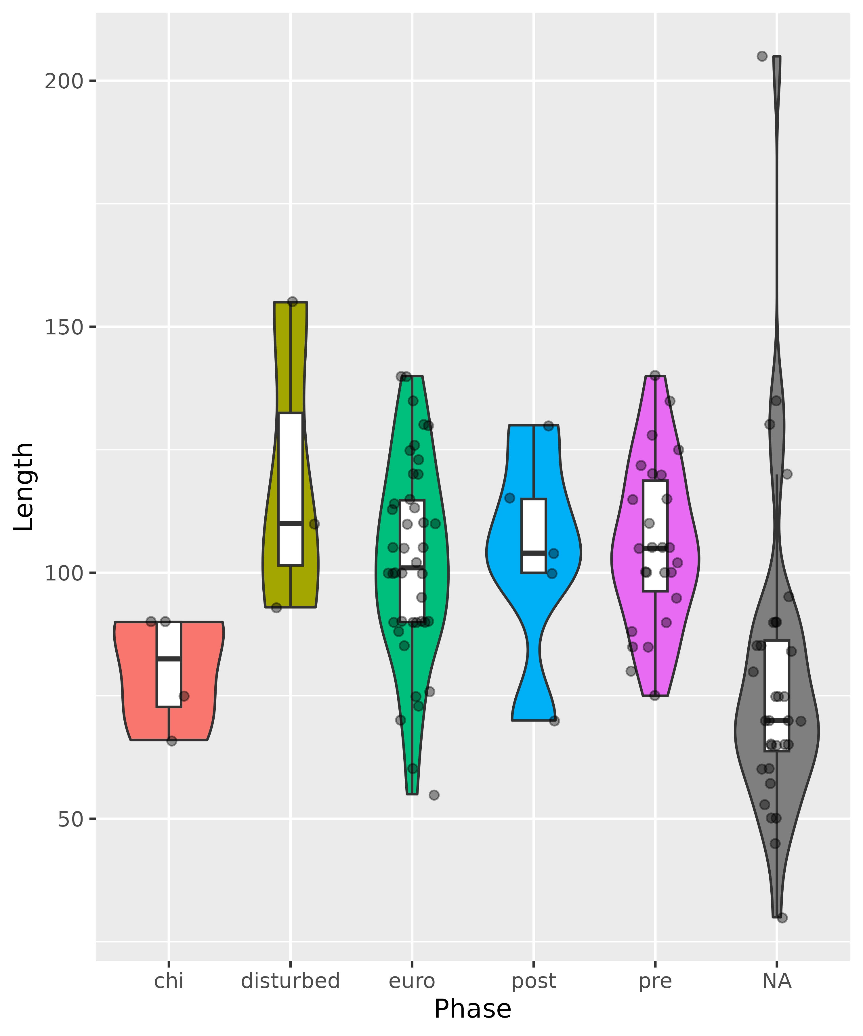

Caption.