SOFI

<https://seekingalpha.com/article/4406011-sofi-growing-fintech-company>

**SoFi: A Growing Fintech Company**

Feb. 14, 2021 7:36 AM ET[**Social Capital Hedosophia Holdings Corp. V (IPOE)**](https://seekingalpha.com/symbol/IPOE?source=content_type%3Areact%7Csection%3Amain_content%7Csection_asset%3Ameta%7Cfirst_level_url%3Aarticle%7Csymbol%3AIPOE), [**SOFI**](https://seekingalpha.com/symbol/SOFI?source=content_type%3Areact%7Csection%3Amain_content%7Csection_asset%3Ameta%7Cfirst_level_url%3Aarticle%7Csymbol%3ASOFI)[75 Comments](https://seekingalpha.com/article/4406011-sofi-growing-fintech-company#comments)27 Likes

**Summary**

* SoFi recently signed a definitive agreement to go public with Chamath Palihapitiya's SPAC.
* The deal values the company at $8.65 billion.
* SoFi will trade at a market capitalization of $21 billion with 865 million shares outstanding when the deal closes.
* The company has a strong growth profile and looks set to continue this as a public company.

SoFi (NYSE:[IPOE](https://seekingalpha.com/symbol/IPOE?source=content_type%3Areact%7Csection%3Amain_content%7Cbutton%3Abody_link)) is a fast-growing American personal finance company that offers a suite of financial products to consumers directly through its [app](https://apps.apple.com/us/app/sofi-invest-and-track-money/id1191985736) and [website](https://www.sofi.com/). The company is going public via Chamath Palihapitiya's SPAC Social Capital Hedosophia Holdings Corp. V. The transaction is expected to deliver up to [$2.4 billion](https://www.businesswire.com/news/home/20210107005746/en/SoFi-A-Leading-Next-Generation-Financial-Services-Platform-to-Become-Publicly-traded-via-Merger-with-Social-Capital-Hedosophia) of gross proceeds to SoFi including a $1.2 billion PIPE placing the company at an equity value of $8.65 billion.

SoFi (NYSE:[IPOE](https://seekingalpha.com/symbol/IPOE?source=content_type%3Areact%7Csection%3Amain_content%7Cbutton%3Abody_link)) is a fast-growing American personal finance company that offers a suite of financial products to consumers directly through its [app](https://apps.apple.com/us/app/sofi-invest-and-track-money/id1191985736) and [website](https://www.sofi.com/). The company is going public via Chamath Palihapitiya's SPAC Social Capital Hedosophia Holdings Corp. V. The transaction is expected to deliver up to [$2.4 billion](https://www.businesswire.com/news/home/20210107005746/en/SoFi-A-Leading-Next-Generation-Financial-Services-Platform-to-Become-Publicly-traded-via-Merger-with-Social-Capital-Hedosophia) of gross proceeds to SoFi including a $1.2 billion PIPE placing the company at an equity value of $8.65 billion.

SoFi has been structured around three operating segments; (1) Lending; (2) Technology platform; and (3) Financial Services. Its lending arm constituted 83% of estimated 2021 fiscal year revenue. This deals with personal, home, and private student loans. [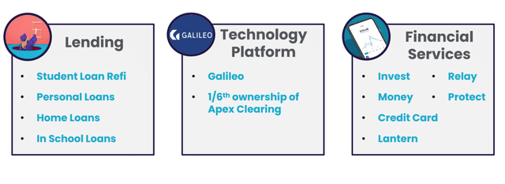](https://static.seekingalpha.com/uploads/2021/2/13/41871776-1613194750169458_origin.png)

*SoFi Investor Call Deck (*[*Source*](https://www.dropbox.com/s/ffybqu77l1z4wxu/SoFi%20Investor%20Call%20Deck%20.pdf?dl=0)*)*

The technology platform constitutes primarily Galileo Financial Technologies, acquired by SoFi for[$1.2 billion](https://techcrunch.com/2020/04/07/another-major-fintech-exit-as-sofi-acquires-banking-and-payments-platform-galileo-for-1-2b/) in April 2020. This is an API and financial processing platform used by a suite of fintech companies including MoneyLion (NYSE:[FUSE](https://seekingalpha.com/symbol/FUSE?source=content_type%3Areact%7Csection%3Amain_content%7Cbutton%3Abody_link)), Skrill (NYSE:[BFT](https://seekingalpha.com/symbol/BFT?source=content_type%3Areact%7Csection%3Amain_content%7Cbutton%3Abody_link)), Robinhood, Interactive Brokers (IEX:[IBKR](https://seekingalpha.com/symbol/IBKR?source=content_type%3Areact%7Csection%3Amain_content%7Cbutton%3Abody_link)), Chime, and Shipt.

SoFi's 17% ownership of Apex Clearing as of January 12, 2021, had been [reduced to less than 1%](https://www.sofi.com/blog/sofi-invest-411/). Apex provides trade clearing to a number of stockbroking platforms which used to include Robinhood until the commission-free stock trading app [launched its own](https://www.cnbc.com/2018/10/10/robinhood-launches-its-own-trade-clearing-system-as-customer-growth-surges.html) clearing system. This disposal might be linked to Apex's rumoured deal to[go public via SPAC](https://www.bloomberg.com/news/articles/2021-02-12/clearing-house-apex-is-said-in-merger-talks-with-ledecky-spac).

SoFi's financial services include its stock trading app and the recently launched [SoFi credit card](https://www.finextra.com/pressarticle/84717/sofi-launches-credit-card) which provides 2% unlimited cash back on all purchases when users redeem into a related SoFi product. This cross-selling of multiple financial products forms a major tenet for SoFi's bull case as it helps to boost revenue while minimising churn. This has been most highlighted in the 220% growth of their multi-product members from 125,000 as at the end of Q4 2019 to 400,000 as at the end of Q4 2020. The company estimates this will rise to 775,000 as at the end of the 2021 fiscal year, a 95% year-over-year increase.

[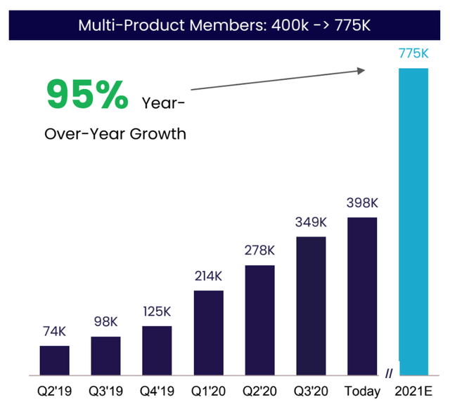](https://static.seekingalpha.com/uploads/2021/2/13/41871776-1613202708131412_origin.png)

*SoFi Investor Call Deck (*[*Source*](https://www.dropbox.com/s/ffybqu77l1z4wxu/SoFi%20Investor%20Call%20Deck%20.pdf?dl=0)*)*

## SoFi Stadium

The SoFi stadium, the home of the Los Angeles Rams and the Chargers, has been a source of controversy over the price the company paid for branding rights. SoFi is paying [$30 million annually](https://www.bloomberg.com/news/articles/2019-09-15/sofi-to-pay-30-million-a-year-for-la-rams-stadium-naming-rights) over 20 years for the 70,000 seat stadium that will host both the 2022 Super Bowl as well as the 2028 Olympics opening and closing ceremony.

The company has a $200 million annual marketing budget so this forms just 15% of this and could help raise the company's profile.

[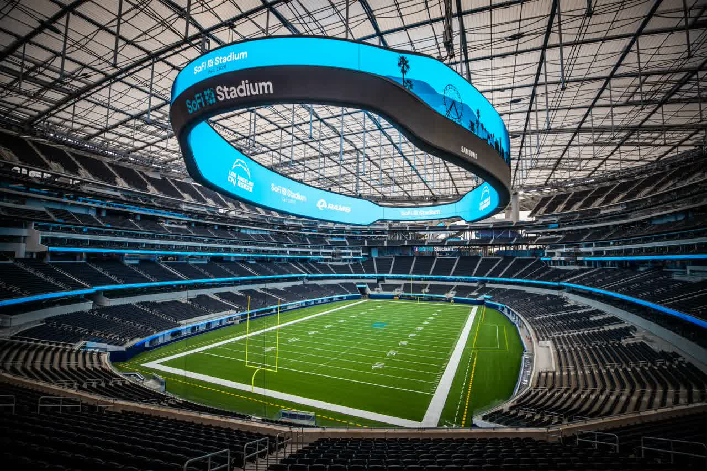](https://static.seekingalpha.com/uploads/2021/2/13/saupload_sofi-stadium-rich-fury-getty-for-hollywood-park-management-company_thumb1.jpg)

SoFi Stadium ([*Source*](https://www.lamag.com/citythinkblog/sofi-stadium-opening/))

## Strong Forward Revenue Visibility And A Path To Positive EBITDA

SoFi is on track to exceed 3 million members for 2021. This would be a year-over-year increase of 75%, a full 100 basis points more than the 74% increase of its FY 2020 over FY 2019.

[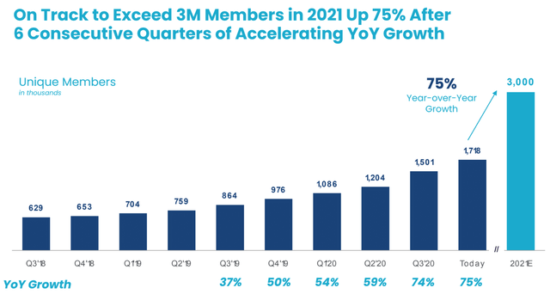](https://static.seekingalpha.com/uploads/2021/2/13/41871776-1613202657986199_origin.png)

SoFi Investor Call Deck ([*Source*](https://www.dropbox.com/s/ffybqu77l1z4wxu/SoFi%20Investor%20Call%20Deck%20.pdf?dl=0))

The accelerating growth in members runs contrary to the law of large numbers and points to growing momentum with their business model. Further, SoFi's investing app experienced a surge in downloads with the recent Robinhood debacle around blocked GameStop trades.

[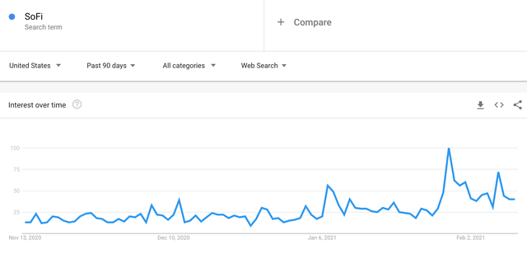](https://static.seekingalpha.com/uploads/2021/2/13/41871776-1613218157746887_origin.png)SoFi Google Trends ([*Source*](https://trends.google.com/trends/explore?date=today%203-m&geo=US&q=SoFi))

This might contribute to a potential outperformance of its member growth forecast and should lead to stronger revenue accretion and profitability in the quarters ahead.

[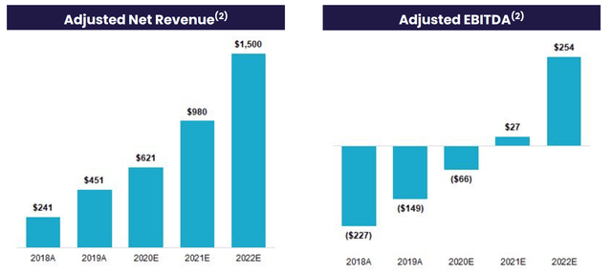](https://static.seekingalpha.com/uploads/2021/2/13/41871776-1613202678472003_origin.png)

*SoFi Investor Call Deck (*[*Source*](https://www.dropbox.com/s/ffybqu77l1z4wxu/SoFi%20Investor%20Call%20Deck%20.pdf?dl=0)*)*

SoFi's current price of $23.70 and 865 million shares outstanding place its revenue multiple at 22x using estimates for $980 million in revenue for its 2021 FY. As previously stated, I think SoFi is well placed to beat this revenue guidance. This should see the revenue multiple for its 2022 FY drop beyond the current 14x ascertained using the $1.5 billion forecast for the same year. The company's [preliminary approval](https://www.reuters.com/article/us-sofi-bank-charter-idUSKBN27D27W) for a U.S. bank charter will also help meet the forecast for EBITDA profitability in 2021 by lowering their cost of capital and enabling increased net interest margin from holding loans longer.

As a public company, SoFi should be able to more fully monetise its shares for bolt-on acquisitions of companies that expand the operational capability of its three operating segments. This company is likely to look at both opportunities in the technology platform space while chasing international expansion. SoFi does have a presence in [Hong Kong](https://www.bloomberg.com/news/articles/2020-04-21/sofi-acquires-hong-kong-s-8-securities-in-first-global-push) but is still mostly constrained to the USA.

## A Buy And Hold Position

SoFi has a brand with a growing profile that is carving out a strong role for itself in North American personal finance. The company going public has provided the platform it needs to continue with its history of strategic bolt-on acquisitions. This will cement its fintech status and maintain the trajectory of revenue growth in the coming fiscal years.

However, investors might be averse to taking a position at the current valuation. This is especially true as the broader market makes increasingly higher highs pushing valuations to extremes. As the spectre of a market crash grows larger so too does a pullback in the price of SoFi's common shares. I am long and will likely add to my position on any significant pullback.

This article was written by

[Winds Research profile picture.](https://seekingalpha.com/author/winds-research?source=content_type%3Areact%7Cfirst_level_url%3Aarticle%7Csection%3Amain_content%7Csection_asset%3Aauthor_follow_bottom%7Cbutton%3Aavatar)

[**Winds Research**](https://seekingalpha.com/author/winds-research?source=content_type%3Areact%7Cfirst_level_url%3Aarticle%7Csection%3Amain_content%7Csection_asset%3Aauthor_follow_bottom%7Cbutton%3Aname)Follow

3.25K Followers

The stock market is an incredibly powerful mechanism, as daily fluctuations in price get aggregated to incr... more

Long/Short Equity, Growth At A Reasonable Price, Long-Term Horizon

Contributor Since2015

The stock market is an incredibly powerful mechanism, as daily fluctuations in price get aggregated to incredible wealth creation or destruction over the long term. These two polarising forces lay at the core of Winds Research. The aim is to avoid wealth destruction and embrace wealth creation. Not an easy feat in its entirety, but one achieved nonetheless from an almost radical obsession with achieving superior financial returns.

**Disclosure:** I am/we are long IPOE. I wrote this article myself, and it expresses my own opinions. I am not receiving compensation for it (other than from Seeking Alpha). I have no business relationship with any company whose stock is mentioned in this article.