**Gizathon Agent Idea Submission Form**

Your idea is eligible only if it answers all three of the following questions with a YES!

1) Does my agent idea contain Machine Learning, needs ZK, and is actionable?

Yes, BTC action something like BUY/SELL/Hold will be predicted by ML model (have done some basic research), and that proof of that prediction – will be sent to an agent, that will re-balance the portfolio of digital assets for customers. We need ZKML so customers can trust that the same model is being used for agents actions on their portfolio.

2) Is it possible to obtain the necessary data to build the model?

Yes, Public data exists for ETF Flows (daily), PCI (monthly), unemployment( monthly )

3) Is it a feasible problem for an ML model?

Yes, Public data exists for ETF Flows (daily), PCI (monthly), unemployment( monthly ) - Regession, XGBoost.

Project Name * Portfolio Rebalancing Predictor

Project Code * Don’t have a code

The code that was sent to you upon registration (32 characters)

Team Size *2.

Agent Idea Description *

Based on the proof supplied to the Agent, the agent will re-balance the portfolio

Define Use Case and Requirements *

Recently, there has been a postulation on the variables affecting the bitcoin price (ETF flows – predominant, US-CPI, Unemployment numbers, Interest Rates and Direction) etc,

The model attempts to predict based on these factors.

Agent Specifications & Scope *

What actions is the agent expected to make and how often?

1. The Agents will have to rebalance against BTC-and other ALTCOIN (TBD) positions based on the prediction volatility band & my trading guidelines.
2. Weekly or monthly rebalance.

Do you need to build new smart contracts for it or integrate with existing ones? No we will use some existing DEX to swap wrapped BTC.

Define Model Requirements *

Please define the type, complexity and model below

Should be able use Regression, XGBoost and train it on the inputs of ETF Flows (daily), PCI (monthly), unemployment (monthly) and BTC price.

Define Dataset Requirements * - Public data exists for ETF Flows (daily), PCI (monthly), unemployment (monthly). We will need to gather that and BTC price is obviously, there is lot of places to get the price.

Define Agent Feasibility * - Since the data is available we should be able to do XGBoost model to call for the verifiable proof and then agent action will be BTC (we can use Wrapped BTC) or some altcoin swap on existing DeX on EVM compatible chains we are hoping the SDKs of Giza agent should enable us to do this.

Workflow Chart

Provide an end to end workflow chart of agent execution onchain

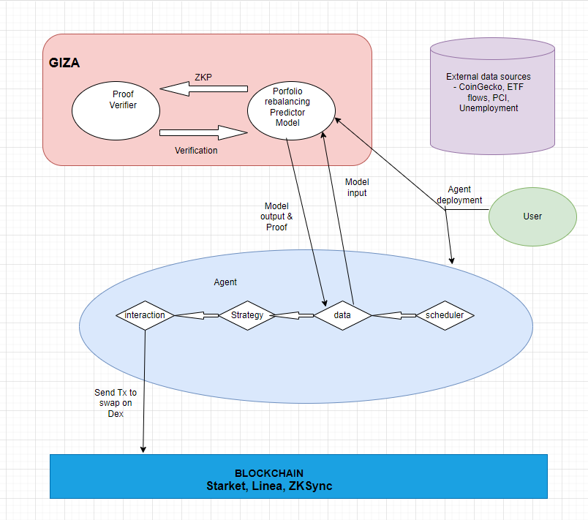

Attach file

Drop files here