|  |  |  |  |  |  |  |  |  |  |  |
| --- | --- | --- | --- | --- | --- | --- | --- | --- | --- | --- |
| Order ID: **220004509383720960-18650** | | | | | Order Date: **20-08-2023** | | | | |  |
| POS: **07-Delhi** | | | | | Invoice Date: **21-08-2023** | | | | |  |
| **SOLD BY(PHARMACY) BILL TO / SHIP TO (PATIENT)**  **Healthsaverz Medical LLP Shiv Kala**  Plot No 17 to 20, Electronic City, T-585 2nd floor, Baljeet Nagar, Gali  Harton Complex, Sector 18, Udyog no - 2, near Young Angel Public  Vihar Phase 4, School, , Delhi - 110008  GSTIN **06AAKFH4738G1ZA** Doctor Name **Ekta Jain** | | | | | | | | | |  |  |  |
| DL No. 20-5574-OB,21-5574-B,HR-66-1453-OW/H,HR-66-1453-W/H | | | | | | | |  | |  |  |  |
| # | ITEM NAME | MFR/MKT | HSN | BATCH | EXP | MRP | DIS | UNIT  PRICE | GST% |  | QTY | AMOUNT |
| 1 | TRAVACOM  EYE DROPS | ALCON  LABORATO | 30049  0 | 22A19  AX | 12/23 | 869.00 | 152.5 1 | 738.65 12.00 | |  | 1 | 716.49 |
| 2 | D3 MUST 60K  ORANGE | MANKIND  PHARMACE | 30045  0 | I6IAV0 03 | 02/24 | 70.49 | 12.37 | 59.92 12.00 | |  | 1 | 58.12 |
| 3 | SUPRADYN  DAILY | PIRAMAL  PHARMA LI | 21069  0 | MH028 1 | 07/23 | 54.90 | 2.75 | 52.16 18.00 | |  | 1 | 52.15 |
| 4 | SUPRACAL  2000 STRIP | PHARMED  PRIVATE L | 30049  099 | SPCP2 2013 | 06/24 | 318.00 | 55.81 | 270.30 12.00 | |  | 1 | 262.19 |
| 5 | SYNCA EYE  DROPS 5ML | PURE & CURE | 30049  0 | FHZ01 16 | 01/24 | 530.00 | 93.01 | 450.50 12.00 | |  | 1 | 436.99 |

**Tax Invoice**  Invoice no. : **C7021-22-1127158**



|  |  |  |
| --- | --- | --- |
| Taxable Amt | IGST % | IGST Amt |
| 1315.88 | 12.00 | 157.91 |
| 44.19 | 18.00 | 7.96 |
| 1360.07 |  | 165.87 |

**MRP Total 1842.39**

PharmEasy Savings @ 14.70% 270.87

Subtotal 1571.53

Coupon Savings 45.58

**Notes:**

**PHARMACIST**

Ajay Chauhan(PR No.: 38718)

Pharmacist signature

**For Healthsaverz Medical LLP**

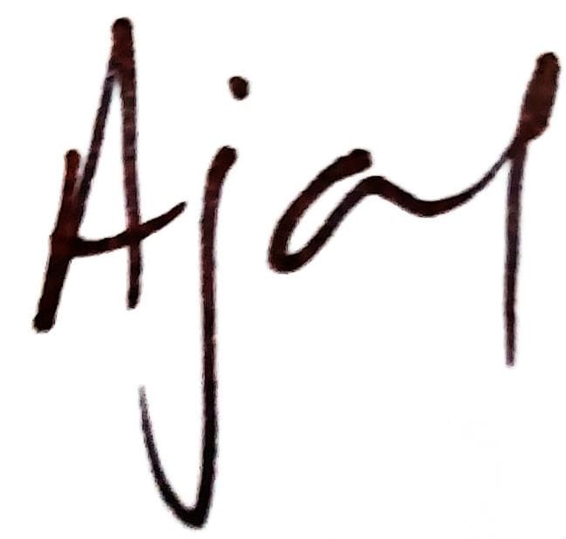

**1525.94**

**Total savings is Rs. 316.45/-**

**Total Invoice Amount**

Amount In Words : One thousand Five Hundred Twenty Five Rupees And Ninety Four paise.

Whether GST is payable on reverse charge - No. Keep the original invoice and barcode on medicines intact for returns. Pharmeasy is only a technology platform and facilitates the connect between the retailer and customer.



For details visit **https://pharmeasy.in/terms-and-conditions.**

Original For Receipent Duplicate For Transporter Triplicate For Supplier