|  |  |  |  |  |  |  |  |  |  |  |  |  |  |
| --- | --- | --- | --- | --- | --- | --- | --- | --- | --- | --- | --- | --- | --- |
| Order ID: **22000458939664949-163230** | | | | | Order Date: **02-08-2022** | | | | |  |  | |  |
| POS: | | | | | Invoice Date: **04-08-2022** | | | | |  |  | |  |
| **SOLD BY(PHARMACY) BILL TO / SHIP TO (PATIENT)**  **Healthsaverz Medical LLP Nain Chand**  Plot No 17 to 20, Electronic City, A113 New AshokNager, Gali  Harton Complex, Sector 18, Udyog no - 8,  Vihar Phase 4, Delhi - 110096  GSTIN **06AAKFH4738G1ZA** Doctor Name **Manish Kumar** | | | | | | | | | |  |  |  | | |
| DL No. 20-5574-OB,21-5574-B,HR-66-1453-OW/H,HR-66-1453-W/H | | | | | | | |  | |  |  |  | | |
| # | ITEM NAME | MFR/MKT | HSN | BATCH | EXP | MRP | DIS | UNIT  PRICE | GST% |  | QTY | AMOUNT | | |
| 1 | TRAVACOM  EYE DROPS | ALCON  LABORATO | 30049  0 | 22A19  AX | 12/23 | 869.00 | 762.55 | 738.65 12.00 | |  | 5 | 3,582.45 | | |
| 2 | D3 MUST 60K  ORANGE | MANKIND  PHARMACE | 30045  0 | I6IAV0 03 | 02/24 | 70.00 | 84.00 | 61.60 12.00 | |  | 10 | 616.00 | | |
| 3 | SUPRADYN  DAILY | PIRAMAL  PHARMA LI | 21069  0 | MH028 1 | 07/23 | 54.90 | 13.75 | 52.16 18.00 | |  | 5 | 260.80 | | |
| 4 | SUPRACAL  2000 STRIP | PHARMED  PRIVATE L | 30049  099 | SPCP2 2013 | 06/24 | 318.00 | 238.50 | 270.30 12.00 | |  | 5 | 1351.50 | | |
| 5 | SYNCA EYE  DROPS 5ML | PURE & CURE | 30049  0 | FHZ01 16 | 01/24 | 530.00 | 397.5 | 450.50 12.00 | |  | 5 | 2252.50 | | |

**Tax Invoice**  Invoice no. : **C7021-22-1126426**



**Notes:**

**PHARMACIST**

Ajay Chauhan(PR No.: 38718)

Pharmacist signature

**For Healthsaverz Medical LLP**

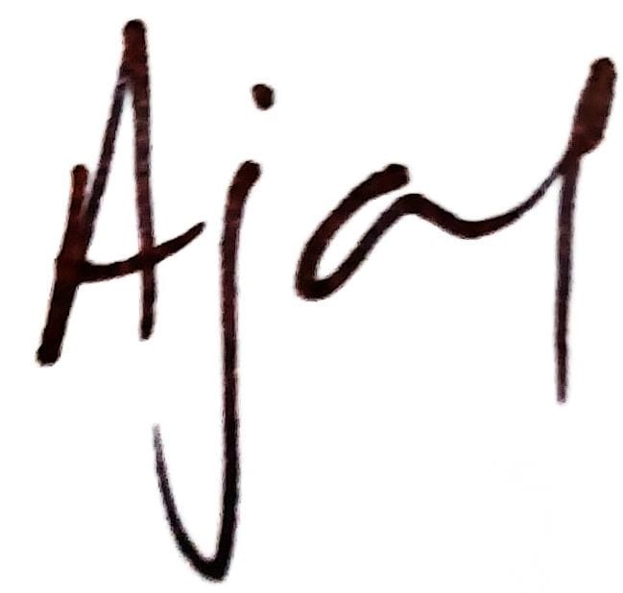

**8060.25**

**Total savings is Rs. 1496.25/-**

**Total Invoice Amount**

Amount In Words : Eight thousand Sixty Three Rupees And Twenty Five paise.

Whether GST is payable on reverse charge - No. Keep the original invoice and barcode on medicines intact for returns. Pharmeasy is only a technology platform and facilitates the connect between the retailer and customer.



For details visit **https://pharmeasy.in/terms-and-conditions.**

Original For Receipent Duplicate For Transporter Triplicate For Supplier