input­ none

output­ ten rows of asterisks starting with one, increasing by one each time.

assignment­ print the first pattern of the four only using for loops, print statements, and the string literal ‘\*’, without multiplying the string literal using the least statements as possible.

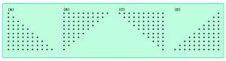

for loop to print 10 lines of how many asterisks there are for loop to print from one asterisk everytime it runs without skipping lines running as many times as needed.

print a line to skip to the next line