Flow Charts

Name: Ruhika Chatterjee

Period: Python Period 5

When you finish with this inquiry, you should be able to:

* Identify the purpose of flow charts
* Identify flow chart symbols
* Create Python code or pseudocode from a flow chart

**Flow charts are a graphical representation of an algorithm, often used in the design phase of programming to work out the logical flow of a program**

*Definition from http://www.wiley.com/college/busin/icmis/oakman/outline/chap05/slides/symbols.htm

There are many flow chart symbols, but we will only focus on a few basic ones.

Find the meaning of each symbol in a flow chart (use the Internet and/or look sample flow charts below):

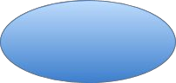

Oval: It tells you when the flowchart begins and ends.

Flowcharts can have multiple ends.



Flow Line: The lines determine the flow throughout the chart.

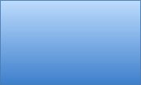

Rectangle: Used to show an action, process, task, or operation. It tells you what has to be done or an action that has to be taken. Usually has a verb. Most common shape.

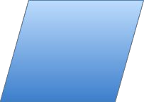

Parallelogram: It shows you input or output.

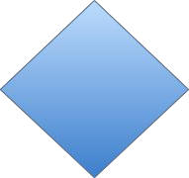

Diamond: Requires an answer to a question. Your answer determines where on the flow chart you go.

Here is a sample flow chart:

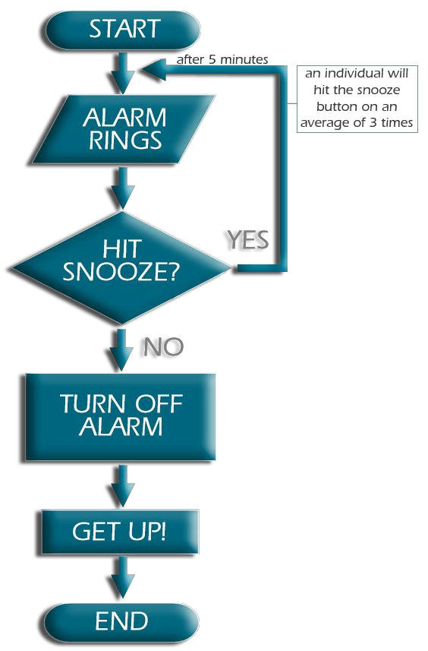

Describe the flow chart in a few sentences:

The flowchart shows a person in the morning after the alarm rings. The person faces a decision of whether to hit snooze or turn the alarm off. Then the person has to either get up or sleep for another 5 minutes.

Can you write Python code or pseudocode for the following flow chart?

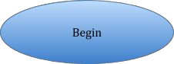

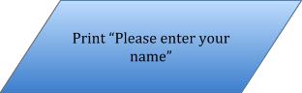

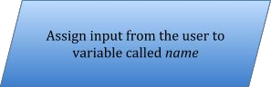

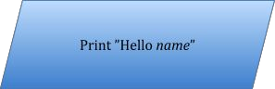



Write Python code/pseudocode here:

#Get the user’s name from the user and assign it to a variable print (“Please enter your name”) name = input ()

#Greet the user print (“Hello”, name)