PHS Python Programming: Looping Structures – FOR Loops

**Recorder: Ruhika Chatterjee**

**Date: 10/9/15**

**Python Period: 5**

**Learning Objectives:**

Students will be able to:

* Explain the difference between for loops and while loops
* Write a syntactically correct for loop in a program
* Describe the range() function and used it correctly within a for loop
* Evaluate assignments to determine if it should contain a for loop or a while loop

**Prior Knowledge:**

* Students have an understanding of while loops
* Students know the 3 elements of a coding loop o initialize a variable used in the condition statement

o include a condition statement that causes the loop to end when the condition is false o Within the loop body, update the variable used in the test condition

* Students have an understanding of predefined functions

**Questions:**

1. Use this code snippet to answer the questions below:

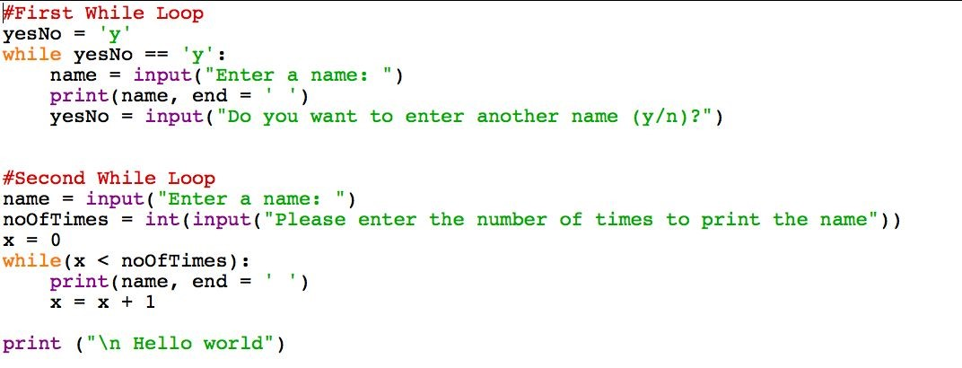

* 1. What is the same about the two while loops? What is different?

They both print the same thing.One has a sentinel control loop and the second one has a question in the beggining asking how many times the user wants to print it.

* 1. If the user enters 5 for noOfTimes, how many times will the second while loop run? 5 times

* 1. How many times will the first while loop run?

1 time

**When a block of code needs to be run a finite number of times, a FOR loop can be used**

1. Use these code snippets for the questions below:

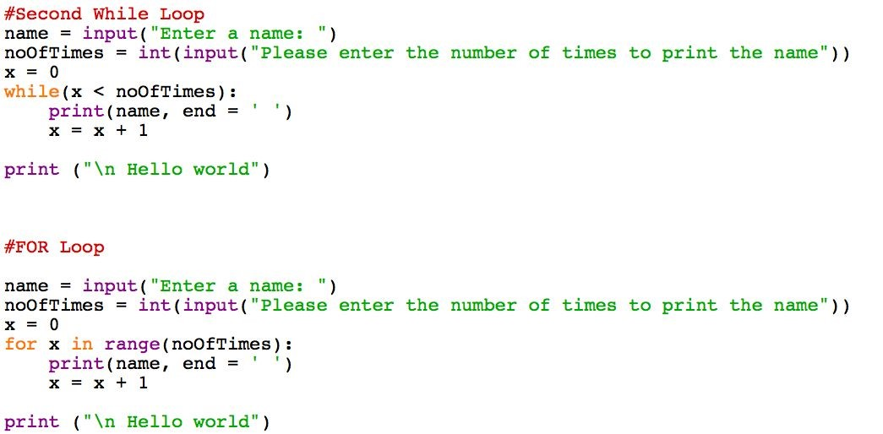

* 1. Enter and execute the above code. What is the output for each loop?

name = Ruhika noOfTimes = 5

RuhikaRuhikaRuhikaRuhikaRuhika

Hello World

* 1. Which code fragment is more concise (*clear, yet brief*​ ​)? The for loop

**The Python predefined range() function is used to produce a series of numbers. It can be used in a FOR loop to determine the number of times the loop is executed.**

1. Enter and execute the following code fragments. State the output:
   1. for x in range(5):

print(x, end=” “) _________0 1 2 3 4 _________________________

* 1. for x in range(1, 5):

print(x, end= “ “) _____________1234_________________________

* 1. for x in range(3, 20, 2): print(x, end = “ “) _____________35791113151719__________

* 1. numIterations = 6 for x in range(numIterations):

print(x, end = “ “) ________________012345___________________

* 1. numIterations = 6 for x in range(1, numIterations +1) print(x, end= “ “) ________________123456________________________

* 1. for x in range(10, 1, -1) print(x, end= “ “) ________________1098765432_________________________

1. Based on the answers to 3 a – f, explain in your own words what the range() function does. Include an explanation of the arguments.

Range prints the numbers between the two numbers, including the first number. If there is a third argument, then it prints the prints every __ of the number. It adds the third number to the last number printed. If it is negative, it counts backwards.

**In a FOR loop, you can include a list of values in place of the range() function**

1. Enter and execute the following code:

for x in [3, 6, 9, 12, 15, 18]:

print(x, end = “ “)

369121518

* + 1. Rewrite the code using the range() function.

for x in range (3, 21, 3):

print(x, end = "")

* + 1. Why would you use the range() function instead of a list of numbers?

It makes it much easier to read, write, and change the code. Also, it saves time if there are many numbers.

* + 1. What does the argument end = “ “ mean in the print() function?

It tells the interpreter not to start a new line.

1. Yesterday you learned about three actions that must occur in every loop:
   * 1. Initialize a variable used in the condition expression
     2. Include the condition expression that causes the loop to end when the condition is false
     3. Within the loop body, update the variable used in the condition statement

How are these three actions implemented in the following FOR loop?

for x in range(1, 5):

print(x, end = “ “)

The initialized variable is in the range function, and also in the condition expression. Also, x must be initialized. The updating variable is also in the range function. All three parts of the loop is in the range ().

1. Rewrite the following while loop as a for loop:

counter = 0.

while counter < 100:

print(“I will not throw paper airplanes in class”) counter = counter + 1

for x in range(0,100):

print (“I will not throw paper airplanes in class”)

1. Complete the arguments in the following range function so the code prints even numbers between 100 and 200 inclusive.

for x in range(_______________100, 202, 2__________________):

print(x)

1. Complete the arguments in the following range function so that the code prints: 77 to 7 in steps of 7. (77, 70, 63, 56,….)

for x in range(___________77, 0, -7_______________________):

print(x)

1. Is it better to use a FOR loop when you know the number of times the loop should be executed or when you do not know? Support your answer.

When you do know because it has a set range / inputed range unlike while.

1. Determine if a WHILE loop or a FOR loop is more appropriate for the following problems. Write the FOR or WHILE loop code snippet

* + 1. Prompt the user for 6 numbers. Calculate the average of the six numbers and print it to the screen.

For loop

total = 0 for x in range (6):

number = int (input ('Please enter a number:'))

total = total + number

average = total / 6

print ('The average is', average)

* + 1. Prompt the user to enter numbers until the user decides he/she is finished.

Calculate the average of the numbers and print it to the screen. While loop

yesNo = 'y' total = 0

numoftimes = 0

while yesNo == 'y': numoftimes = numoftimes + 1 num = int (input ('Please enter a number:')) total = total + num

yesNo = input ('Do you want to enter another number? (y/n):')

average = total / numoftimes print ('The average is', average)

c) Prompt the user for the amount of numbers she/he wants to enter. Prompt the user to enter those numbers, then find the average and print it to the screen.

For loop

total = 0

numoftimes = int (input ('How many numbers do you want to enter:'))

for x in range(numoftimes):

num = int (input ('Please enter a number:')) total = total + num

average = total / numoftimes

print ('The average is', average)

12) Write a FOR loop to print the following:

99 bottles of milk on the wall, 99 bottle of milk! Take 1 down, pass it around, 98 bottle of milk on the wall.

98 bottles of milk on the wall, 98 bottles of milk! Take 1 down, pass it around, 97 bottles of milk on the wall.

…1 bottles of milk on the wall, 1 bottles of milk! Take 1 down, pass it around, 0 bottles of milk on the wall.

numofbottles = 99 for x in range(99): print (numofbottles, 'bottles of milk on the wall,', numofbottles, 'bottles of milk! Take 1

down, pass it around,', end = '') numofbottles = numofbottles - 1

print (numofbottles, 'bottles of milk on the wall.')