PHS Python Programming: If/Else, Nested

If/Else, Elif

**Name:** Ruhika Chatterjee​

**Date:** 10/5/15

# Python Period:​ 5

**Learning Objectives:**

Students will be able to:

* Identify when to use if else statements
* Explain the purpose of nested if-else statements
* Correctly use the if-elif structure in a program
* Explain how to properly test code using the if-elif structure

# Prior Knowledge

* Students can use if statements in coding programs
* Students understand condition statements

1. Create a file YI_IfElseCode.py with the following code:

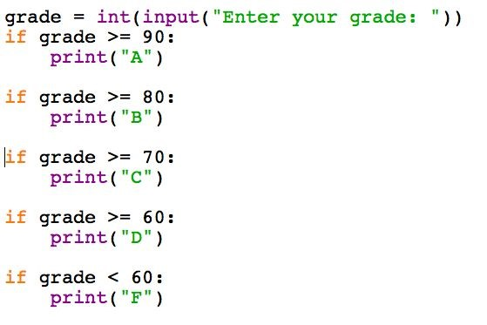

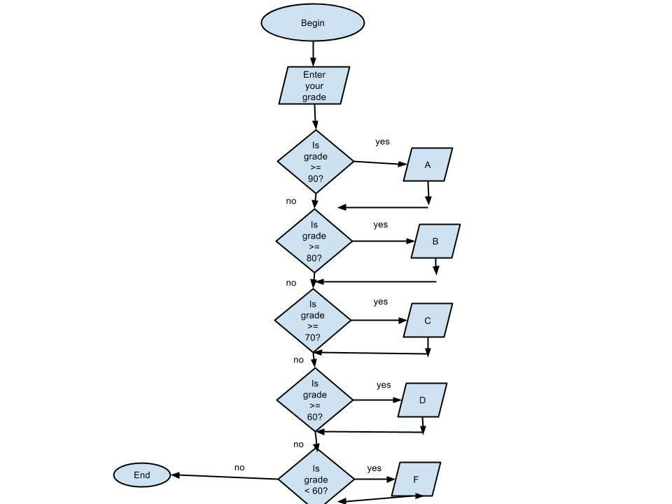

Record the expected result of the program for the following test input:

* 1. 55 ___________F_______________

* 1. 60 ___________D_______________

* 1. 70 __________C________________

* 1. 80 ___________B_______________

* 1. 90 __________A________________

Now run the program with the test data and record the actual results

* 1. 55 ___________F_________________
  2. 60 __________D__________________
  3. 70 _______________C____________

______D_____________

* 1. 80 __________B C D__________________
  2. 90 ________A B C D____________________

* 1. Did the actual test results match your expectations? If not, why not?

No because it runs through each if statement, even if it already went through one.

1. Modify the code to look like this:

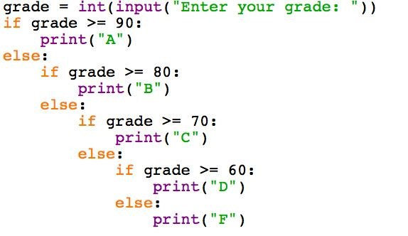

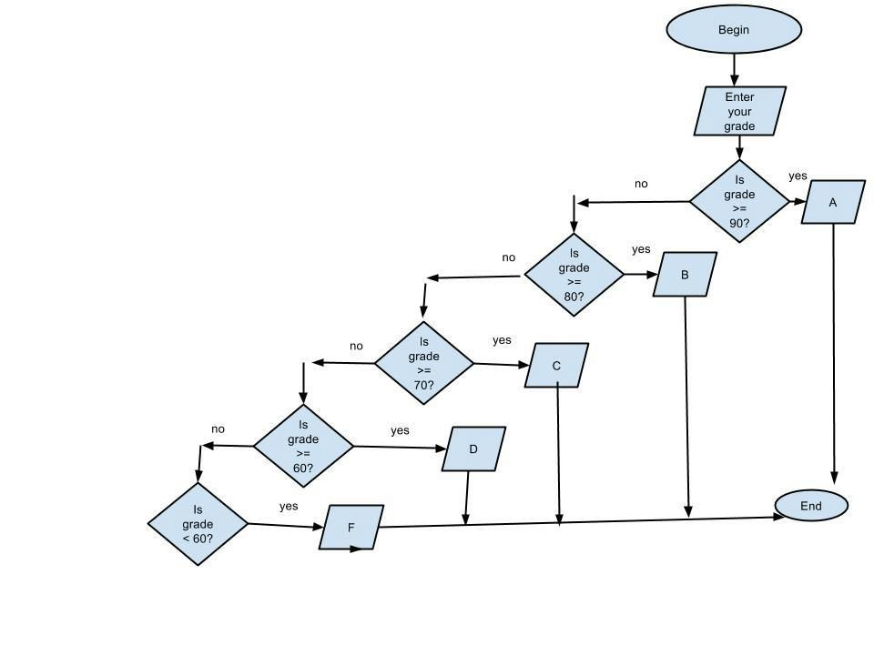

Enter the test data again and record the result:

* 1. 55 ___________F_________________

* 1. 60 ___________D_________________

* 1. 70 ___________C_________________

* 1. 80 ___________B_________________

* 1. 90 ____________A________________

* 1. What is the difference between the two code snippets?

In the first one, it ran through each if statement, in this one it ran through the statements till one was true, then stopped.

* 1. How many inputs are necessary to properly test the code snippets? Defend your answer.

There are at least 5 inputs needed to test the code snippets because you must test one variable for each possible output, which is 5 in this program.

1. Modify the code again to look like this:

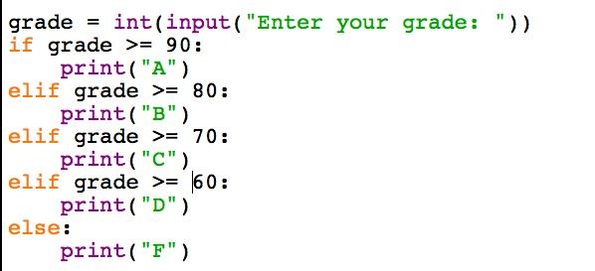

Enter the test data again (55, 60, 70, 80, 90)

* 1. How does the output for this code compare with the output for the previous program?

The program is the same as the previous program.

* 1. What new keyword is used in this code?

The new keyword used is “elif”.

* 1. Notice the syntax of this program compared to the previous program. Which program contains simpler indentation?

The last program has simpler indentation

**elif is the Python keyword that represents else if and allows you to test for one of several options. As soon as one of the condition statements is true, the rest are ignored.**

* 1. When is the code associated with the else statement executed? If all other if or elif statements in that block are false.

* 1. Describe how an if/elif/else statement works.

If the statement in the if statement is true, then the code under that is executed, and the rest in the statement is ignored. Then it checks if the next elif is true, if it is, it executes the code under that. It repeats this for all of the elif statements. If all the if and elif statements are false, then it executes the else statement.

* 1. How would you modify the last code snippet to print an error message if the grade entered is greater than 100 or less than 0?

Change the else to ‘elif grade < 60 and grade > 0:’ and add a else statement after that block that is ‘print (‘Error’)

* 1. Is the use of the else statement mandatory when creating an if/elif statement? Explain your answer.

The use of an else statement is not mandatory because when the interpreter is done running through the statements (that are false), it will just pass that block of code. It is like typing the following into python:

if hi == ‘hi’: #random if statement print (‘hi’) #random code else:

pass