**Python Activity 4: Predefined Functions**

“How can I use the built-in code that is already part of Python?”

# Learning Objectives

Students will be able to:

*Content:*

* Explain the purpose of a predefined function
* Explain the functions: abs(), pow(), int() round(), random
* Explain the math library functions: floor() and ceil()
* Explain the use of the **import** ​ statement​
* Explain the purpose of a function argument

*Process:*

* Write code that uses predefined functions

# Prior Knowledge

* Python concepts from Activities 1­3
* Understanding of flowchart input symbols

# Further Reading

● *Transitioning from Visual Logic to Python:*​ Chapter 4

**Model 1: Predefined functions in** ​***Python* print(), round(), abs(), pow(), int(), etc.** are known as ​ ​***predefined functions***​**.** ​Information that a function needs to do its work is sent to the function between the parentheses (). This information is known as an ***argument.*** ​To use a function, ​**call**​ the function. ​**input(“Enter your name”)**​ is a call to the ​***input***​ function sending the string “Enter your name” as an argument

**Critical Thinking Questions:**

1. What are the predefined functions in the following program?

1. 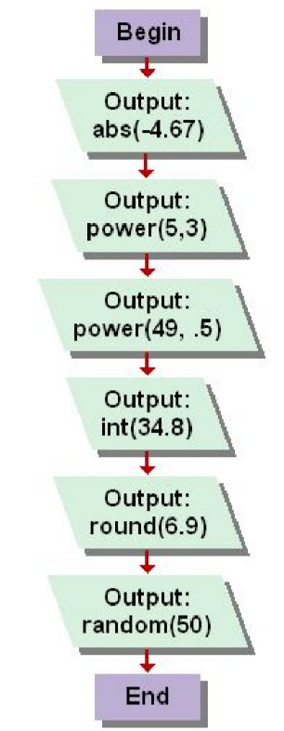Compare each statement in the Python program with its corresponding statement in the flowchart. Enter and execute the Python program.

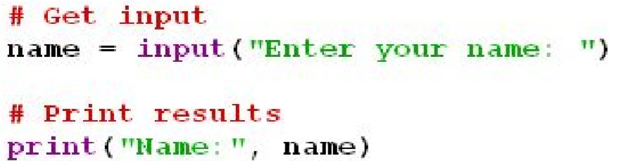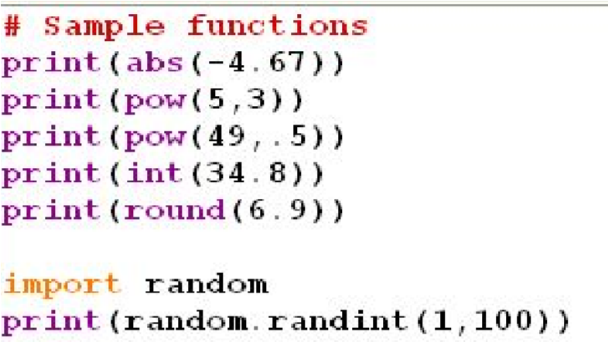

* 1. What is the output for each statement ?

|  |  |  |
| --- | --- | --- |
| ●  ●  ●  ●  ●  ● | print(abs(­4.67)) print(pow(5,3)) print(pow(49,.5)) print(int(34.8)) print(round(6.9)) import random | _____​4.67​_____  _____​125​_____  _____​7.0​_____  _____​34​_____  _____​7​_____ |

print(random.randint(1,100))_____​51​_____

* 1. Is there a difference between the ​round()​ function and the ​int()​ function? If so, what is the difference?

Yes, the round function checks if the decimal is closer to the higher number or not, while the int function just removes the decimal point and everything after it.

1. What is the output for each line of code? Verify your answers by executing the code and explain the answer given by the interpreter.
   1. print(abs(4.5))

**4.5**

* 1. print(int(“678”))

**678**

* 1. round(­5.6)

**­6**

* 1. import random random.randint(4,10)

**5**

What is the purpose of “​import random​”? What happens if you omit that line of code?

The purpose of import random is to call that module into the program If you don’t do that, you get a name error.

1. Write a definition of a ​***predefined function***​.

A predefined function is a function created in Python that can be so that you don’t have to use as many lines of code.

1. Circle the ​**argument**​ in the following predefined function: number = 45.78 answer = round​**(number)**

1. How many arguments can a function have?

As many as you want to have. The less there are, though, the easier for the computer to

read, and the better the program runs.

1. **answer = pow(4,3)**​. What is/are the argument(s) in this code?

Pow() means “to the power of”. It takes the first number as the base and the second as the

exponent. The arguments are the base, 4, and the exponent, 3.

1. If a function contains more than one argument, do you think the order of the arguments makes a difference? Explain your answer.

The order does matter, depending on the function that is being used. For example, in pow(), the first number will be the exponent and the second will be the exponent. Changing the order would change the answer. When you are adding, the order does not matter.

1. Execute the following code:

import math x = 4.7 y = 5.3 z = ­4.8 a = ­3.2 print(math.ceil(x)) print(math.ceil(y)) print(math.ceil(z)) print(math.ceil(a)) print(math.floor(x)) print(math.floor(y)) print(math.floor(z)) print(math.floor(a))

* + 1. Explain what the ​**ceil()**​ function does.

Ceil() rounds up, no matter the number.

* + 1. Explain the purpose of the ​**floor()** ​function.

Floor() rounds down, no matter the number. It is the same as the int function, It

just looks at the whole part of the number. You can use it for inputs, like int().

* + 1. Why are the calls to the ​**floor()** ​ and ​**ceil()**​ functions preceded by “​**math.”?**

Because the predefined function is part of the module math, so you must import

it, and then tell python that it must look under that module.

**Application Questions: Use the Python Interpreter to check your work**

1. Write a line of code that prints the integer portion of the number 21.45. print (int (21.45))

1. Write code that prompts the user for a floating point number and prints the smallest integer that is larger than the number the user entered. import math

num = math.ceil (float (input (‘Please enter a floating point number (a decimal):’))) print (‘The number is’, num)

1. Write a line of code that prints a random number between one and 6. import random

print(random.randint(1,6))

1. Assume that a user enters any number and that the number is stored in the variable ​**userNumber**​. Write a line of code that converts the input to a float. Then write a line of code that prints the positive value of the user’s input. userNumber = float (input (‘Enter a number:’)) print (abs(userNumber))

1. Write a line of code that calculates the square root of 900 and stores the result in the variable **answer.**

import math

answer = math.sqrt (900)

**Individual Homework Activity:**

1. Chapter 4 Review: p.36 #2