Variable Scope Inquiry

video on Global and Local Variable Scope

**Name: Ruhika Chatterjee Python Period: 5**

Type the following code snippet in the Python Tutor Visualizer to answer the following questions:

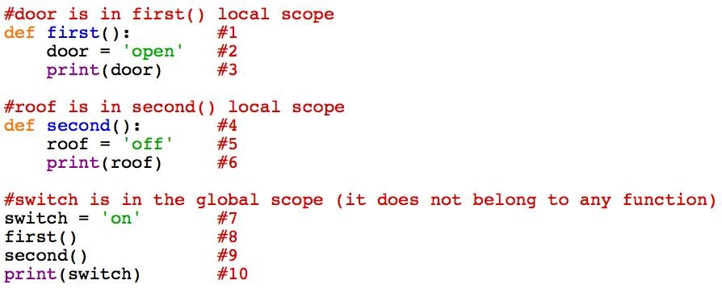

1. What line of code is the first to be executed? ​Line # 7

1. Stop after executing line #2. Which variables are visible (are listed in the visualizer)?

Switch and Door

* 1. Is variable ‘roof’ visible? No​​ ​**Note: variable ‘door’ is in the scope of function *first***​​.

1. Stop after executing line #5. Which variables are visible? Switch and Roof​
   1. Is variable ‘door’ visible? No​​ ​**Note: variable ‘roof’ is in the scope of function *second***​.

1. What variable was visible during the entire run of the program? Switch​ ​ ​**Note: variable**

**‘switch’ is in the global scope (it belongs to the entire program, not a specific function).**

1. Read the comments in the code snippet. Based on the comments and your answers to questions 1 ­ 4,and give a definition for the word scope:

Scope is where a variable can be seen, either locally (in a function) or globally.

***A simple definition of scope is the part of a computer program to which a variable***

***belongs.***​ ​*A “local” variable is in the scope of a function. Global variables are in the scope of the program (they are visible the entire time the program is running).*

Type the following code snippet in the Python Tutor Visualizer to answer the following questions:

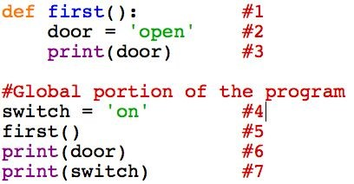

1. Stop on line #2. What scope does the variable ‘door’ belong to? Local (first)​

1. Continue to execute the code to line #6. Line #6 is in the global scope of the program (code has scope also!). A syntax error will occur. What is the error? ​NameError

1. Look at the visualizer screen. Is the variable ‘door’ listed anymore? ​No

1. Based on your answer to 6 ­ 8, why has the syntax error occurred?

The variable ‘door’ was in the local scope of the function first, and can no longer be seen by the code of the global scope.

***Principle #1: Code in the global scope of the program cannot use variables local to functions***

Type the following code snippet in the Python Tutor Visualizer to answer the following questions:

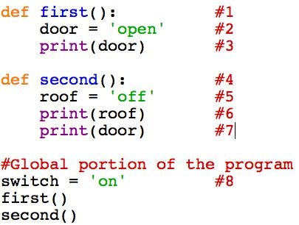

1. Execute line #6 and stop. What variables are currently visible in the Python Tutor visualizer? ​Switch and Roof

1. Execute line #7. A syntax error occurs. What is the error? NameError​

1. What caused the syntax error?

A local variable was called in a different function from where it was defined.

***Principle #2 Code in a function’s local scope cannot use variables in the scope of a different function.***

Type the following code snippet in the Python Tutor Visualizer to answer the following questions:

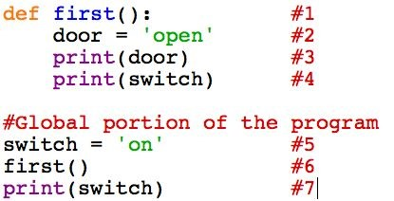

1. Does this code have any syntax errors? ​No

1. Define the scope of the variables in the code:
   1. door: local (first)​
   2. switch: ​global

1. What is the output of this code? open on on

***Principle #3 Global variables can be ACCESSED (and used) in functions*** Change the above code to this:

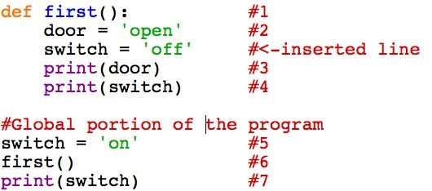

1. Does this code have a syntax error? ​No

1. What is the output of this code? How is it different than the code snippet above questions 13 & 14? open

off on

The second printed is off here, and was on above.

1. Execute the code again and stop at line #3. How many variables named ‘switch’ are listed on the visualizer screen? 2​
   1. Define the scope of the variables visible at this point:
      * 1. switch: ​global
        2. switch: ​local (first) iii. door: ​local (first) ***Principle #4 A global variable cannot be changed inside a function. If code is written to assign a value to a variable in a function, that variable is local to the function.***
2. If

­ functions cannot access variables local to other functions and

­ functions cannot change global variables

How do functions get values needed to do work and how do they pass values to other functions? Hint: think about programs WebShopping and MyStory

Functions use return variables and parameters to get the values that they need.