Indiana AI Document Verification Integration — Architecture Guide

Audience: Developers joining the project
Author: Solution Architecture
Status: POC (proof-of-concept)
Runtime: .NET 8 · ASP.NET Core Web API · Clean Architecture

Table of Contents

1. [What this project is (and is not)](#1-what-this-project-is-and-is-not)
2. [The business problem](#2-the-business-problem)
3. [System context — who talks to whom](#3-system-context--who-talks-to-whom)
4. [The five APIs](#4-the-five-apis)
5. [Architectural style: Clean Architecture](#5-architectural-style-clean-architecture)
6. [Project structure & responsibilities](#6-project-structure--responsibilities)
7. [The request lifecycle (end to end)](#7-the-request-lifecycle-end-to-end)
8. [Key abstractions (the seams)](#8-key-abstractions-the-seams)
9. [Mock vs live — the toggle](#9-mock-vs-live--the-toggle)
10. [The domain model](#10-the-domain-model)
11. [Validation & error codes](#11-validation--error-codes)
12. [Cross-cutting concerns](#12-cross-cutting-concerns)
13. [Testing strategy](#13-testing-strategy)
14. [How to run & explore](#14-how-to-run--explore)
15. [Design decisions & trade-offs (FAQ)](#15-design-decisions--trade-offs-faq)
16. [Roadmap to production](#16-roadmap-to-production)
17. [Glossary](#17-glossary)

1. What this project is (and is not)

This is a proof-of-concept that demonstrates the architecture of the Indiana
AI Document Verification integration. Its job is to make the agreed design
tangible and runnable so the team can validate the contracts and the flow
before committing to the full build.

It IS:
* A faithful implementation of the real API contracts (document_upload,
document_validate, GetEDMSFileQuery) — same JSON shapes as the AI team's schema.
* A working ASP.NET Core service with Swagger you can call today.
* A clean, layered codebase organized so the mocks can be replaced with live
integrations without rewrites.

It is NOT:
* A production system. The AI verification engine, the File Management Server
(FMS/EDMS) and the results database are mocked.
* The Screener flow (APIs 4 & 5) — those are out of scope for this POC.

> Mental model: think of this as the "AI Integration Gateway" — the
> middleware that sits between the Provider Portal and the AI Verification
> Service, doing mapping, routing, correlation and orchestration.

2. The business problem

Indiana Medicaid provider enrollment requires document verification. A
provider (or facility) submits an enrollment with attachments — W-9, hospital
license, CLIA certificate, DEA certificate, etc. Someone has to confirm that
what the provider typed matches what the documents actually say.

Doing this manually is slow and error-prone. The AI Verification Service
automates it: it reads each uploaded document, extracts the key fields, and
compares them against the entered enrollment data, flagging mismatches (wrong
document type, mismatched license number, mismatched address, expired dates,
and so on).

This project is the integration layer that lets the Provider Portal drive
that AI service.

3. System context — who talks to whom

┌─────────────────┐ document_upload / validate ┌───────────────────────────┐
│ Provider Portal │ ─────────────────────────────► │ AI Verification Service │
│ │ ◄───────────────────────────── │ (Enso) │
└─────────────────┘ ack / validation results └───────────┬───────────────┘
│ needs the file bytes
▼
┌───────────────────────────┐
│ File Management Server │
│ (FMS / EDMS) │
└───────────────────────────┘

┌─────────────────┐ screener/document_upload ┌───────────────────────────┐
│ Screener Service│ ─────────────────────────────► │ AI Verification Service │
│ (Appian) │ ◄───────────────────────────── │ │
└─────────────────┘ peApplicationReviewResponse └───────────────────────────┘
(APIs 4 & 5 — out of scope for this POC)

In this POC, we play the role of the AI Integration Gateway / AI Verification
Service boundary. We accept the portal's calls, and we *simulate* the AI engine
and the FMS behind them.

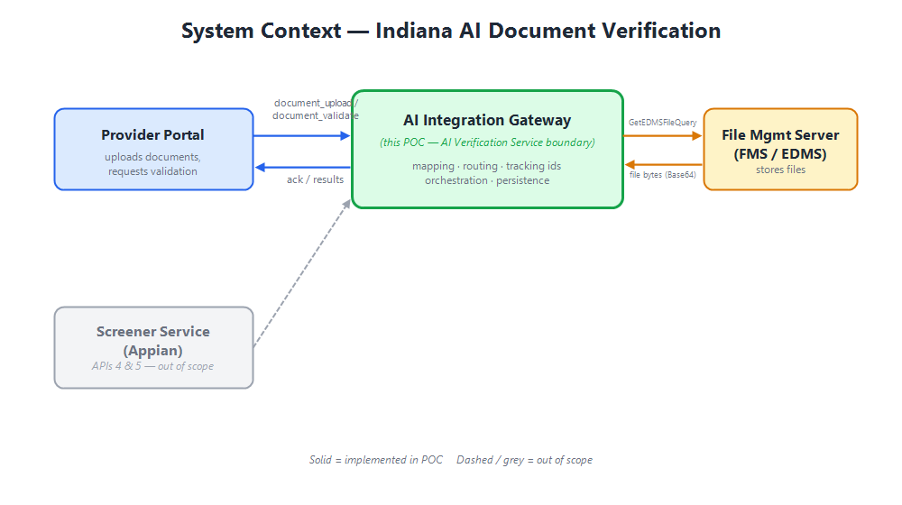

4. The five APIs

* # API Endpoint (real) Source → Target Auth In POC?
* --- ----- ----------------- ----------------- ------ ---------
* 1 Document upload /pe/document_upload Portal → AI Service X-API-Key, X-Source ✅ POST /api/document-upload
* 2 FMS file download .../GetEDMSFileQuery AI Service → FMS — ✅ POST /api/artifact-retrieval
* 3 Document validate /pe/document_validate Portal → AI Service X-API-Key, X-Source ✅ POST /api/document-validate
* 4 Screener request /pe/screener/document_upload Screener → AI Service X-API-Key, X-Source ❌ out of scope
* 5 Screener disposition peApplicationReviewResponse AI Service → Screener — ❌ out of scope

Upload vs Validate — same request body, different phase:
* Upload (1) is a fast *acknowledgement*. It maps the payload, mints tracking
ids, confirms routing, and returns ack_status (1002/PASS). It does not
fetch files or run the AI.
* Validate (3) is the *real work*. For each attachment it pulls the file
(via API 2), runs the AI comparison, persists a result, and returns
failedDocs + resultsSummary (2000 PASS / 2001 FAIL).

5. Architectural style: Clean Architecture

We use Clean Architecture (a.k.a. Ports & Adapters / Hexagonal). The guiding
rule is the Dependency Rule: source code dependencies point inward only.

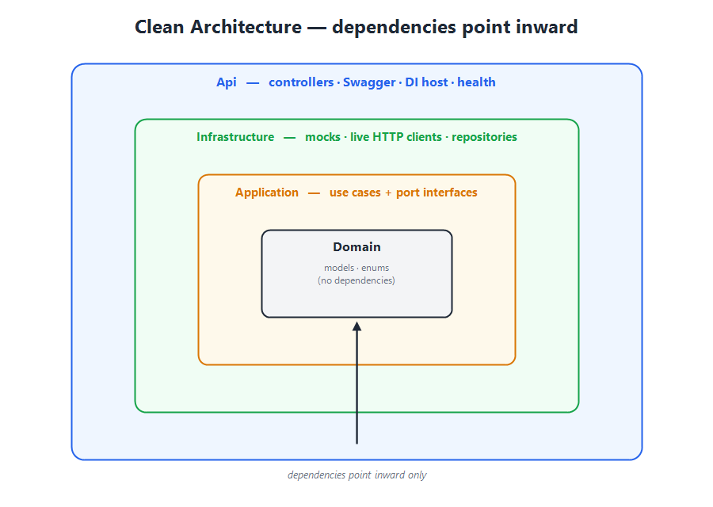

┌───────────────────────────────────────────────┐
│ Api │ ← controllers, Swagger, DI host
│ ┌───────────────────────────────────────┐ │
│ │ Infrastructure │ │ ← mocks, live HTTP clients, repos
│ │ ┌───────────────────────────────┐ │ │
│ │ │ Application │ │ │ ← use cases, port interfaces
│ │ │ ┌───────────────────────┐ │ │ │
│ │ │ │ Domain │ │ │ │ ← models, enums (no dependencies)
│ │ │ └───────────────────────┘ │ │ │
│ │ └───────────────────────────────┘ │ │
│ └───────────────────────────────────────┘ │
└───────────────────────────────────────────────┘

Dependencies: Api → Application → Domain
Api → Infrastructure → Application → Domain

Why this matters to you as a developer:
* Domain and Application know *nothing* about HTTP, Enso, or FMS. They're
pure C# you can unit-test in milliseconds.
* Infrastructure implements the interfaces the Application *declares*. This is
the "dependency inversion" — the inner layer owns the contract, the outer layer
obeys it.
* Swapping a mock for a real integration is an Infrastructure-only change.

6. Project structure & responsibilities

Indiana.AI.Integration.sln
├── src
│ ├── Indiana.AI.Domain # The "what": models & enums. Zero dependencies.
│ ├── Indiana.AI.Application # The "how": use cases + port interfaces (Abstractions).
│ ├── Indiana.AI.Infrastructure # The "with what": mocks, live HTTP clients, persistence.
│ └── Indiana.AI.Api # The "entry": controllers, Swagger, DI wiring, health.
├── tests
│ └── Indiana.AI.Tests # xUnit tests for the inner layers.
└── samples # Real schema (API-Schema.yaml) + sample payloads.

Indiana.AI.Domain
The vocabulary of the system. Plain C# classes (POCOs) and enums that mirror the
PE API schema: Route, Enrollment, ProviderInformation (and its many
sub-objects), Attachment, UploadRequest, UploadResponse,
DocumentValidationResponse, the FMS GetEdmsFileRequest/Response, plus internal
types (TrackingContext, AIVerificationPayload, VerificationResult).
No behavior, no dependencies — this layer can't reference anything else.

Indiana.AI.Application
The business logic and — crucially — the interfaces (ports) that describe
what the outer world must provide:
* Abstractions/ — IAiPlatformClient, IAIPayloadMapper, IRouter,
IValidationEngine, IWorkflowService, IDocumentAdapter, IAdapterResolver,
IArtifactRetrievalService, IDocumentVerificationService,
IVerificationResultRepository.
* Mapping/ — AIPayloadMapper (enrollment → canonical AI payload, tracking ids).
* Services/ — Router, ValidationEngine, WorkflowService,
LocalAiPlatformClient (the in-process/mock AI platform).

Indiana.AI.Infrastructure
Concrete implementations of the ports:
* Adapters/ — FmsAdapter + MockEdmsRepository (seeded PDFs),
FileStorageAdapter, AdapterResolver, MockDocumentVerificationService +
MockExtractionDataset.
* Live/ — EnsoAiPlatformClient (real API 1 & 3), RealFmsAdapter (real API 2).
* Persistence/ — InMemoryVerificationResultRepository.
* Configuration/ — IntegrationOptions (the UseMocks toggle + endpoints).

Indiana.AI.Api
The composition root and HTTP surface:
* Controllers/ — DocumentsController (the 4 document routes),
StatusController.
* Program.cs — registers AddApplication() + AddInfrastructure(config),
configures Swagger, health checks, and the root→Swagger redirect.

7. The request lifecycle (end to end)

Here's what happens on POST /api/document-validate (the most interesting path):

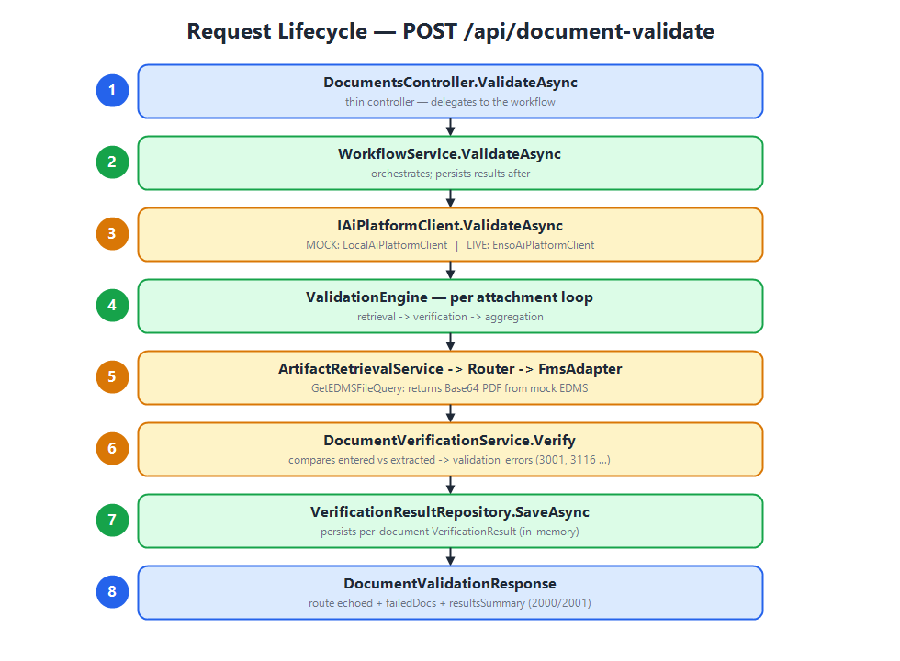

1. DocumentsController.ValidateAsync(request)
│
2. IWorkflowService.ValidateAsync(request)
│ (WorkflowService)
3. ├─► IAiPlatformClient.ValidateAsync(request)
│ (LocalAiPlatformClient in mock mode / EnsoAiPlatformClient in live mode)
│ │
4. │ └─► IValidationEngine.ValidateAsync(request, tracking)
│ │ for each attachment:
5. │ ├─► IArtifactRetrievalService.RetrieveByFileIdAsync(fileId)
│ │ └─► IRouter.ResolveChannel("Provider Enrollment") → "FMS"
│ │ └─► IAdapterResolver.Resolve("FMS") → FmsAdapter
│ │ └─► FmsAdapter.GetArtifactAsync(fileId) → EDMS record (Base64 PDF)
6. │ ├─► IDocumentVerificationService.Verify(attachment, provider, artifact)
│ │ └─► compares entered vs extracted → List<ValidationError>
7. │ └─► aggregates FailedDocs + ResultsSummary (counts)
│
8. ├─► for each attachment: IVerificationResultRepository.SaveAsync(result)
│
9. └─► returns DocumentValidationResponse (route echoed + failedDocs + resultsSummary)

Reading the flow: the controller is thin. WorkflowService orchestrates.
The AI platform boundary (IAiPlatformClient) is where mock/live diverge. Under
the mock, the ValidationEngine walks each document through retrieval →
verification → aggregation, and the workflow persists the per-document outcome.

The upload path (API 1) is the same shape but stops at the acknowledgement —
no retrieval, no verification, no persistence.

8. Key abstractions (the seams)

These interfaces are the joints where the system flexes. Learn these and you
understand the architecture.

* Interface Responsibility Mock impl Live impl
* ----------- ---------------- ----------- -----------
* IAiPlatformClient The AI Verification Service boundary (upload + validate) LocalAiPlatformClient EnsoAiPlatformClient
* IDocumentAdapter Fetch a document artifact for a channel FmsAdapter RealFmsAdapter
* IAdapterResolver Pick the adapter for a channel AdapterResolver (same)
* IArtifactRetrievalService Retrieve via router + adapter (API 2) ArtifactRetrievalService (same)
* IDocumentVerificationService The AI extraction/compare (mocked) MockDocumentVerificationService *(replace w/ real AI)*
* IVerificationResultRepository Persist/read results InMemoryVerificationResultRepository *(replace w/ DB)*
* IRouter Module → channel routing Router (same)
* IValidationEngine Orchestrate per-document validation ValidationEngine (same)
* IWorkflowService Top-level facade for controllers WorkflowService (same)
* IAIPayloadMapper Enrollment → canonical payload + tracking AIPayloadMapper (same)

The adapter framework deserves a special mention. Multiple
IDocumentAdapters register (each with a Channel like "FMS" or
"FileStorage"); AdapterResolver builds a dictionary keyed by channel and
hands back the right one at runtime. This is the Strategy pattern — add a new
back-end by adding a new adapter, no changes to callers.

9. Mock vs live — the toggle

A single config flag selects the mode. No code changes to switch.

// appsettings.json
"Integration": {
"UseMocks": true, // false → live Enso + FMS
"Enso": {
"BaseUrl": "https://enso-apis.enso.dev.pgwcloud.net",
"UploadPath": "/pe/document_upload",
"ValidatePath": "/pe/document_validate",
"ApiKey": "", // issued X-API-Key
"Source": "provider_portal" // X-Source
},
"Fms": {
"BaseUrl": "https://bas-fltest-perf.mapshc.com/HPP.Core.FileMgmtApi",
"GetEdmsFilePath": "/R6.0/FileMgmtQuery/GetEDMSFileQuery"
}
}

AddInfrastructure(configuration) reads UseMocks:

return options.UseMocks
? services.AddMockIntegration() // LocalAiPlatformClient + FmsAdapter + mock AI
: services.AddLiveIntegration(options); // EnsoAiPlatformClient + RealFmsAdapter (typed HttpClients)

The live registration configures typed HttpClients with the base address and
the X-API-Key / X-Source headers. Because the two integrations
(IAiPlatformClient and IDocumentAdapter) are independent, you can run a
hybrid — e.g. live FMS + mock AI — by mixing the registrations.

> Design intent: the POC ships mock-first (UseMocks: true) so it runs with
> zero credentials. Onboarding = drop in the API key and flip the flag.

10. The domain model

The models mirror the PE API schema exactly (property names via
[JsonPropertyName]), so the wire JSON matches the AI team's samples.

The envelope — Route. Every AI-service call carries a route block. Think
of it as *headers in the body*: domain, apiVer, tenantID, appClient,
requestGUID (correlation id), requestType (document_upload /
document_validate), timeStampId. Responses echo it back so callers can
correlate.

The payload — Enrollment → ProviderInformation. This is deep and real:
business & individual info, specialties, CLIA/license/DEA details, PE
certifications, malpractice insurance, addresses, attachments, EFT, education,
backdate request, etc. Attachment is the key sub-object:
{ fileId, fileName, attachmentTypeCode, attachmentTypeName }.

Responses.
* UploadResponse = route + ack_status { code, status, processingTimeMs, timestamp }.
* DocumentValidationResponse = route + failedDocs[] + resultsSummary
(with totalDocs / passedDocs / failedDocs / errorDocs).
* GetEdmsFileResponse = the FMS where / queryResult envelope, with
fileData as Base64.

Internal (not on the wire). TrackingContext (correlation threaded through
the workflow), AIVerificationPayload (the canonical shape the mapper produces),
VerificationResult (what we persist).

11. Validation & error codes

Two families of codes:

Acknowledgement / summary:

* Code Meaning
* ------ ---------
* 1002 Upload accepted
* 2000 Validation passed
* 2001 Validation failed
* 4004 File / result not found

Field-level validation_errors (from the AI sample):

* Code Meaning
* ------ ---------
* 3001 attachment type mismatch
* 3101 name / legal name mismatch
* 3109 address mismatch
* 3116 CLIA number mismatch
* 3120 tax id mismatch
* 3123 license number mismatch
* 3127 effective date mismatch
* 3129 expiration / end date mismatch
* 3133 generic field mismatch
* 3150 issue date mismatch

How the mock produces them. MockExtractionDataset holds a per-fileId
"extraction profile" — what the AI *pretends* to read from each document.
MockDocumentVerificationService compares each profile field against the entered
enrollment value; a mismatch emits the matching error code. This is why
validating the provided sample payload reproduces the AI's sample response
(5 failed docs across 6 attachments, same codes and entered/extracted values).

In live mode, this whole step is replaced by the real AI engine — the codes
and shapes stay identical, only the source of truth changes.

12. Cross-cutting concerns

* Correlation / tracing. AIPayloadMapper derives TrackingContext from
route.requestGUID and enrollment.trackingID, threaded through validation and
persistence so one enrollment is traceable end-to-end.
* Serialization. System.Text.Json with explicit [JsonPropertyName] to
match the exact wire contract (ack_status, validation_errors, camelCase).
* Async & cancellation. All I/O-facing methods are async and take a
CancellationToken.
* Error handling. Missing artifacts surface as KeyNotFoundException, mapped
to 404 + code 4004 at the controller. In validation they're counted as
errorDocs.
* Health & discoverability. GET /health, GET /api/status, Swagger at
/swagger, root redirects to Swagger, XML doc comments surfaced in the UI.
* Configuration & DI. Options bound from the Integration section;
everything wired through constructor injection (no service-locator, no statics).

13. Testing strategy

Indiana.AI.Tests (xUnit) targets the inner layers, which are pure and fast:

* Payload mapping — tracking ids derived from route/enrollment; projection.
* Router — module→channel mapping, defaults, supported channels.
* Artifact retrieval — GetEDMSFileQuery envelope, Base64 PDF, not-found.
* Validation engine — PASS on clean doc; FAIL with 3001 and the CLIA
field-mismatch codes; multi-document counts.
* Local AI platform client — ack 1002 + route echo; validate delegates.
* Repository — save / get / overwrite.

Tests construct the mock stack directly (no HTTP), so the suite runs in ~100ms.
The Tests project intentionally does not reference the Api project, so it runs
on the plain net8.0 runtime.

> Testability is a feature of the architecture, not an afterthought. Because
> the logic lives in the inner layers behind interfaces, we test behavior without
> spinning up a web host or hitting a network.

14. How to run & explore

# Build & test
dotnet build Indiana.AI.Integration.sln
dotnet test Indiana.AI.Integration.sln

# Run the API (mock mode by default)
dotnet run --project src/Indiana.AI.Api

Open the root URL → it redirects to Swagger. Or use
src/Indiana.AI.Api/Indiana.AI.Api.http and the payloads in samples/.

Suggested first exploration:
1. POST /api/document-upload with samples/1 - Doc Upload Request.json → see the 1002 ack.
2. POST /api/document-validate with samples/3 - Doc Validate Request.json → see 5 failed docs with real codes.
3. GET /api/verification-results/{fileId} → see the persisted outcome.
4. POST /api/artifact-retrieval with { "where": { "edmsFileId": "9eb84ea3-…" } } → see the Base64 PDF envelope.

15. Design decisions & trade-offs (FAQ)

Q: Why mock behind interfaces instead of just stubbing the controllers?
So the *real* orchestration, mapping, routing and persistence code runs in the
demo. Only the true external boundaries (AI engine, FMS, DB) are faked. That
makes the POC a genuine skeleton of production, not a throwaway.

Q: Why is IAiPlatformClient separate from IValidationEngine?
IAiPlatformClient is the *external boundary* (could be an HTTP call to Enso).
IValidationEngine is our *internal orchestration* used by the local/mock
implementation. In live mode the engine isn't used — Enso does that work.

Q: Why an adapter framework for a single FMS?
It costs almost nothing and it models the real intent: retrieval is
channel-based, and future back-ends (secondary EDMS, file storage) slot in
without touching callers. FileStorageAdapter exists to prove the point.

Q: Why in-memory persistence?
It's a POC. IVerificationResultRepository is the seam; swap in EF Core/Dapper
later with no ripple.

Q: Why does the response echo route?
The real contract does. It lets asynchronous/multi-hop callers correlate replies
to requests.

Q: Why target net8.0 when the SDK is newer?
Requirement. The Api project sets RollForward=Major so it still runs on a newer
installed runtime.

16. Roadmap to production

1. Wire the live AI engine. Replace MockDocumentVerificationService — or,
more simply, run in live mode where Enso does validation via
EnsoAiPlatformClient. Supply X-API-Key / X-Source.
2. Wire the real FMS. RealFmsAdapter already calls GetEDMSFileQuery;
confirm the exact request/response envelope against the live FMS contract.
3. Durable persistence. Implement IVerificationResultRepository over a DB.
4. Screener APIs (4 & 5). Add the screener upload endpoint and the Appian
peApplicationReviewResponse callback.
5. Hardening. AuthN/Z on our endpoints, retry/circuit-breaker (Polly) on the
HTTP clients, structured logging + correlation propagation, input validation,
idempotency on timeStampId.

Each step is additive and localized to Infrastructure — the Domain,
Application, and API layers stay put. That is the whole point of the design.

17. Glossary

* Term Meaning
* ------ ---------
* AI Verification Service (Enso) External service that reads documents and validates them against entered data (APIs 1, 3, 4).
* FMS / EDMS File Management Server / Electronic Document Management System — stores the uploaded files (API 2, GetEDMSFileQuery).
* Provider Portal The enrollment front-end that uploads documents and requests validation.
* Screener Service Appian workflow that submits enrollments for AI review (APIs 4 & 5).
* Route The envelope/header block on every AI-service call (domain, tenant, correlation id, request type).
* Attachment A document reference: fileId + fileName + attachmentTypeCode/Name.
* Artifact The actual document bytes retrieved from FMS (returned Base64).
* Channel The logical back-end an adapter serves (e.g. FMS, FileStorage).
* Tracking / Correlation id Ids (trackingID, requestGUID) that trace one enrollment across services.
* Port / Adapter An interface (port) in Application, implemented (adapter) in Infrastructure.

