# iCONSULT: A BUSINESS CONSULTANCY INTEGRATED WITH PROJECT MANAGEMENT SYSTEM AND CLIENT MANAGEMENT SYSTEM

A Thesis

Presented to the Faculty of

**Computer Studies Department**

College of Science

Technological University of the Philippines

Ayala Boulevard, Manila

By

**Bautista, Clarieza H.**

**Cabigting, Monique Kyle**

**Rueras, Ritchelle T.**

**San Diego, Trishia**

**In Partial Fulfillment of the**

**Requirements for the Degree**

**Bachelor of Science in Information System**

**September 2024**

**Chapter 1**

**THE PROBLEM AND ITS SETTING**

**Introduction**

In today’s rapidly evolving business landscape, entrepreneurs and companies worldwide are constantly seeking strategies to stay competitive and achieve sustainable growth. A career in business consulting relies on planning, organization, creativity, and strategic thinking to help businesses troubleshoot and problem-solve effectively (Forage, 2024). “Business consulting involves providing expert advice and guidance to organizations to help them improve their operations, achieve their goals, and solve complex business problems,” says Michael Tschudy. A business consultant is a professional with a wide array of skills who assists business owners with their endeavors. Consultants are knowledgeable because of their education and previous experience. Additionally, business consultants provide management consulting to help organizations improve their performance and efficiency (Peek S. 2024).

Consulting is essentially an advisory service which means that, in principle, consultants are not used to running organizations or to take decisions on behalf of the managers. They have no direct authority and cannot implement or decide changes. The responsibility of business consultants in the Philippines and other countries lies solely on the quality and integrity of their advice. It is up to the clients to carry all the responsibilities they may face from following it.

According to (Afsaneh and Chesteen. 2019) A mail survey of 126 businesses that had sought assistance from the SBDC at the University of Utah was conducted. Results obtained from 106 respondents (84% response rate) indicate that overall, business

managers/owners were highly satisfied with the services they received and that they found them useful. They also reported that the consulting had a positive impact on their business. Appropriateness and lack of consultant expertise were cited as primary reasons for not implementing some of the recommendations. Some organizations employ consulting companies to provide useful ideas and a professional service (O’Mahoney & Markham, 2013). Fincham and Clark (2002) describe the management consultancy industry as one of the fastest growing industries. With these challenges, this project proposes the integration of a comprehensive Project Management System and Client Management System within iConsult to address the challenges faced by consultants and enhance their ability to deliver successful outcomes for clients. By leveraging technology and implementing efficient systems, iConsult aims to optimize its consulting operations, drive client satisfaction, and maintain a competitive edge in the business consultancy industry in the Philippines.

**Background of the Study**

The business consultancy industry plays a crucial role in empowering businesses to achieve their goals. Traditionally, consultants provided expert advice through face-to- face interactions and manual methods for project management and client communication. However, a recent article by Dogbeda Azumah (2024) highlights the significant changes in this field. This study explores the challenges faced by traditional consultancy methods and proposes the development of "iConsult," a web-based application designed to address these issues.

Over the years, business consultancies have evolved from offering basic advisory

services to become strategic partners for organizations. As industries become more complex, the demand for specialized consultancy services has grown exponentially. Unfortunately, outdated systems hinder their ability to meet these demands effectively. Azumah (2024) highlights the challenges of traditional consulting methods, which rely heavily on spreadsheets and email threads, in meeting evolving client priorities due to digital transformation and social change. These methods lead to inefficiency, disorganization, communication silos, loss of information, and missed deadlines, which can result in misunderstandings, delays, and client dissatisfaction. The time-consuming and error-prone nature of manual processes makes it difficult to manage multiple projects and client interactions effectively.

As we narrow our focus from the broader field of business consultancy to the specific requirements of consultancy project management and client communication, several key concepts and theories emerge that underpin the development of iConsult: A Business Consultancy Integrated with Project Management System and Client Management System. According to Azumah (2024), the evolving landscape of business consultancy in the 21st century is characterized by digital disruption, cultural shifts, and ethical dilemmas. Consultants are required to adapt innovatively to meet clients’ changing needs beyond traditional operational efficiency. This highlights the importance of streamlining consultancy operations, improving communication and transparency, and enhancing project management efficiency, which are all central to the proposed solution. Additionally, the integration of project management systems and client management systems aligns with the principles of efficiency, organization, enhanced communication, and client satisfaction (Azumah, 2024). By incorporating these key concepts and theories

into the development of iConsult, the aim is to create a user-friendly platform that meets the dynamic needs of both consultants and clients in the modern business environment.

A comprehensive review of existing literature by Tahri (2021) highlighted the need for a system that includes planning, portfolio management, content management, collaboration tools, and satisfaction surveys to optimize project realization and decision- making processes. However, there is a knowledge gap in evaluating the practical implications and effectiveness of these integrated systems in real-world consultancy settings. Another study by Yan et al. (2020) developed a cloud-based university research project management system to streamline project application, review, progress management, and research results display. Despite advancements in cloud-based systems, there is a lack of research on the integration of project management systems with client management systems tailored for business consultancies. This gap highlights the need for comprehensive studies exploring the integration of project and client management systems to address the specific challenges faced by consultancy professionals. The proposed capstone project, iConsult, aims to bridge this gap and provide valuable insights and solutions for consultancy professionals to streamline operations, improve communication, and drive business growth.

The purpose of "iConsult," is to develop a web-based application integrated with a project management system and a client management system, specifically designed to address the challenges faced by business consultancies. By creating this integrated platform, the project aims to streamline consultancy operations, improve communication and transparency, enhance project management efficiency, and ultimately boost client satisfaction and business growth. "iConsult" will offer a user-friendly experience for both consultants and clients, providing real-time updates, secure document storage, and seamless communication channels.

In conclusion, the business consultancy industry is facing significant challenges due to outdated methods of project management and client communication. The proposed solution, "iConsult," aims to address these challenges by developing a web-based application integrated with a project management system and a client management system. By streamlining consultancy operations, improving communication and transparency, enhancing project management efficiency, and boosting client satisfaction and business growth, "iConsult" will offer a user-friendly experience for both consultants and clients. This study aims to bridge the gap in the industry by providing valuable insights and solutions to consultancy professionals, ultimately driving business success in the modern digital era.

# Objectives of the Study

*General Objective*

The study aims to develop a user-friendly web-based application integrated with a project and client management system, that aims to improve efficiency, and client satisfaction within business consultancies.

*Specifically, the study aims to:*

1. Create and design the system with the following characteristics:
   1. A real-time online consultation scheduler, allowing clients to schedule consultations instantly.
   2. A project management module to manages project, task and deadlines.
   3. A client management module that manages clients information, appointments, feedback, projects, and payments.
   4. A document sharing feature that allows user to upload and access files.
   5. To facilitate secure payment processing, the system will use PayPal Sandbox.
   6. The system will utilize data visualization reports, for analysis and identify areas for improvement.
2. Develop the system, using the following software developments tools:
   1. **Front-End Development**: HTML, CSS, and JS, React.js
   2. **Back-End Development**: Node.js
   3. **Framework:** Express.js
   4. **Database Management**: MySQL
   5. **Additional Tools** : Twilio API, PayPal Sandbox, Google Calendar API, SendGrid Email API
   6. **Development and Hosting** : AWS, Netlify
   7. **Version control** : Github
3. Evaluate the system in terms of functional suitability, and efficiency.
4. Determine the system's acceptability using the ISO 25010 evaluation instrument, focusing on functional suitability and efficiency criteria.

**Scope and Limitations of the Study**

The scope of this study encompasses the development and implementation of "iConsult," a user-friendly web-based application designed to improve efficiency, communication, and client satisfaction within business consultancies. The application will integrate comprehensive project management and task assigning. This module allows consultants to initiate and manage projects from start to finish. Consultants can create new projects, define specific tasks, assign those tasks to employees, and set deadlines within a centralized plan. Task statuses are tracked in real-time, providing consultants with visibility into project milestones, progress, and any potential delays. This module not only streamlines internal operations but also gives clients the ability to monitor the status of their projects, ensuring transparency and accountability.

Furthermore, client management module which allows clients to interact with consultants through a user-friendly interface. Clients can view project progress, access relevant documents (like contracts, reports, and business related papers), and provide feedback on services rendered. This feedback is crucial for maintaining strong client relationships and ensuring that their expectations are met.

Online appointment scheduling within iConsult allows clients to easily book appointments based on their preferred dates and available time slots. Consultants can also set their availability to conduct appointments, accept requested appointments, and view scheduled appointments. Real-time notifications keep consultants and clients connected. Clients receive alerts about progress, appointments, and any updates from their consultant.

Additionally, a robust reporting system with visualization techniques in iConsult enhances the application's ability to provide comprehensive insights and analytic. This system allows consultants to generate detailed reports that visualize various aspects of project and business operations. It incorporates visualization techniques like charts, graphs, and visual representations, where users can easily interpret complex data, trends, and performance metrics.

The development process will utilize front-end technologies such as HTML, CSS, JavaScript, and React.js serve as the foundation for the user interface, providing the structure, styling, and interactivity required for an engaging user experience. For the back-end development we will use Node.js with Express.js and MySQL to manage databases. For enhanced system features, we'll incorporate external APIs like Twilio for SMS notifications, SendGrid for managing email notifications, including appointment reminders, payment receipts, and project updates, Google Calendar for scheduling, and PayPal Sandbox for payment processing. To facilitate development and deployment, we'll utilize cloud services from AWS and Netlify. Finally, we'll employ GitHub for version control to track changes and collaborate effectively. The system will be evaluated for functional suitability and efficiency, and its acceptability will be assessed using the ISO 25010 evaluation instrument.

The "iConsult" system has several key limitations. Firstly, although this system will use SMS and send notifications to clients about task updates, it does not include a messaging feature similar to other messengers that offer real-time communication between users. As a result, consultants and clients will need to rely on external communication tools for direct messaging. Secondly, clients cannot book appointments or access the website until a consultant creates their account and to prevent multiple account creations. This may limit accessibility and convenience for users. Lastly, the system relies on external APIs (Twilio, SendGrid, Google Calendar, PayPal Sandbox) which may introduce potential points of failure or limitations. These limitations reflect the focus on providing essential project management and client management features within the scope of the current development phase, prioritizing ease of use and core functionality over more advanced capabilities.

**Significance of the Study**

This study holds significant value for various stakeholders within the business consultancy landscape. By developing "iConsult," a web-based application that integrates project management and client management systems, this research aims to address challenges faced by consultancies, ultimately improving the industry as a whole.

For business consultancies, iConsult offers the potential to optimize operations, enhance communication with clients and consultants, and boost overall client satisfaction. This can lead to significant business growth in a competitive environment. Consultants themselves will benefit from streamlined tasks and reduced manual work, allowing them to focus on higher-value activities. Clients will enjoy enhanced transparency, real-time project updates, and efficient service delivery, leading to greater satisfaction with the consultancy services they receive.

Finally, future researchers can utilize this study as a reference point for conducting related research in the field of business consultancy technology.

**Chapter 2**

**CONCEPTUAL FRAMEWORK**

This chapter will encapsulate the related literature and studies that support the project. It will also introduce the conceptual model of the study and the operational definitions of terms. The relationships between the various sources will be explored, highlighting their importance to the study and defining the research gap that the study aims to bridge.

**Review of Related Literature**

This section will present the key concepts and ideas that are relevant in this study. It will include discussions on Business Consultancy, Business Consultancy Services, Hypertext Markup Language (HTML), Cascading Style Sheet (CSS), Tailwind, JavaScript, MySql, ReactJS, NodeJS, PhP, Express.js, Github, Visual Studio Code, Netlify, AWS, Paypal Sandbox, Google Calendar API, Twilio, SendGrid Email, and Figma.

***Business Consultancy***

In today's dynamic business environment, companies increasingly seek external expertise to navigate complex challenges and achieve their goals (Indeed Editorial Team, 2024). Business consultancies, staffed by skilled consultants with industry-specific knowledge, act as strategic partners to their clients (Peek, 2024). Through in-depth analysis of internal operations and external market forces, consultants develop insightful solutions that propel businesses towards success.

At the heart of a successful consultancy lies the strength of its relationships with clients. Research by Da Costa et al. (2020) underscores this established concept, highlighting the significance of factors like consultant competence, client understanding, transparency, professionalism, and alignment of values. Building trust is paramount, ensuring clients feel confident in the expertise guiding their journey. Effective consultants go beyond generic solutions, tailoring strategies to address the specific needs of each client (Da Costa et al., 2020).

The consultancy industry is constantly evolving. Cui & Santos (2023) highlight the dynamic nature of the consulting industry in China, where continuous adaptation is crucial for addressing evolving client expectations. One key aspect of this evolution is the increasing importance of digital transformation for businesses. As highlighted in "Digital Transformation of Incumbent Firms: A Business Model Innovation Perspective" (2023), a successful digital transformation requires a holistic change in a company's business model. Technology platforms can bridge geographical divides and facilitate seamless communication between consultants and clients. Cloud-based document sharing, video conferencing tools, and project management software enable real-time updates and efficient information exchange, echoing the findings of Mevoli (2023) on the importance of continuous improvement. This fosters a sense of partnership and keeps everyone on the same page throughout the project life-cycle.

Building strong relationships is just one facet of a consultancy's success. To remain competitive in a dynamic landscape, consultancies must prioritize continuous improvement and innovation (Cui & Santos, 2023). This encompasses adapting to evolving client needs and expectations, employing effective project management practices, strategically utilizing resources, and embracing innovation across all aspects of the business, from service offerings to operational processes (Mevoli, 2023). By fostering a culture of continuous improvement and innovation, consultancies can differentiate themselves and maintain a sustainable competitive advantage. By leveraging technology to enhance communication, collaboration, and client service, consultancies can cultivate stronger relationships with their clients. This foundation of trust and collaboration is essential for navigating the complexities of the business world and achieving successful outcomes for all parties involved.

***Sole Proprietorship***

The business landscape is brimming with diverse structures, each catering to specific needs. One of the most common and straightforward structures, particularly for budding ventures, is the sole proprietorship (Twin, 2024). According to Investopedia (2024), a sole proprietorship consists of a single owner who manages the business, receives all profits, and bears full responsibility for any debts or losses incurred. This simplicity in setup and tax filing makes it an attractive option for many small businesses and independent contractors, including consultants in the initial stages of their practice.

While sole proprietorship offers ease of establishment, it's important to acknowledge their limitations. They lack the liability protection that separates the owner's personal assets from business debts. This can be a significant drawback as a consultancy grows and takes on larger project.

***Business Consultancy Types and Services***

In the Philippines, business consultancies offer a range of services to assist companies in various aspects of their operations. As highlighted by De Castro (2024), consulting services can provide valuable perspectives on various business challenges. Here's a look at some of the key consultancy types offered in the Philippines:

**Marketing Consulting.** Marketing consultants help businesses develop their brand identity and expand their reach ( De Castro, 2024). They can assist with creating a compelling brand image, developing marketing campaigns, and crafting effective social media strategies.

**Human Resource (HR) Consulting.** HR consultants offer guidance on various HR functions, including recruitment, payroll processing, employee performance management, and training ( De Castro, 2024). Companies can outsource specific HR tasks or seek broader strategic advice on building a strong workforce.

**Strategy Consulting.** Strategy consultants collaborate with executives to develop long- term business plans and navigate complex decisions (Peak, 2024). Strategy consultants offer businesses a comprehensive perspective on critical decisions, including strategic alignment, strategic planning and execution, strategy optimization, market entry guidance, and integration and effectiveness. They work with leadership teams to define objectives, develop a comprehensive plan, and analyze existing strategies for improvement. Their expertise leads to well-informed decisions for long-term success (Nagy, 2024).

**Operations Consulting.** Operations consultants focus on optimizing day-to- day business processes for efficiency and cost-effectiveness (Peek, 2024). Operation consultants are specialists in streamlining a company's daily operations for maximum efficiency and cost-effectiveness. They analyze business processes, focusing on key metrics like cost, efficiency, and quality. They offer core services such as process management, outsourcing optimization, procurement improvement, supply chain management, and risk management integration. They also offer specialized services like ROI consulting, risk and compliance consulting, e-commerce consulting, and cross- functional collaboration (Nagy, 2024). By leveraging their expertise, businesses can improve efficiency, cost savings, and competitiveness.

**Management Consulting.** Management consulting is a broad field encompassing strategy, HR, and operations expertise (Indeed Editorial Team, 2024). Management consultants are expert advisors who help companies optimize resource allocation and achieve objectives. They bridge the gap between strategy and execution, analyze existing management practices, and offer specialized services like leadership development, project management expertise, and management framework implementation. By leveraging their knowledge, companies can gain insights, improve practices, and achieve their strategic objectives more effectively (Nagy, 2024).

**Information Technology (IT) Consulting.** IT consultants offer specialized knowledge of information technology systems (Indeed Editorial Team, 2024). They advise on software selection, system implementation, and data security. IT consultants can also train employees on new systems and ensure smooth integration with existing technology infrastructure.

**Legal Consulting.** Legal consultants provide guidance on legal matters that could impact a business (Indeed Editorial Team, 2024). They help companies navigate regulations, manage legal risks, and ensure compliance with relevant laws.

**Financial Consulting -** Financial consultants offer expertise in managing a company's financial health ( De Castro, 2024). They assist with investment decisions, debt management, and overall financial planning. Some consultants specialize in areas like taxes, daily expenses, and retirement plans. Below are some key accounting services offered by consultancies (Tabar, 2023):

**Bookkeeping:** According to De Castro, M. (2024), business consultancies offer valuable assistance to companies in the Philippines in managing their bookkeeping and registering their books of accounts with the Bureau of Internal Revenue (BIR). They handle daily transaction recording and categorization, managing invoicing and customer payments, performing bank reconciliations, generating essential monthly financial statements, and providing payroll processing services. They also help navigate BIR requirements, guiding companies through the registration process, and meeting legal requirements.

**Tax Services:** Business consultancies offer valuable support in managing a company's taxes. According to De Castro, M. (2024), consultancies ensure companies file required tax returns on time, minimize errors, and optimize tax strategies. They can also represent the company during tax audits, negotiate with tax authorities, and protect their rights. They stay updated with tax laws in the Philippines and help develop efficient internal processes for managing taxes. By leveraging the expertise of a business consultancy, companies can achieve peace of mind regarding their tax obligations, optimize tax strategies, and receive valuable support throughout the tax filing process.

**Forensic Accounting:** Forensic accounting consultants are professionals who can detect and analyze financial fraud within a business, providing expert opinions for legal proceedings.

**Accounting Auditing:** Consultants can conduct independent audits of a company's financial statements, verifying accuracy and ensuring compliance with accounting standards, thus fostering trust with investors and stakeholders.

**Payable Accounts Management:** Consultancies can streamline accounts payable management, including reviewing invoices, authorizing payments, and ensuring timely settlements, thereby improving cash flow management and avoiding late payment penalties.

**Bank Reconciliation:** Consultants can aid in bank reconciliation, a crucial process that compares bank statements with internal financial records to detect discrepancies, thereby ensuring data accuracy and preventing fraud.

**Account Receivable Management:** Consultancies can enhance a company's collections process, minimize payment delays, and boost cash flow by implementing efficient invoicing systems and promptly resolving outstanding payments.

**Payroll Processing:** Consultants handle payroll processing, ensuring accurate payments, withholding taxes, and maintaining detailed records, allowing businesses to focus on core operations and comply with labor regulations. According to De Castro (2023), business consultancies in the Philippines can assist companies in setting up a compliant payroll system by guiding them through registration, establishing payroll processes, understanding labor laws, employee data collection and management, managing payroll bank accounts, processing and calculations, and providing ongoing support.

A web-based application with integrated project management and client management features can be a valuable tool for financial accounting consultancies. It enhances efficiency and streamlines operations by improving project management, ensuring efficient execution and optimal consultant utilization. Secure document storage fosters collaboration and eliminates time spent searching for scattered files. Real-time access to project/services updates and documents is provided through secure client portals. Reporting and analytic features provide valuable insights into project/service performance, resource allocation, and client feedback, enabling consultants to optimize workflows and demonstrate value to clients. The system can also break down complex accounting projects/services into manageable tasks with clear deadlines and assigned team members. This positions the application as a valuable tool for financial accounting consultancies.

***Project Management System***

Several studies have investigated the complex interaction between various factors and project management in different contexts. For instance, Buchynska and Homotiuk (2023) focus on communication in multinational corporations, while Lalic et al. (2022) explore the influence of project management approaches on project success. Additionally, research by Kafaji (2022) examines the roles of formal (FPM) and informal (IPM) project management on business operational success. His study highlights the importance of both structured approaches and informal practices in achieving successful project outcomes.

According to Alexey Nikolaevich Shikov (June 2023), the present research established an interest in the creation of web applications for managing company projects and ideas. Shikov's work discusses the design, implementation, and testing of a web service designed to help users manage and evaluate projects. The application allows users to develop their own business projects while also evaluating the solutions of others. The primary goal is taking into consideration the cost categories linked with the project's feasibility research, as well as tracking development versions in an automated fashion. The study area was investigated, and the system's design and data model required for functioning were explained. The system's needs are defined based on the data received, allowing for detailed design. The selected technologies for project implementation are discussed, and the server and client components are constructed, with implementation outcomes shown.

According to Betty Purwandari and Teguh Raharjo (2020) in their study published, the challenges faced in Agile project execution were categorized into various PMBOK knowledge areas. These challenges include stakeholder management, project resource management, integration management, scope management, and schedule management. The biggest challenge identified revolves around stakeholder management, encompassing issues related to Agile adoption, transition, and transformation. Additionally, challenges in project resource management, integration management, scope management, and schedule management were discussed. The study also maps potential solutions to these challenges using references such as the PMBOK Guide, Prince2 Agile, and Agile Practice Guide. The findings of this study provide valuable insights for both academicians and practitioners in understanding and effectively addressing the challenges associated with Agile project management. To understand how consultancies navigate these complexities, research by Webthesis (2021) provides a practical perspective. They analyze a consultancy firm's application of Waterfall and Agile approaches for a real- world project. This can offer valuable insights into how consultancies address the complexities of Agile methodologies in their work.

Ottaviani et al. (2023) highlight the trend of digital technologies being integrated into Project Management Information Systems (PMIS). Weinert and Banaś (2024) contribute to this discussion by analyzing the functionalism of PMIS within a traditional project management approach, focusing on how PMIS can be used for storing, organizing, and controlling project information in accordance with the Project Management Body of Knowledge (PMBOK). This focus on traditional functionality provides valuable insights for organizations that rely on established project management practices. However, the absence of a standardized data model, as identified by Ottaviani et al. (2023), hampers effective integration with other business applications and limits the utilization of collected data. To address these limitations, Ottaviani et al. (2023) propose a standard PMIS model. This model identifies PM objects and represents them in a structured data model, outlining their attributes, methods, and interrelationships. The model is structured to accommodate core PM processes such as task and resource management, project scheduling, risk management, and progress control. The study evaluates the impact and benefits of implementing this standard model while acknowledging its limitations and providing recommendations for practical implementation.

In addition, the study emphasizes the importance of proper project management tools in the construction industry, particularly in the context of budget allocation, scheduling efficiency, and overall project success. By comparing the capabilities and outputs of different Project Management Software (PMS), project managers can make informed decisions regarding software selection, ensuring that the chosen tool aligns with the specific needs and requirements of their projects. Furthermore, the study underscores the significance of familiarity with the selected PMS and the potential challenges associated with accessibility and usability. Overall, the findings provide valuable insights for project managers aiming to optimize project planning and implementation processes through effective utilization of Project Management Software (Franz S. et al., 2023).

While the aforementioned studies explore various functionality and approaches to project management software (PMS), the practical implementation within a specific industry context is crucial. Santos et al. (2022) conducted a case study comparing Primavera P6, MS Project, ProjectLibre, and MS Excel for a commercial construction project in the Philippines. Their findings highlight the importance of considering factors like budget allocation, scheduling needs, and software accessibility when selecting a PMS for a specific project within the construction industry.

***Client Management System***

Customer Relationship Management (CRM) systems have been extensively studied for their impact across various industries, including their potential to transform business strategies and enhance customer relationships. Guerola-Navarro et al. (2022) provide a comprehensive review of how CRM impacts entrepreneurial marketing, highlighting its role in discovering and leveraging new opportunities to meet evolving customer needs. Their semi-systematic review of 86 studies emphasizes the alignment of CRM with relationship marketing and customer-centric business models, illustrating how CRM contributes to technological and social change in entrepreneurship. Ngelyaratan and Soediantono (2022) focus on the application of CRM in the defense industry, employing the Kaizen method to improve business processes and customer relationships. Their literature review of 30 journal articles from 2014 to 2021 provides insights into the benefits of CRM implementation.

According to Antonio Specchia (2022), implementing a CRM system for small and medium businesses can significantly enhance sales processes, improve customer relationships, and drive business growth. By focusing on the practical, business-oriented aspects of CRM, this book aims to empower business owners to leverage CRM technology effectively, ensuring they reap the full benefits of this powerful tool.

According to Yang and Babapour (2023), in today's rapidly evolving technological landscape, businesses worldwide are increasingly adopting Information Technology (IT) tools such as electronic customer relationship management (E-CRM). This study aims to explore the impact of information availability, system security, and quality on consumer satisfaction and E-CRM efficacy in online shopping websites. The growth of information and communication technology (ICT) has driven businesses to implement E-CRM to enhance client relationships, profitability, loyalty, and satisfaction.

In addition to Michalis Frangos (2022), the potential of using email communication analysis to enhance CRM in the fund administration industry is significant. By employing a deep learning framework that integrates NLP and graph-based approaches, the study provides a scalable and objective method for evaluating service quality and understanding client relationships. Implementing these techniques can lead to improved CRM practices and better service outcomes in the industry.

This study focuses on analyzing and designing a Customer Relationship Management (CRM) system to address business problems and enhance the business strategy of the Umrah division at PT XYZ Tours & Travel Indonesia. By implementing a CRM system, the division aims to improve efficiency in its business processes, facilitate better customer relationships, and expand its reach to target customers (I. P. Sinaga, A. Rholas Jonathan Situngkir, V. M., 2021).

According to W. Sardjono (2023), Customer Relationship Management (CRM) is integral to business continuity and development, facilitating the establishment and maintenance of sales and customer relationships. However, despite implementing CRM, a retail company experienced a gap between its targeted sales and actual sales performance. This study aims to analyze the factors causing this gap, construct a suitable regression model, and propose necessary strategies for improvement.

This study provides valuable insights into the barriers hindering the implementation of Social CRM systems in the construction industry. By identifying and modeling these barriers, stakeholders in the built environment can develop targeted strategies to overcome them, ultimately fostering stronger and more sustainable relationships among construction stakeholders (Rapheal, O., 2023).

According to Soumaya Lamrhari (2021), Social Customer Relationship Management (social CRM) has emerged as a critical strategy for companies aiming to improve customer experience and drive effective marketing strategies. By integrating social media data into CRM processes, companies can gain deeper insights into customer behavior and preferences. However, the vast amount of social media data presents significant analytical challenges. This paper proposes a social CRM analytic framework designed to address these challenges and enhance customer retention, acquisition, and conversion.

The proposed social CRM analytic framework effectively addresses the challenges of incorporating social media data into CRM processes. By leveraging advanced analytical techniques, the framework enhances customer retention, acquisition, and conversion rates. Both academics and practitioners can benefit from the insights provided by this study, leading to more informed decision-making and improved customer relationships.

The study of Lian Shunding (2023) highlights that Customer Relationship Management (CRM) systems are essential for businesses of all sizes, offering a range of functionality to streamline and automate organizational processes. While CRM systems are often a component of larger Enterprise Resource Planning (ERP) systems, their primary focus is on enhancing the relationship between a company and its customers. This project focuses on developing a CRM system specifically tailored for customer service management, addressing some of the shortcomings in existing CRM solutions. In the competitive business environment, customer retention is crucial for growth and sustainability. Many existing CRM products are heavily focused on pre-sales processes, often neglecting the vital after-sales support that influences customer satisfaction and retention. High customer churn rates can severely impact a company's development and profitability. Therefore, this project aims to fill this gap by developing a CRM system with a strong focus on customer service management.

However, the functionalities offered by CRM systems are constantly evolving. Data Analytics Capabilities (DAC) are becoming increasingly important for CRM effectiveness. Jabado (2024) conducted an empirical study in the retail industry that highlights DAC as a Critical Success Factor (CSF) for CRM systems. His research demonstrates that integrating DAC leads to better marketing decisions and ultimately, higher business profitability. Jabado's (2024) findings challenge traditional views on technology's impact and offer valuable insights for organizations aiming to optimize their CRM systems.

According to Nitin Liladhar Rane (2023), the study examines different criteria for measuring customer satisfaction, including types of surveys and the impact of employee satisfaction on customer satisfaction. Additionally, the paper explores the impact of technology on customer satisfaction and its role in enhancing the customer experience. Another important factor in customer loyalty is the customer experience. This paper delves into measuring and sustaining customer experience, particularly in online settings, and discusses the impact of social media and technology on the customer experience. Effective customer feedback and complaint management are also essential for maintaining a positive customer experience. Customer relationship management (CRM) is a crucial strategy for enhancing customer loyalty. This paper presents a framework for CRM and examines its effect on customer retention. Additionally, it explores the importance of understanding customer value and the different approaches to customer value. The paper presents effective strategies for enhancing customer loyalty through quality service. These strategies include understanding customer expectations, training and empowering employees, personalizing the customer experience, maintaining consistency across touch points, timely and effective communication, focusing on continuous improvement, rewarding customer loyalty, building emotional connections, resolving complaints effectively, measuring and monitoring customer satisfaction, anticipating customer needs, encouraging and responding to customer feedback, and investing in technology.

***Hypertext Markup Language (HTML)***

According to an article by Taha Sufiyan (2023), “HTML is primarily used to develop web pages and web applications that run on web browsers like Chrome, Firefox, and Internet Explorer.” Developers use HTML (Hypertext Markup Language) because it is the foundation language for creating and structuring content on the web. Every developer undoubtedly uses HTML when creating a project. HTML will be the primary technology that the researchers will use since the system will be a web-based application.

Additionally, HTML is compatible with other technologies that the researchers will use for the system's development, like CSS (Cascading Style Sheets) and JavaScript. Its simplicity and human-readable syntax facilitate quick learning and implementation, which is why it remains a cornerstone technology for web developers across the globe. Furthermore, HTML's ongoing evolution through standards set by the World Wide Web Consortium (W3C) ensures that it continues to meet the needs of modern web applications, supporting new features and improving web accessibility.

***Cascading Style Sheet (CSS)***

According to an article by Jamie Juviler (2024) “If you’re building a website, HTML is your best friend. With it, you create all of your page content, including headings, paragraphs, images, tables, forms, lists, and so on. However, you can’t control how these elements look on the page, at least not with HTML alone. That’s why we have CSS.” Developers use CSS (Cascading Style Sheets) because it is a powerful tool for controlling the visual presentation of web pages, enabling the separation of content from design. CSS

allows developers to apply consistent styles, such as fonts, colors, spacing, and layout, across multiple web pages, ensuring a cohesive and professional appearance. This separation enhances maintainability, as changes to the design can be made in one central stylesheet without altering the HTML content.

As Rajesh Kumar (2022) states, “A Cascading Style Sheet, commonly known as CSS, is a layer of design over HTML elements. It is a general idea that HTML is like a skeleton and CSS is the skin over it.” CSS supports responsive design, making the system functional on various devices, particularly those used by the client. CSS will be a tool to enable researchers to develop a user-friendly website, especially for the client's side. One of the ultimate goals of this study is to build a system that is easy to understand and user- friendly. Thus, incorporating CSS will be a primary technology to use alongside HTML.

***JavaScript***

According to an article by Athena Ozanich (2022), “JavaScript is the flagship of interactive web development, and as a result, it is all but universal in this industry.” This is evident in its widespread adoption and the myriad of powerful capabilities it offers, making it an essential tool in modern web development. JavaScript is a versatile programming language primarily used for creating interactive and dynamic content on websites. It will allow researchers to implement complex features such as interactive forms, animations, and real-time updates, enhancing the user experience.

As Brian O'Grady states (2023), “The JavaScript programming language is text- based and can be used on both client and server sides.” JavaScript will be crucial in building an engaging and user-friendly interface. It can power the dynamic elements of your platform, such as real-time project updates, interactive dashboards, and client communication features, which will be implemented on the system. Additionally, JavaScript frameworks will be a big help throughout the development process.

***Tailwind***

According to Ed Orozco (2024), “Starting out a new project with zero styles is daunting. Even if you're a designer, choosing all the colors and creating a typography scale is extremely time consuming.” CSS can be hard, designing can be hard, but Tailwind CSS makes coding and designing easier by providing a comprehensive set of utility-first classes that can be directly applied to HTML elements. “Tailwind CSS is basically a bunch of ready-to-use CSS classes that cover most styling cases and it's easy to learn.” This approach eliminates the need to write custom CSS for each styling need, allowing developers to quickly and efficiently implement designs. The utility classes in Tailwind are highly descriptive and intuitive, which simplifies the process of creating complex layouts and responsive designs. This direct application of styles within the HTML makes it easier to see the relationship between the content and its appearance, reducing the cognitive load on developers.

As Kunal Ukey (2023) stated, “The framework is designed to be highly customizable, allowing you to create unique designs quickly and easily.” Tailwind CSS will be immensely beneficial for this development. Its responsive design utilities make it easy to create layouts that work seamlessly on various devices, ensuring accessibility and user-friendliness. Additionally, Tailwind's high customizability allows for tailored design solutions specific to iConsult’s needs, while its efficient CSS generation reduces overall bundle size, improving platform performance. By simplifying maintenance and scalability, Tailwind ensures that iConsult can easily update and expand its system, maintaining a modern, professional, and responsive interface that enhances user engagement and satisfaction.

***ReactJS***

According to an article by Shahil Modan (2023), “Ever since its launch, it has taken the front-end development space by storm.” Industry giants like Apple, Netflix, and PayPal are using React. With so many companies, including some of the top brands in the world, adopting React, it must really have something significant to offer. Using ReactJS will be a significant aid for researchers in developing the system, as ReactJS offers a component-based architecture that aligns well with the modular nature of such a complex system. This allows developers to break down the user interface into reusable components, promoting code reusability, maintainability, and scalability. Given iConsult's need to have a user-friendly functionality for project management and client management system, ReactJS provides the solution that meets the demands of modern business consultancy.

According to an article by a Consummate Custom Software Development company, TatvaSoft (2024), “ReactJS comes with a variety of features including the virtual DOM, JSX, states, props, one-way data binding, React Hooks and more.” ReactJS comes with many features that help the development process. Additionally, researchers will use JavaScript as part of front-end development, and ReactJS as its framework is a great choice since it is an open-source JavaScript library maintained by Facebook and a community of developers. You can find a vast collection of React tutorials on YouTube and explanatory articles on the internet from professionals and experts, which means it will be easy to learn ReactJS.

***MySQL***

According to an article by Sherry Quach (2024), “If you’re venturing into the world of databases, chances are you’ve already heard of MySQL and its reputation as a powerhouse of data management.”, MySQL is an open-source Relational Database Management System (RDBMS) many websites, applications, and businesses rely on MySQL as their backbone. Because of its reputation for managing data, it is easy to learn because of the numerous tutorials created by developers available on the internet, no wonder it gains popularity.

MySQL is an ideal choice for powering the backend database, as it encompasses both client and admin sides. For the client side, MySQL can efficiently store and manage client-related information, such as contact details, project specifications. This ensures that client interactions are seamlessly recorded and accessible for project management purposes. On the admin side, MySQL provides a robust platform for managing project data, user accounts, permissions, and system configurations. Its support for complex queries and transactions enables admins to efficiently organize and track projects, assign tasks, and oversee client interactions. MySQL is commonly used in systems with client and admin sides because of its reliability, scalability, and flexibility.

Additionally, as Domantas G (2024) states, “With its Access Privilege System and User Account Management, MySQL sets the security bar high. Host-based verification and password encryption are both available.” The system that will be implemented will store sensitive information about clients and business services. While SQL (Structured Query Language) itself is not a security feature, databases like MySQL implement security measures to protect data and prevent unauthorized access.

***NodeJS***

According to an article by Tomislav Capan (2023), “Node.js uses non-blocking, event-driven I/O to remain lightweight and efficient in the face of data-intensive real-time applications that run across distributed devices.” The desired system to develop will involve a significant amount of I/O operations, such as reading/writing to databases, handling client requests, and managing project documents. Node.js is highly efficient in handling such I/O operations due to its asynchronous nature, ensuring fast and responsive interactions.

As Ana Karen (2022) states, “With Node.js, JavaScript is used for both front- end and back-end development, making the language more consistent across the entire application.” With Node.js, researchers won't have to use different languages to develop the desired project management and client management system. For example, most applications use different languages for the front-end (like HTML, CSS, and JavaScript) and back-end (like PHP, Ruby on Rails, or Java). Node.js's non-blocking, event-driven architecture ensures the system remains lightweight and efficient, handling multiple simultaneous connections without compromising performance. This is essential for a system like project management and client management system, which involves real-time project updates, client communications, and data synchronization.

***Vite***

According to an article by Gurung, B. (2024). Data collected from survey and interviews showed most participants favoured using Vite than CRA for building React applications. The participants stated they preferred Vite as it is lighter and faster. The popularity index taken from GitHub, npm, and Google trends showed an increase in popularity for Vite compared to CRA. Due to Vite’s faster building and development time, more developers are switching from CRA to Vite. Although Vite does not enjoy the same level of ecosystem as CRA in terms of documentation and resources availability, with time and rapid increase in support for Vite, it might become a suitable alternative of CRA as CRA has been deprecated by the React team.

***XAMPP***

According to an article by Naik, S. (2023b, April 5) XAMPP is a cross-platform web server that is free and open-source. XAMPP is a short form for Cross-Platform, Apache, MySQL, PHP, and Perl. XAMPP is a popular cross-platform web server that allows programmers to write and test their code on a local webserver. It was created by Apache Friends, and the public can revise or modify its native source code. It includes MariaDB, Apache HTTP Server, and interpreters for PHP and Perl, among other computer languages. Because of XAMPP’s simplicity of deployment, a developer can quickly and easily install a WAMP or LAMP stack on an operating system, with the added benefit that common add-in apps like WordPress and Joomla can also be loaded.

***Express.js***

According to Sharma (2024), Node.js is a fast JavaScript runtime environment used to build server-side applications; however, it lacks the capability to serve files, handle requests, and manage HTTP methods, which is where Express.js plays a crucial role. Express.js is a framework built on top of Node.js that facilitates the rapid development of APIs and web applications, streamlining the process for both mobile and web platforms. Its features enable developers to create single-page, multi-page, and hybrid applications efficiently. Moreover, Express.js enhances server management and routing capabilities, thereby saving substantial coding time—often cutting it by nearly half—while maintaining the efficiency of web and mobile applications (Sharma, 2024). The framework is particularly appealing for new developers because it is written in JavaScript, an accessible language for those without prior programming experience. Additionally, Express.js is designed to be time-efficient, fast, economical, and easy to learn, with an asynchronous nature that further improves performance. Overall, Express.js not only simplifies the development process but also empowers a broader range of developers to engage in web development, making it a vital tool in the modern web ecosystem.

***Github***

According to an article by Jamie Juviler (2024P) “Today, GitHub is one of the most popular resources for developers to share code and work on projects together.” Using GitHub for the iConsult project provides numerous advantages that significantly enhance development and project management. GitHub is built on Git, a powerful version control

system, allowing multiple developers to collaborate seamlessly, track changes, and maintain a comprehensive history of code modifications. This is crucial for managing the complex codebase of a project management and client management system. GitHub's robust collaboration tools, including pull requests, code reviews, and issue tracking, facilitate effective communication and ensure code quality. GitHub will make it easier for researchers to communicate with each other more effectively, fostering a collaborative environment where ideas can be shared, feedback can be exchanged, and contributions can be coordinated seamlessly.

According to an article by Kinsta (2023), “Anyone can sign up and host a public code repository for free on GitHub, making it especially popular with open- source projects.” GitHub's open-door policy has significantly contributed to its widespread popularity, particularly among open-source projects. By removing barriers to entry and providing a platform for transparent and inclusive collaboration, GitHub plays a pivotal role in driving innovation and advancing the ethos of open-source software development. Therefore, GitHub is a good choice for researchers, as it offers a conducive environment for collaborative coding and knowledge-sharing.

***Visual Studio Code***

According to an article by Anastasija Uspenski (2023), “Visual Studio Code (VS Code) is a code editor from the Microsoft family. It is free to use, open-source, and compatible with Windows, Linux, and macOS operating systems.” Utilizing Visual Studio Code for the development of the client management and project management system offers several compelling advantages. Firstly, Visual Studio Code is a versatile and powerful Integrated Development Environment (IDE) that is available for free, making it accessible to developers of all backgrounds. Its extensive support for a wide range of programming languages, including JavaScript, along with other tools that researchers will use like HTML, CSS, and JSX, ensures compatibility with the technologies essential for building the iConsult system.

As Priya Pedamkar (2023) states, “In normal terms, it facilitates the user’s ability to write the code easily. Many say it is half an IDE and half an editor, but the decision is up to the coders.” This IDE also supports Windows, which is what the researcher will use. Additionally, VS Code doesn’t occupy much drive space; you will need less than 200MB of free space to download it. Furthermore, it has a simple user interface, making coding and troubleshooting easier for researchers.

***Google Calendar API***

As Steven Ang Cheong Seng (2024) states, “The Google Calendar API empowers users to integrate calendar data with external applications, automate tasks, and gain valuable insights through data visualization, ultimately promoting efficient time management.” Integrating the Google Calendar API into the iConsult project offers numerous advantages that align seamlessly with the system's objectives. By leveraging this API, iConsult can streamline appointment scheduling processes, allowing clients to seamlessly book appointments with consultants through the familiar interface of Google Calendar. Consultants can conveniently manage their availability directly within Google Calendar, reducing scheduling conflicts and ensuring accurate appointment bookings.

According to an article by Ben Lloyd Pearson (2020), “The Google Calendar API enables developers to add full calendar data and functionality into their app using a REST interface.” This underscores the API's ability to empower developers to enhance their applications with robust scheduling features, such as event creation, modification, and retrieval, all while leveraging the familiar and powerful infrastructure of Google Calendar. Additionally, the API facilitates automated reminders, enhancing communication efficiency and reducing the likelihood of missed appointments. With extensive customization options, developers can tailor the scheduling process to meet the specific needs of iConsult, ensuring flexibility and adaptability.

***Twilio***

According to an article by Luke Marthinusen (2022) “Twilio offers developers a platform for building voice, video and messaging applications.” Incorporating the Twilio API into the iConsult offers numerous advantages that align perfectly with its objectives and functionality. Firstly, the Twilio API facilitates the implementation of automated reminders, a feature essential for the online appointment scheduling aspect of the application. By leveraging Twilio's capabilities, the system can seamlessly send reminders to clients via email or SMS, ensuring that appointments are not missed and enhancing overall user experience. Moreover, the Twilio API can enhance communication logs within the client management features of the application. It enables the recording of all interactions with clients, including text messages and phone calls, providing a comprehensive communication history that can be accessed and reviewed by consultants as needed. According to an article by Alex Drozdov (2021), “Twilio is a true pioneer in cloud communication and has an efficient development strategy that allows them to have long-term success.” Additionally, Twilio will be used because its features enable real-time communication between consultants and clients. Whether it's for scheduling consultations or follow-up meetings, integrating Twilio allows for seamless and secure communication channels, enhancing client engagement and satisfaction. The utilization of the Twilio API will contribute to the effectiveness of the project management and client management system.

***SendGrid Email***

According to Mittal (2024), SendGrid is a comprehensive email service provider that offers a robust Email API for developers, along with a suite of marketing tools designed to streamline business communication. Beyond its core email-sending capabilities, SendGrid offers advanced email analytics to optimize outreach strategies, including open rates, click-through rates, and geographical engagement. Its wide integration network supports over 320 applications, allowing businesses to connect SendGrid with their existing CRM and marketing platforms, enhancing communication processes and enhancing overall business operations. The Email API leverages SMTP (Simple Mail Transfer Protocol) to facilitate the sending of large volumes of transactional and triggered emails, such as password resets, account confirmations, and shipping notifications (SendGrid, 2024).

***Hypertext Preprocessor(PHP)***

According to Christian Paul Apiag (May 2023) PHP (Hypertext Preprocessor) is explored for its advantages and applications in business consultancy, particularly when integrated into project management and client management systems. PHP is widely recognized for its effectiveness in web development, specifically in creating dynamic and interactive websites. Developed by Rasmus Lerdorf in the mid-1990s, PHP has evolved into a robust scripting language that operates on servers, making it ideal for handling server-side logic and interacting with databases. One of PHP's primary strengths lies in its seamless integration with HTML, allowing developers to embed PHP code directly within HTML pages. This capability simplifies the process of generating dynamic content and enables efficient web application development. Moreover, PHP supports a wide range of databases, including MySQL, Oracle, and PostgreSQL. This versatility makes PHP a powerful tool for constructing complex web applications that interact with various data sources, facilitating robust functionalities such as data storage, retrieval, and manipulation. For business consultancies managing project and client data, PHP's database connectivity enhances the ability to develop tailored solutions that meet specific operational and analytical requirements. The open-source nature of PHP and its cost-free availability further contribute to its popularity among developers and businesses alike. This accessibility lowers the barrier to entry for adopting PHP-based solutions, allowing businesses to leverage its extensive community support and continuously evolving ecosystem of libraries and frameworks.

***Paypal***

According to Saeed Shadlou in their study published in April 2023. The PayPal API facilitates seamless payment processing directly within the consultancy's systems, enhancing convenience for clients and streamlining financial transactions. This integration not only simplifies the payment process but also ensures security, leveraging PayPal's robust measures for handling online transactions. Clients benefit from the familiarity and trust associated with PayPal's brand in Business to Consumer (B2C) transactions, which can increase their confidence in engaging with the consultancy. The flexibility of the PayPal API supports various payment methods, including credit cards, debit cards, and PayPal balances. This versatility accommodates diverse client preferences, improving the overall user experience and reducing friction in completing transactions. For recurring payments such as retainer fees or subscription-based services, the PayPal API automates payment scheduling. This automation not only enhances operational efficiency but also ensures timely and consistent cash flow for the consultancy, contributing to financial stability.

***Amazon Web Services (AWS)***

According to an article by Abayomi Fashina (November 2023), underscores the transformative impact of integrating Amazon Web Services (AWS) into business consultancy operations, particularly within project management and client management systems. AWS offers unparalleled scalability and flexibility, enabling consultancies to dynamically adjust computing resources in response to project demands without the constraints of physical infrastructure investments. This scalability supports efficient resource allocation, essential for managing fluctuating workloads within client management systems and optimizing operational efficiency.

AWS's robust suite of Business Intelligence (BI) tools, including SQL Server Integration Services (SSIS), Analysis Services (SSAS), and Reporting Services (SSRS), empowers consultancies with powerful data integration, analysis, and reporting capabilities. These tools enable data-driven decision-making across projects and client engagements, enhancing operational insights and client satisfaction. Moreover, AWS's advanced analytics and machine learning services, exemplified by Amazon SageMaker, facilitate the deployment of predictive analytics models to derive actionable insights, as demonstrated in Fashina's study on predictive factors influencing road fatalities.

AWS further supports seamless collaboration and remote access, crucial for distributed teams and client interactions across different locations. Its high availability and disaster recovery features ensure operational resilience, minimizing downtime risks and safeguarding continuity in project execution and client service delivery. In conclusion, Abayomi Fashina's research highlights AWS as a pivotal enabler of agility, efficiency, and data-driven excellence in business consultancies, underscoring its role in enhancing operational capabilities, client outcomes, and competitive advantage in a dynamic marketplace.

***Netlify***

According to an article by Nabendu Biswas(March2021) integrating Netlify into business consultancy operations presents several advantageous benefits, particularly within project management and client management systems. Netlify streamlines the deployment process of websites and web applications through its user-friendly platform, automating tasks that traditionally require manual effort. This capability is crucial for consultancies handling multiple client projects, ensuring efficient and error-free deployment cycles. Moreover, Netlify supports Continuous Integration and Continuous Deployment (CI/CD) pipelines, enabling consultancies to implement automated workflows for building, testing, and deploying projects. This not only accelerates the delivery of client deliverables but also ensures seamless updates and improvements to deployed applications. Netlify's scalability and performance are bolstered by its global content delivery network (CDN), which enhances website loading times and reliability across diverse geographic locations. For consultancies managing client projects with stringent performance requirements, Netlify's CDN capabilities provide a competitive edge in delivering high-quality user experiences. Security is also a paramount feature of Netlify, offering HTTPS encryption by default and robust access controls to safeguard sensitive client data and comply with regulatory standards. This is particularly beneficial for consultancies handling confidential information, ensuring client trust and regulatory compliance. Netlify supports custom domain configurations, enabling consultancies to deploy client projects under branded domains, enhancing brand consistency and professionalism in client interactions. The platform also provides analytics and monitoring tools to track website performance metrics and user engagement, empowering consultancies to optimize client websites based on actionable insights. In conclusion, integrating Netlify into business consultancy operations, as explored by Nabendu Biswas, enhances deployment efficiency, scalability, security, collaboration, and performance across client projects, ultimately improving client service delivery and competitiveness in the digital marketplace.

***Figma***

According to an article by Kyle Miller (2021) “The user interface is uncluttered and well organized, making it extremely easy to use.” Figma is an excellent choice for creating UI/UX designs for this project due to several reasons. Firstly, Figma is a collaborative design tool that allows multiple team members to work on designs simultaneously, fostering efficient teamwork and collaboration. Since the proposed project involves not only one designer, Figma's collaborative features enable seamless communication and iteration of design ideas. Secondly, Figma offers a user-friendly interface and intuitive design tools that make it accessible to designers of all skill levels. Additionally, Figma's cloud-based nature allows for easy access to design files from anywhere with an internet connection. This is particularly beneficial for remote teams who may need to access and collaborate on designs from different locations. “If you are students or educators, you can get a free Professional plan in Figma.” as noted by Abdul Aziz Ahwan (2021) (2020). While there are many design tools available in the market, Figma has gained popularity for its affordability compared to other design software. In contrast to other high-end tools, Figma is less expensive but still provides the necessary functionality required to develop the iConsult project.

***ISO 25010***

ISO 25010, titled “Systems and software engineering – Systems and software Quality Requirements and Evaluation (SQuaRE) – System and software quality models”, is a software quality standard. It describes the models, consisting of characteristics and sub-characteristics, for both software product quality, and software quality in use together with practical guidance on the use of the quality models. Software quality reflects how well software conforms to the design but also how it meets non-functional requirements such as security or maintainability as described by the characteristics in ISO 25010. Software quality measurement quantifies to what extent the software rates with regard to each of the characteristics.

According to ISO/IEC 25010 comprises eight quality characteristics, and these are:  
**Functional Suitability**

Functional Suitability refers to how well a product or system is able to provide functions that meet the stated and implied needs.

* Functional Completeness: Refers to the set of functions that covers all of the specified tasks and user objectives.
* Functional Correctness: Refers to how well a product or system provides the correct results with the needed degree of precision.

**Reliability**

Reliability refers to how well a system, product, or component performs specified functions under specified conditions.

* **Maturity:** Refers to how well a system, product, or component is able to meet your needs for reliability.
* **Availability**: Refers to whether a system, product, or component is operational and accessible.
* **Fault Tolerance:** Refers to how well a system, product, or component operates despite hardware and/or software faults.

**Performance Efficiency**

Performance Efficiency refers to the performance related to the amount of resources used.

* **Time Behavior:** Refers to the response and processing times, and throughput rates of a product or system while it’s performing its functions.
* **Resource Utilization:** Refers to the amounts and types of resources used by a product or system while performing its functions.
* **Capacity:** Refers to the maximum limits of a product or system parameter.

**Usability**

Usability refers to how well a product or system can be used to achieve specified goals effectively, efficiently, and satisfactorily.

* **Appropriateness Recognizability**: Refers to how well you can recognize whether a product or system is appropriate for your needs.
* **Learnability:** Refers to how easy it is to learn how to use a product or system.
* **Operability:** Refers to whether a product or system has attributes that make it easy to operate and control.
* **User Error Protection:** Refers to how well a system protects users against making errors.
* **User Interface Aesthetics:** Refers to whether a user interface is pleasing.
* **Accessibility:** Refers to how well a product or system can be used with the widest range of characteristics and capabilities.

**Security**

Security refers to how well a product or system protects information and data from security vulnerabilities.

* **Confidentiality**: Refers to how well a product or system is able to ensure that data is only accessible to those who have authorized access.
* **Integrity**: Refers to how well a system, product, or component is able to prevent unauthorized access and modification to computer programs and/or data.
* **Non-repudiation**: Refers to how well actions or events can be proven to have taken place.
* **Accountability:** Refers to the actions of an unauthorized user can be traced back to them.
* **Authenticity:** Refers to how well the identity of a subject or resource can be proved.

**Compatibility**

Compatibility refers to how well a product, system, or component can exchange information as well as perform its required functions while sharing the same hardware or software environment.

* **Co-existence:** Refers to how well a product can perform its required functions efficiently while sharing a common environment and resources with products, without negatively impacting any other product.
* **Interoperability:** Refers to how well two or more systems, products, or components are able to exchange information and use that information.

**Maintainability**

Maintainability refers to how well a product or system can be modified to improve, correct, or adapt to changes in the environment as well as requirements.

* **Modularity:** Refers to whether the components of a system or program can be changed with minimal impact on the other components.
* **Reusability:** Refers to how well an asset can be used in more than one system.
* **Analysability:** Refers to the effectiveness of an impact assessment on intended changes. In addition, it also refers to the diagnosis of deficiencies or causes of failures, or to identify parts to be modified.
* **Modifiability**: Refers to how well a product or system can be modified without introducing defects or degrading existing product quality.
* **Testability:** Refers to how effective the test criteria is for a system, product, or component. In addition, it also refers to the tests that can be performed to determine whether the test criteria has been met.

**Portability**

Portability refers to how well a system, product, or component can be transferred from one environment to another.

* **Adaptability**: Refers to how well a product or system can be adapted for different or evolving hardware, software, or other usage environments.
* **Installability:** Refers to how successfully a product or system can be installed and/or uninstalled.
* **Replaceability:** Refers to how well a product can replace another comparable product.

In the current study, ISO 25010 serves as a foundational framework for evaluating the quality characteristics of software systems. Developed as part of the ISO/IEC 25000 series, ISO 25010 defines nine key quality characteristics essential for assessing software performance and user satisfaction (Santos 2021). These characteristics include functional suitability, performance efficiency, compatibility, usability, reliability, security, maintainability, portability, and operational suitability.

***Synthesis of Review of Related Literature***

Existing literature highlights the significant challenges faced by business consultancies due to their reliance on manual processes. These inefficiencies manifest in missed deadlines, wasted time, communication gaps, and ultimately, client dissatisfaction (Forage, 2024; Peek S. 2024). Moreover, traditional methods of project management and client communication, often involving spreadsheets and email threads, struggle to keep pace with the evolving needs of clients in the digital age (Azumah, 2024).

Research emphasizes the importance of effective project management practices for consultancies. Studies point to the need for improved planning, organization, and resource allocation to ensure successful project delivery (Tahri, 2021). However, a clear gap exists in the current landscape regarding integrated solutions specifically designed for business consultancies. While cloud-based project management systems exist, they often lack the integration with client management functionality crucial for consultancies (Yan et al., 2020).

Therefore, this research gap presents an opportunity for the development of a comprehensive system that addresses the challenges faced by consultancies. By integrating project management and client management functionality, such a system can streamline operations, improve communication, and enhance client satisfaction.

This study aims to bridge this gap by developing "iConsult," a web-based application designed to address the challenges identified in the literature review. iConsult will integrate project management features like task management, scheduling, and performance analysis with client management functionality like appointment scheduling, secure document storage, and feedback mechanisms. By focusing on these core functionality, iConsult aims to optimize business consultancy services, improve efficiency, and ultimately drive successful outcomes for both consultants and their clients.

***Review of Related Studies***

This study presents the related studies and works that have already been conducted relevant to the fields of project management and client management.

A study by Tahri (2021) entitled "Designing a Project Management Integrated System" successfully aimed to create a project management system that integrates twelve management functionality. These include planning, project portfolio management, content management, collaboration platform, issues management, deliverables management, resource management, change management, configuration management, workflow management, electronic document management, and satisfaction surveys. The final system integrates key features found in existing project management software, plus additional functionality and a specific portfolio management module to support multi- criteria analysis projects and maturity assessment of project management.

A similar work was conducted by IEEE (2020) entitled "University Research Project Management System Based on Cloud Platform." This study designed a cloud-based university research project management system, which includes modules for project application and review, project opening management, project progress management, project completion management, and project research results display. The system facilitates distributed submission and network review of project declarations, opening reports, progress reports, and conclusion reports, improving efficiency and saving time for project management personnel, review experts, and teachers.

Porntrakoon and Moemeng (2022) conducted a study entitled "Student Project Management System (SPMS)." This web-based application helps students, project advisors, and faculty administrators manage projects from start to finish. Its main features include project title recommendation, project and team prioritization, project and team matching, project management and scoring, and report generation. The system currently hosts 205 projects and 228 users, including 201 teams, 25 project advisors, and 2 administrators.

In addition, several other works have developed systems with similar features aimed at improving project management processes. These include works by IEEE (2022), Baashar et al. (2020), Hamizah (2021), UTAR (2023), and Li et al., (2022) who describes a project management system built with the Vue3.0 framework. Each of these studies focused on creating platforms that integrate various project management functionality, improve efficiency, and provide comprehensive project information and management tools.

These studies collectively highlight the evolution of project and client management systems, introducing innovative features to streamline management processes and enhance project and client satisfaction. The current study will develop a platform that caters to both project and client management systems. By integrating features from previous research, it will offer a comprehensive solution for business consultancies, aiming to streamline the project management process and enhance client relationships. Leveraging insights from the authors, the current study aspires to address existing gaps in the market and provide an all- encompassing, user-friendly platform for modern business consultancy needs.

**Conceptual Model of the Study**

**Figure 1**

*Conceptual Model of the Study*

Figure 1 shows the conceptual model of the study, which illustrates the process of conducting a study.

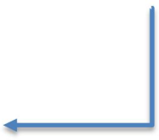

**INPUT**

**Knowledge Requirements:**

**PROCESS**

**OUTPUT**

•

•

•

Business Consultancy

Business Consultancy Services

Project Management System

Client Management System

ISO 25010

Analyze

•

iConsult: A Business

•

**Software Requirements:**

Design

Consultancy

Visual Studio Code,Vite

Figma

HTML, CSS

JavaScript, React.js

Integrated with

Develop

Node.js, Express.js

MySQL,

Twilio API, Google

Calendar API, SendGrid API

Paypal sandbox

Aws, Netlify

Project Management

•

•

System and Client

Testing

Management System

**Hardware Requirements:**

Processor: Intel Core i3 or higher

Installed RAM: 16 GB RAM

Storage: 500 GB SSD

**Evaluation**

# Input

# The input phase of the system consists of three main requirements. First, this project requires a consultant with knowledge of business practices, project management systems, client management, and ISO 25010.

# Second, the researcher used several Software requirements. These include HTML, CSS, JavaScript, ReactJS, NodeJS, Express.js, and MySQL for handling databases, Additionally Twilio API, Google, Calendar API, Paypal sandbox, Sendgrid, Aws, and Netlify. Throughout the development process, the researcher used tools like Visual Studio Code, Figma, and Github.

# Lastly, the researcher will use Hardware Requirements that can be used to access the system, an Intel Core i3 processor (or better), 16GB of RAM, and a 500GB SSD.

# Process

# This process includes four main stages: analysis, design, development, and testing. During the analysis stage, thorough research and assessment will be conducted to understand the requirements, goals, and challenges of the project. In the design stage, the gathered information will be translated into a comprehensive plan. This includes creating system architecture, designing user interfaces, and defining the integration between the project management and client management systems.

# Following the design stage, the iConsult system will be built using a robust set of technologies. Visual Studio Code will serve as the primary IDE, with Figma for UI/UX design and GitHub for version control. The front end will utilize HTML, CSS, JavaScript, PHP, Vite and ReactJs to ensure a fast development process. On the back end, Node.js and MySQL will manage server-side operations and data storage, and XAMPP will be utilized to simulate server environments during development. Key integrations include Paypal sandbox for payments, Twilio and SendGrid for notifications, Google Calendar API for scheduling. Lastly Aws and Netlify is to deploy the system.

# Once the development is complete, the system will undergo rigorous testing. This phase aims to identify any defects, errors, or issues in the system's functionality, performance, and security.

# Output

# The output of the project is a web-based that integrates a project management system and a client management system for business consultancies. This application allows business consultancies to effectively manage projects, clients, appointments, communication, and other relevant aspects of their operation.

# Operational Definition of Terms

# The following terms are defined to better understand the study.

# *Clients* refers to a **customer** who seeks professional services from the business consultancy.

# *Consultants* refers to a **business professional** who provides expert advice and guidance to clients.

# *Track progress* refers to the process of monitoring and evaluating the **advancement of a project**.

# *Task* refers to the process of creating, assigning, monitoring, and updating tasks within projects.

# *Project* refers to the process of overseeing and controlling all aspects of a project.

# *Employee* refers to a **team member** who works for the business consultancy and is assigned tasks related to projects or services.

**Chapter 3**

**METHODOLOGY**

This chapter includes the project design, project development, operating and testing procedure, and evaluation procedure of the study.

**Project Design**

The project design of the study is explained below using Unified Modelling Language (UML), System Flow Chart, UI Design, and Wireframe.

**Figure 2**

*Use Case Diagram*

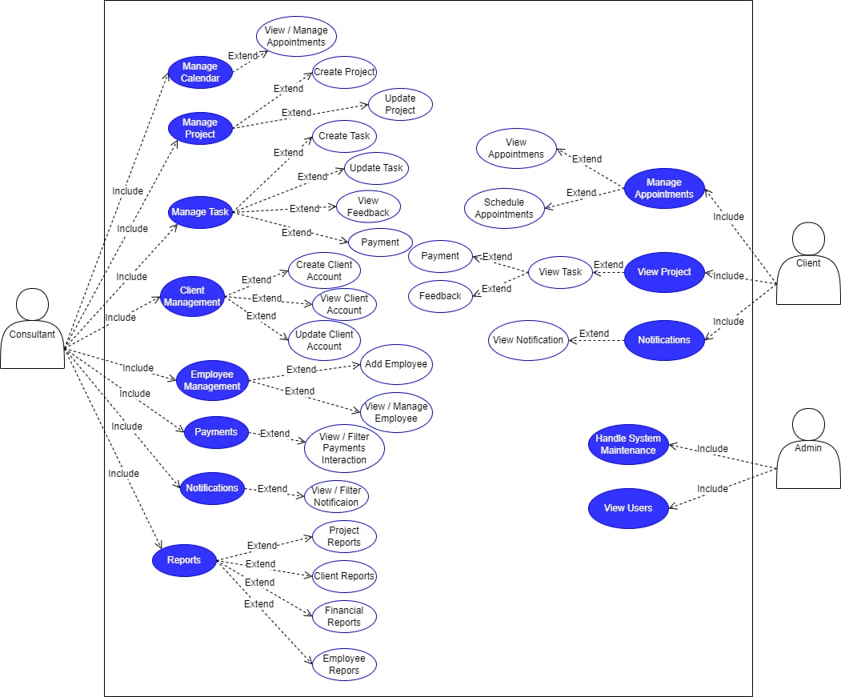

Figure 2 presents a detailed use case diagram for iConsult, a web-based application that integrates project management and client management functionality within a business consultancy. This diagram provides a visual overview of the key actors and their interactions with the system.

The clients can browse available time slots and book appointments conveniently. They can view the project to track its progress. In the "view task" section, clients have access to payment options and can provide feedback to rate the quality of service. Additionally, the system keeps clients updated on important information, such as upcoming appointments, deadlines, payment due, and any other significant developments related to their project.

Consultants, as another key actor, manage all aspects of projects within iConsult. This includes managing appointments, creating project plans, assigning tasks, creating the client account, add employee, monitoring the notifications and project progress to ensure everything stays on track. Consultants can also utilize iConsult's reporting features to analyze project performance and gain valuable insights to guide decision-making.

Finally, the admin oversees system maintenance and manages all technical aspects to ensure smooth operation. They have access to view all users within the system.

***Module Hierarchy Chart***

# **Figure 3**

***Module Hierarchy Chart***

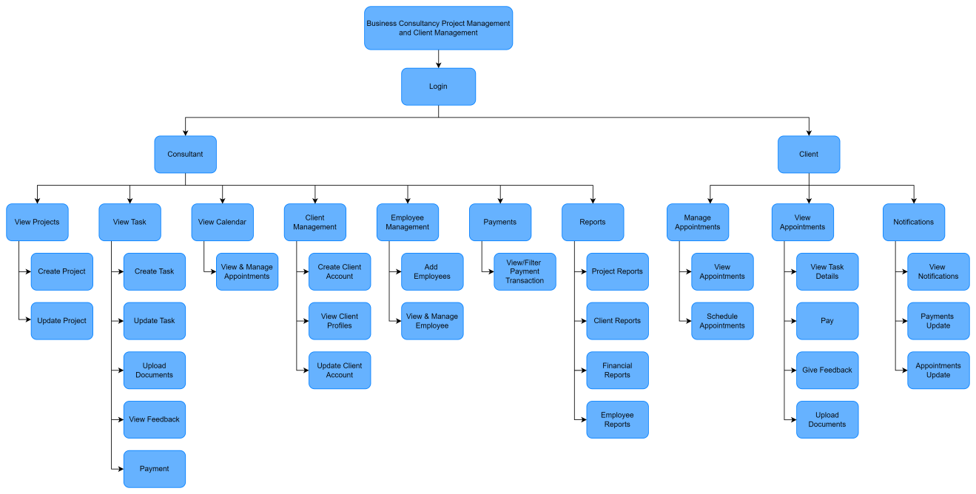

Figure 3 illustrates the hierarchical structure of the Business Consultancy Project Management and Client Management system. It depicts the interconnectedness of modules through the central Login functionality, accessed with consultant-provided credentials.

Consultants navigate key modules like View Projects, View Tasks, View Calendar, Client Management, Employee Management, Payments, and Reports, each catering to specific operational needs. Clients utilize Manage Appointments for viewing their appointments and schedule their appointments to manage their consultations, View Appointments for tracking project details, payments, and give feedback to the consultants, and also to upload transaction documents. Notifications for receiving alerts regarding the status of the project, payment history and appointments update.

By visualizing the module hierarchy, this diagram effectively conveys the organization and interrelationships between modules. This clarifies the roles and responsibilities of consultants, and clients within the iConsult system.

***Data Flow Diagram***

# Figure 4

*Context Level Diagram*

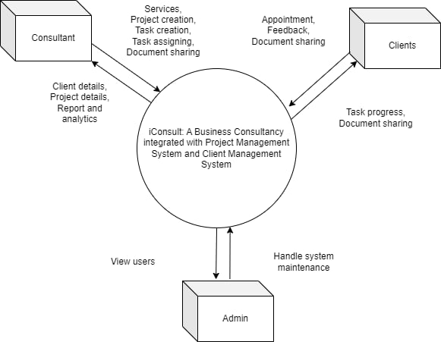

Figure 4 shows the Data Flow Diagram. It shows the flow of data between external entities and the whole system.

The system has three external entities: Clients, Consultant, and Admin. Interacting with it, clients schedule appointments, including their personal information, for the consultation. Next, clients need to upload relevant documents based on the discussion or requirements provided by the consultants. Lastly, clients can provide feedback on their experience and the quality of service they received, helping the system to improve and address any issues. They will receive business services to be consulted through the system. Next, they can view task progress and also upload documents.

Consultants will give customer service details, project creation, task creation, task assigning, and document sharing to the system. They can view client details, reports and analytic, and project details in the system.

Admin will be responsible for maintaining the overall functionality, ensuring everything runs smoothly. The admin will also have access to view all users, including consultants and clients from the system.

***Entity Relationship Diagram***

# Figure 5

*Entity Relationship Diagram*

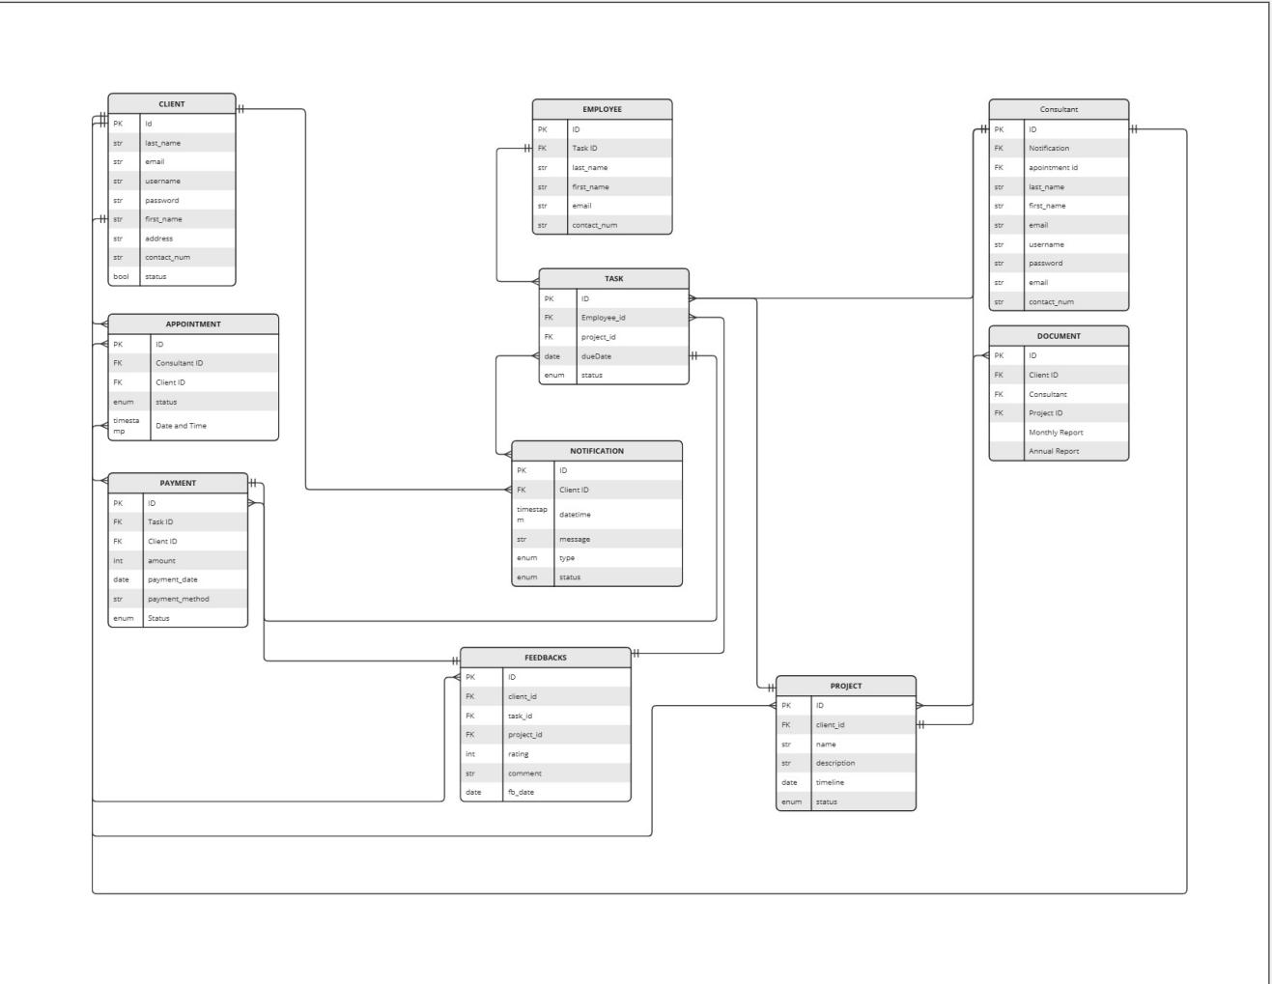

This Entity-Relationship Diagram (ERD) as shown in Figure 5, represents the structure of a business consultancy management system with key entities such as Client, Appointment, Payment, Project, Task, Document, Feedback, Employee, User, and Notification. Each entity has its own attributes, with relationships established between them through foreign keys (FK).

The Client entity is connected to multiple entities such as Appointment, Payment, Project, Feedback, Document, and Notification. For instance, clients can schedule Appointments, make Payments, and provide Feedback related to tasks. The Project entity links to both Task and Document entities, allowing clients and consultants to manage and track tasks and upload relevant project documents. The Notification entity alerts clients about various updates (appointments, payments, etc.), and the Task entity assigns employees to specific projects, tracking the task's due dates and statuses. Feedback allows clients to rate and comment on services, and employees are linked to tasks through the Employee entity, while User manages login credentials for the system. The system is designed to handle various business processes such as client interactions, project management, payment tracking, and feedback collection efficiently.

***System Flow Chart***

# Figure 6

*System Flowchart (Client)*

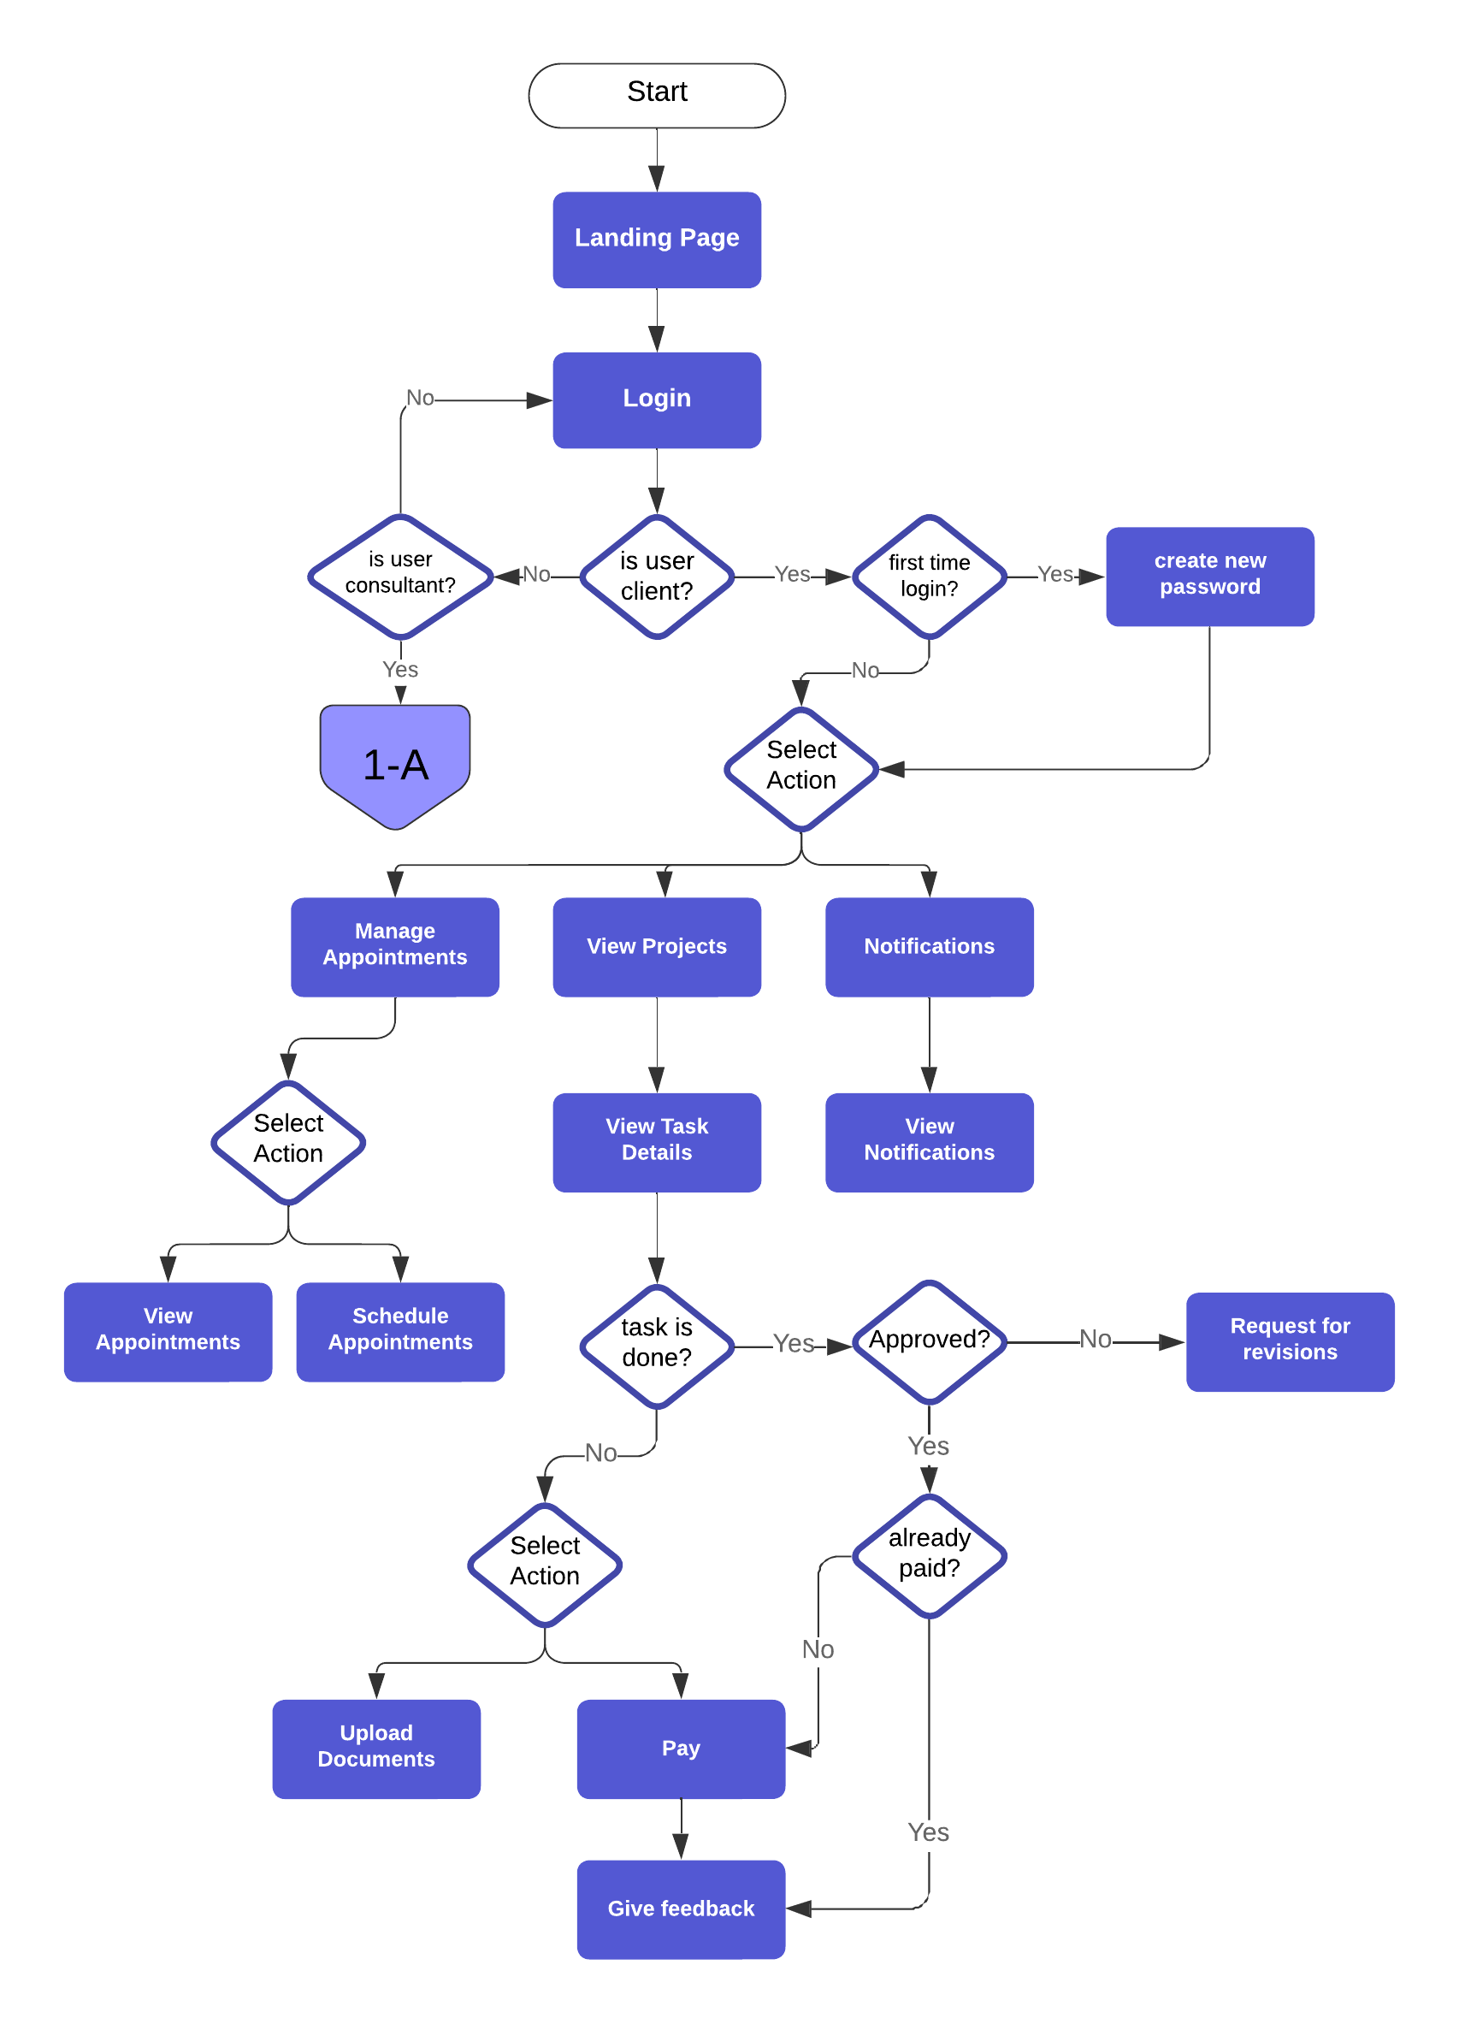

Figure 6 shows the flow of the "iConsult" from the landing page to the clients interacting with the system. The client begins by logging in and, if it's their first time, they are prompted to create a new password. After logging in, the client can manage appointments (view or schedule), view project tasks, upload documents, and pay for services. Additionally, they can view notifications and provide feedback after completing tasks or making payments. This process ensures that clients can efficiently manage their appointments, monitor project progress, and stay informed through notifications.

# Figure 7

*System Flowchart (Consultant)*

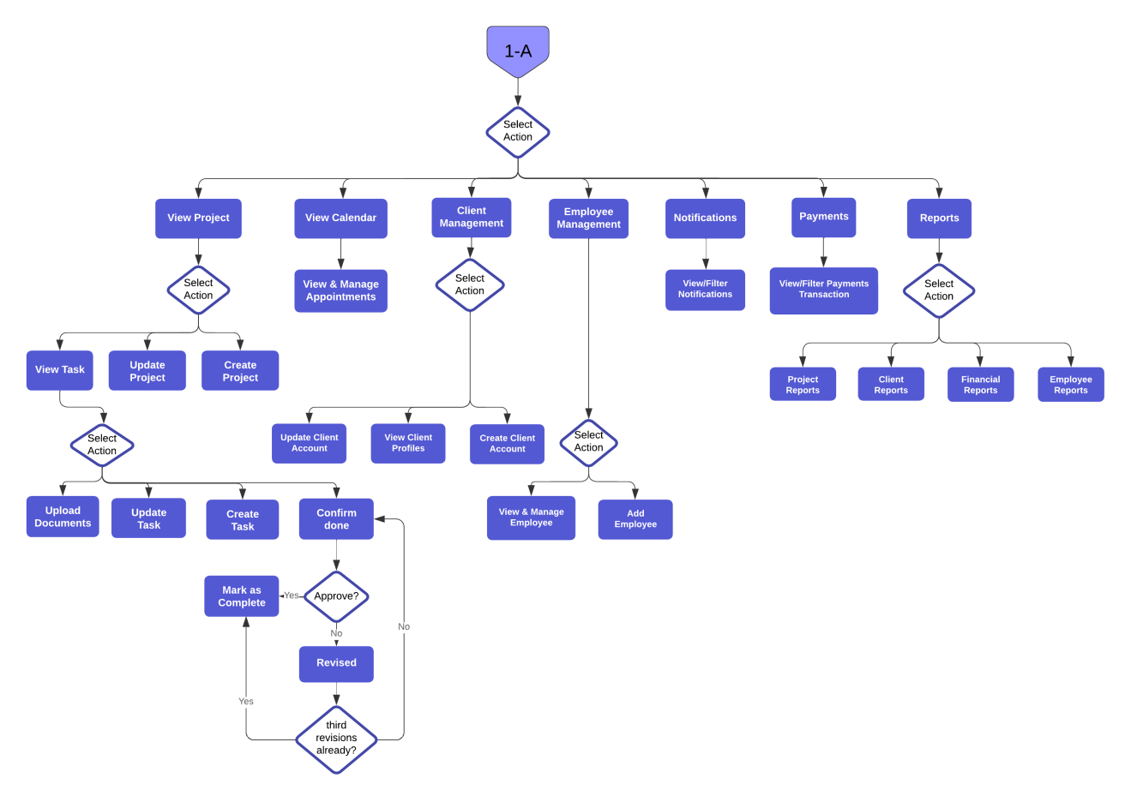

Figure 7 shows the flow of the "iConsult" from the landing page to the consultants interacting with the system. The consultants has several key responsibilities, including managing client appointments, managing projects by creating projects based on the services clients consulted for, breaking these projects into manageable tasks, and assigning tasks to specific employee. Additionally, the consultants can generate comprehensive reports including project-specific reports, financial reports, employee reports and client reports for comprehensive insights, as well as create accounts for clients. Once clients have been given their accounts, they can schedule appointments directly through the web interface, view updates on their projects or services, directly pay through the web application, view and upload documents related to the tasks and provide feedback after a service is completed, contributing to the continuous improvement of service quality.

***Wireframe***

# Figure 8

*Login*

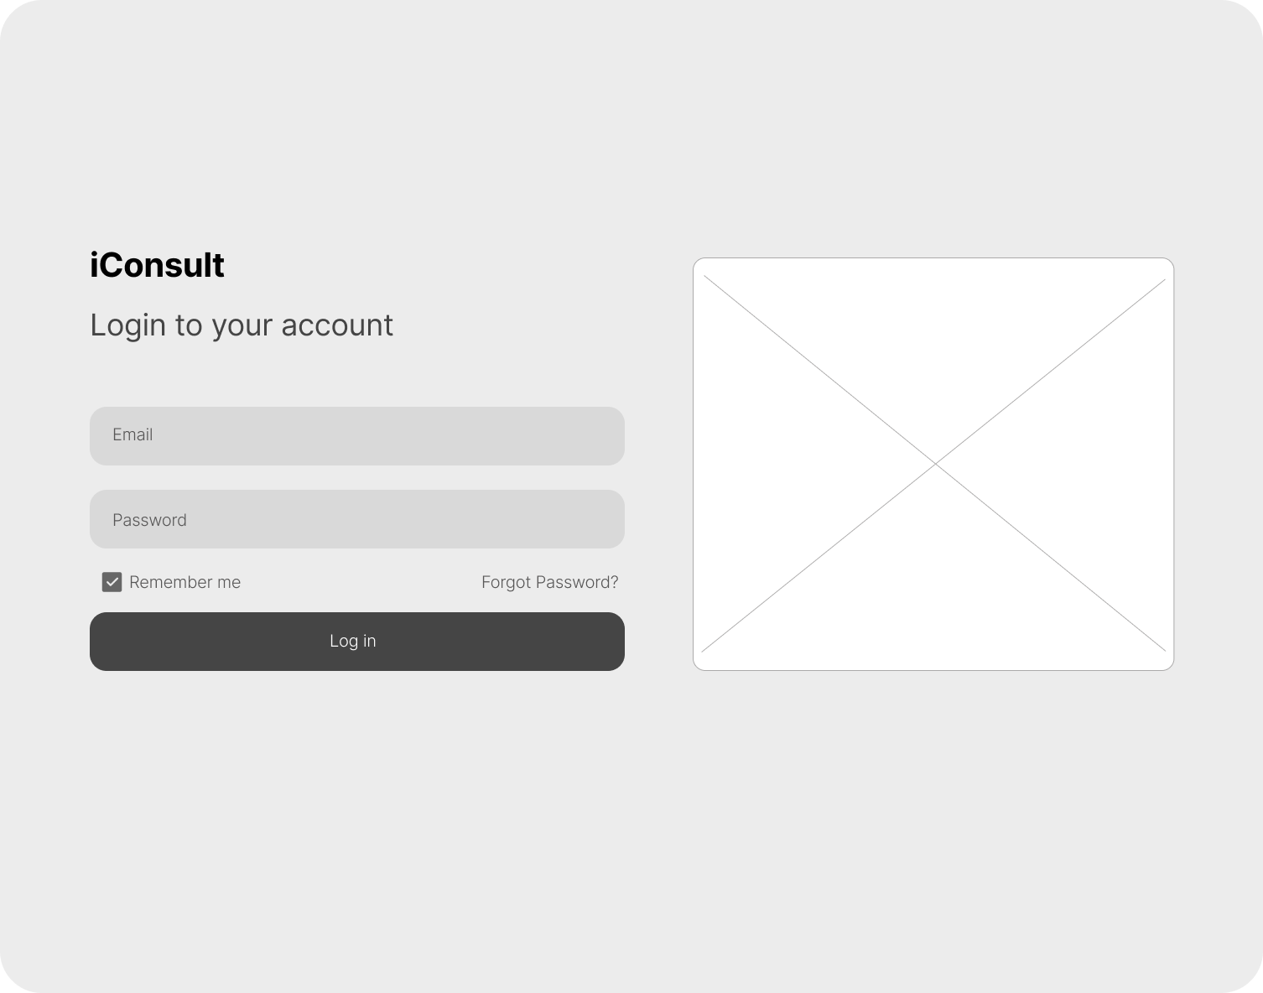

This Figure 8 illustrates where consultants, and clients can log in to access their accounts.

# 

# Figure 9

# *Admin Dashboard*

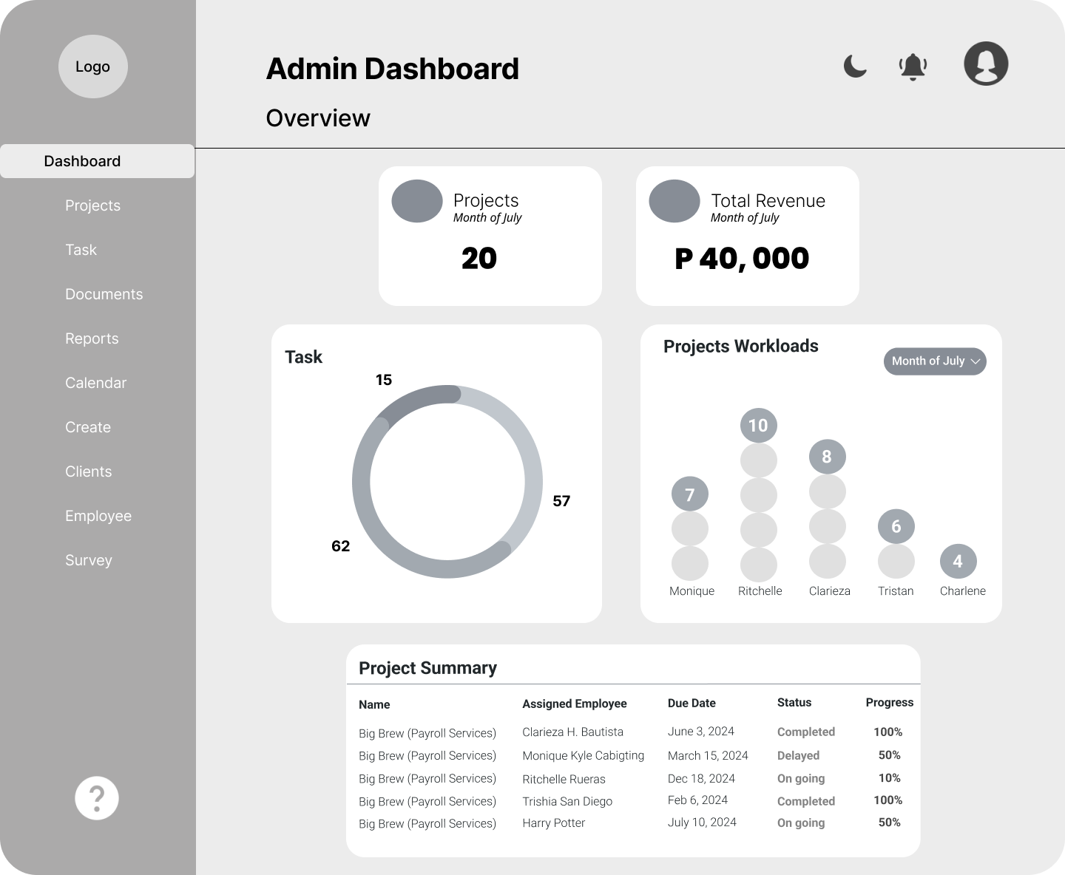

This Figure 9 shows where the consultant can view real-time analytics and monitor the overall performance of the business.

**Figure 10.1**

*Projects***`**

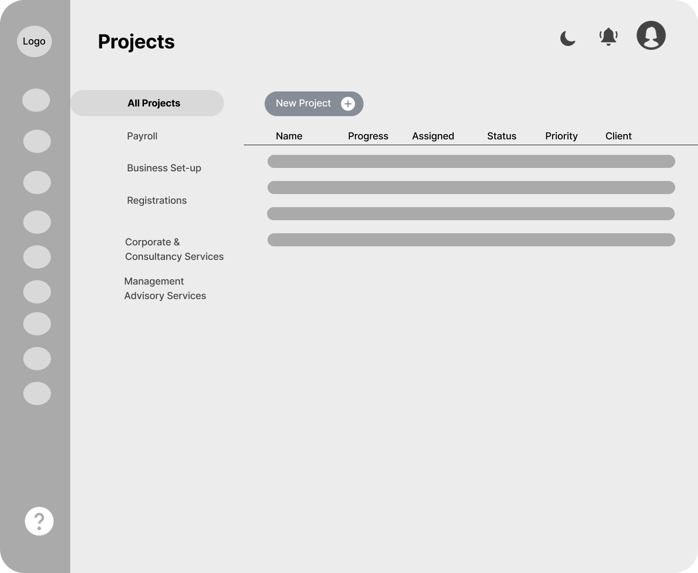

This Figure 10.1 shows where the consultant can view all the projects, see a summary of their statuses, add new projects and update projects information.

# Figure 10.2

*Task Tracking*

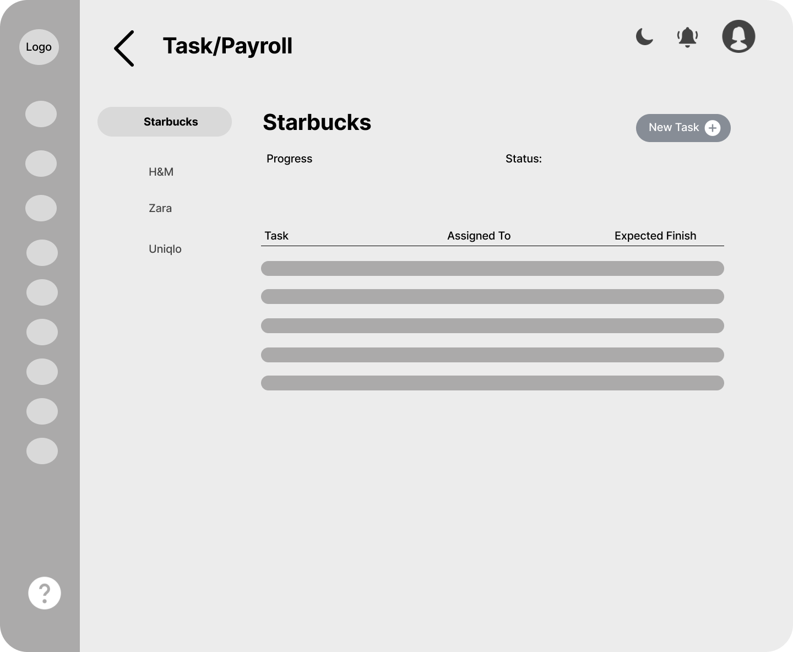

This Figure 10.2 shows where the consultant can create, view, edit, and delete tasks which can be accessed when a certain project is clicked.

# Figure 10.3

*Task Assigning*

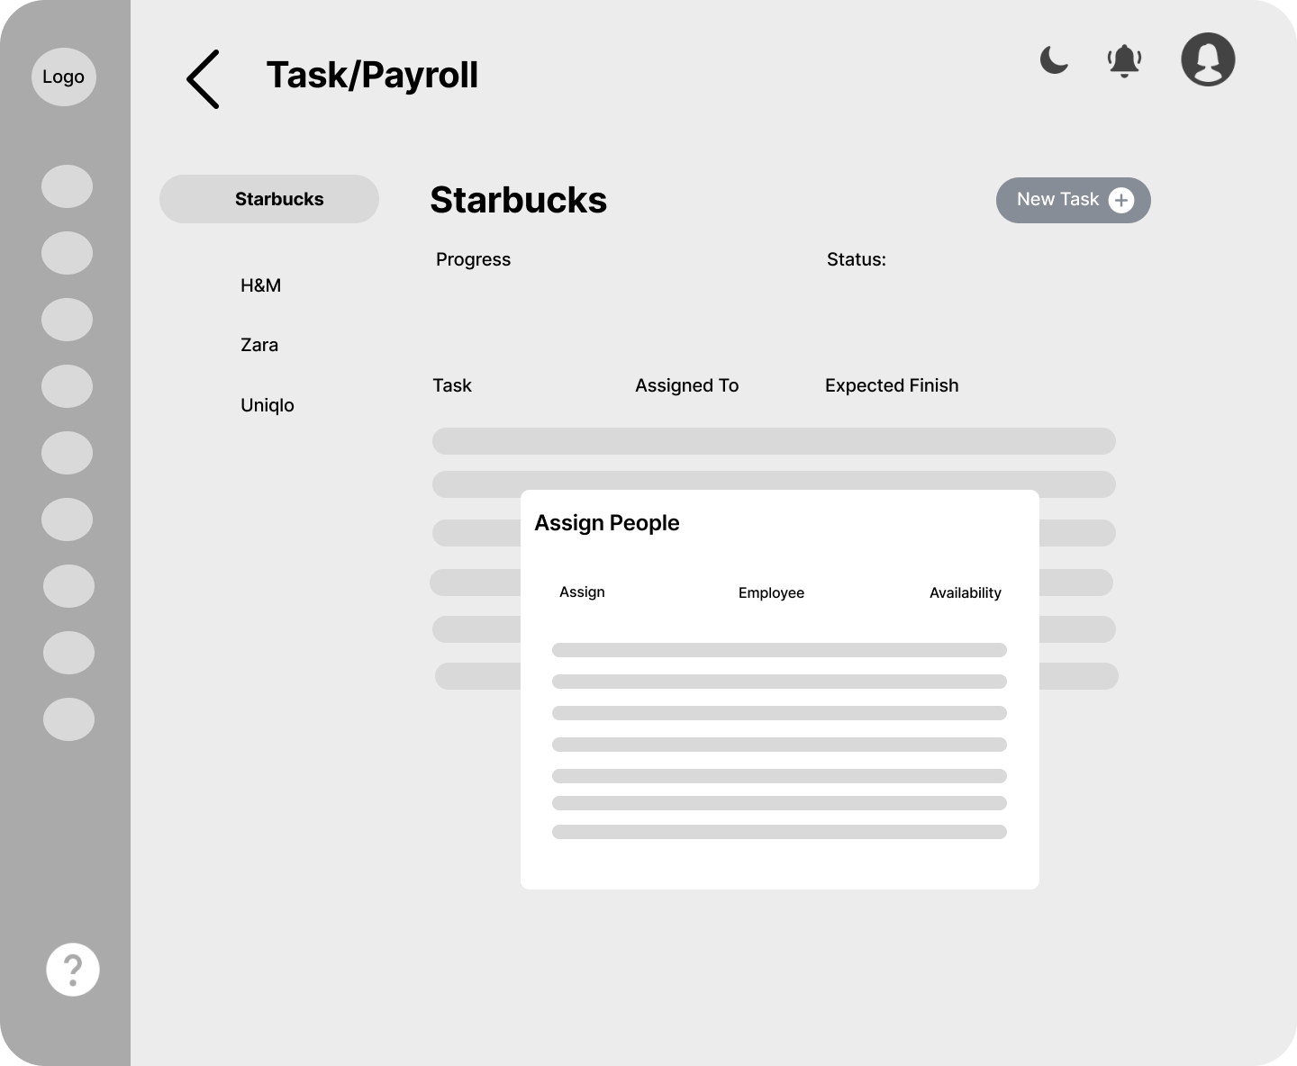

This Figure 10.3 shows where the consultants can assign tasks to employees.

# Figure 11

*Documents*

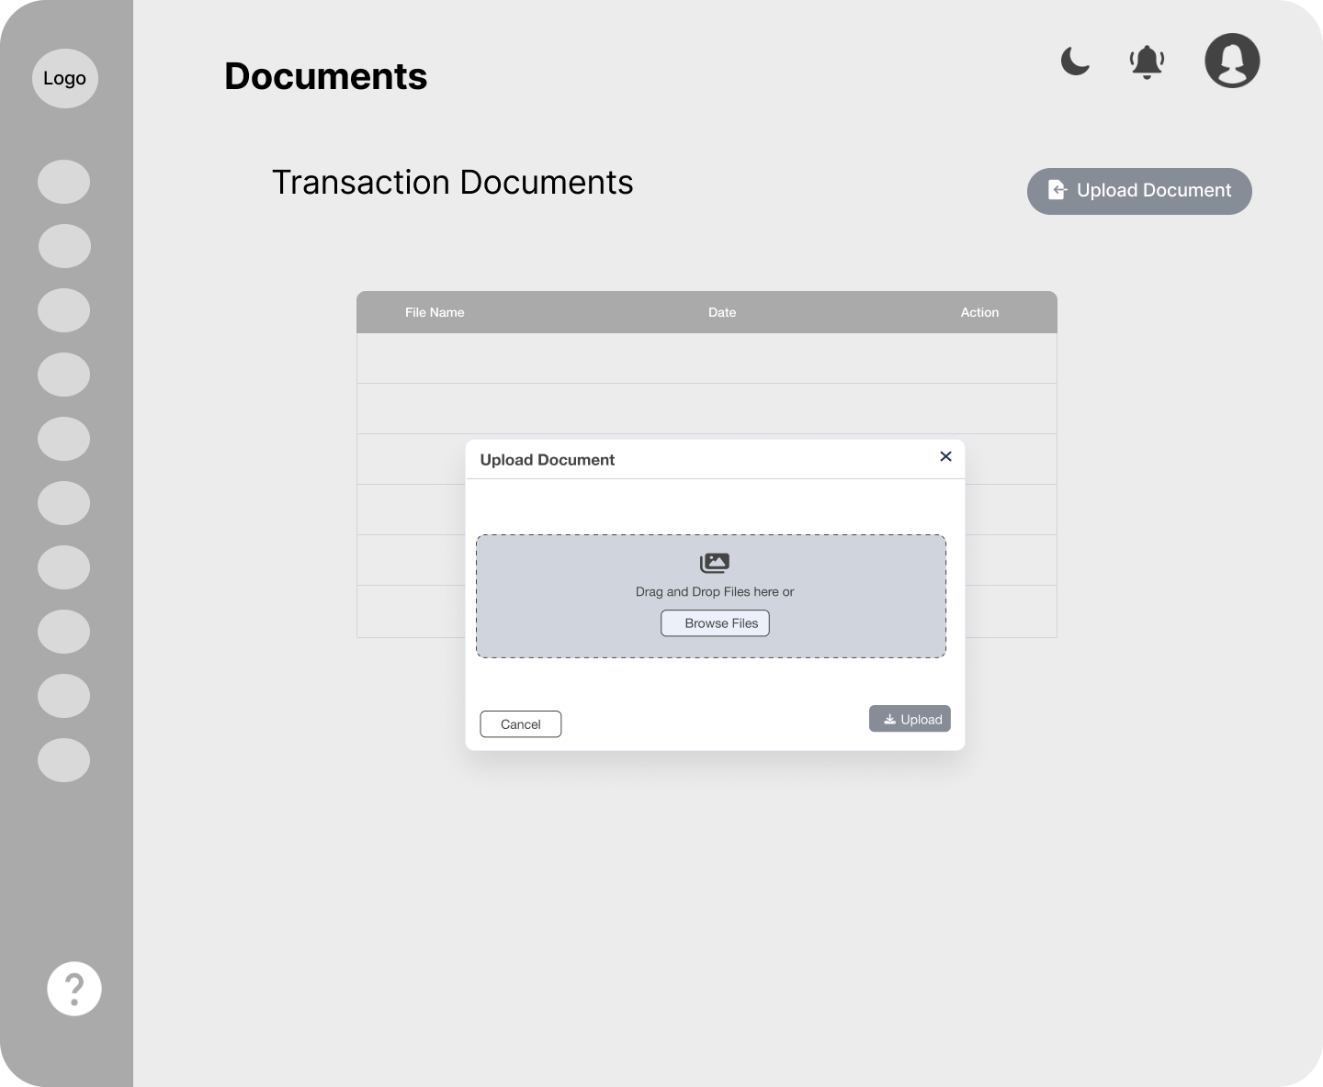

This Figure 11 is where the consultant can view both the documents uploaded by them and the clients.

**Figure 12**

# *Reports*

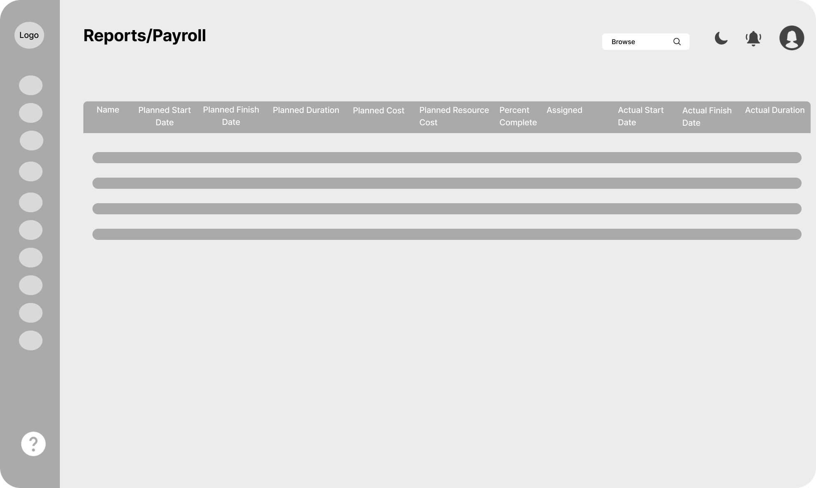

This Figure 12 shows where the consultant can view detailed information about each project.

# Figure 13

*Calendar*

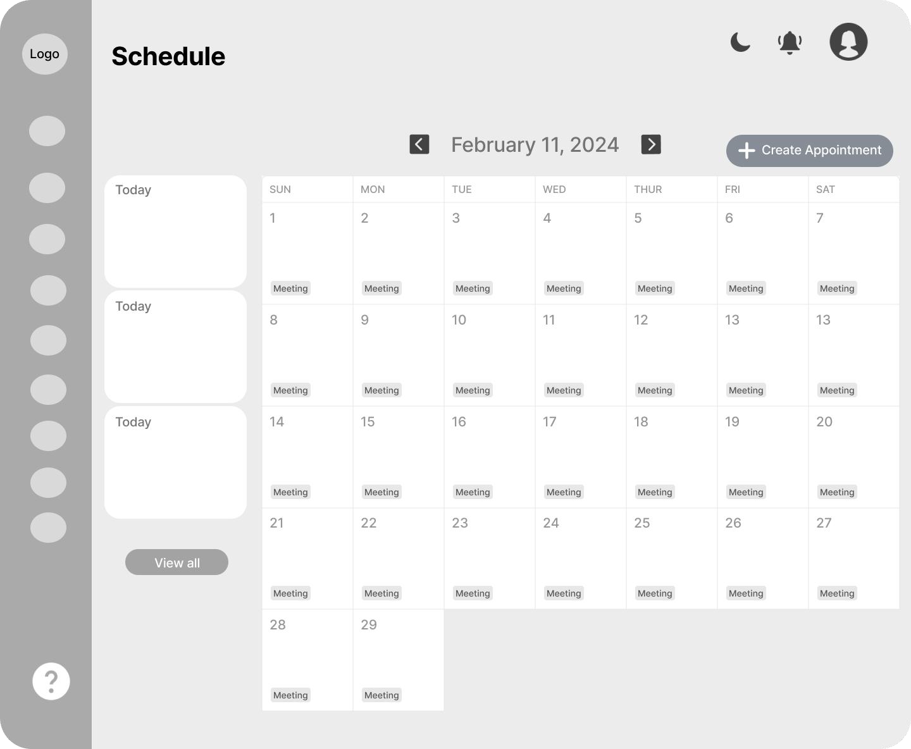

This Figure 13 is where the consultant can manage his/her scheduled appointments.

# Figure 14

*Create Account*

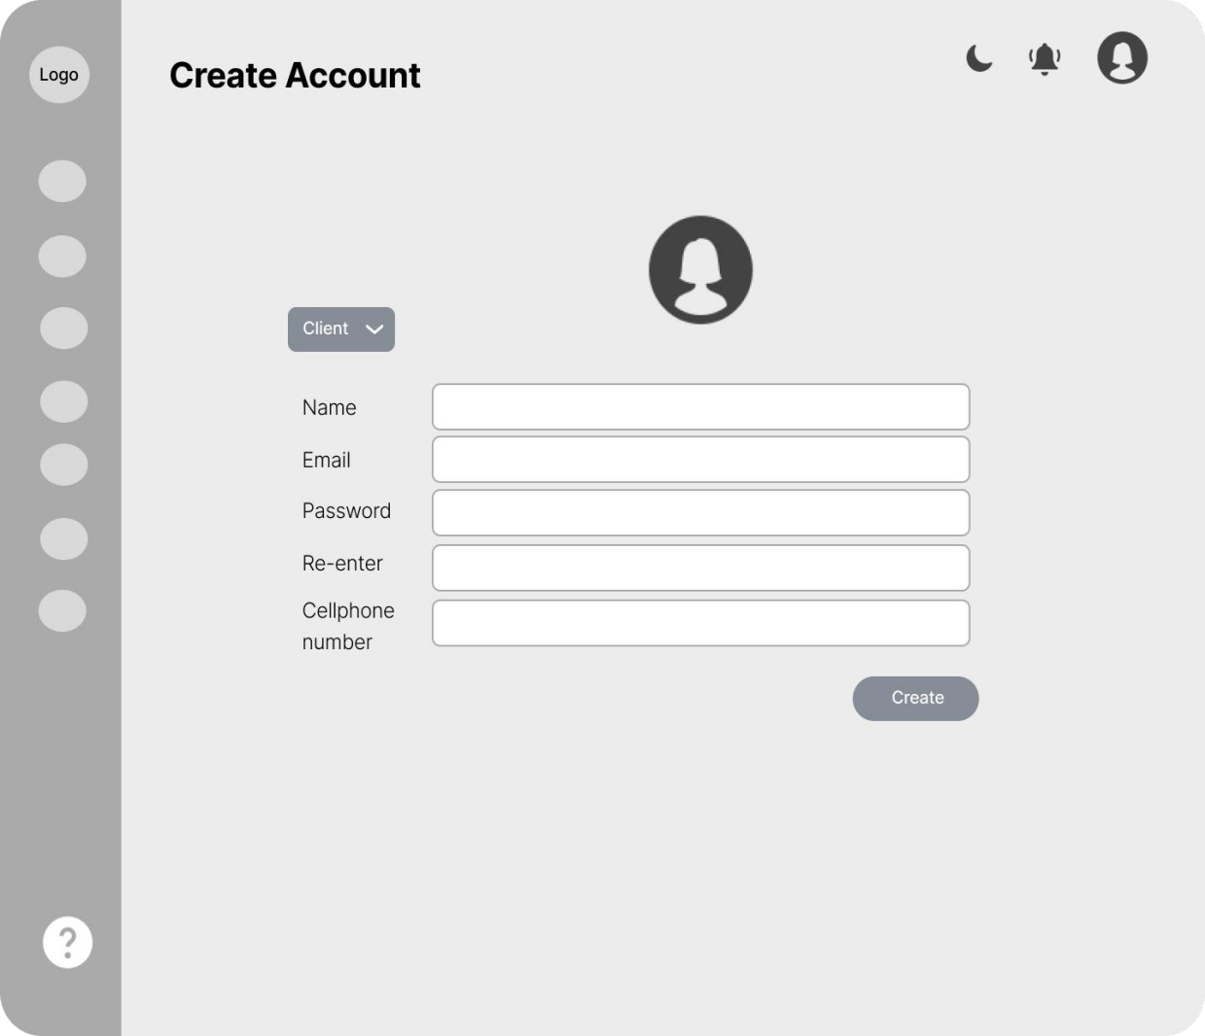

This Figure 14 shows where the consultant can create an account for clients.

# Figure 15

*Client Information*

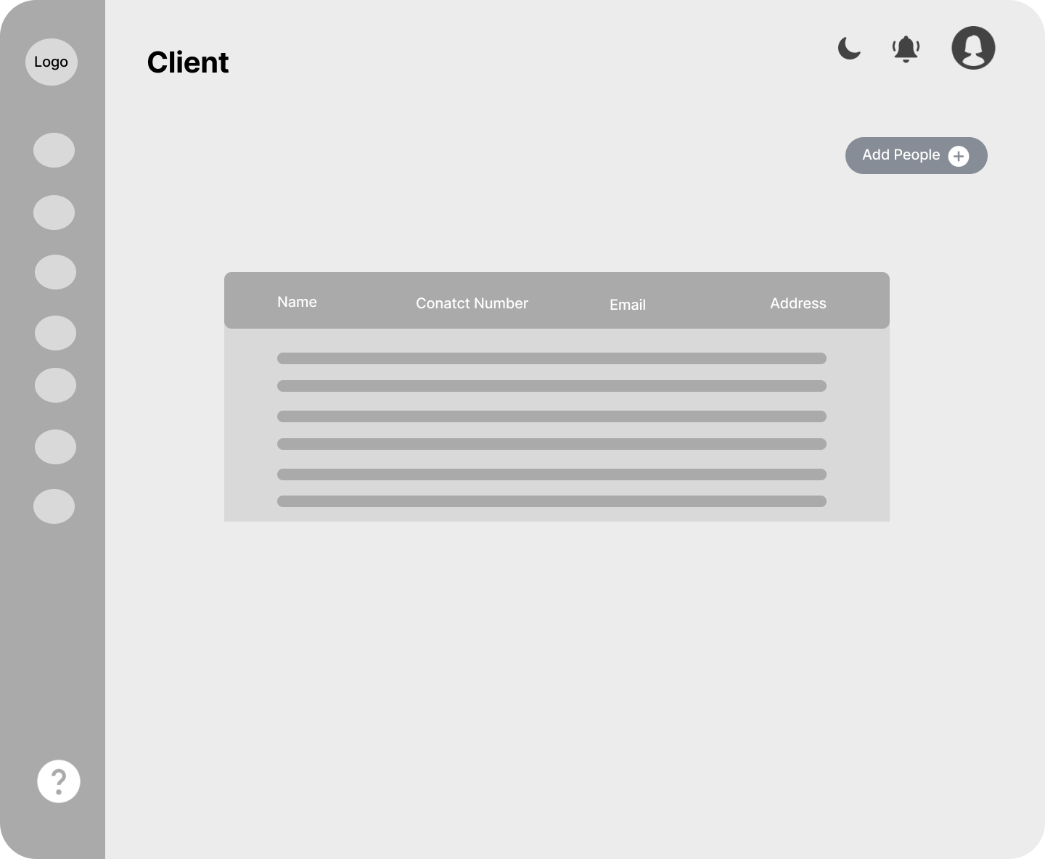

This Figure 15 shows where the consultant can create, view, and update client’s information.

# Figure 16

*Employee Information*

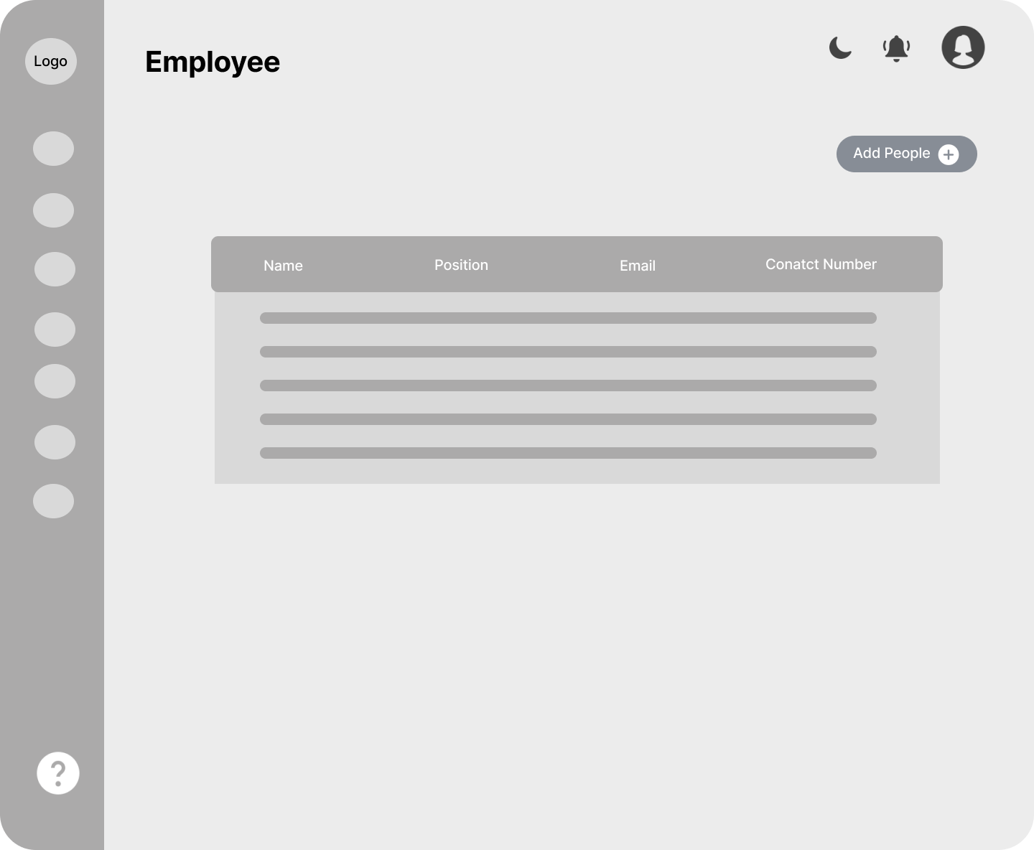

This Figure 16 is where the consultant can create, view, and update employee’s information.

# Figure 17

*Client Services*

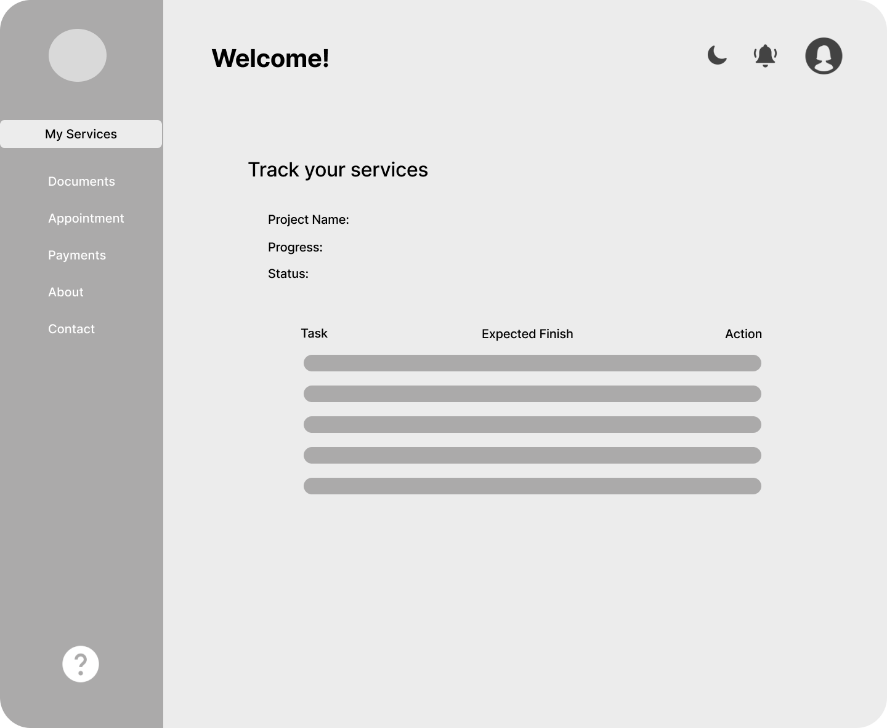

This Figure 17 shows where the client can track the progress of the project and task.

# Figure 18

*Client Documents*

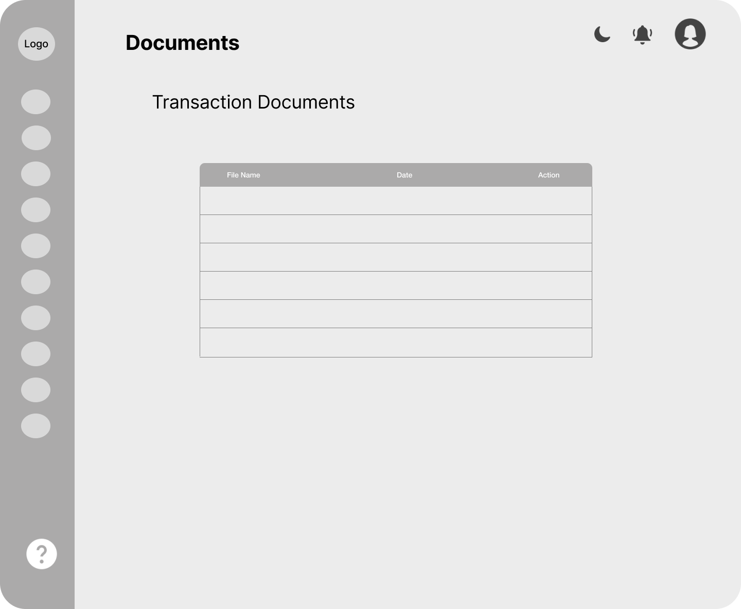

This Figure 18 shows where the client can view and upload project or task related documents.

# Figure 19

*Client Payments*

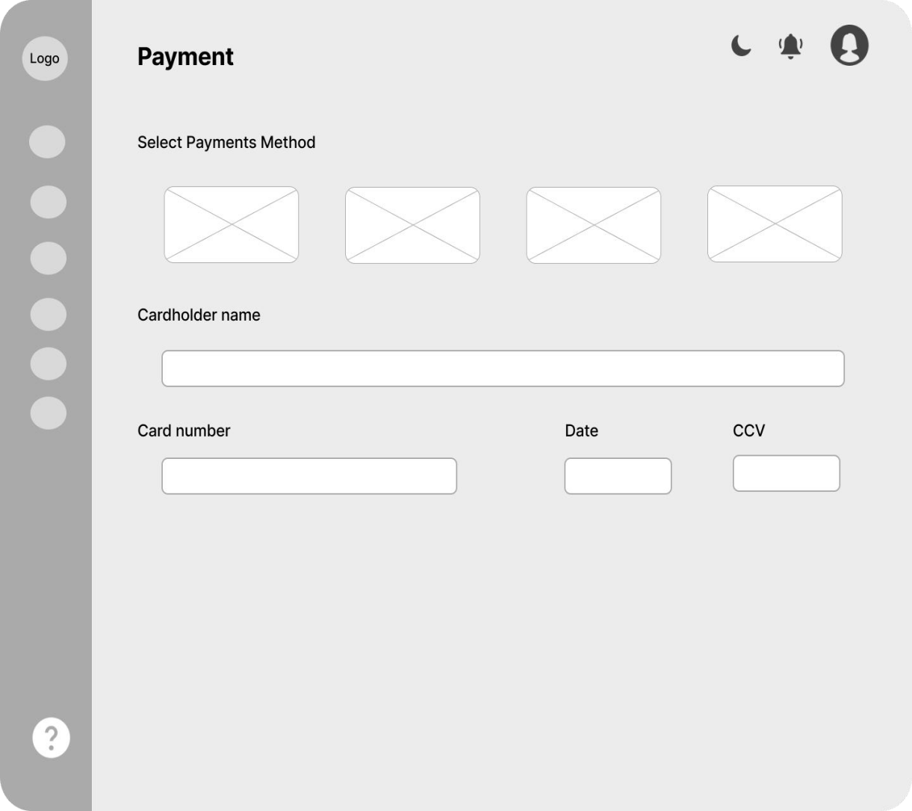

This Figure 19 is where clients can pay online both before and after services are rendered.

# Figure 20

*Appointment Form*

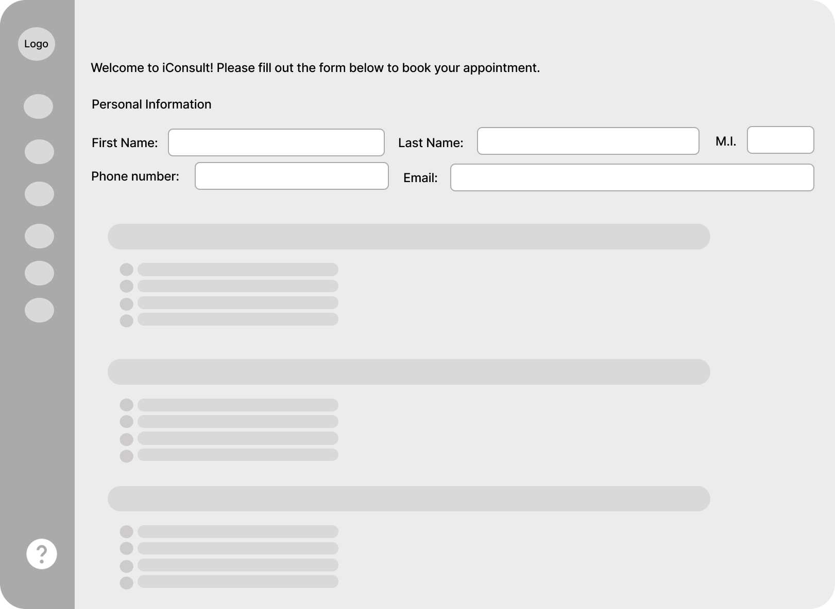

This Figure 20 shows where clients can request appointments by specifying their desired date, time, and purpose.

# Project Development

# The Web-based Business Consultancy with Project Management and Client Management System was developed using the Scrum Agile Development Methodology that helped the researchers to determine specific modules and features that are accomplished during a sprint of a given time frame, usually lasting to one-to-four weeks. With the given methodology, the researchers easily identified the problems that are encountered by the web-based ordering system and provided solutions regarding these problems. This allowed the researchers to progress efficiently and effectively during the project development.

# Scrum is a widely used framework and a popular way to organize and handle complicated projects, especially in making software (Bhaskar S., 2024). In our project, we will implement the Scrum technique for guiding our method of development. This technique is an agile framework that focuses on iterative development, collaboration, and adaptation. Our process will include breaking down the project into smaller tasks known as 'user stories'. Sprints are also part of this system. It is the amount of time given for completing a set of activities. There will also be daily Scrum meetings or stand-ups to track and review the project's progress, challenges, and requirements. At the end of the sprint, we will conduct a sprint review to demonstrate the completed work and gather feedback. These sprint reviews will provide feedback that can be used to know how well we did and also to assess the parts of the project that still needs improvement. Using this methodology will be very helpful for us researchers to develop an effective, efficient, and user-friendly website or platform for our client.

# Figure 21*.*

*Scrum Agile Methodology Framework*

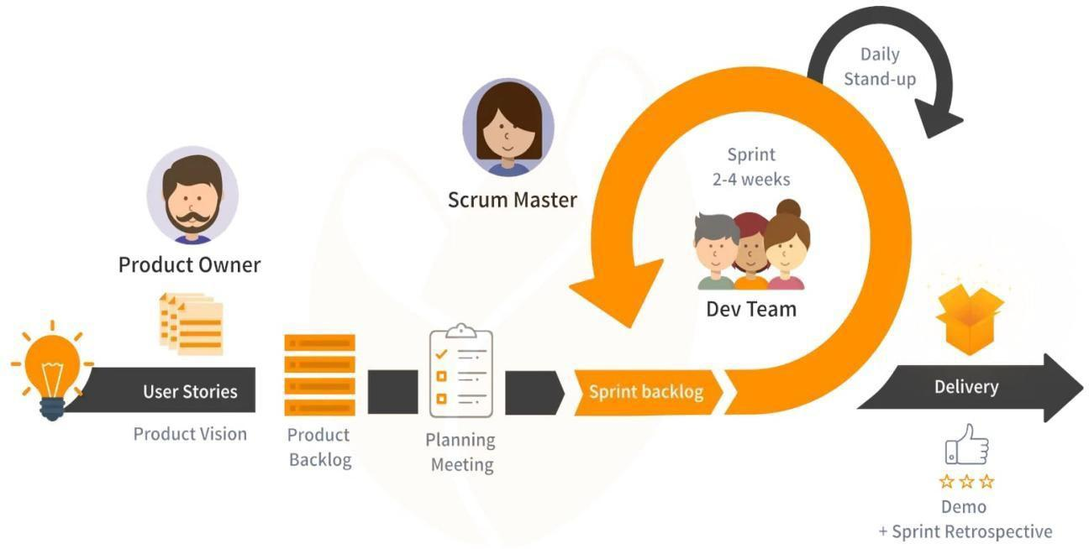

# Phases:

# Sprint Planning Meeting - The development team conducted meetings in order to determine what module in the product backlog they work on in the next sprint. In this phase, the duration of the upcoming sprint was identified as well.

# Daily Scrum Meeting - There was a daily 20-minute meeting for the scrum team to monitor and evaluate the status of the project and make sure that each team is working according to the given task.

# Sprint Review - The sprint review was done at the end of every sprint, where the finished work in a sprint is presented to the product owner. The product owner reviewed the finished work in the sprint and assess whether there will be changes to be made or the finished work is accepted.

# Sprint Retrospective - Sprint Retrospective is a meeting, dedicated on determining what went well during the last sprint, and as well what can be improved in the next sprint. With sprint retrospective, there is a continuous improvement in sprints, making each sprint more successful than the last.

# Roles:

# Product Owner - The client who utilized the software is represented by the product owner. The product owner decides what features and modules will be added to the product, what changes will the product have, and whether to accept or reject the finished product.

# Development Team - is a team of individuals responsible to deliver the requested and committed product increments.

# Scrum Master - the scrum master was responsible for the productivity and the effectiveness of the development team. They are responsible for ensuring that the team understands scrum in theory and practice and offering assistance and guidance as the team progresses in their sprints.

# Tools:

# Product Backlog - The product backlog is a complete list of features and modules based on the needs and requirements of iConsult Project Management and Client Management System web-based application provided by the product owner that the development team executed in the finished product.

# Sprint Backlog - It is a set of tasks from the product backlog, which is identified during the Sprint Planning Meeting. These tasks need to be accomplished during the upcoming sprint.

# Operation and Testing Procedures

# In the future, the operations of the system will be ensured to be correct by testing the system's features and functionality. The tests will verify every function in the system to ensure it functions properly as intended.

# *Functional Suitability Testing* will be conducted to test if the functionality of the features of the web-based application can achieve the expected output. The following procedures will be the steps accomplished in this test. An example of how the Operation and Testing Procedure sections could be defined for the given test case will be provided. A sample test case will be shown in Table 1.

# Table 1.

# *Sample Test Case*

|  |  |  |  |  |  |  |
| --- | --- | --- | --- | --- | --- | --- |
| **Test Case ID** | | |  | | **UC Reference** | |
| **Objective** | | | To ensure that the system will be able to manage projects. | | | |
| **Assumptions/ Preconditions** | | | The admin is logged in as a valid admin account. | | | |
| **Actions** | | | **Expected Result** | | **Actual Result** | |
| 1. The admin signs into the admin account. 2. The admin clicks on "Projects" from the menu. | | | 1. The system enables the admin to generate reports. | | 1. The system successfully allows the admin to manage projects. | |
| **Status** |  | PASSED | **Severity** |  | **Priority** |  |

The table serves as a standardized format for the test case document utilized by the researchers. Each row in the table corresponds to a specific test case and includes key details such as the test case ID, objective, expected result, action procedure, test data, actual result, and status. The status column indicates the outcome of the test case, whether it passed, failed, was not executed, or was blocked. This organized layout guarantees comprehensive testing and validation of the web application's functionality.

**Table 2.**

*Classification of Error Severity*

|  |  |
| --- | --- |
| **Severity** | **Description** |
| Critical | The problem signifies that the process has been completely stopped and cannot continue until it is resolved. |
| Major | The problem causes the system to crash.  Nevertheless, some system components are still functional. |
| Minor | The problem does not result in any significant system failure. |

The table provides a clear and comprehensive overview of error severity classification. It outlines three distinct levels: Critical, Major, and Minor. Each level clarifies the potential impact of the corresponding error on the system's functionality. This table serves as a valuable quick-reference tool, enabling stakeholders to categorize errors based on their severity. This categorization facilitates efficient prioritization and resource allocation for error identification and resolution effort.

**Table 3**

*Classification of Error Priority Levels*

|  |  |
| --- | --- |
| **Priority** | **Description** |
| High | The problem needs to be resolved as soon as possible since it significantly affects the application. |
| Medium | The problem should be fixed throughout the normal course of development. |
| Low | The problem must be resolved when a more crucial feature is taken care of. |

The table offers a structured classification scheme for error priority levels. It categorizes errors into three distinct levels: High, Medium, and Low. Each level is accompanied by a description that clarifies the urgency of addressing the error. This table serves as a valuable tool to prioritize and allocate resources effectively. By assigning an appropriate priority level to each error, development teams can optimize their workflows. This ensures that critical issues are addressed promptly, while less urgent problems are tackled at designated points within the development cycle.

# Table 4

*Overall Summary of Functionality Test Cases*

|  |  |
| --- | --- |
| **Use Case** | **No. of Test Cases** |
| Verified User Admin  **Total** |  |

This table outlines a comprehensive set of functional test cases categorized by user roles: "Verified User," and "Admin." Each user role represents a specific use case within the system. Additionally, a dedicated "Total" row summarizes the cumulative number of test cases across all user roles. This table serves as a template for capturing and organizing detailed test case information, facilitating a structured approach to functional testing.

# Table 5

*Reliability Test Cases Summary*

|  |  |
| --- | --- |
| **Test Case ID** | **Objectives** |
|  | |

The test case ID serves as a unique identifier assigned to each test case, facilitating easy reference and tracking. The objectives of each test case include a description of the goals and purposes, specifically outlining the aspects of reliability being assessed or verified.

# Table 6

# *Testing Procedure for Functionality Suitability*

|  |  |  |
| --- | --- | --- |
| **Modules** | **Steps to be taken** | **Expected Output** |
| 1. Project Management | 1. Navigate to the "Projects" section.  2. Create a new project by adding the project title, description, and timeline.  3. View the project details and track its progress.  4. Update the project status. | 1. The project should be created successfully, with accurate details displayed. 2. Updates should be reflected in real-time, and clients should see the project on their dashboard. |
| 2.Task Management | 1. Navigate to the "Tasks" section within a project. 2. Create a new task, specifying the task name, description, payment, due, and assign employee. 3. Close the task once completed. | 1. Tasks should be created, assigned, and updated correctly. 2. The progress and status changes should reflect immediately both client and consultants, and completed tasks should be marked as closed. |
| 1. Calendar | 1. Access the "Calendar" section. 2. Check the consultant's availability and view existing events. 3. Set availability for consultations and sync with the project deadlines. | 1. The calendar should accurately display all project due, tasks due, and consultation availability. 2. New events should be added successfully, and the availability of the consultant should be correctly updated. |
| 4.Client Management | 1. Navigate to the "Client" section. 2. Create account for new client with their details. 3. View client profiles, project history, and notes related to each client. 4. Update client details and log interactions. | 1. Clients accounts should be added to the system, and their details should be accessible and up-to-date. 2. Any changes or new interactions should be saved and reflected correctly. |
| 1. Notifications | 1. Trigger a system event (e.g., task assignment, deadline approaching) to generate a notification. 2. View the notification in the notification center. | 1. Notifications should be generated and displayed in real-time. |
| 1. Payments | 1. Navigate to the "Payments" section. 2. View a list of pending and completed payments. | 1. Payments should be listed correctly, with accurate statuses (pending, completed). |
| 1. Reports | 1. Navigate to the "Reports" section. 2. Select the type of report to generate (e.g., project progress, task completion rate). 3. Apply filters such as date range or employee to narrow down the data. 4. Generate and download the report in PDF or Excel format. | 1. The report should be generated accurately based on the selected filters. 2. Should be downloadable in the specified format with the correct data reflected. |
| 1. Project (client) | 1. Access the "Projects" section. 2. View a list of all ongoing and completed projects associated with the client. 3. Select a specific project to see details such as progress, milestones, tasks, payment, and deadlines. 4. Download any related documents or reports shared within the project. 5. Provide feedback or comments on the project's progress. | 1. The list of projects should be displayed correctly, with accurate details about progress and deadlines. 2. Clients should be able to view and download shared documents and provide feedback within the system. |
| 1. Notifications (client) | 1. Trigger notifications by system events (e.g., task completion, new consultation scheduled, document shared). 2. View notifications in the notification center upon logging in. 3. Click on notifications to be directed to the relevant project or consultation. | 1. Notifications should appear in real-time based on relevant system events. 2. Clients should be able to view, access relevant details by clicking. |
| 1. Payments (client) | 1. Navigate to the "Tasks" section inside a project. 2. Select a task associated with payments. 3. View the task details, including the amount due, payment methods, and deadlines. 4. Complete the payment using the available methods (e.g., credit card, PayPal). 5. Confirm the payment and view transaction details. 6. Download receipts for completed payments. | 1. Tasks with associated payments should display payment details clearly. 2. Clients should be able to complete payments within the task, and the status should update in real-time. 3. Receipts should be downloadable for completed transactions. |

Reliability Testing will be conducted to assess how the system performs under specified environmental conditions. This testing assesses how the system functions under various environmental conditions and its performance over a defined period. The following table outlines a collection of test cases designed to examine the functionality of various system modules including project management, task management, calendar, client and employee management, notifications, reports, and payments. Each row represents a distinct test case, detailing the procedures for execution and the anticipated results. Documenting and organizing test cases in a table format facilitates streamlined test process management and ensures comprehensive testing of each system capability against established procedures and expected outcomes.

**Table 7**

*Testing Execution Summary*

|  |  |  |  |
| --- | --- | --- | --- |
| **Text Execution** | **Expected Result** | **Active Result Cycle 1** | **Cycle 2** |
| No. of Test Cases Results of Test Cases | 100% |  |  |
| Passed | 100% |  |  |
| Failed | 0% |  |  |
| No. of Test Cases Not Executed | 0% |  |  |

The table provides a comprehensive summary of the test case execution process. It signifies the successful completion of all test cases, with no instances of unexecuted tests. While the "expected results" column currently remains unfilled, it is intended to be populated with the anticipated outcomes for each test case. The conducted tests have yielded a positive outcome, with all test cases passing without any failures. Overall, this chart serves as a concise overview of the testing status, confirming the successful and complete execution of all test cases.

# Evaluation Procedure

Using ISO 25010, the system will be assessed. A diverse group of evaluators, including students, faculty members, and professionals, will be presented with the prototype. Random users from the College of Science, consisting of both web-based programming experts and students, will participate in the evaluation. A minimum of 30 students will be included among the respondents. The system will be demonstrated to the participants, who will then receive surveys to complete. The following outlines the planned evaluation process:

**General Evaluation Process**

1. Each respondent will receive a software assessment form to use in evaluating the effectiveness of the system.
2. The web-based application's functions will be demonstrated, and a discussion of its objectives will be held, to demonstrate how to use it.
3. The application will be made available to all respondents.
4. According to Table eight (8), respondents will be asked to evaluate the system in light of the ISO 25010 standard evaluation criteria, using a 4-point Likert scale where (4) is the highest rating and (1) is the lowest rating.
5. This project will be evaluated using the following characteristics: functional suitability and reliability.
6. Based on the evaluation data collected, the overall weighted mean rating for each criterion and the grand weighted mean will be determined.
7. The evaluation outcomes will utilize the weighted mean value range shown in Table nine (9) and the qualitative analysis relating to that range.

# Table 8

*Four-point Likert Scale*

|  |  |
| --- | --- |
| **Scale** | **Descriptive Rating** |
| 4 | Highly Acceptable |
| 3 | Very Acceptable |
| 2 | Fairly Acceptable |
| 1 | Not Acceptable |

The table presents a rating scale with numerical values (1-4) and corresponding descriptive labels. "Highly Acceptable" (4), "Very Acceptable" (3), "Fairly Acceptable" (2), and "Not Acceptable" (1) define the scale. This table facilitates evaluating something's acceptability. Higher numerical values indicate a more favorable rating. The descriptive labels help understand the acceptability level based on the numerical values.

**Table 9**

*The Range of Mean Ratings and the Equivalent Descriptive Rating*

|  |  |
| --- | --- |
| **Scale** | **Descriptive Rating** |
| 3.26 - 4.0 | Highly Acceptable |
| 2.51 - 3.25 | Very Acceptable |
| 1.76 - 2.50 | Fairly Acceptable |
| 1.00 - 1.75 | Not Acceptable |

The table shows numerical ranges in each row with corresponding descriptive ratings in the next column. This scale allows assessment or grading based on acceptability levels. Each rating has its own numerical range. For instance, values between 3.26 and 4.0 are considered "Highly Acceptable" according to the descriptors. Likewise, other ranges correspond to "Very Acceptable," "Fairly Acceptable," or "Not Acceptable."

# REFERENCES

Ahwan, A. A. (2021, December 14). How to Get Figma Professional Plan for Free — Figma Education only for Students & Educators. *Medium*. [https://medium.com/@abdulazizahwan/how-to-get-figma-professional-plan-for-free-](https://medium.com/%40abdulazizahwan/how-to-get-figma-professional-plan-for-free-figma-education-only-for-students-educators-bb7ecd14b9b3) figma-education-only-for-students-educators-bb7ecd14b9b3

*Analysis and design of the customer Relationship Management system of UMRAH in PT. XYZ Tours & Travels Indonesia*. (2021). IEEE Conference Publication | IEEE Xplore. <https://ieeexplore.ieee.org/abstract/document/9535087>

Baashar, Y., Alhussian, H., Patel, A., Alkawsi, G., Alzahrani, A. I., Alfarraj, O., & Hayder, G. (2020). Customer relationship management systems (CRMS) in the healthcare environment: A systematic literature review. *Computer Standards & Interfaces*, *71*, 103442. <https://doi.org/10.1016/j.csi.2020.103442>

Buchynska, T., & Homotiuk, A. (2023). *BUSINESS COMMUNICATIONS IN PROJECT MANAGEMENT OF INTERNATIONAL COMPANIES*. Buchynska | INNOVATIVE ECONOMY. <http://inneco.org/index.php/innecoen/article/view/1175>

Capan, T. (2013, August 13). *Why the Hell Would I Use Node.js? A Case-by-case Tutorial*. Toptal Engineering Blog. [https://www.toptal.com/javascript/why-the-hell-](https://www.toptal.com/javascript/why-the-hell-would-i-use-node-js) would-i-use-node-js

*Comparison of the Different Project Management Software used for a Commercial Project in the Philippines: A Case Study*. (2022). IEEE Conference Publication | IEEE Xplore. <https://ieeexplore.ieee.org/abstract/document/10071670>

Cui, E., & Santos, M. G. (2023). Analysis of consultancy firm and client’s Relationship: Basis for Strategic plan. *The Quest*, *2*(3). <https://doi.org/10.60008/thequest.v2i3.141>

*Customer Relation Management (CRM) system for Customer Service Management - UTAR Institutional Repository*. (2023). <http://eprints.utar.edu.my/5525/>

Da Costa, R. L., Dias, Á., Pereira, L. F., Santos, J., & Miguel, I. (2020). THE BASIS FOR a CONSTRUCTIVE RELATIONSHIP BETWEEN MANAGEMENT CONSULTANTS AND CLIENTS (SMES). *Verslas: Teorija Ir Praktika*, *21*(2), 666–674.

De Castro, M., & De Castro, M. (2024, February 9). *Top business services in the Philippines*. Grit PH. <https://grit.ph/business-services/>

Drozdov, A. (2021, April 23). How Twilio works: An overview. *Yellow*. <https://yellow.systems/blog/what-is-twilio-how-does-it-work>

Forage. (2024, February 22). *What is Business Consulting?* Career Discovery and Success | Auburn University. [https://career.auburn.edu/blog/2024/02/22/what-is-](https://career.auburn.edu/blog/2024/02/22/what-is-business-consulting/) business-consulting/

Frangos, M., & O’Shea, F. (2022). A graph-based approach to client relationship management in fund administration. *Machine Learning With Applications*, *10*, 100433. <https://doi.org/10.1016/j.mlwa.2022.100433>

G, D. (2024, January 19). *What is MySQL and how does it work*. Hostinger Tutorials. <https://www.hostinger.com/tutorials/what-is-mysql>

Gil-Gomez, H., Guerola-Navarro, V., Oltra-Badenes, R., & Lozano-Quilis, J. A. (2020). Customer relationship management: digital transformation and sustainable business model innovation. *Ekonomska Istraživanja/Ekonomska IstražIvanja*, *33*(1), 2733– 2750. <https://doi.org/10.1080/1331677x.2019.1676283>

Govender, S. (2023, October 10). *How to leverage Google Forms API*. MarketSplash. [https://marketsplash.com/google-forms-api/#link3](https://marketsplash.com/google-forms-api/)

Hamizah O. (March 2021). WEB-BASED CUSTOMER RELATIONSHIP MANAGEMENT (CRM) SYSTEM FOR EDUCATIONAL SECTOR INTEGRATED WITH MOBILE INSTANCE MESSAGE (MIM) USING

WHATSAPP APPLICATION. <https://www.researchgate.net/publication/354399958>

Jabado, R. (2024). *Impact of data analytics capabilities on CRM systems’ effectiveness and business profitability: An empirical study in the retail industry*. Informit.

[https://search.informit.org/doi/abs/10.3316/informit.T202404030001070070483146](https://search.informit.org/doi/abs/10.3316/informit.T2024040300010700704831461) 1

Juviler, J. (2024, April 1). What Is GitHub? (And What Is It Used For?). <https://blog.hubspot.com/website/what-is-github-used-for>

K, S. (2022). A Literature Review on Customer Relationship Management. *ResearchGate*. [https://www.researchgate.net/publication/363634167_A_Literature_Review_on_Cus](https://www.researchgate.net/publication/363634167_A_Literature_Review_on_Customer_Relationship_Management) tomer_Relationship_Management

Kafaji, M. A. (2022). Interchange roles of formal and informal project management on business operational success. Production Planning & Control, 35(4), 416–436. <https://doi.org/10.1080/09537287.2022.2089265>

Karen, A. (2024, March 11). 5 Reasons Why You Should Choose Node.js for App Development. ClickIT. [https://www.clickittech.com/developer/why-use-](https://www.clickittech.com/developer/why-use-node-js/)node-js/

Kotciuba, I. Y., Iskhakov, G. T., & Shikov, A. N. (2023). Business project selection support system based on automated business idea management. Vestnik Astrahanskogo Gosudarstvennogo Tehničeskogo Universiteta. Seriâ: Èkonomika, 2023(2), 7–14. <https://doi.org/10.24143/2073-5537-2023-2-7-14>

Kumar, R. (2022, December 23). *What Is CSS and its Importance in Web Development ?*

*- DevOpsSchool.com*. DevOpsSchool.com. [https://www.devopsschool.com/blog/what-is-css-and-its-importance-in-web-](https://www.devopsschool.com/blog/what-is-css-and-its-importance-in-web-development/) development/

Lalic, D. C., Lalic, B., Delić, M., Gracanin, D., & Stefanovic, D. (2022). How project management approach impact project success? From traditional to agile.

International Journal of Managing Projects in Business, 15(3), 494–521. [https://doi.org/10.1108/ijmpb-04-](https://doi.org/10.1108/ijmpb-04-2021-0108)2021-0108

Lamrhari, S., Ghazi, H. E., Oubrich, M., & Faker, A. E. (2022). A social CRM analytic framework for improving customer retention, acquisition, and conversion. Technological Forecasting & Social Change/Technological Forecasting and Social Change, 174, 121275. <https://doi.org/10.1016/j.techfore.2021.121275>

Li, C., Zhang, S. Y., Na, J. S., & Yue, L. (2022). Design and implementation of project management system based on Vue3.0 framework. In Proceedings of the 2022 2nd International Conference on Algorithms, High Performance Computing and Artificial Intelligence (AHPCAI) (pp. 347-353). Institute of Electrical and Electronics Engineers (IEEE). <https://doi.org/10.1109/AHPCAI57455.2022.10087744>

Machiri, S. N., Oloko, M., Ngugi, J. K., & Odhiambo, R. (2024). Customer Relationship Management as a Firm-level Factor and its role in Firm Performance: A Study on the Firms Listed at Nairobi Securities Exchange. *Journal of Information Systems and Technology Research*, *3*(1), 1–9. <https://doi.org/10.55537/jistr.v3i1.713>

Marthinusen, L. (2023, November 14). What is Twilio? Explained in 2 minutes. <https://www.mo.agency/blog/what-is-twilio>

Mevoli, A. M. (2023). The influence of innovation on competitive advantage in the management consultancy sector. Proceedings of the . . . European Conference on Entrepreneurship and Tabar, P. J., & Tabar, P. J. (2023, October 23). Best Accounting Firms in the Philippines. Grit PH. <https://grit.ph/accounting-firms/>

Mittal, N. (2024, August 6). *SendGrid Review: Features, pricing, pros & cons [2024]*. Mailmodo. [https://www.mailmodo.com/guides/sendgrid-review/#what-is- sendgrid](https://www.mailmodo.com/guides/sendgrid-review/#what-is-sendgrid)

Modan, S. (2023). *Benefits and reasons to choose ReactJS for your project*. Peerbits. [https://www.peerbits.com/blog/reasons-to-choose-reactjs-for-your-web-](https://www.peerbits.com/blog/reasons-to-choose-reactjs-for-your-web-development-project.html) development-project.html

Model of Customer Relationship Management Systems Evaluation using factor analysis. (2023). IEEE Conference Publication | IEEE Xplore. [https://ieeexplore.ieee.org/document/10277947/keywords#keywords](https://ieeexplore.ieee.org/document/10277947/keywords)

Nagy, A. (2024, February 24). 34 Different types of consulting services (And how to pick your specialty). Paperbell. [https://paperbell.com/blog/types-of-](https://paperbell.com/blog/types-of-consulting/)consulting

Ngelyaratan, D., & Soediantono, D. (2022). Customer Relationship Management (CRM) and Recommendation for Implementation in the defense Industry: A literature review. [www.jiemar.org](http://www.jiemar.org/). <https://doi.org/10.7777/jiemar.v3i3.279>

Nylas. (2023, April 24). How to Integrate The Google Calendar API Into Your App.

Nylas. <https://www.nylas.com/blog/integrate-google-calendar-api/>

O’Grady, B. (2023, October 23). What is JavaScript and What is it Used for? - Code Institute IE. Code Institute IE.

[https://codeinstitute.net/global/blog/what-is- javascript-and-why-should-i-](https://codeinstitute.net/global/blog/what-is-javascript-and-why-should-i-learn-it/)learn-it/

Orozco, E. (2024, April 30). Why use Tailwind CSS. Ed Orozco. <https://www.edorozco.com/why-use-tailwind-css/>

Ottaviani, F., Rebuglio, M., & De Marco, A. (2023). Project Management Information System Data Model Development and Explanation. <https://doi.org/10.5220/0012052200003546>

Ozanich, A. (2022, June 6). What Is JavaScript & Why Is It Important? <https://blog.hubspot.com/website/what-is-javascript>

Pedamkar, P. (2023, October 17). Visual Studio Code. EDUCBA. <https://www.educba.com/what-is-visual-studio-code/>

Peek, S. (2024, January 16). What is a business consultant? Business News Daily. <https://www.businessnewsdaily.com/4610-business-consultant.html>

Porntrakoon, P., & Moemeng, C. (2022). *Student Project Management System (SPMS)*. [https://www.semanticscholar.org/paper/Student-Project-Management-System-](https://www.semanticscholar.org/paper/Student-Project-Management-System-(SPMS)-Porntrakoon-Moemeng/22a0fb777858b4bb177a9634cca07ed8780025b1) (SPMS)-Porntrakoon-Moemeng/22a0fb777858b4bb177a9634cca07ed8780025b1

Project management in the consultancy sector: comparing Waterfall and Agile approaches - Webthesis. (2021). <https://webthesis.biblio.polito.it/18411/>

Quach, S., & Quach, S. (2024, February 22). MySQL: What It Is, How It Works, And What It’s Used For. Knowi. [https://www.knowi.com/blog/mysql-](https://www.knowi.com/blog/mysql-what-it-is-how-it-works-and-what-its-used-for/)what-it-is-how- it- works-and-what-its-used-for/

Raharjo, T., & Purwandari, B. (2020). Agile Project Management Challenges and Mapping Solutions. <https://doi.org/10.1145/3378936.3378949>

Rane, N. L., Achari, A., & Choudhary, S. P. (2023). Enhancing customer loyalty through quality of service: Effective strategies to improve customer satisfaction, experience, relationship, and engagement. International Research Journal of Modernization in Engineering Technology and Science, 5(5). <https://doi.org/10.56726/IRJMETS38104>

Rapheal, O., Adedeji, A., Opeyemi, O., & Olugbenro, O. (2023). Modelling client and construction firm barriers hindering social client relationship management system implementation in the built environment. Architectural Engineering and Design Management, 20(1), 102–119. <https://doi.org/10.1080/17452007.2023.2282121>

Reasons why you should use Figma in your design process. (n.d.). Deer Designer. [https://deerdesigner.com/blog/5-reasons-why-you-should-use-figma-in-](https://deerdesigner.com/blog/5-reasons-why-you-should-use-figma-in-your-design-process/)your- design- process/

Restrepo, R. (2022, March 4). Google Forms New API Using Node.js. Blog • Stateful. <https://stateful.com/blog/google-form-using-nodejs>

Seng, S. a. C. (2024, May 22). Google Calendar API | Keeping Your Days in Check. Apidog Blog. <https://apidog.com/blog/google-calendar-api/>

Shah, V. (2024, February 23). *Why use react?* TatvaSoft Blog. <https://www.tatvasoft.com/blog/why-use-react/>

Sharma, A. (2024, July 11). *Express JS Tutorial*. Simplilearn.com. <https://www.simplilearn.com/tutorials/nodejs-tutorial/what-is-express-js#:~:text=StackExplore%20Program-,What%20Is%20Express%20JS%3F,helps%20manage%20servers%20and%20routes.>

Specchia, A. (2022). Customer Relationship Management (CRM) for medium and small enterprises. <https://doi.org/10.4324/9781003148388>

Sufiyan, T. (2024, June 10). *The best Guide to HTML Tags*. Simplilearn.com. <https://www.simplilearn.com/tutorials/html-tutorial/html-tags>

Tahri, H. (2021). Designing a Project Management Integrated System. Emi. [https://www.academia.edu/54793849/Designing_a_Project_Management_I](https://www.academia.edu/54793849/Designing_a_Project_Management_Integrated_System?sm=b)ntegrated_System?sm=b

Takagi, N., Varajão, J., Ventura, T., Ubialli, D., & Silva, T. (2024). Managing success criteria and success factors in a BPM project: an approach using PRINCE2 and Success Management on the public sector. Cogent Business & Management, 11(1). <https://doi.org/10.1080/23311975.2024.2336273>

The evolving landscape of consultancy: navigating challenges and seizing opportunities. (2024). <https://www.agbedus.com/blog/article/8/>

Toppin, G., & Czerniawska, F. (2005). Business Consulting: A Guide to How it Works and How to Make it Work. [https://www.semanticscholar.org/paper/Business-](https://www.semanticscholar.org/paper/Business-Consulting%3A-A-Guide-to-How-it-Works-and-to-Toppin-Czerniawska/f4a2726fa78913f7f43b225a6291ac8f531af127) Consulting%3A-A-Guide-to-How-it-Works-and-to-Toppin- Czerniawska/f4a2726fa78913f7f43b225a6291ac8f531af127

Twin, A. (2024, June 10). *What is a sole proprietorship?* Investopedia. [https://www.investopedia.com/terms/s/soleproprietorship.asp#toc-the-bottom-line](https://www.investopedia.com/terms/s/soleproprietorship.asp)

Ukey, K. (2023, February 26). Why you should use TailwindCSS in your ReactJS project. DEV Community. [https://dev.to/kunalukey/why-you-should-](https://dev.to/kunalukey/why-you-should-use-tailwindcss-in-your-reactjs-project-51kf)use-tailwindcss-in- yourreactjs-project-51kf

University Research Project Management System based on cloud platform. (2020). IEEE Conference Publication | IEEE Xplore. <https://ieeexplore.ieee.org/abstract/document/9150160>

Upadhyay, M. (2024, January 30). Explore Laravel And Stripe Integration For Streamlined Payments. WPWeb Infotech. [https://wpwebinfotech.com/blog/laravel-and-stripe- integration/](https://wpwebinfotech.com/blog/laravel-and-stripe-integration/)

Uspenski, A. (2023, July 14). Why VS Code remains a developer favorite, year after year. ShiftMag. <https://shiftmag.dev/vs-code-171/>

Weinert, A., & Banaś, R. (2024). ANALYSIS OF THE FUNCTIONS OF PROJECT MANAGEMENT INFORMATION SYSTEMS – TRADITIONAL APPROACH.

*What is an API? [Quick Read]*. (n.d.). SendGrid. [https://sendgrid.com/en-us/blog/what- is-an-api-quick- read#:~:text=The%20SendGrid%20Email%20API%20leverages,account%20conf irmation%2C%20and%20shipping%20notifications.](https://sendgrid.com/en-us/blog/what-is-an-api-quick-read#:~:text=The%20SendGrid%20Email%20API%20leverages,account%20confirmation%2C%20and%20shipping%20notifications.)

Modern Management Review, 29(1), 59–67. <https://doi.org/10.7862/rz.2024.mmr.05> What Is GitHub? A Beginner’s Introduction to GitHub. (2023, November 17). Kinsta®. <https://kinsta.com/knowledgebase/what-is-github/>

Yang, Z., & Babapour, H. (2022). Critical variables for assessing the effectiveness of electronic customer relationship management systems in online shopping. Kybernetes, 52(9), 3044–3063. <https://doi.org/10.1108/k-10-2021-0952>

Gurung, B. (2024). *A comparative analysis of create-react-app (CRA) and Vite for React.js projects*. Theseus. <https://www.theseus.fi/handle/10024/860241>

Naik, S. (2023b, April 5). *What is XAMPP?* EDUCBA. <https://www.educba.com/what-is-xampp/>