Homework (Week 6)

P1.

Draw the AVL tree resulting from the insertion of an entry with key 52 into the AVL tree of Figure 11.14b (on textbook page 486).



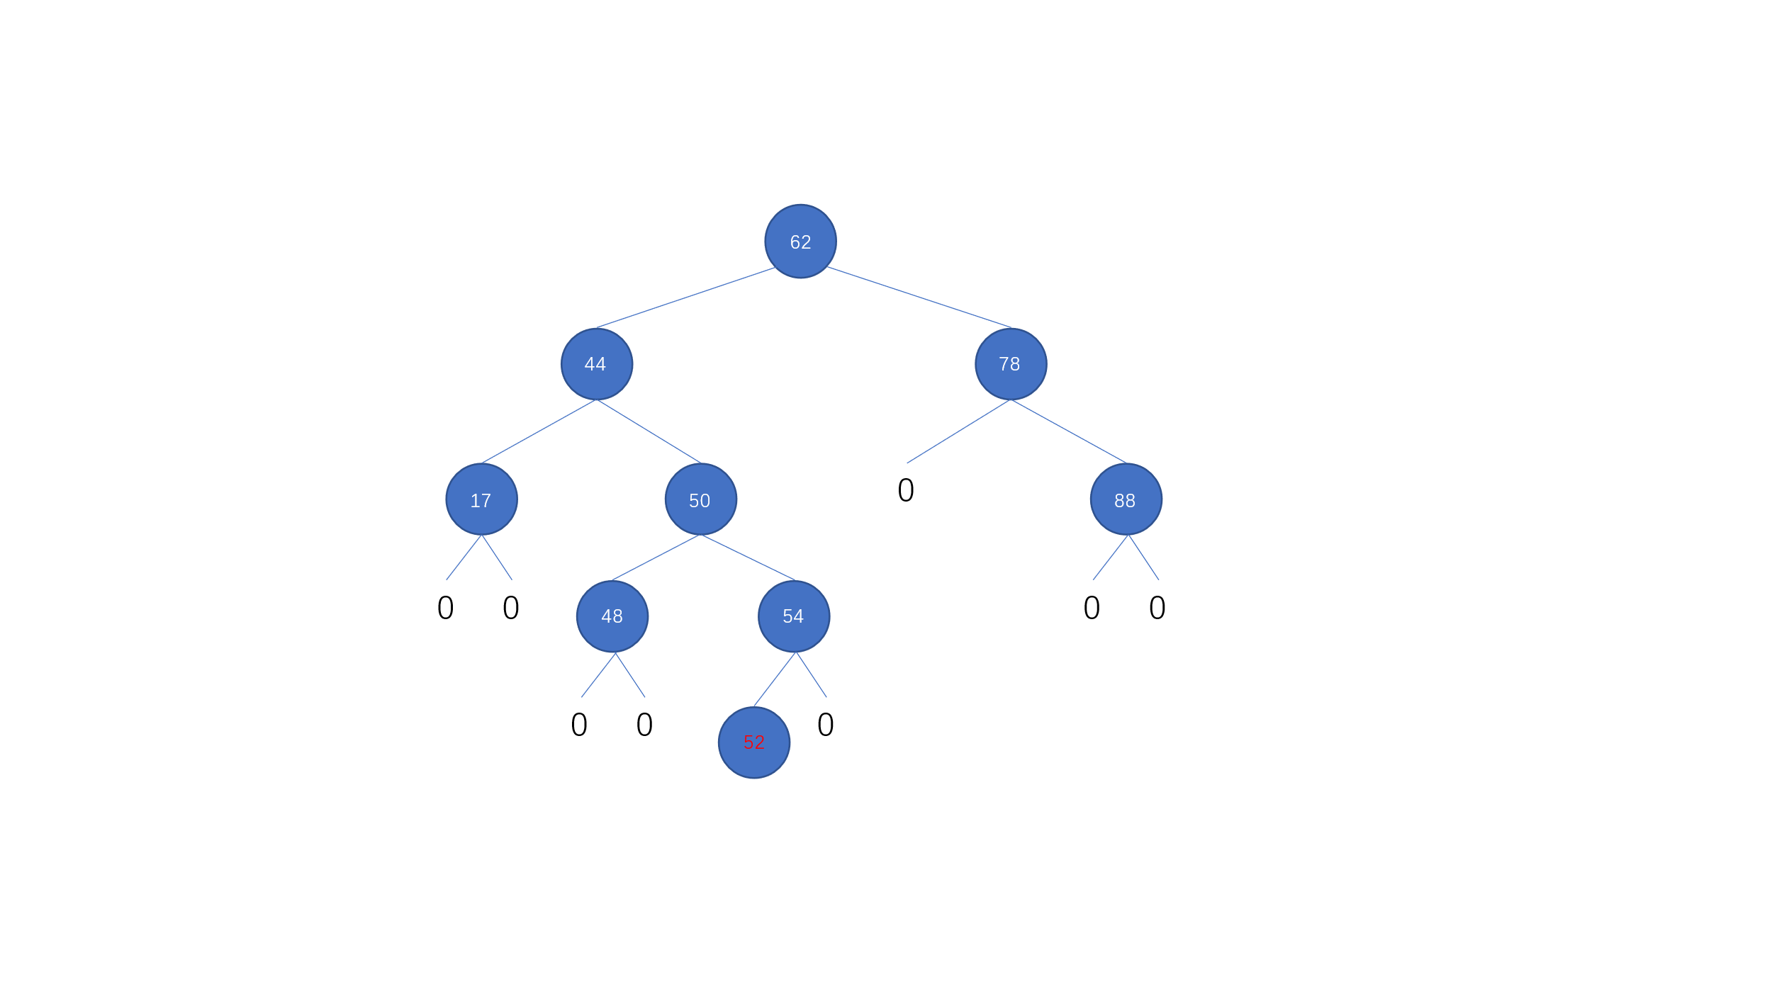

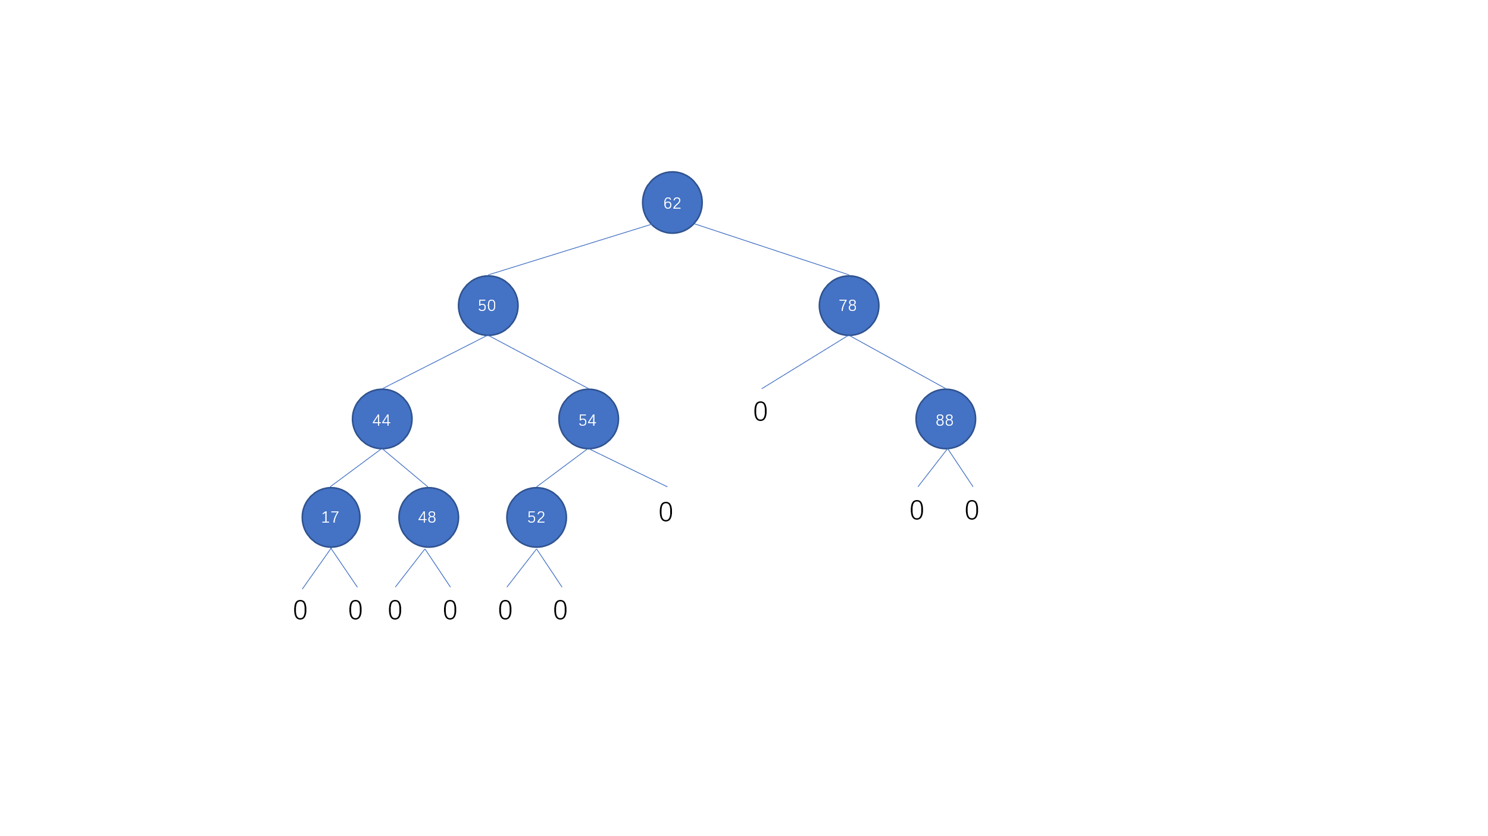

P2.

Draw the AVL tree resulting from the removal of the entry with key 62 from the AVL tree of Figure 11.14b (on textbook page 486).



