Homework (Week 7)

Let G be an undirected graph whose vertices are the integers 1 through 8, and let the adjacent vertices of each vertex be given by the table below:

Vertex Adjacent Vertices

1. (2, 3, 4)
2. (1, 3, 4)
3. (1, 2, 4)
4. (1, 2, 3, 6)
5. (6, 7, 8)
6. (4, 5, 7)
7. (5, 6, 8)
8. (5, 7)

Assume that, in a traversal of G, the adjacent vertices of a given vertex are returned in the same order as they are listed in the table above.

1. Draw G.

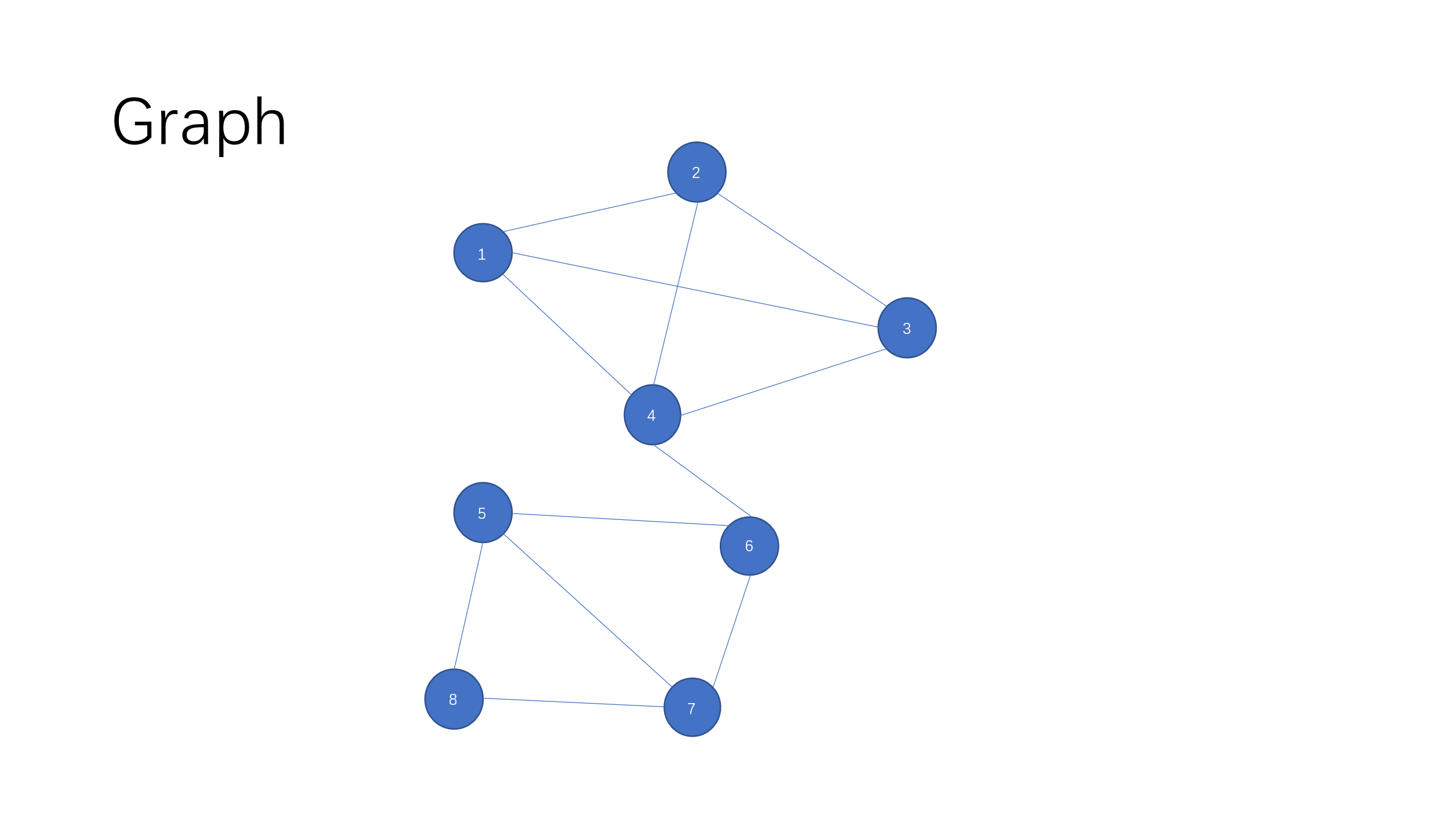

1. Give the sequence of vertices of G visited using a DFS traversal starting at vertex 1.

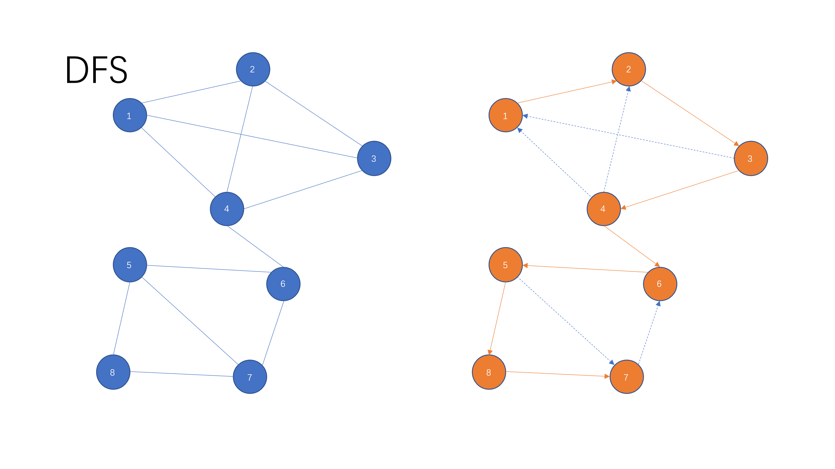

1. Give the sequence of vertices of G visited using a BFS traversal starting at vertex 1

