EECS738 Group Project
Feasibility of backdoor attacks against transfer learning without domain knowledge
I. Baseling attacks: Reimplement BadNets.
For a default setting, the trigger size is 2*2, poison ratio is 1.5%, target label is 2, after 10 iterations.

Following a from-scratch strategy:
Dataset | Attack success rate(%) | Poison model accu(%) | Original Accu(%) | Accu Decrease(%)
MNIST | 99.98 | 99.48 | 99.66 | 0.18
MNISTM | 99.86 | 98.58 | 98.65 | 0.07
GTSRB | 100.00 | 98.78 | 98.84 | 0.06
CIFAR10 | 99.92 | 80.07 | 80.15 | 0.08

Following a tuning strategy:
Dataset | Attack success rate(%) | Poison model accu(%) | Original Accu(%) | Accu Decrease(%)
MNIST | 99.99 | 99.49 | 99.66 | 0.17
MNISTM | 99.98 | 98.52 | 98.65 | 0.13
GTSRB | 100.00 | 98.68 | 98.84 | 0.16
CIFAR10 | 99.71 | 80.11 | 80.15 | 0.04



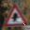

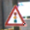
Take GTSRB as example:

Influence of different trigger sizes:
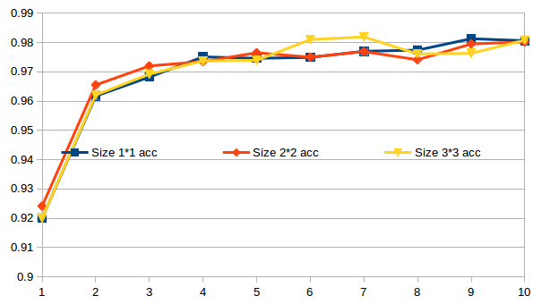
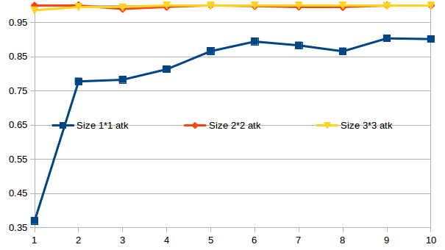

Influence of different poison ratio:
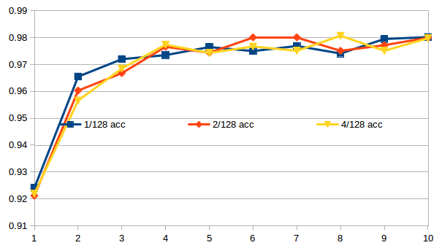
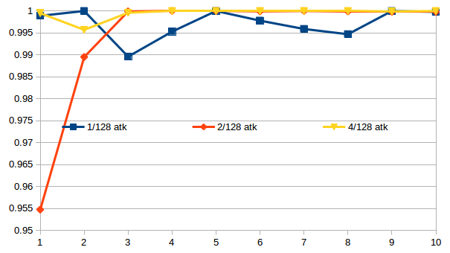

II. Atk against transfer learning.
Trigger size influence:
Take GTSRB to MNISTM as example:
Trigger size | 1*1 | 2*2 | 3*3 | 4*4
Original Accu(%) | 78.18 | 77.88 | 77.17 | 77.08
Atk suc rate(%) | 1.67 | 4.46 | 11.63 | 14.92

Strategy influence:
CIFAR to MNIST
Strategy | Tuning | From-scratch
Original Accu(%) | 97.69 | 97.43
Atk suc rate(%) | 56.35 | 34.75

CIFAR to MNISTM
Trigger size | Tuning | From-scratch
Original Accu(%) | 83.71 | 83.26
Atk suc rate(%) | 26.06 | 19.48

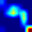
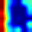
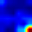


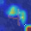
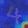

CIFAR to GTSRB
Trigger size | Tuning | From-scratch
Original Accu(%) | 66.07 | 63.14
Atk suc rate(%) | 56.78 | 52.87

Label space influence:
Low to high. Take MNISTM as source domain:
Target Domain | CIFAR | GTSRB | MNIST
Original Accu(%) | 41.77 | 55.92 | 98.01
Atk suc rate(%) | 31.71 | 52.30 | 78.13

High to low. Take GTSRB as source domain:
Target Domain | CIFAR | MNISTM | MNIST
Original Accu(%) | 45.06 | 77.39 | 97.31
Atk suc rate(%) | 7.07 | 5.42 | 0.77

