


FL-AIR Framework User's Guide

Rafik CHENNOUF

Sofiane LAMROUS

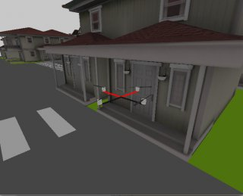

Table of Contents

I) Introduction 3
What is FL-AIR? 3
Why FL-AIR? 3
User guide: 3

II) How to use Fl-AIR ? 4

1) Prerequisites 4
a) Linux 4
b) Serial console 4
c) SSH connection 5
c) SCP 5
c) SVN 6

2) Setup your computer 7
a) Work directory and path variable 7
b) Install packages 8

3) Install Toolchain 9
a) Crossed toolcahin and toolchain 9
b) Graphic drivers 10

4) FLAIR SVN repository 11
a) What is an SVN repository ? 11
b) How FLAIR SVN is organized ? 11

I) Introduction

What is FL-AIR?
FL-AIR is an open source framework written by the Heudiasyc laboratory in C++ language. It aims at helping the creation of application for robots and more specially for UAVs. Many templates are included in the FL-AIR package to help the user to start. It’s important to know that FL-AIR has a cross compiler capable of creating two executable files, one to be executed on the UAV target and the other one on your computer. A simulator is included in the framework so you can test your program safely before running it on drones.

Why FL-AIR?
Many frameworks of robotics exist so why choosing FL-AIR instead of an other?

Pros and cons:
+ FL-AIR developed for UAVs but can be used for other type of robot
+cross compiler and simulator
+Open source

-
-

User guide:
This user guide will teach you from the beginning the important things that you have to know in order to use FL-AIR.
This guide will provide you knowledge and practice so at the end of this course you will be able to write software by yourselves using the framework FL-AIR.

II) How to use Fl-AIR ?
This section will explain how to install Fl-AIR on your computer. This part is very important and must be read and understood before starting to work with the framework.

1) Prerequisites

a) Linux

First of all, make sure that you have a Linux distribution on your computer. The recommended distribution is Mint downloadable here : https://linuxmint.com/. This distribution is popular, user-friendly and simple to install. However, you are not forced to choose Mint, you can also work with another distribution like Ubuntu for example. Whatever your choice, be careful to choose the 64-bit version if you have a recent computer.
As Fl-AIR works on Linux, make sure to know how to use this operating system through the terminal where a lot of operations will be executed. For beginners, this tutorial http://ryanstutorials.net/linuxtutorial/ will give you some knowledge about the Bash command line interface. It is important to know that on the target (uav), unlike the computer, there is only a root account without password. Moreover, only two text editors are available on the target : vi and nano.
Subsequently, for all the tutorial, shell commands that have to be executed on your computer will be indicated as follows, with a dollar symbol $ :

$ command

Shell commands for the target will be indicated as follows, with a sharp symbol # :

# command

Note that the command just above must be executed from a terminal connected to the target directly via a serial connection or the SSH protocol.

b) Serial console

The serial console is used to communicate with the target (uav) either to access U-Boot or a Linux console. The connection is made through a serial port which is a cheap way to allow software developers to directly access the embedded computer. This is invaluable for debugging. Most chip sets designed for embedded computers have a serial port precisely for this purpose. It is important to know that if the SSH connection does not work, the serial console would be the only way to connect to the target because it does not need a network connection.
If you want more information on the serial console and if you want to know how to access it from Linux, consult the following links :
http://www.tldp.org/HOWTO/Remote-Serial-Console-HOWTO/intro.html
https://www.cyberciti.biz/hardware/5-linux-unix-commands-for-connecting-to-t heserial-console/
Regarding U-Boot, it is a primary boot loader used in embedded devices to package the instructions to boot the device's operating system kernel. For further information :
https://wiki.openwrt.org/doc/techref/bootloader/uboot

On Linux, you can use a graphical serial terminal called “CuteCom” :
http://cutecom.sourceforge.net/.

c) SSH connection

Secure Shell (SSH) provides a secure channel over an unsecured network in a client-server architecture, connecting an SSH client application (your computer) with an SSH server (the target = the drone = the uav).

To connect to an SSH server, you must enter the following command :
$ ssh user@server

user is the user name used to connect to the server while server is either the server's name or its IP address. In practice, … ( A completer dans la volière )
For example, to connect to a server named storage as the user toto :
$ ssh toto@storage

To connect the target with its IP address :

$ ssh toto@192.168.3.6

It should be noted that the first time you connect to an SSH server, it will be added to the known hosts file of your computer.

You can find a more detailed SSH tutorial here : https://support.suso.com/supki/SSH_Tutorial_for_Linux

d) SCP

Secure copy or SCP is a means of securely transferring computer files between a local host and a remote host or between two remote hosts. It is based on the Secure Shell (SSH) protocol.

To use it, you have to enter the following command :
$ scp source_path user@server:/destination_path

source_path is the path of the file you want to transfer, user is the user name used to connect to the server and destination_path is the destination path of your file in the server. In practice, user is the same as for the SSH connection.

For example, to copy the file test from your home directory to the server (IP : 192.168.6.1
) into the folder /home/root :

$ scp ~/test root@192.168.6.1:/home/root

For further information : http://www.hypexr.org/linux_scp_help.php

e) SVN

Apache Subversion (SVN) is a software versioning and revision control. SVN is used for the Fl-AIR Framework and works like Git through the terminal.
To check out a working copy from a repository, you must enter :
$ svn checkout
To update your working copy and bring changes from the repository into your working copy :
$ svn update

To send changes from your working copy to the repository :
$ svn commit

If you wish you could also use a visual client such as http://rapidsvn.tigris.org/.
For more details about SVN, follow this link : https://www.tutorialspoint.com/svn/index.htm.

f) CMake

CMake is cross-platform free and open-source software for managing the build process of software using a compiler-independent method. It supports directory hierarchies and applications that depend on multiple libraries.
CMake is used to automatically generate standard building files such as Makefiles or projects for different IDE, through a single configuration file named CmakeLists.txt regardless of the IDE used. Moreover, CMake is able to manage different operating systems.
CMake must be used from the command line. Enter the following command to get the different options :
$ cmake

For example, to create a project for CodeBlocks IDE, you must execute the next command from a repertory containing a CmakeLists.txt file :

$ cmake -G "CodeBlocks - Unix Makefiles"

For further information, follow this link :
https://www.jetbrains.com/help/clion/2016.3/quick-cmake-tutorial.html

2) Setup your computer
In this part we will see how to proceed to have all the tools that you need to start using FLAIR.

a) Work directory and path variable
To work comfortably it is advisable to create a unique directory that contains all FLAIR stuff.
This line allows you to create this directory, it’s located in HOME directory.
$ mkdir $HOME/flair

After this you can add an environment variable to your .bashrc with the path of this directory. It’s like creating a shortcut, and we will use it to simplify the way how we access to FLAIR directory.
To do that we have to edit the bashrc file to declare our environement variable.
$ nano ~/.bashrc

Then add these lines at the end.

# variable for Fl-AIR
export FLAIR_ROOT=$HOME/flair

CTRL+X to close the file and answer yes to save the modifications.
Now we need to reload the script to create our variable $FLAIR_ROOT.
Here is the command :

$ source ~/.bashrc

It’s important to know that all Fl-AIR documentation, scripts and CMakeLists.txt will use this variable. So it’s really recommended not to skip this step.

b) Install packages

To continue we have to install an IDE, you have the choice between CodeBlocks and Eclipse.

To install codeblocks (all Fl-AIR documentation is based on it) :

$ sudo apt-get install codeblocks codeblocks-contrib

or eclipse if you prefer :

$ sudo apt-get install eclipse-cdt

Note that when Codeblocks is not launched from command line, it does not read environment variables set in .bashrc. This can make trouble when a CMakelists.txt is modified for example.

We can fix this by adding a new variable, to do so, go to settings/environment menu. Choose environment variables section on the left.
Click on Add and fill the form :
Key: FLAIR_ROOT
Value: path to the FLAIR_ROOT directory

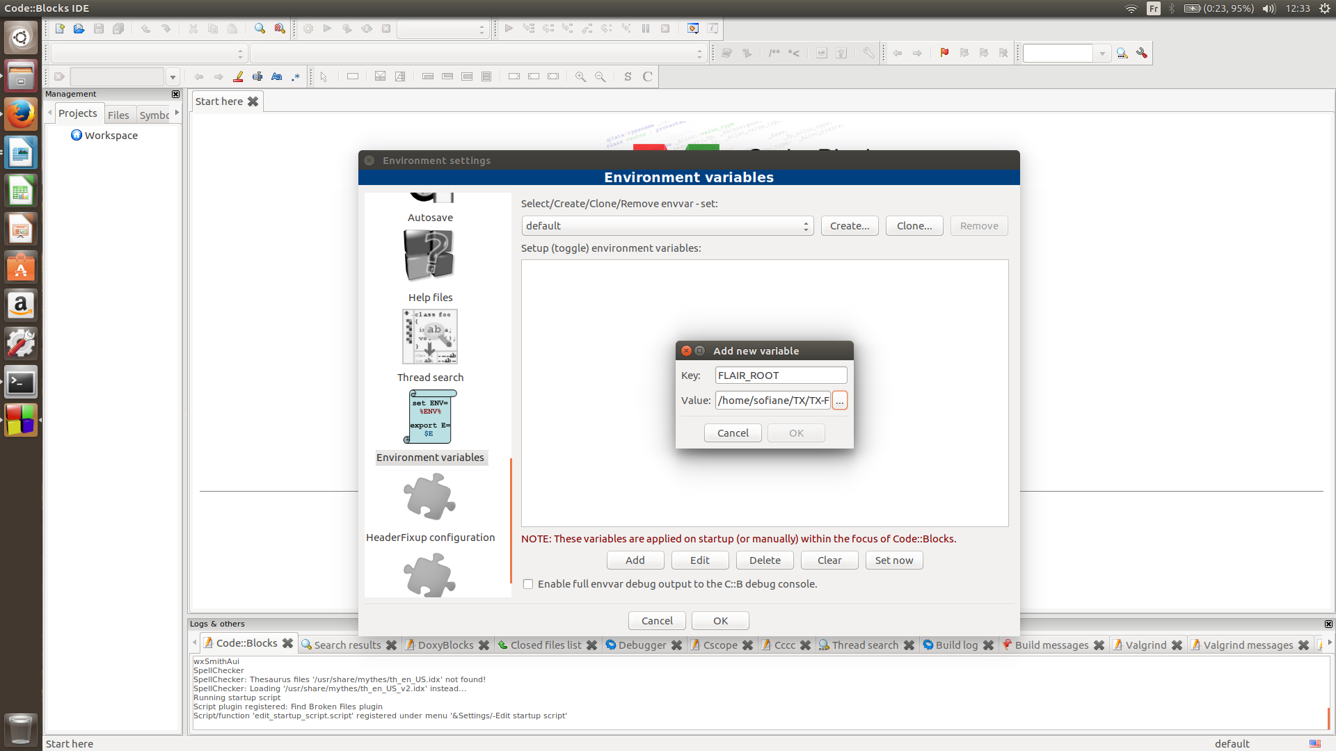 Illustration 1: Add a new environment variable in CodeBlocks

Xenoami

Partie “Setup your computer” incomplète (voir le wiki)

3) Install Toolchain

a) Cross-toolchain and toolchain
A cross compiler is used to compile your programs for your computer and for the target UAV which is based on an ARM architecture.
The version that need to run on the target is made by the cross-toolchain, to install the cross compiler copy and paste these lines:
$ cd ~
$ wget https://uav.hds.utc.fr/src/toolchain/x86_64-meta-toolchain-flair-arm.sh
$ chmod +x x86_64-meta-toolchain-flair-arm.sh
$ sudo ./x86_64-meta-toolchain-flair-arm.sh
$ rm x86_64-meta-toolchain-flair-arm.sh

Here is the command to install the toolchain that will generate an executable for your computer
$ cd ~
$ wget https://uav.hds.utc.fr/src/toolchain/x86_64-meta-toolchain-flair-x86_64.sh
$ chmod +x x86_64-meta-toolchain-flair-x86_64.sh
$ sudo ./x86_64-meta-toolchain-flair-x86_64.sh
$ rm x86_64-meta-toolchain-flair-x86_64.sh

Environment variable
The toolchain installation scripts generate environment variables but to use them you must reload your .bashrc file.
$ source ~/.bashrc

b) Graphics drivers
To use the FLAIR simulator you need to update your graphics drivers and copy them in the toolchain program:

For Nvidia graphics cards
$ sudo cp -r /usr/lib/nvidia-340/* /opt/robomap3/1.7.3/core2-64/sysroots/core2-64-poky-linux/usr/lib

Here “nvidia-340” is the driver version it could be different if you have a more recent version.
For AMD graphic cards

$ sudo cp -r /usr/lib/fglrx/* /opt/robomap3/1.7.3/core2-64/sysroots/core2-64-poky-linux/usr/lib

Fglrx is the default directory that contains AMD graphics driver.

For Intel :

A remplir

If your laptop have two graphics cards it is more complicated because you should disable one of your graphic card.

A expliquer
Parler de PRIME pour Nvidia
Voir pour AMD si t'arrives à résoudre ton problème

4) FLAIR SVN repository

a) What is an SVN repository ?
An SVN repository is used for managing any collection of files that are changed or modified over time. It is a collection of files and directories, bundled together in a special database that also records a complete history of all the changes that have ever been made to these files.

b) How FLAIR SVN is organized ?

Root
| -> tags
| -> latest
| -> 1.0
| -> 1.1
| -> 2.0
| -> ...
| -> trunk
| -> branches
| -> testing
| -> ...

- Tags
The tags are the stable versions of the repository. As these versions are stable you can’t modify them and they are supposed to be functional. The tag latest is the latest stable version, we will use this one.
- Trunk
The trunk branch is the version still under development.
- Other branches
The other branches are used to order other development versions that we can modify without altering the trunk version.

Incomplet (voir wiki)

flair-src

This repository contains the Fl-AIR source.
It is organized as follows:
- demos: demos using Fl-AIR
- lib: FL-AIR libraries sources
- tools: FL-AIR tools sources (ground control station, etc)

flair-dev

This repository contains all necessary files to develop applications with Fl-AIR.
It is organized as follows:
- cmake-modules: modules for cmake
- doc: documentation
- include: Fl-AIR header files
- scripts: scripts used to develop with Fl-AIR

flair-bin

This repository contains Fl-AIR binaries.
It is organized as follows:
- models: models used by Fl-AIR simulator
- lib: Fl-AIR compiled libraries
- tools: Fl-AIR compiled tools

A détaillé un peu plus (à quoi correspond chaque dossier exactement ? Qu'est ce qu'il y a dedans). Mettre par exemple une copie d'écran de l'arborescence

III) Your first program

In this section, you will learn how to develop and compile your first program and execute it on the simulator. You will simulate a drone following a square trajectory around a character able to move inside a motion capture room.

