Business Sales Performance Analytics

SUPERSALES ANALYSIS REPORT

Name: Chinmayi Rudrappa Naik
Internship: Data Science & Analytics Intern – Future Interns

DASHBOARD

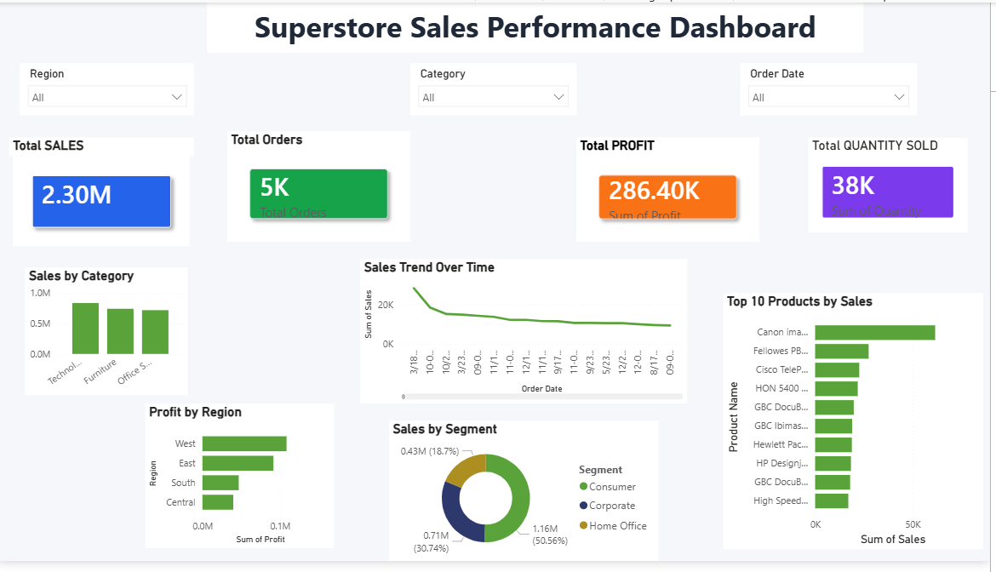

Business Insights:
• The Superstore generated $2.30M in total sales.
• The business earned $286.40K in total profit.
• Approximately 5K orders were processed, with 38K units sold.
• The Technology category generated the highest sales.
• The West region recorded the highest profit.
• The Consumer segment contributed the highest share of sales.
• Sales fluctuated over time, indicating changing customer demand.

Recommendations:
• Focus marketing efforts on Technology products.
• Improve sales performance in lower-performing regions.
• Maintain inventory for top-selling products.
• Increase engagement with Corporate and Home Office customers.
• Monitor sales trends regularly to improve planning and decision-making.

Tools Used
- Microsoft Power BI
- Microsoft Excel

