Step 1: Version Control with Git
Fork the main repository into your GitHub account.
Maintain your version by syncing updates from the main repository as needed.
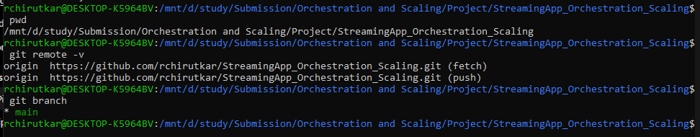
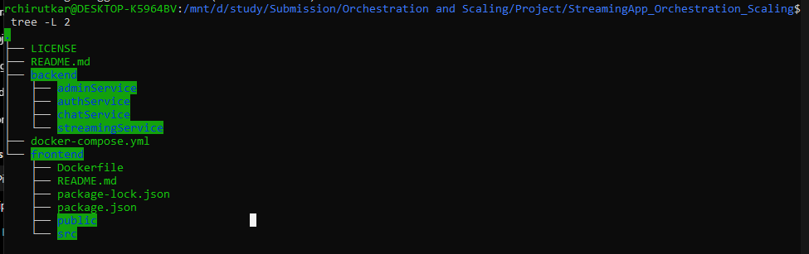
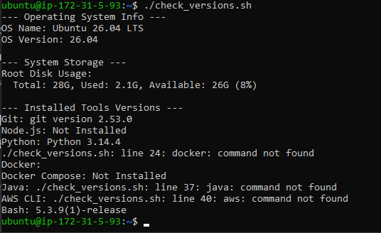
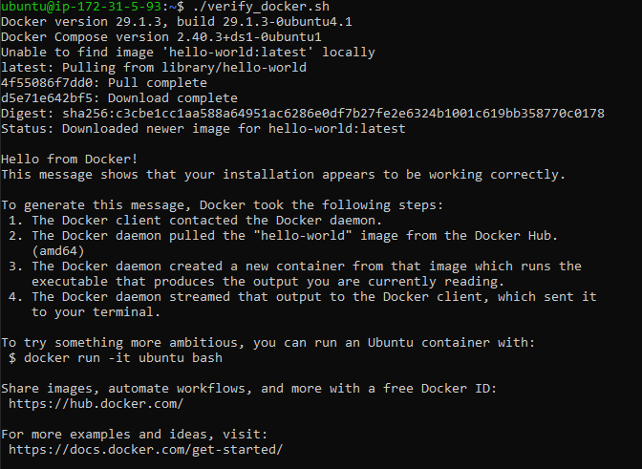
Step 2: Prepare the MERN Application
Containerize the Application
Create Dockerfiles for each component (Frontend and Backend).
Push Docker Images to Amazon ECR
Build Docker images for both components.
Create individual ECR repositories.
Push the images to their respective ECR repositories.
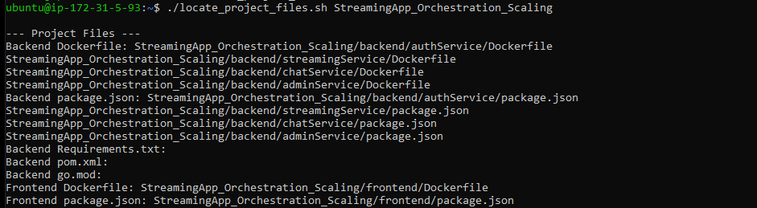
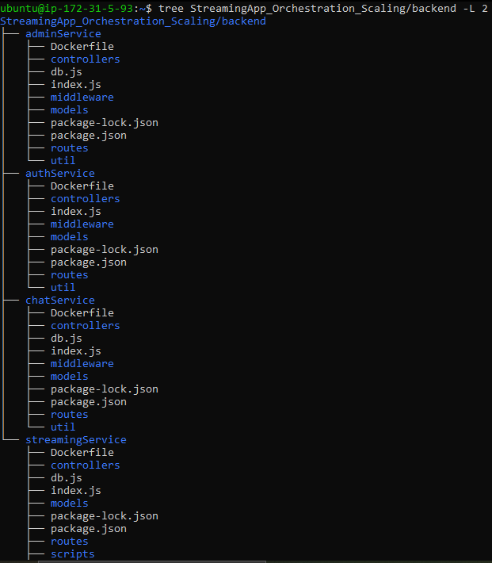
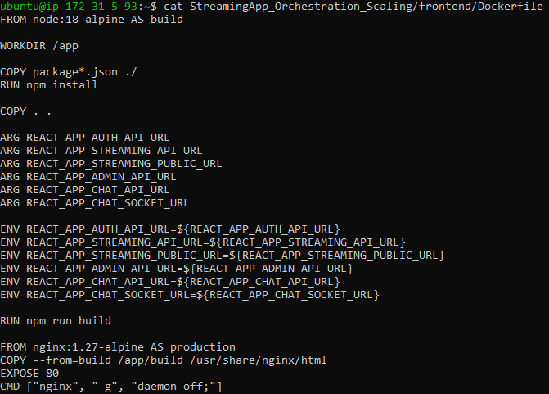
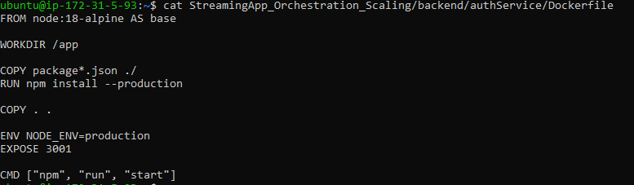
Test Auth Service Dockerfile, if it works then other services will follow the same:
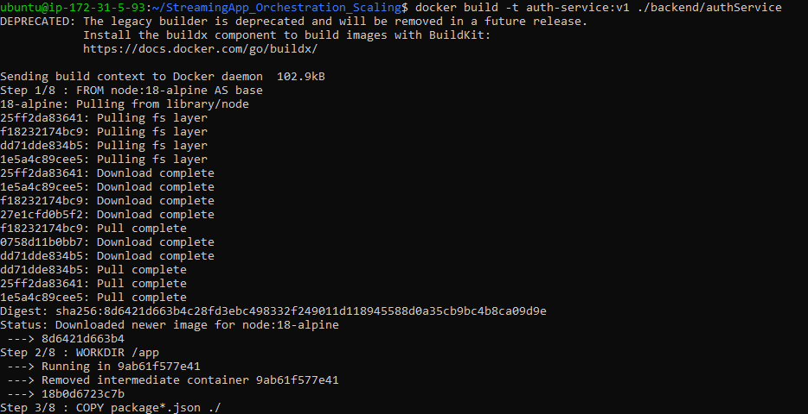
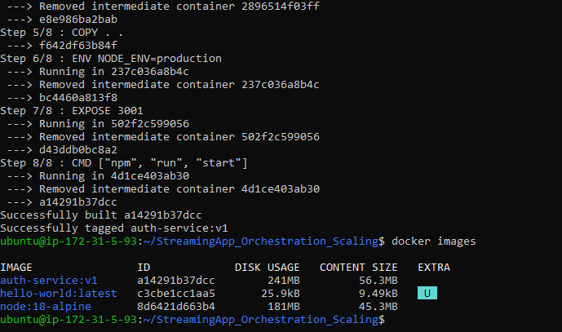
As my EC2 instance is 1GB RAM, so create a temporary 2 GB swap file to increase operational memory.
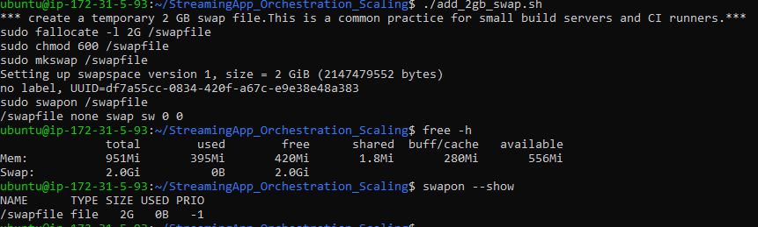
Docker Compose Build
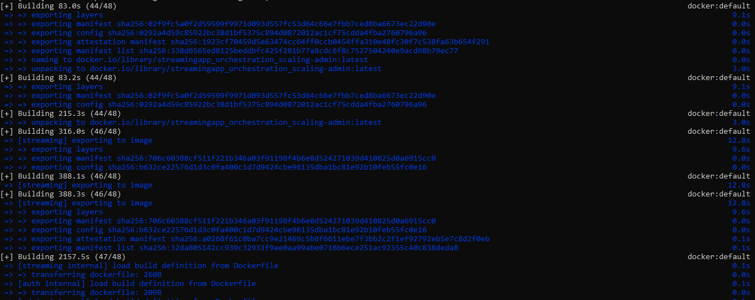

When Docker Compose Build failed for frontend, make changes in frontend/Dockerfile to increase Node.js Heap for React Build
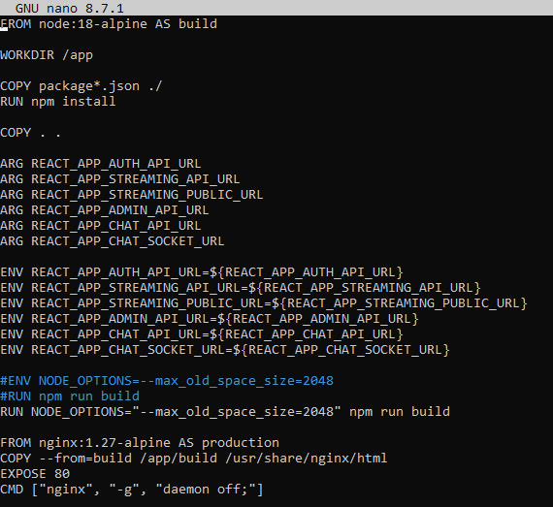
Run Docker Compose Build Frontend
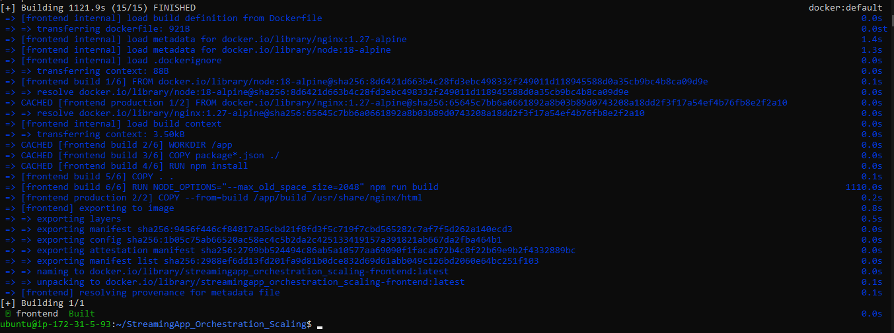
The frontend Docker build initially failed because:
- EC2 instance: t2.micro (1 vCPU, 1 GB RAM)
- React production build exhausted the default Node.js heap.
- Linux swap alone wasn't sufficient because Node.js has its own heap limit.

Resolution
We applied two fixes:
- Added a 2 GB swap file to the EC2 instance.
- Increased the Node.js heap during the React build:
Now run docker compose build again using the cached frontend layers
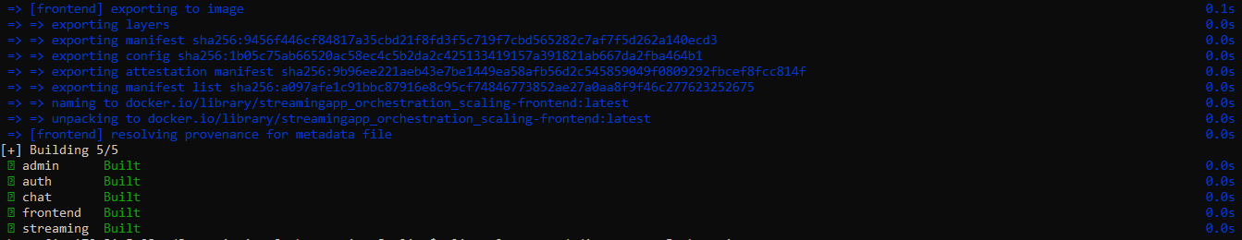
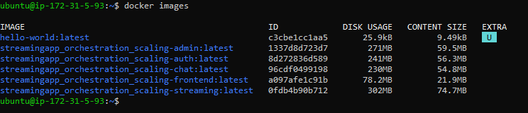
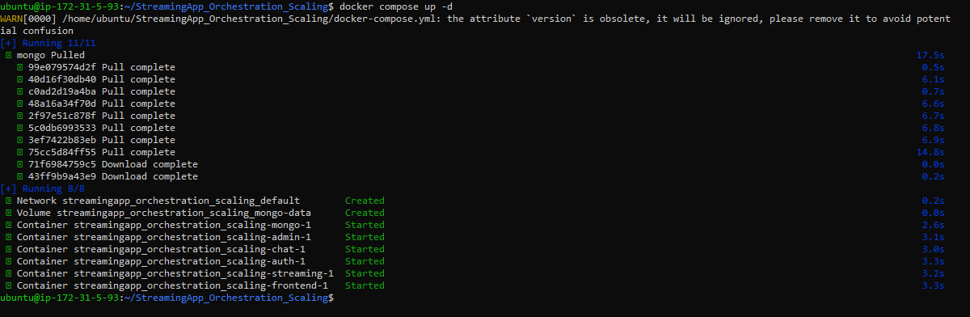
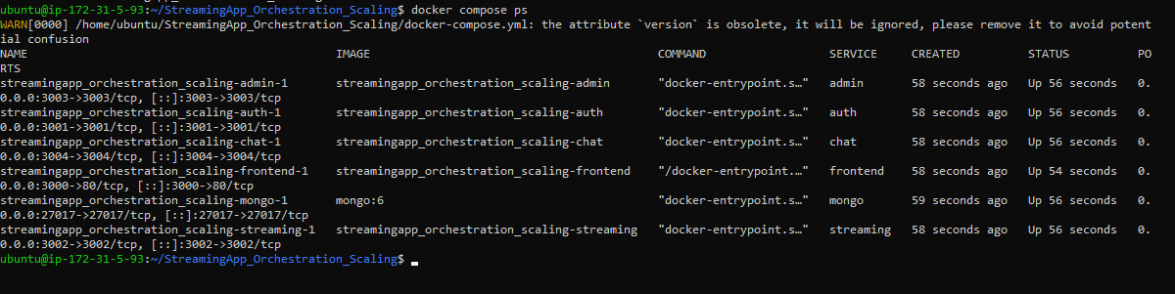
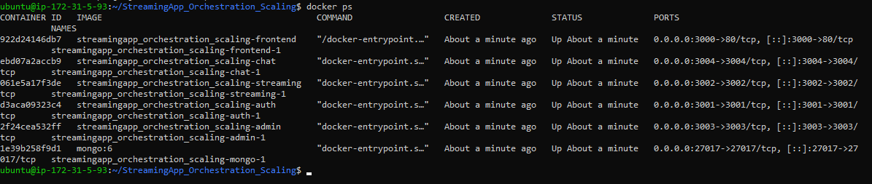
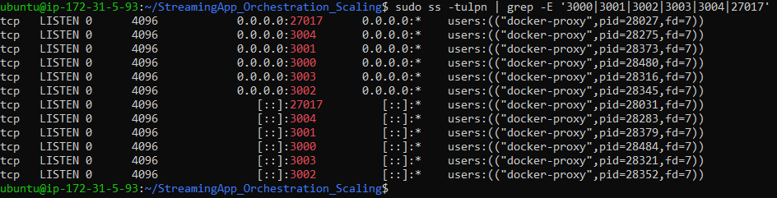
Check the .env files and their use in the project
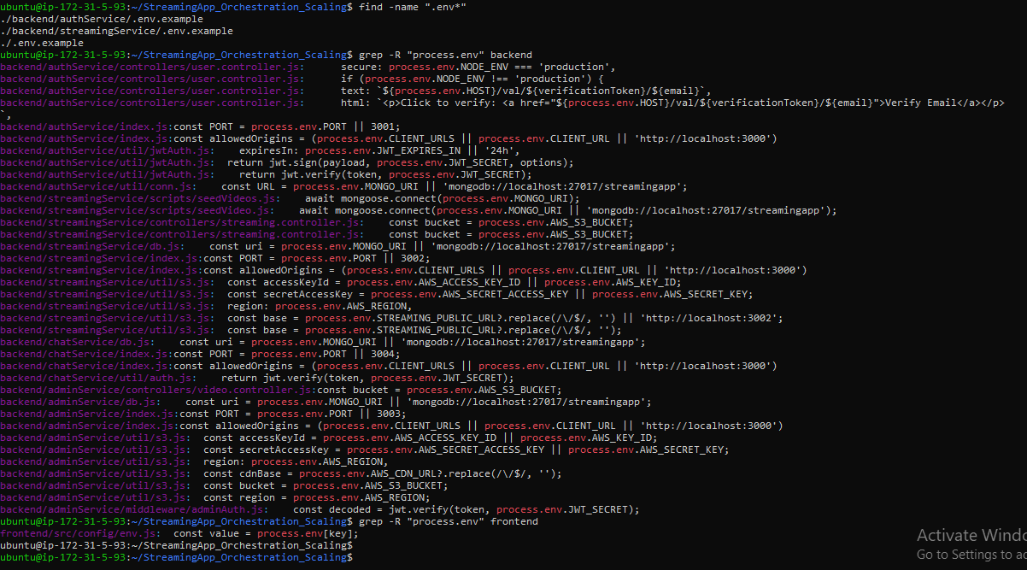
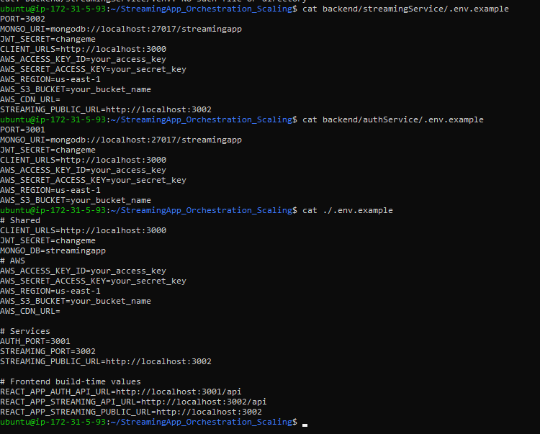

Step 3: AWS Environment Setup
Install and Configure AWS CLI
Set up AWS CLI with your access credentials.

Step 4: Continuous Integration (CI) using Jenkins
Set Up Jenkins
Install Jenkins on an AWS EC2 instance.
Configure necessary plugins and credentials.
Create Jenkins Pipelines
Build and push Docker images to ECR using Jenkins jobs.
Trigger builds automatically on new commits from the Git repository.

Java installed for jenkins
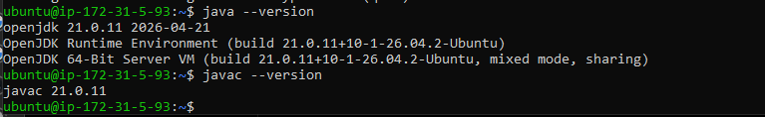
Test Jenkins Pipeline Validating Agent Environment
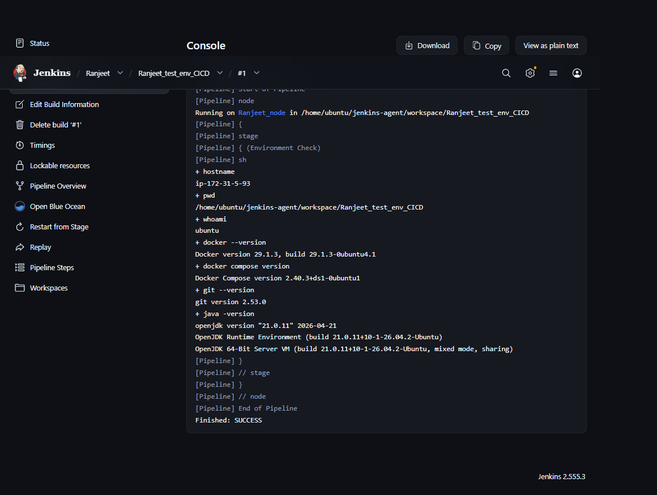

AWS Installation
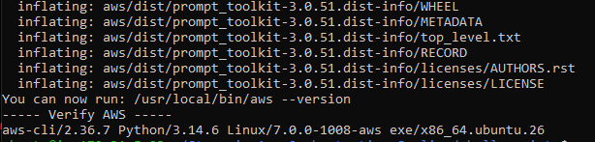
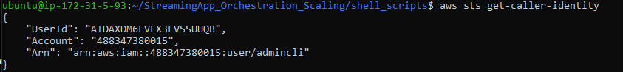
Create ECR repos
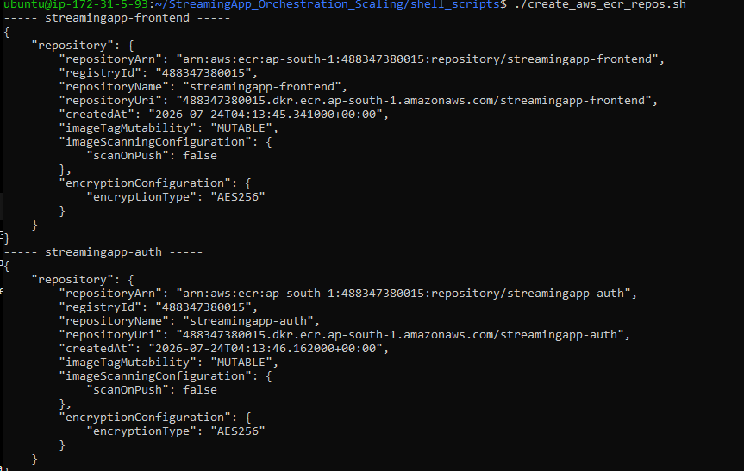
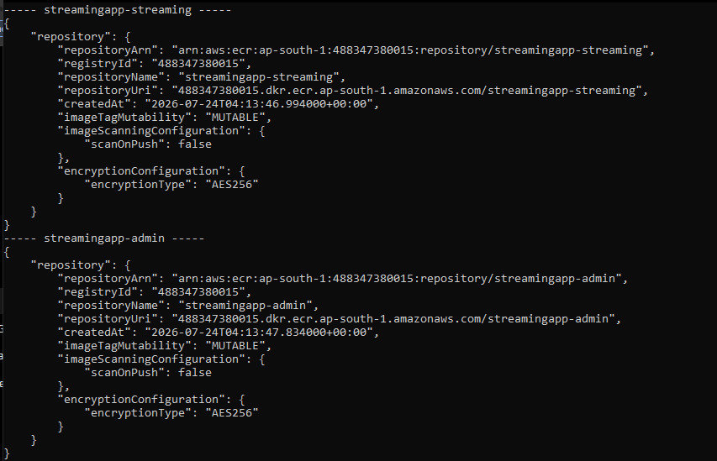
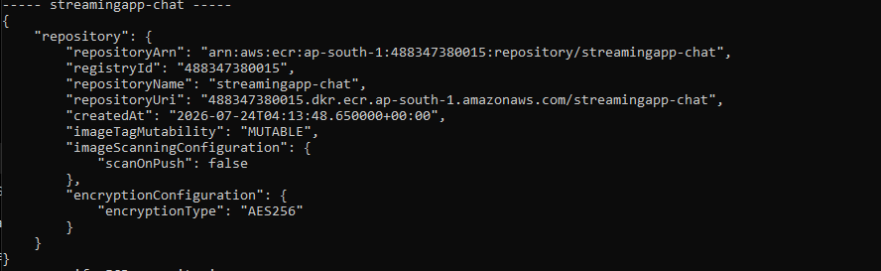
Add AWS credentials in Jenkins
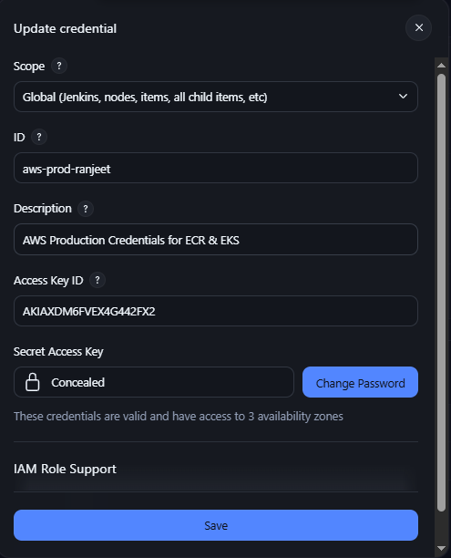

Jenkins Pileline
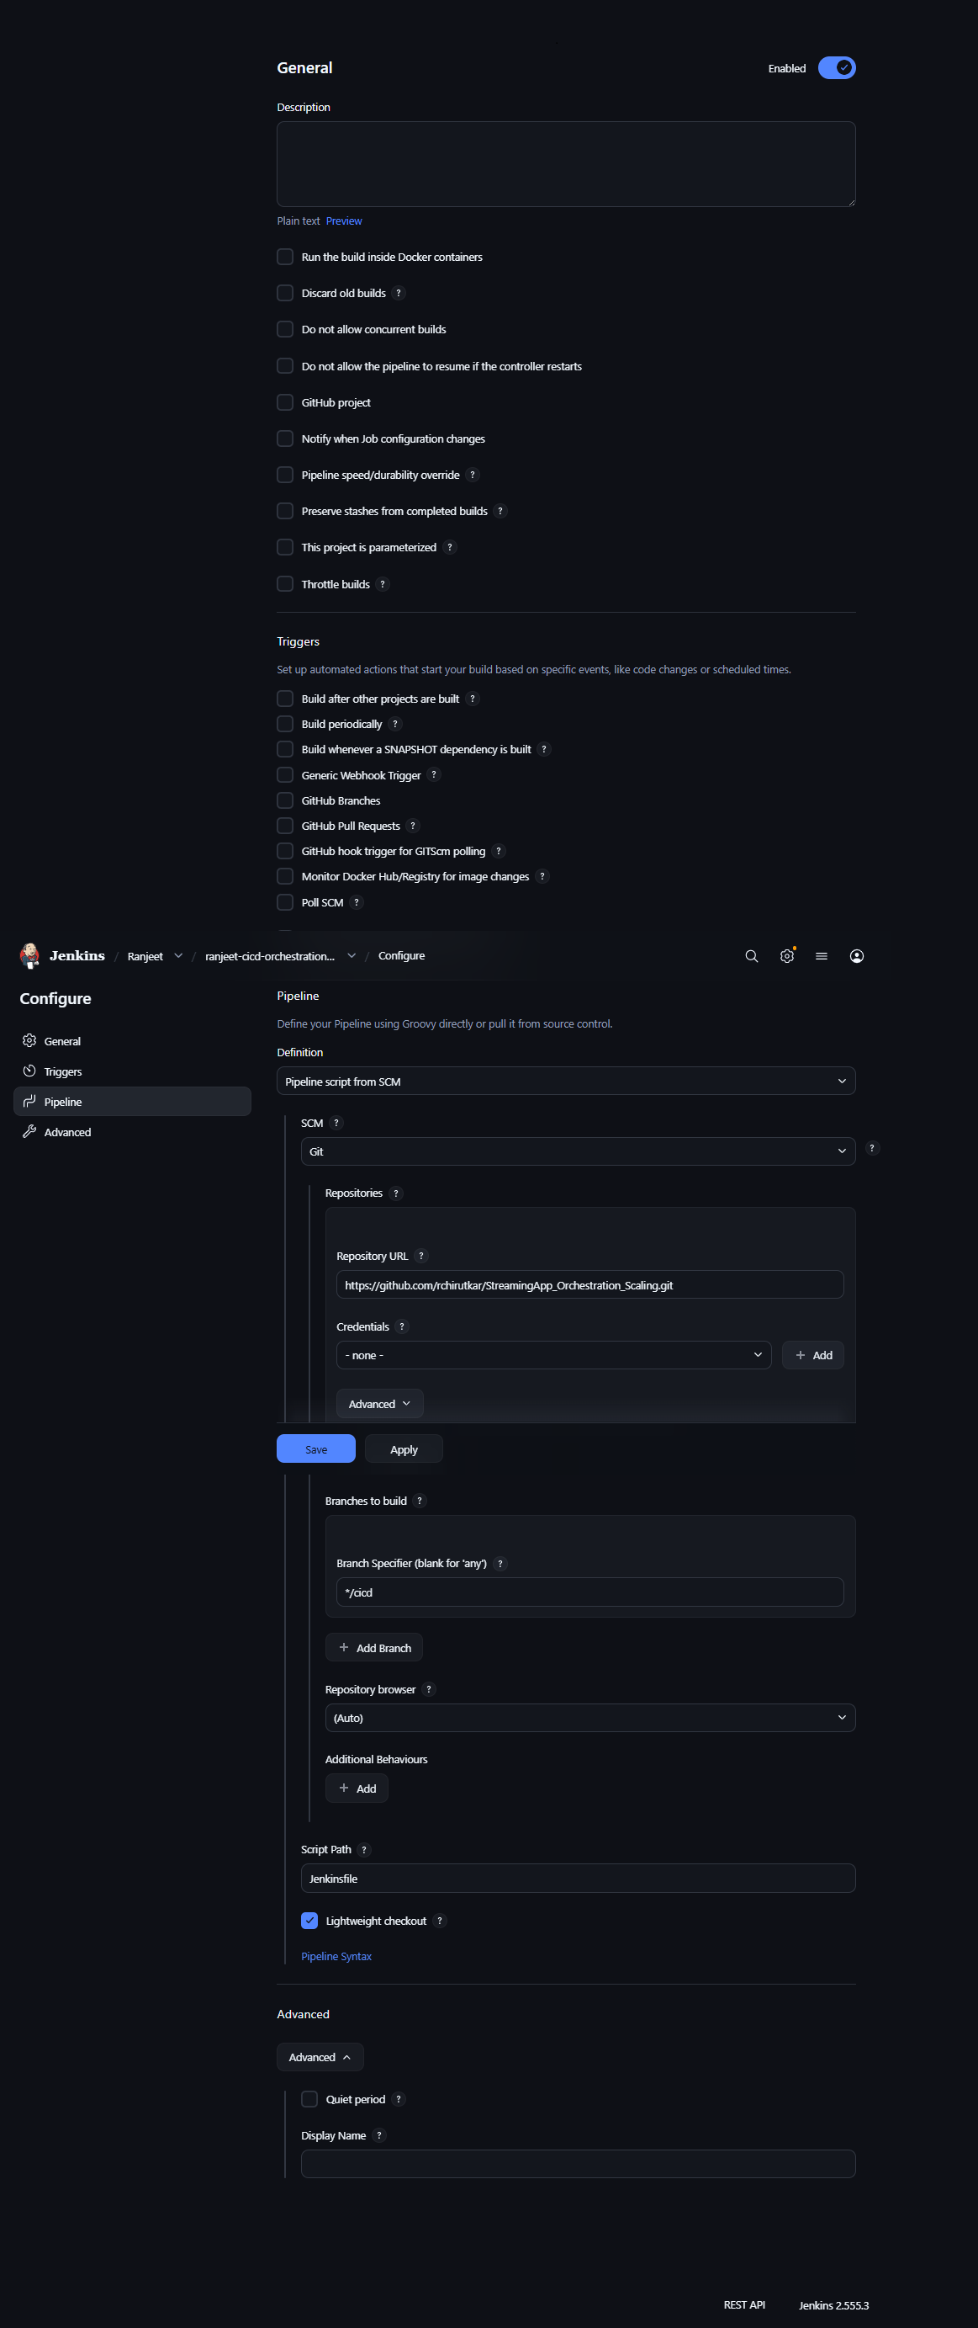

Add Jenkinsfile in cicd branch
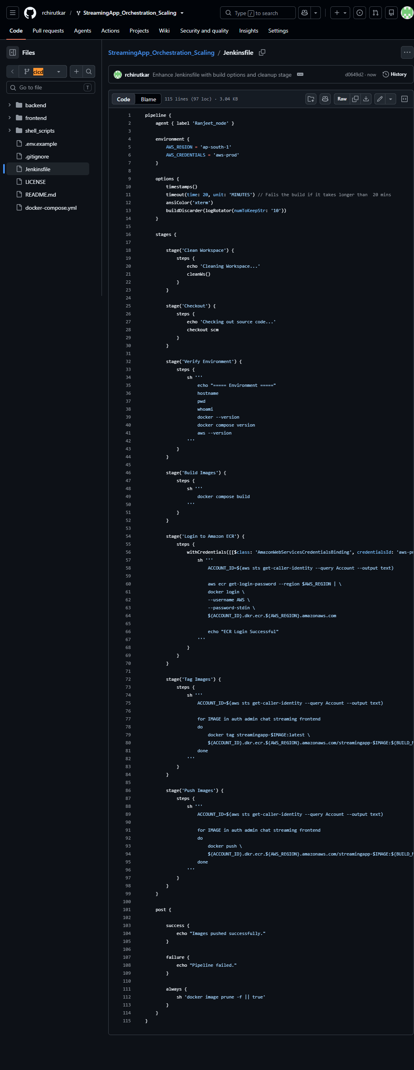
Test Jenkins CICD Pipeline
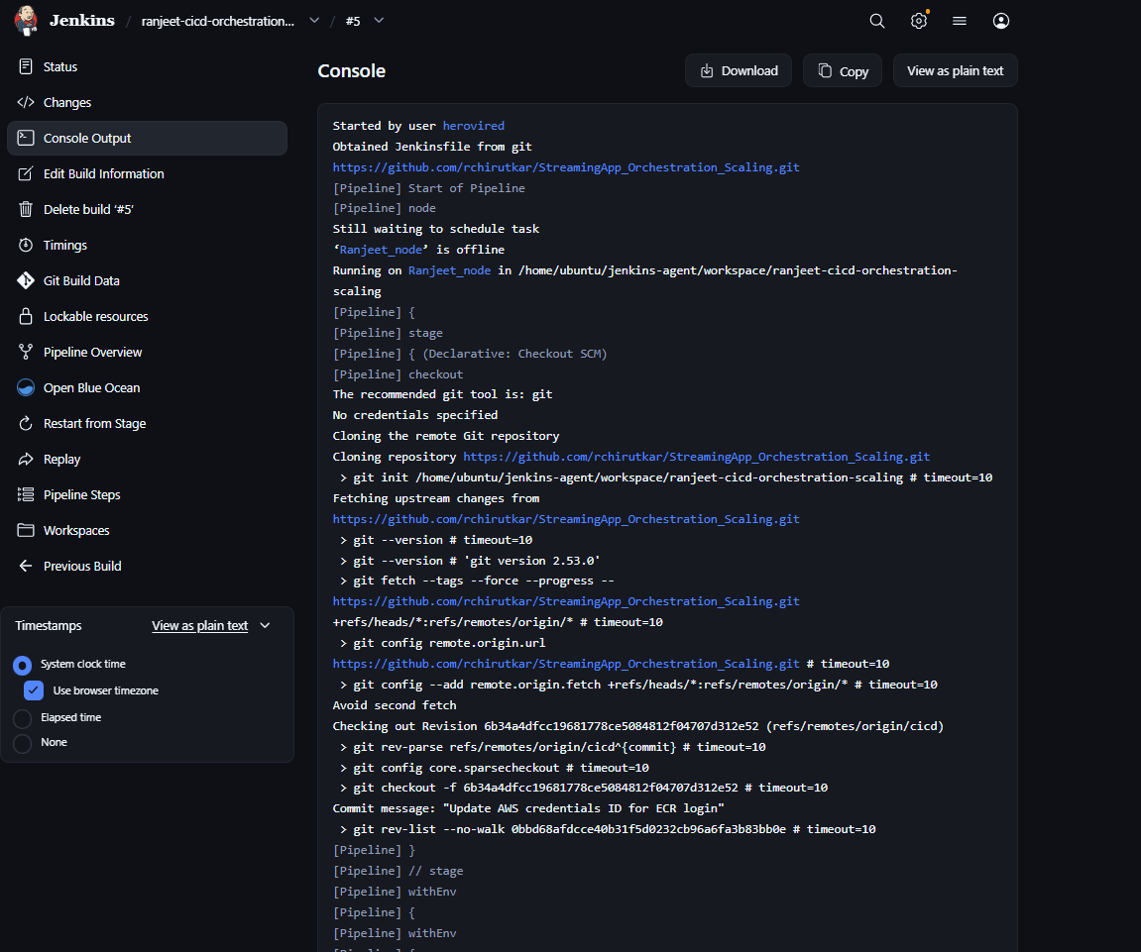
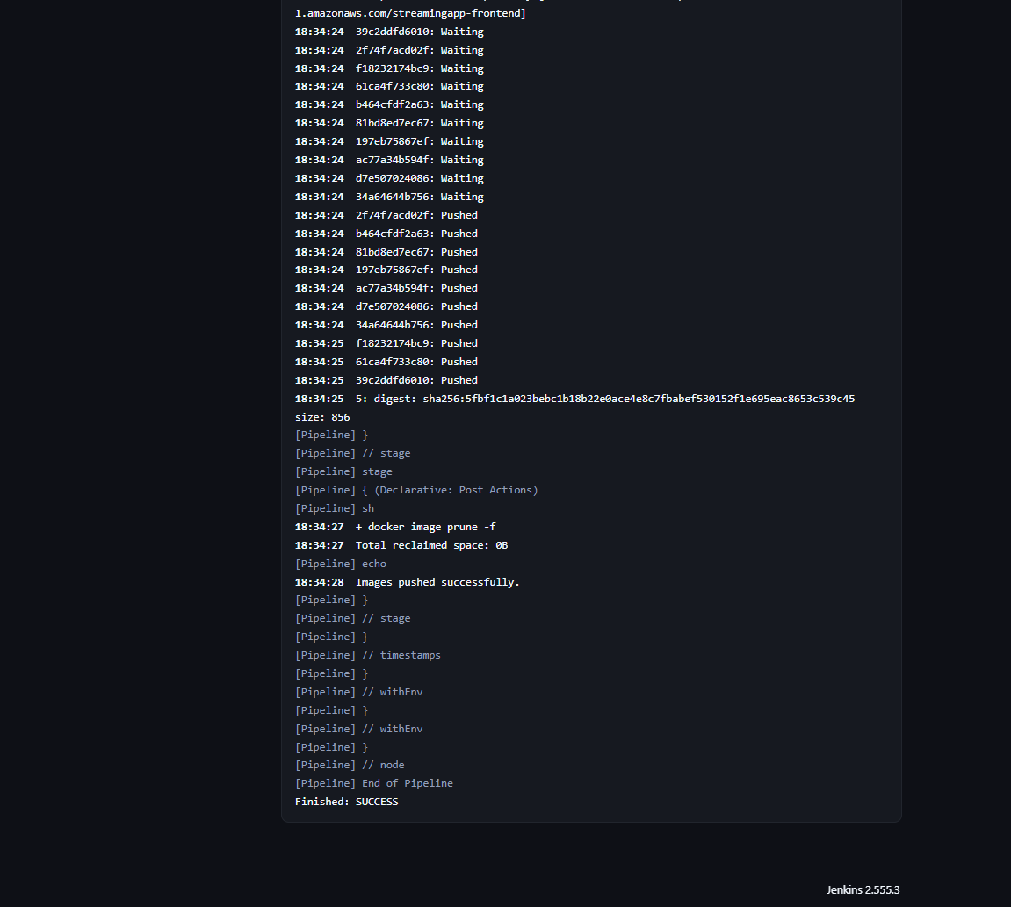
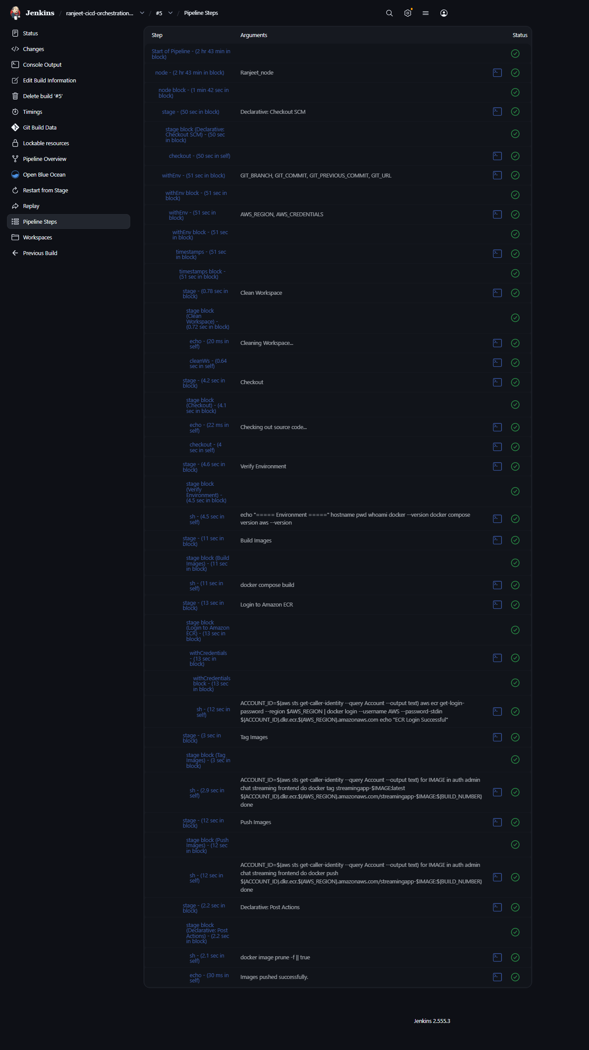
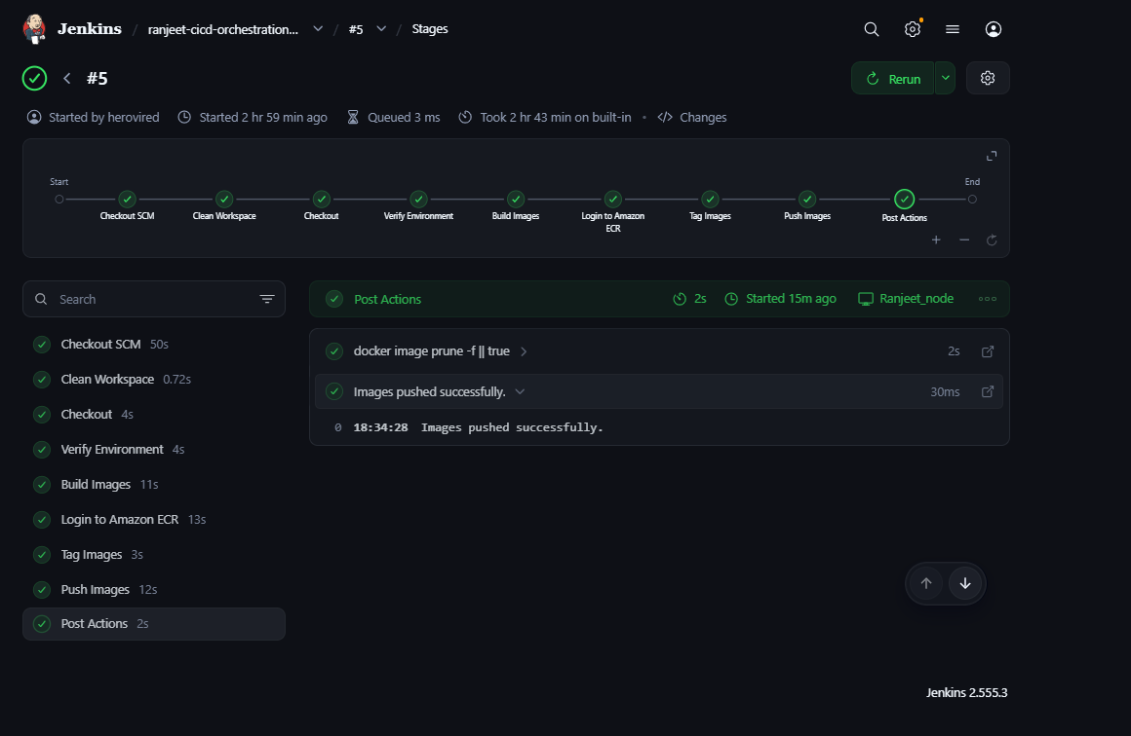
Verify ECR images
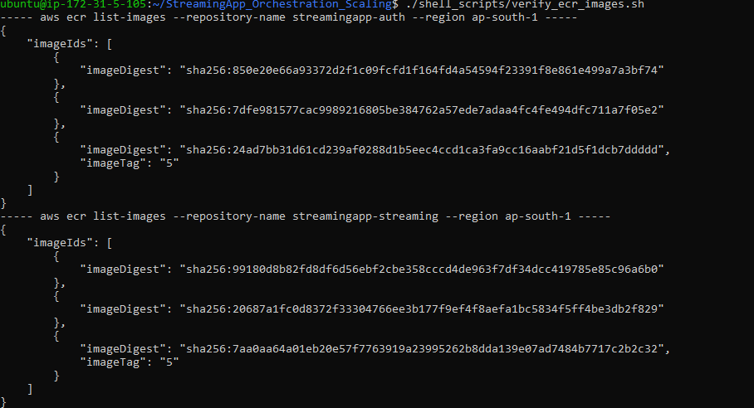
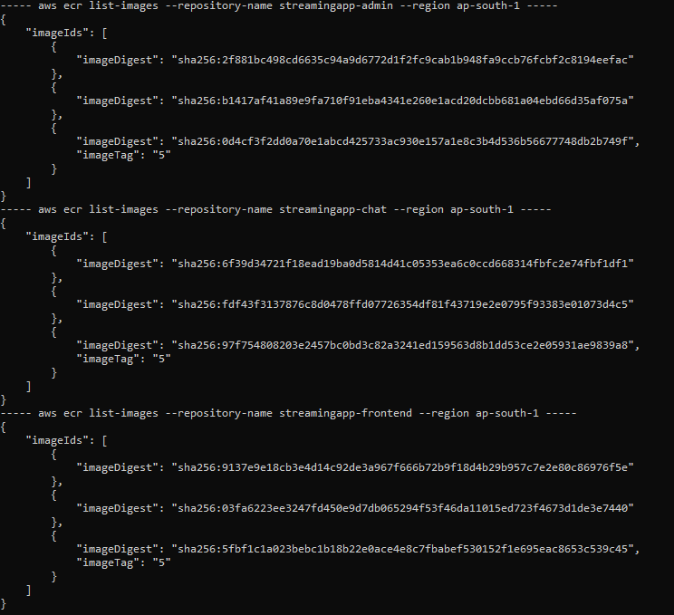

Step 5: Kubernetes Deployment (EKS)
Create an EKS Cluster
Use eksctl or similar tools to set up Amazon EKS.
Deploy via Helm
Package and deploy the MERN stack using Helm charts.
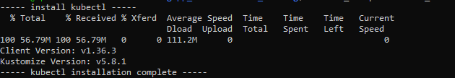
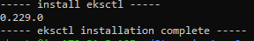
Application has 5 Node.js microservices + MongoDB + Kubernetes system pods. A t2.micro will almost certainly run out of memory. Two t3.small nodes are a much safer.
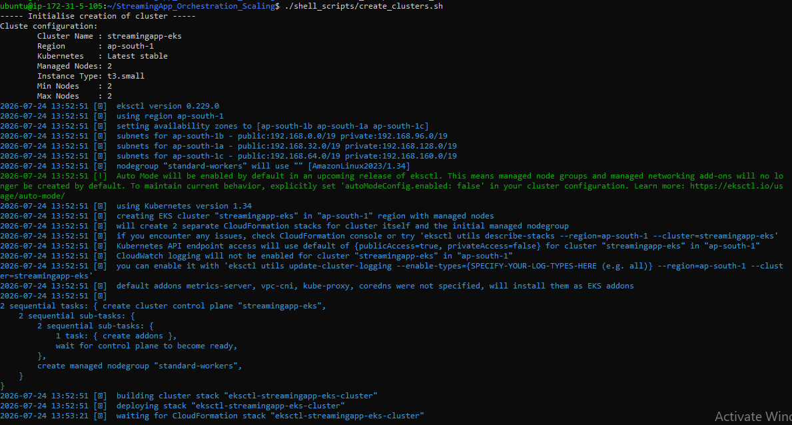
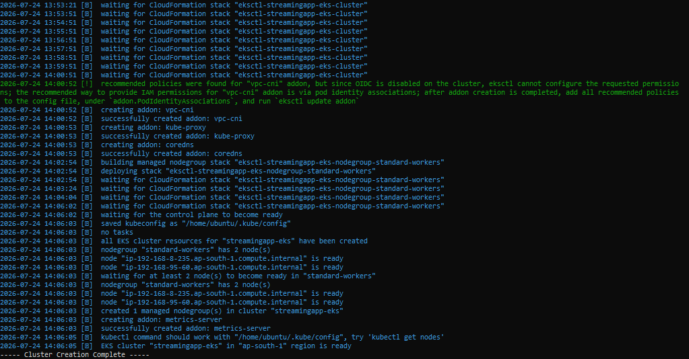
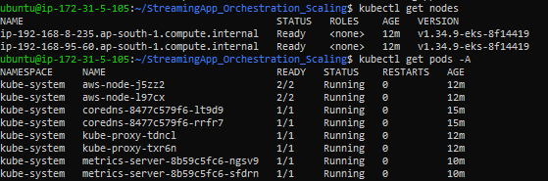
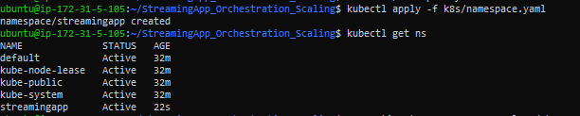
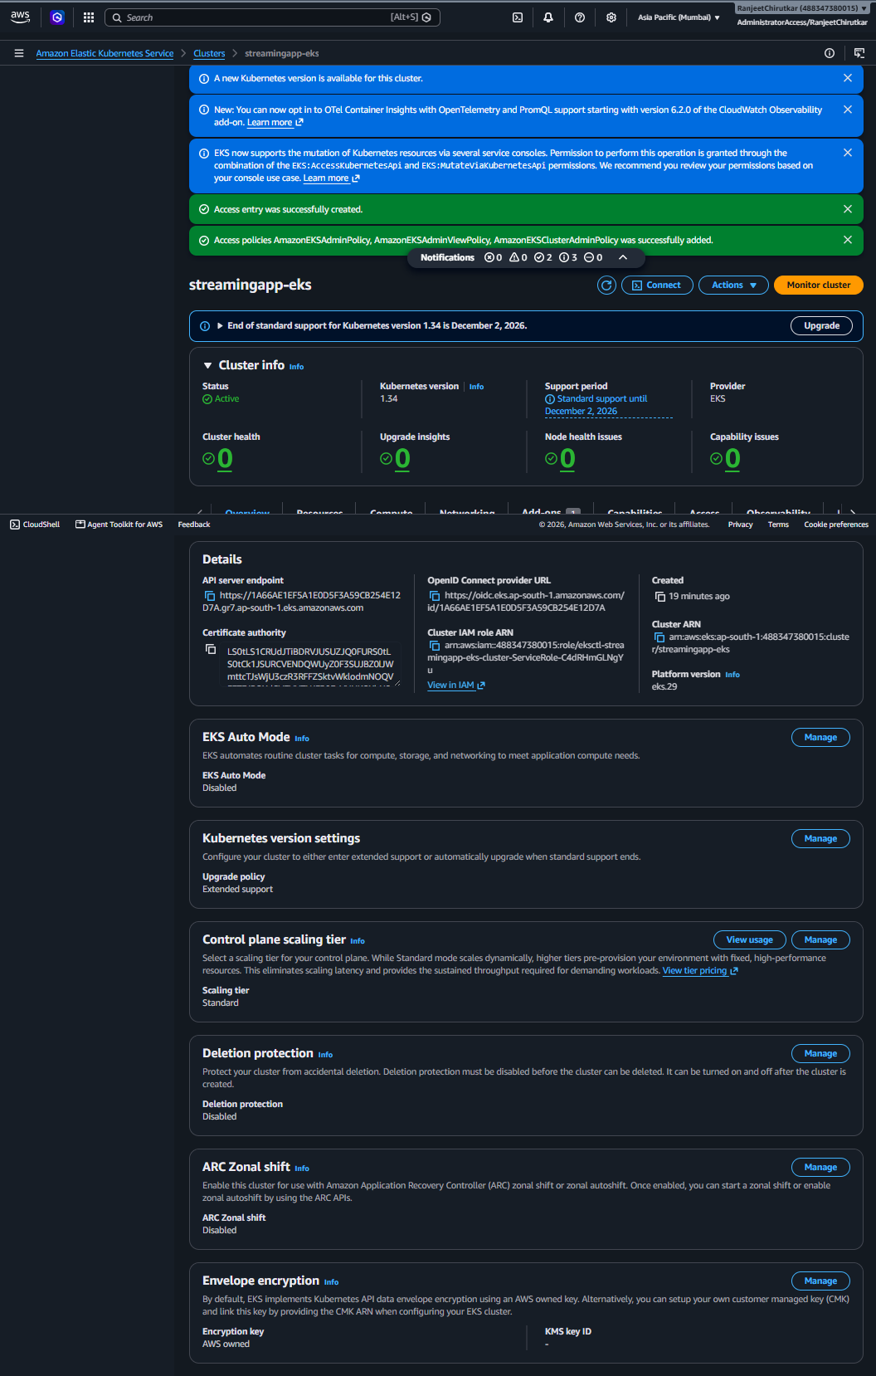
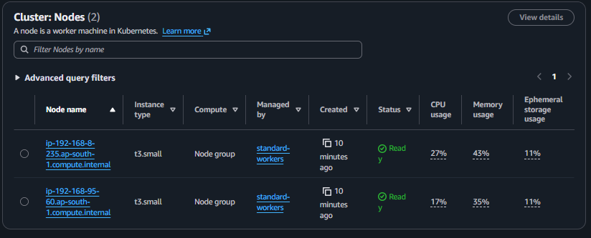
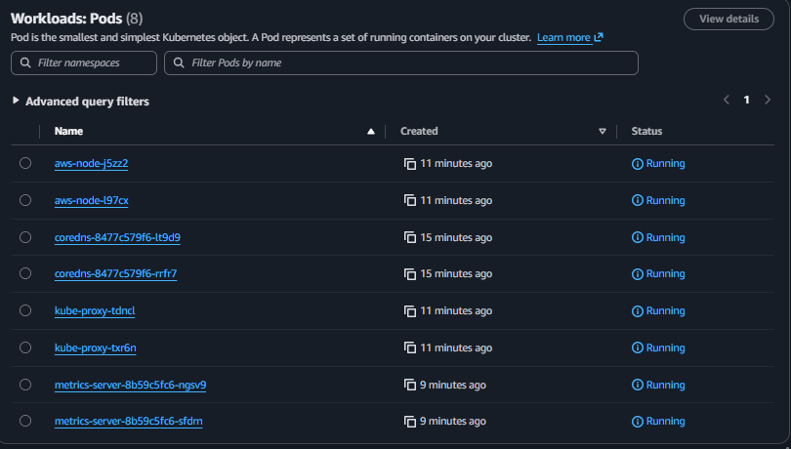
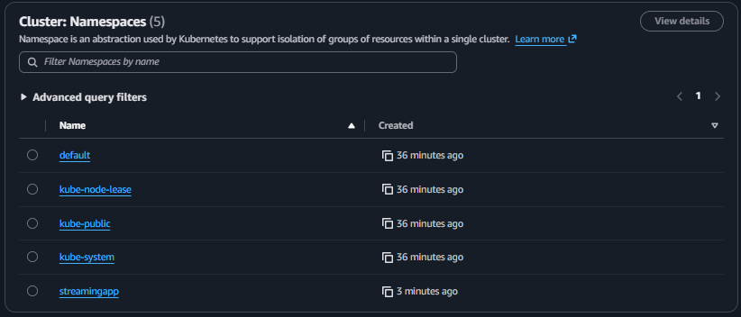

K8S Secrets and Configmap
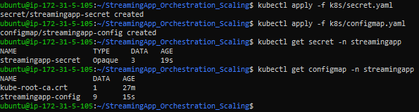
K8S Mongo Deployment and Services
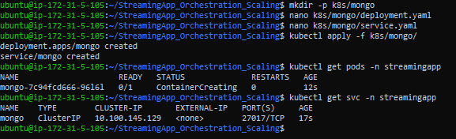
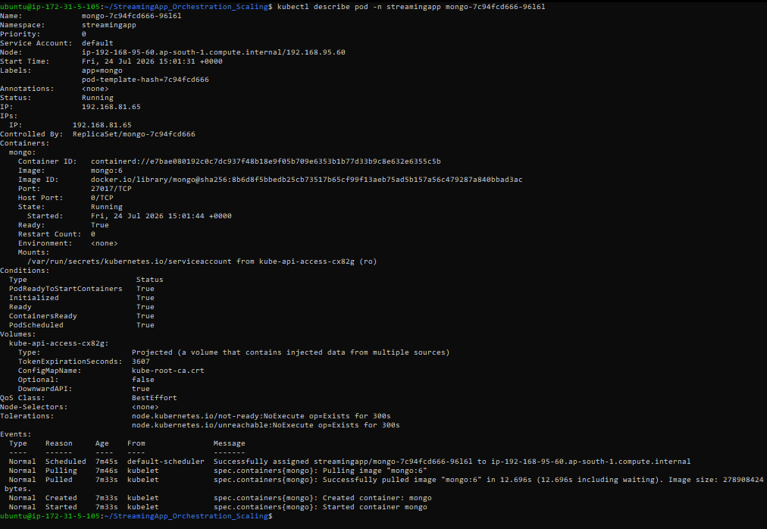
EKS worker nodes authenticate to Amazon ECR using their IAM node role, eliminating the need for Docker registry secrets.
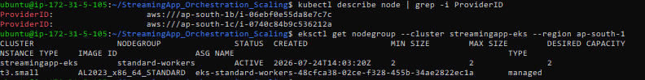

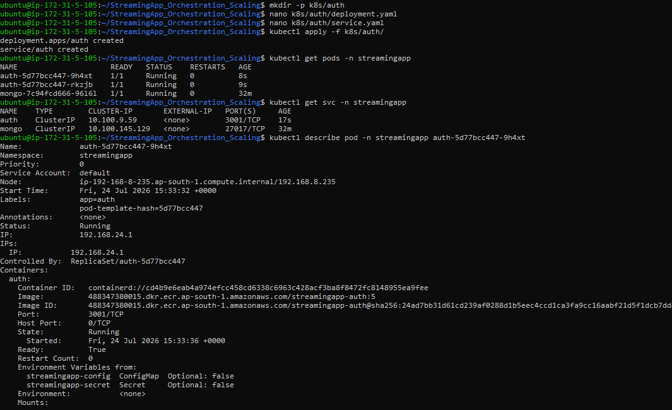
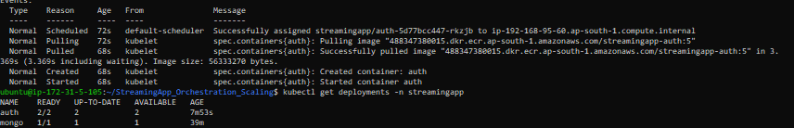
Verify all 5 services on EKS
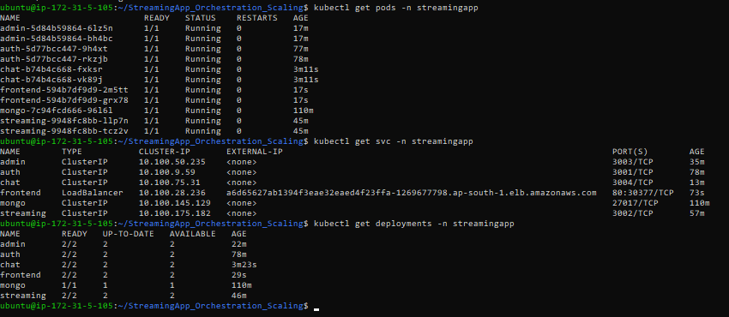
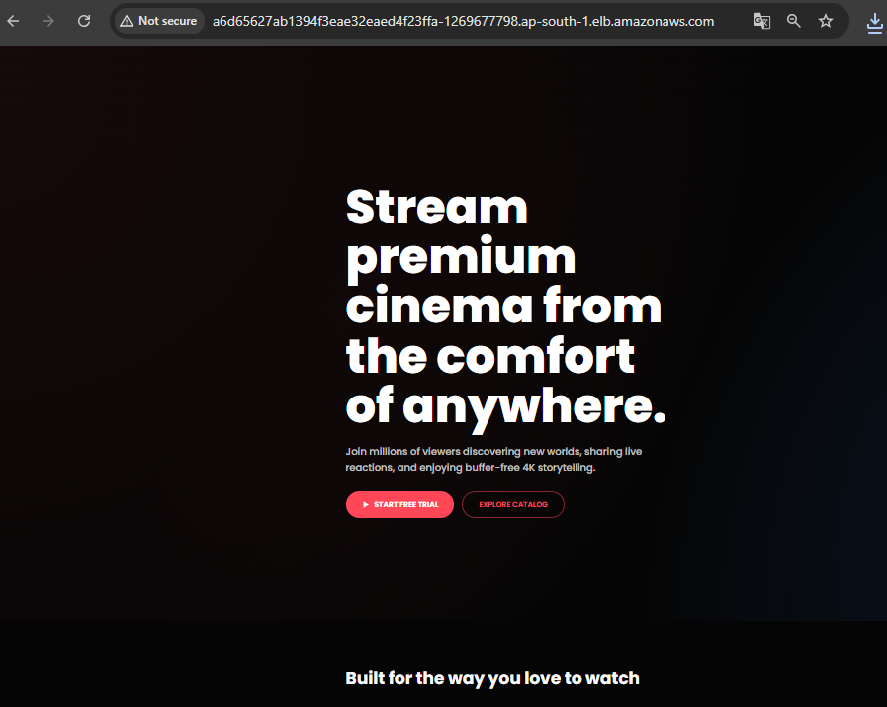
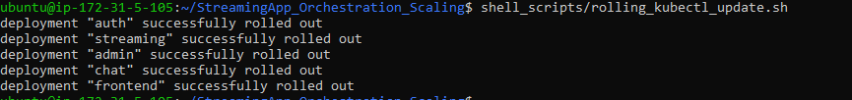
Helm Installation
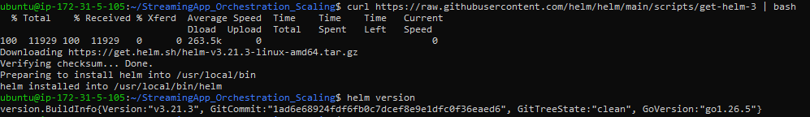
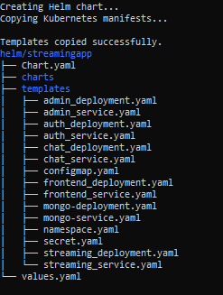
Cluster Overview
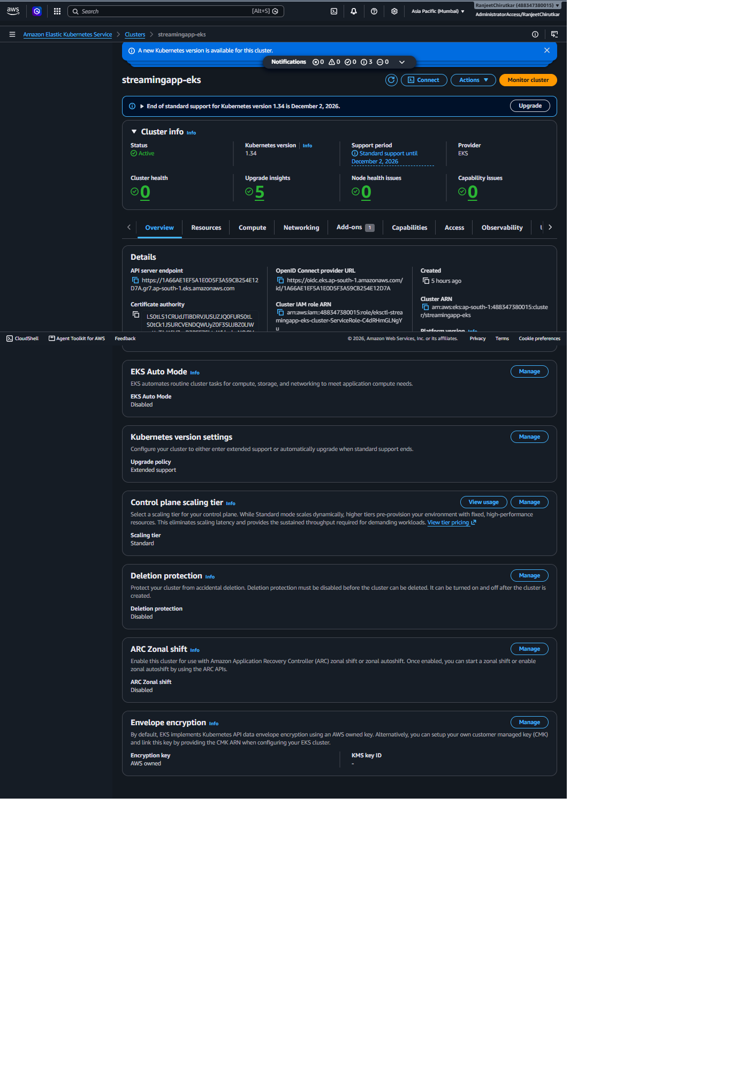
Compute Node Group:
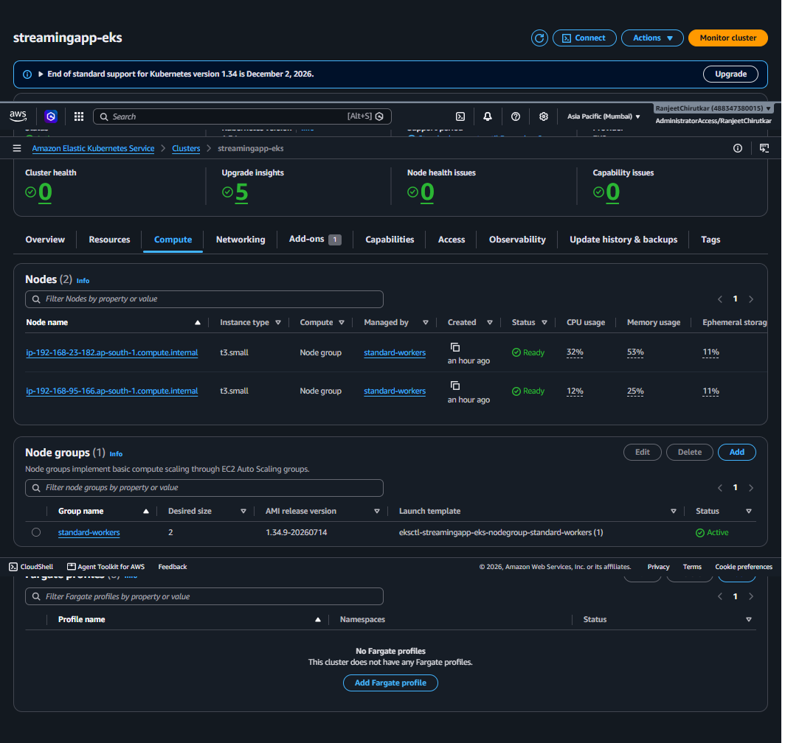

Finally Run Jenkin Pipeline with Helm Deploy:
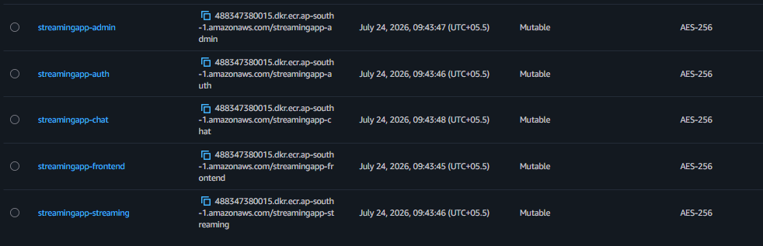
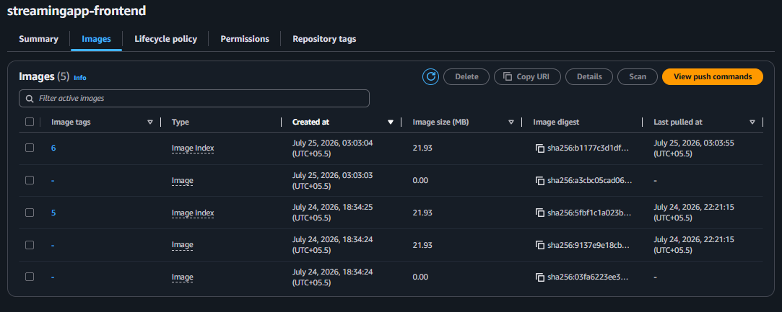
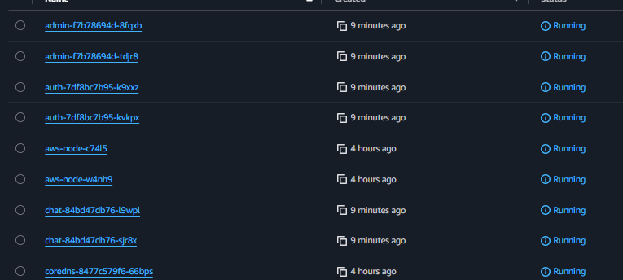
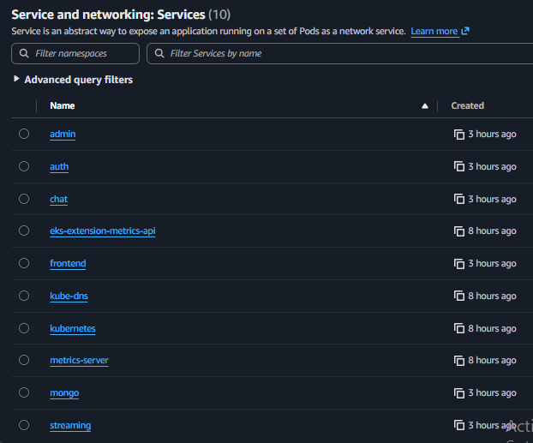
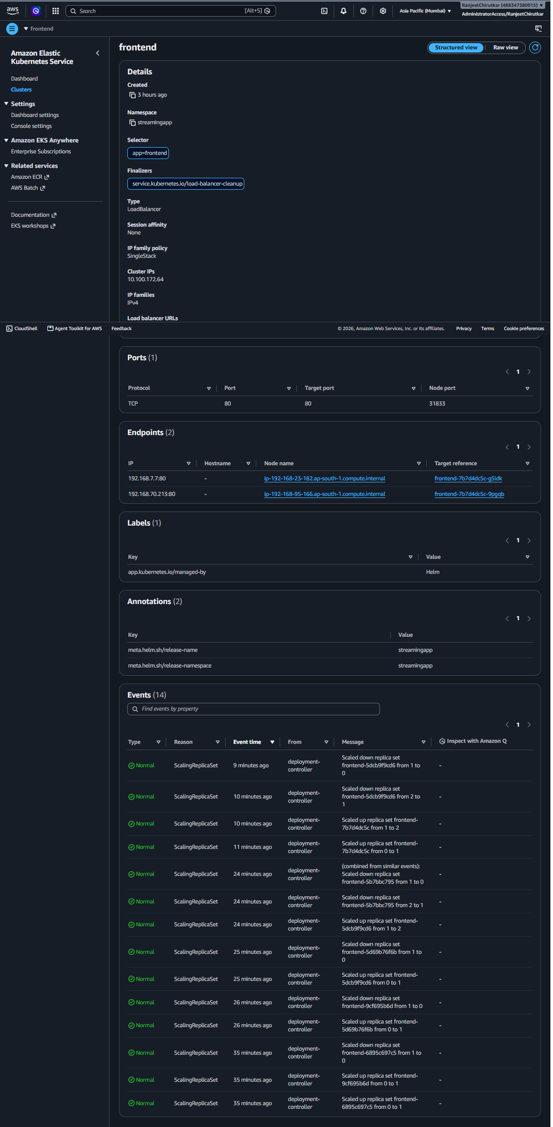

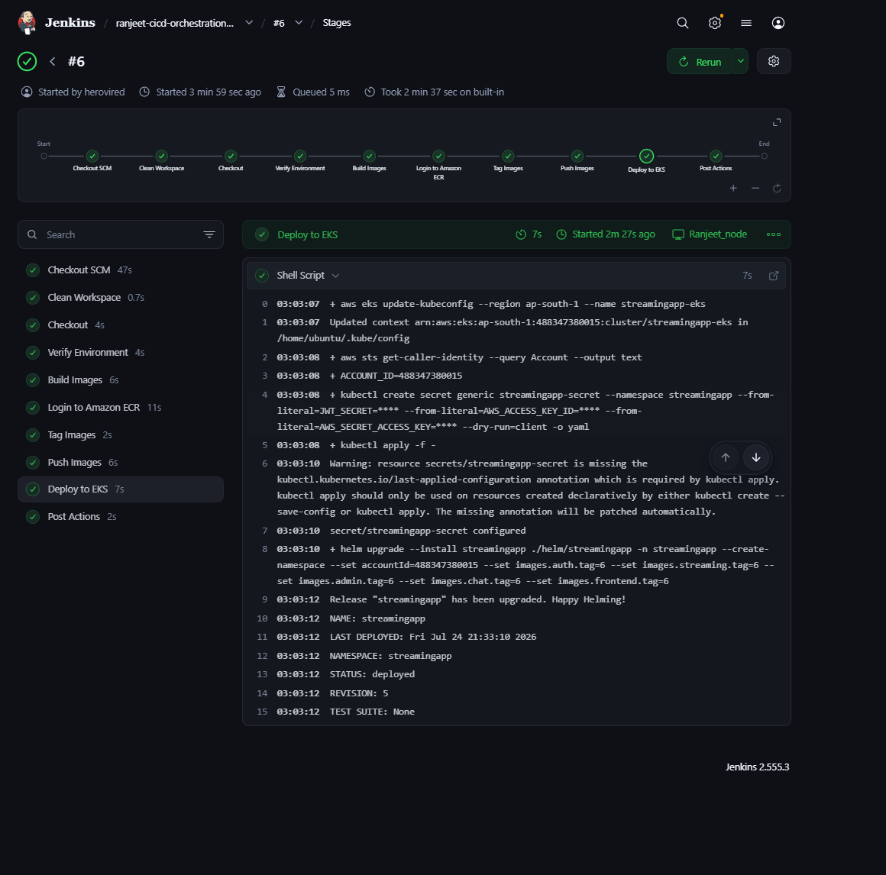
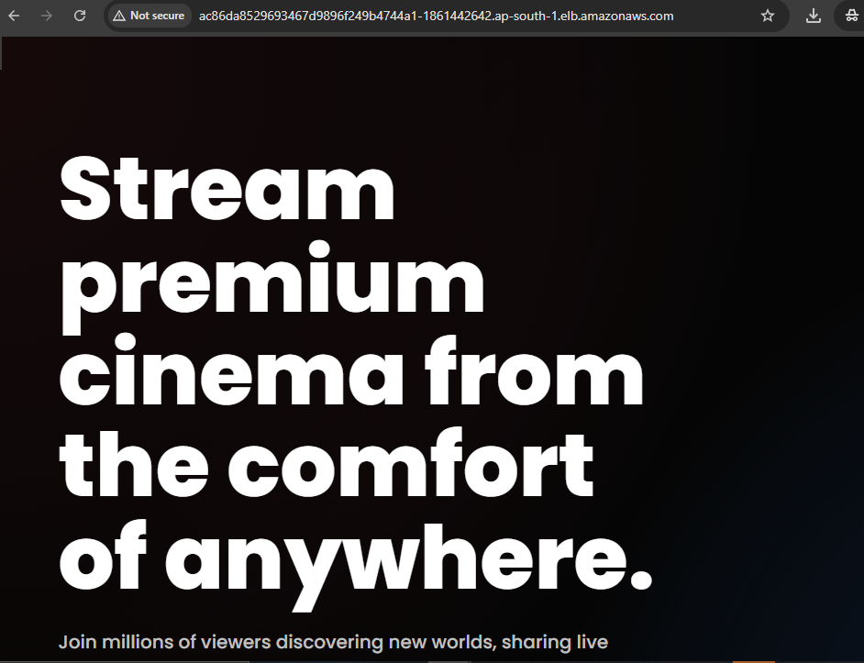
Testing change in code with push into git should trigger the Pipeline and apply the changes in frontend
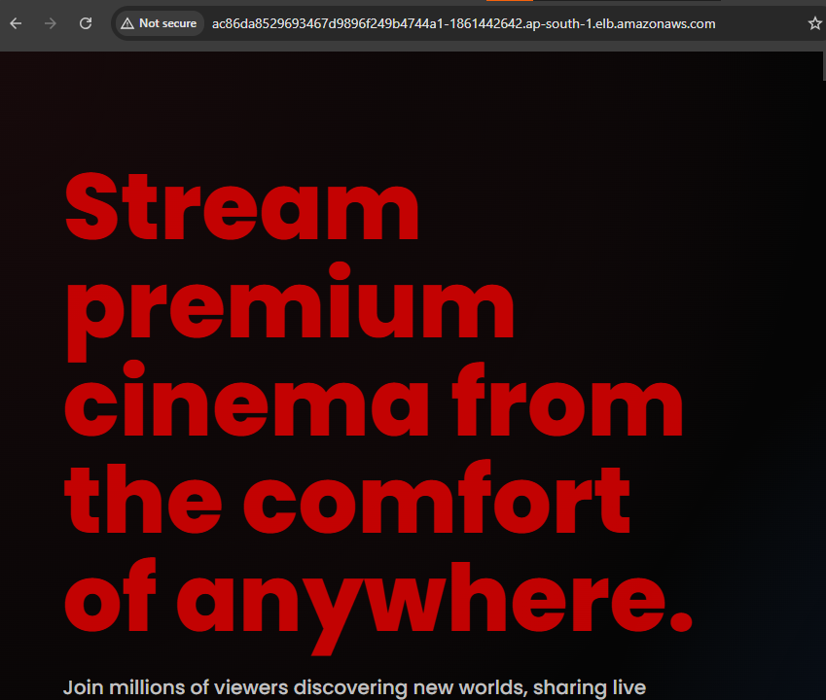

Git Webhook configure:
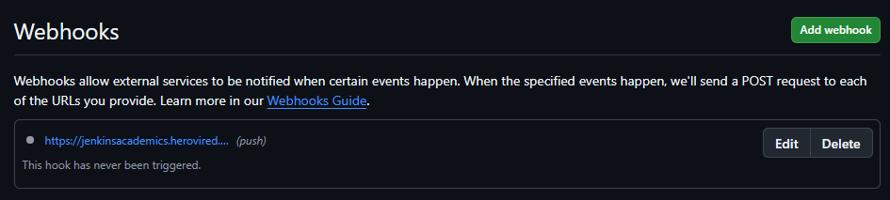

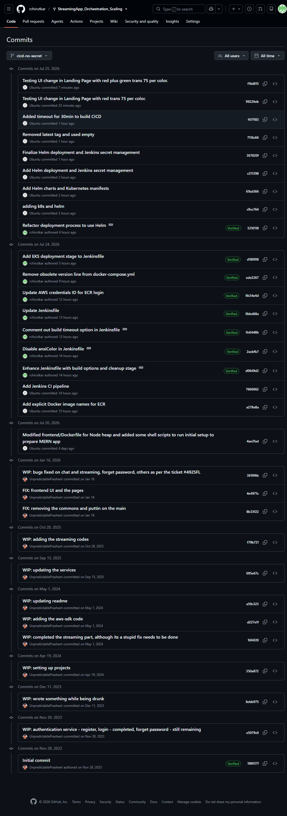
Final Jenkins Configuration
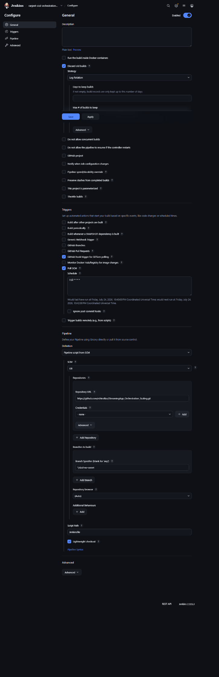

Step 6: Monitoring and Logging
Set Up Monitoring
Use Amazon CloudWatch for metrics and alarms.
Configure Logging
Centralize application logs using CloudWatch Logs or similar tools.
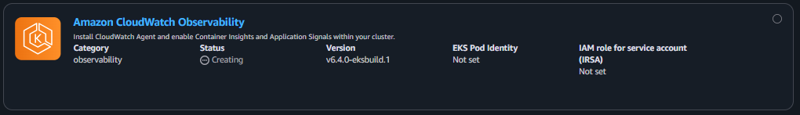
• The Amazon CloudWatch Observability add-on was installed on the EKS cluster.
• Additional IAM/IRSA configuration is required for log and metric collection.
• This is the standard AWS deployment model for CloudWatch on EKS.

Step 7: Documentation
Document the complete system architecture and deployment process.
Include diagrams, configuration steps, and scripts.
Upload the documentation to your GitHub repository.

Step 8: Final Validation
Verify that both frontend and backend are functional and accessible.
Ensure the application meets deployment and scaling requirements.

Bonus: Step 9 — ChatOps Integration
Create SNS Topics
Use SNS topics for various events (e.g., deployment success/failure).
Integrate with Messaging Platform
Connect SNS with Slack, Microsoft Teams, or Telegram for real-time alerts.

