GitHub Action CICD Pipeline Execution Steps:

1. Setup:
- Use a provided Python application repository on GitHub (provide a link to a sample Python application repository).
- Ensure the repository has a main branch and a staging branch.

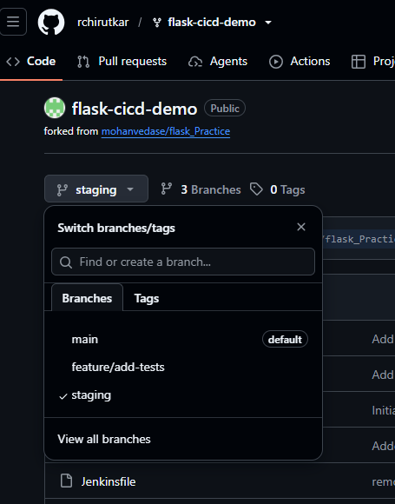

2. GitHub Actions Workflow:
- Create a github/workflows directory in your repository.
- Inside the directory, create a YAML file to define the workflow.
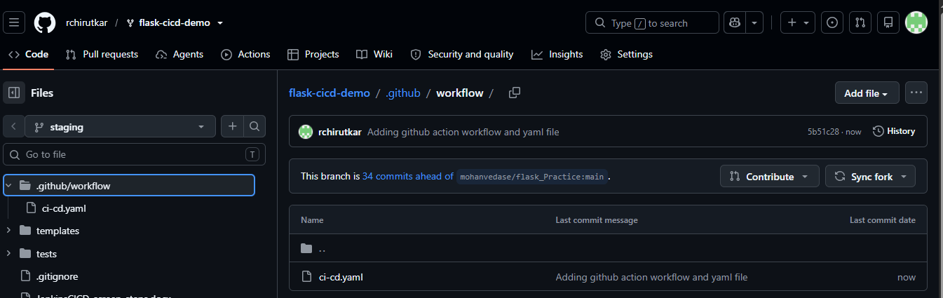
3. Workflow Steps:
- Define a workflow that performs the following jobs:
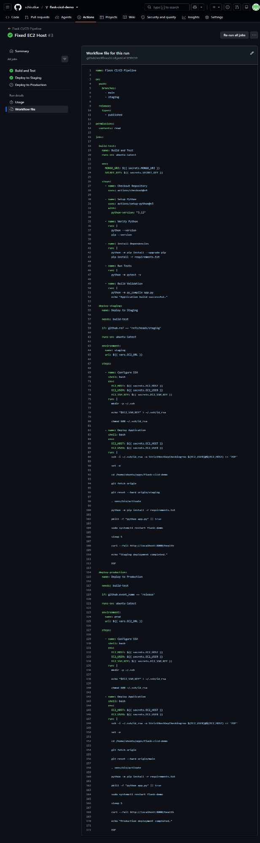
- Install Dependencies: Install all necessary dependencies for the Python application using pip.
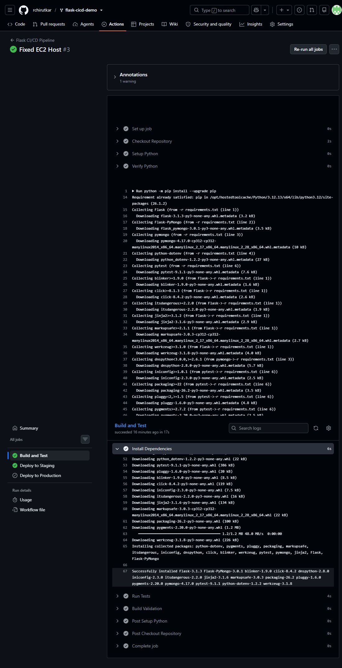
- Run Tests: Execute the test suite using a framework like pytest.
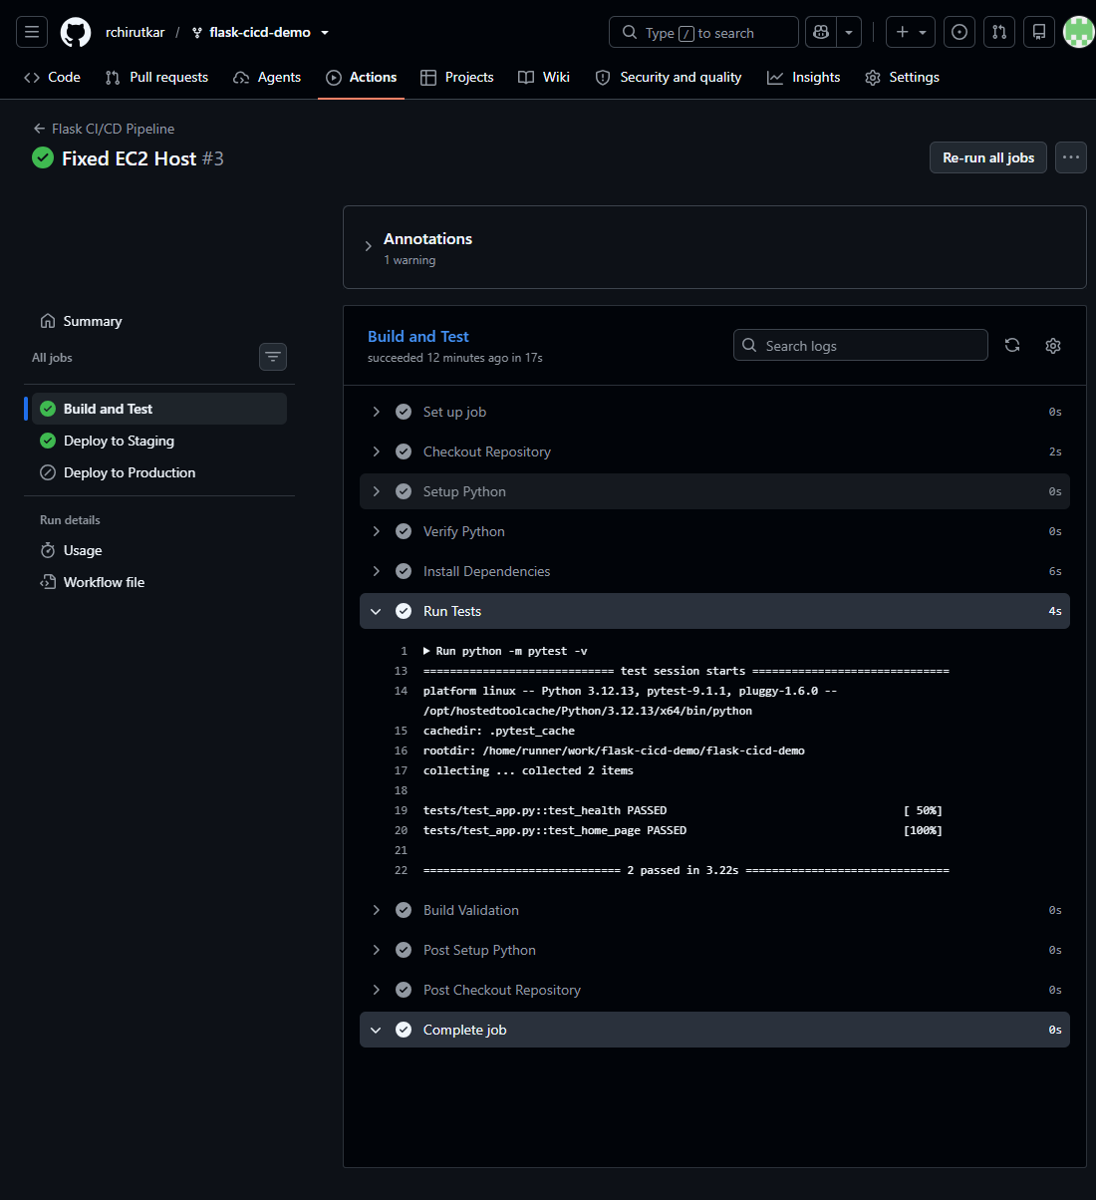

- Build: If tests pass, prepare the application for deployment.
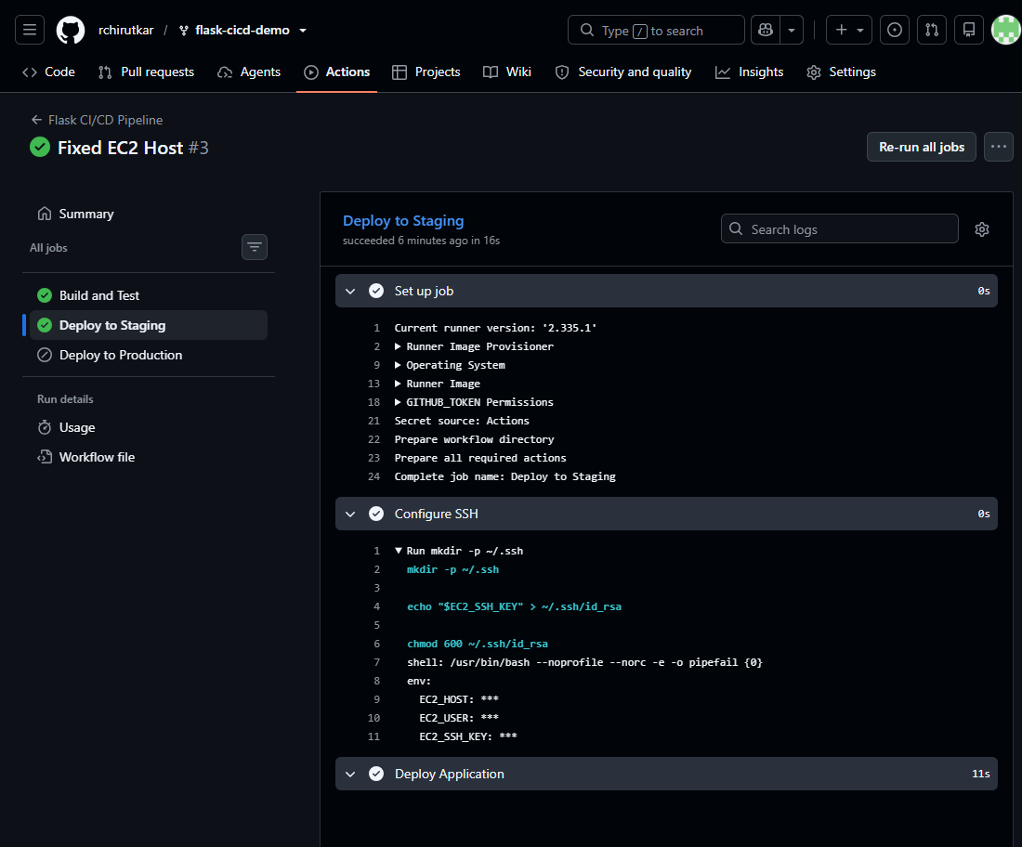

- Deploy to Staging: Deploy the application to a staging environment when changes are pushed to the staging branch.
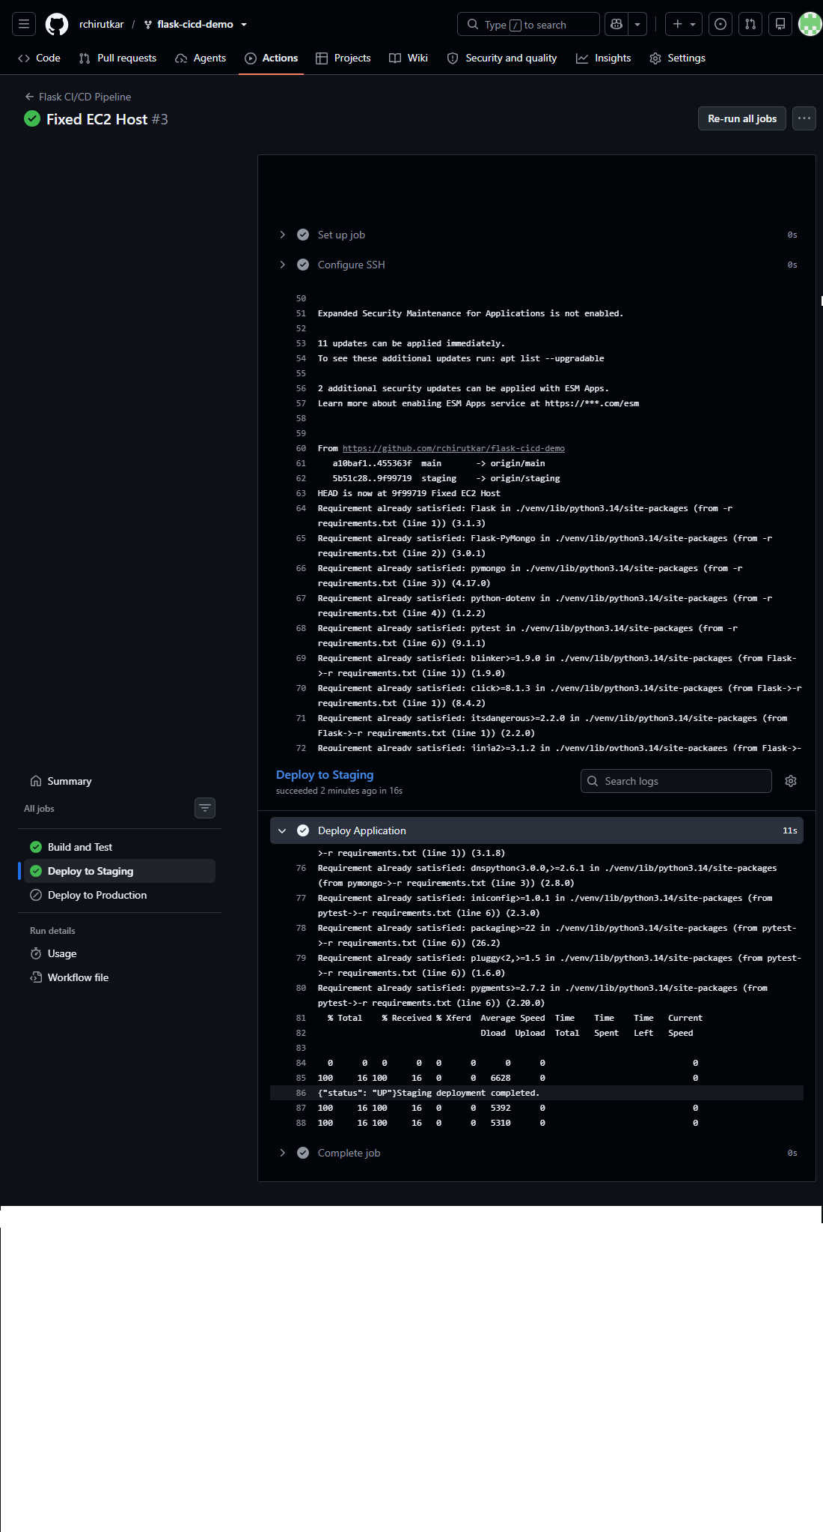

- Deploy to Production: Deploy the application to production when a release is tagged.

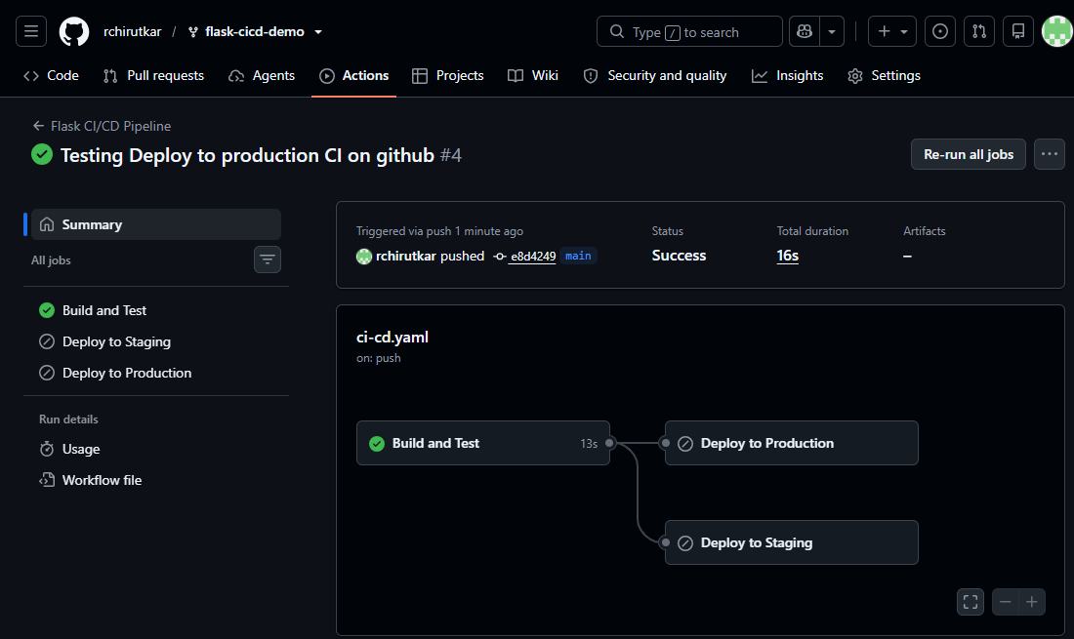
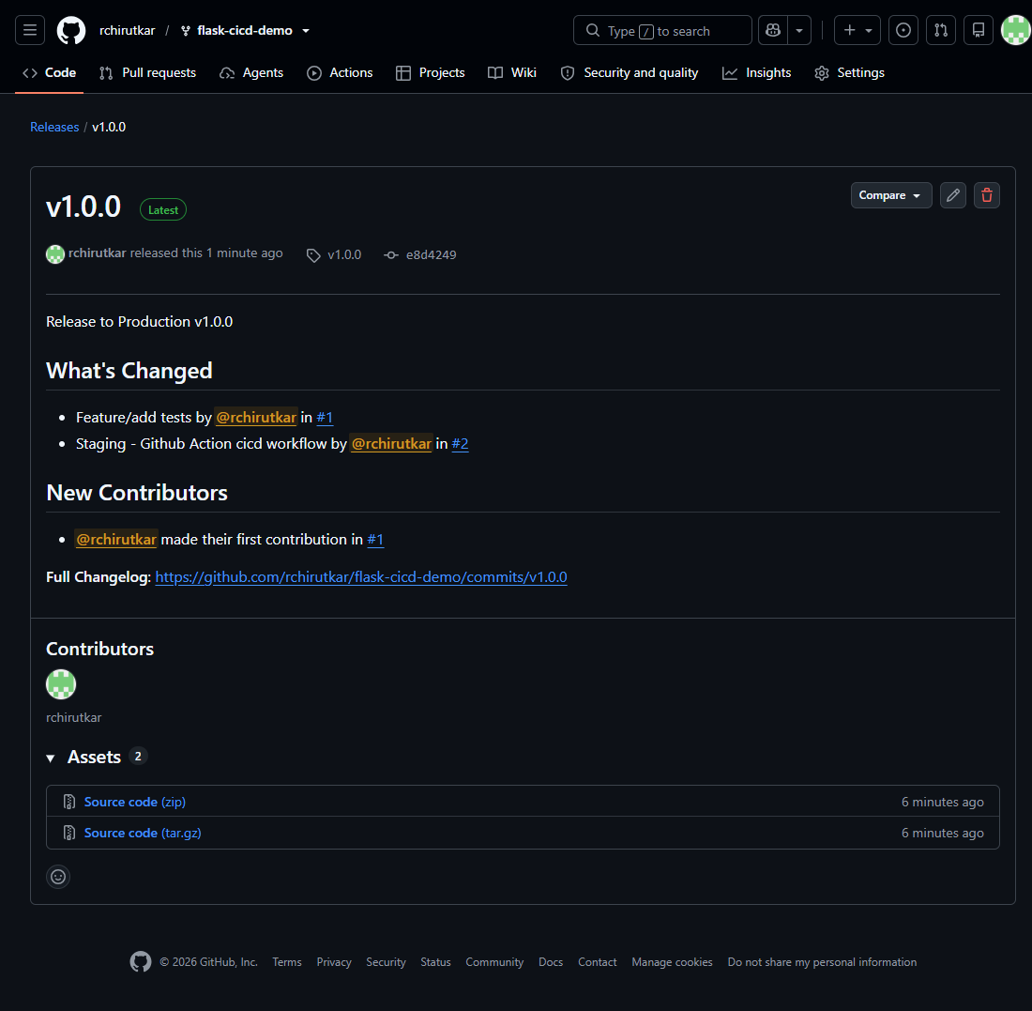
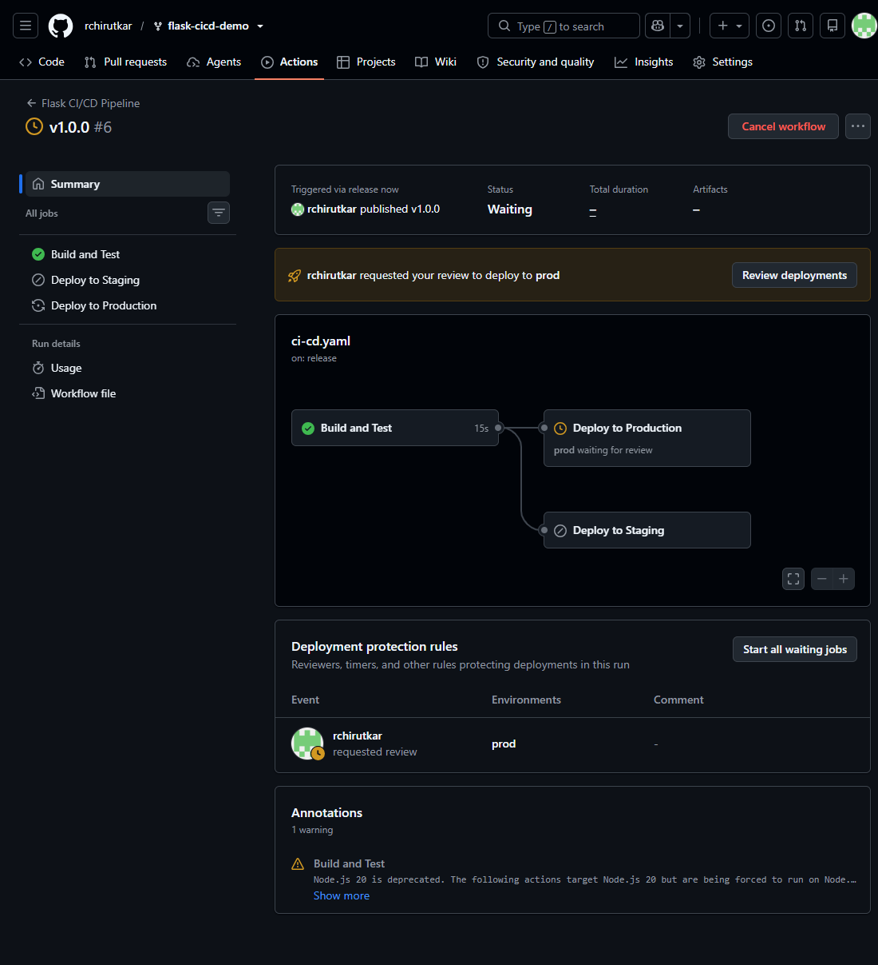
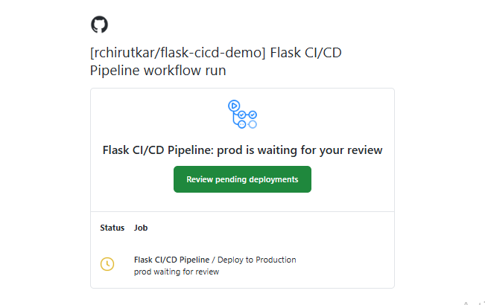
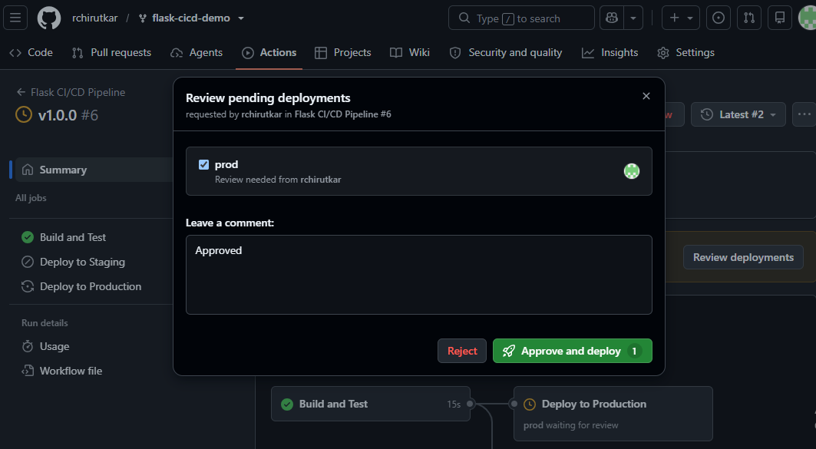
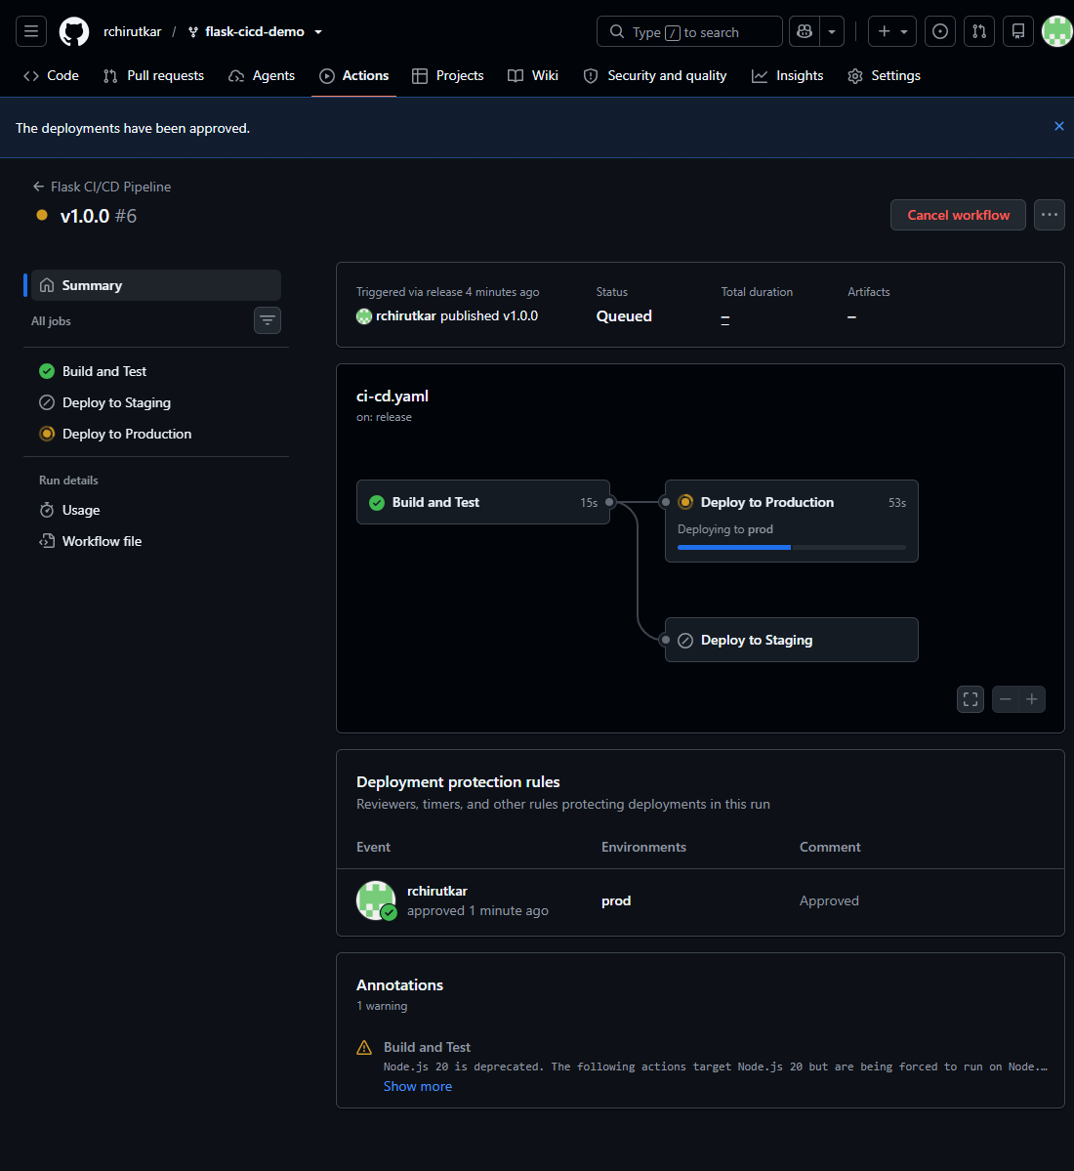

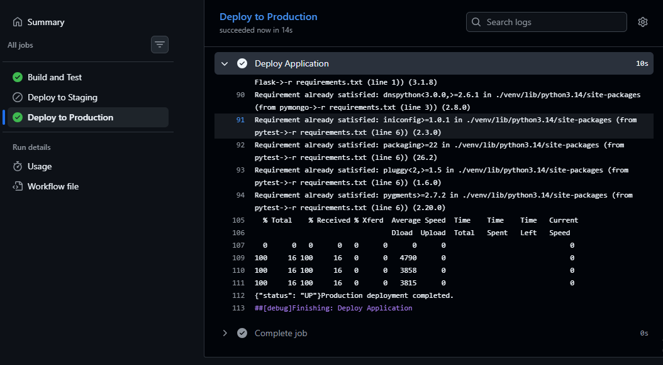
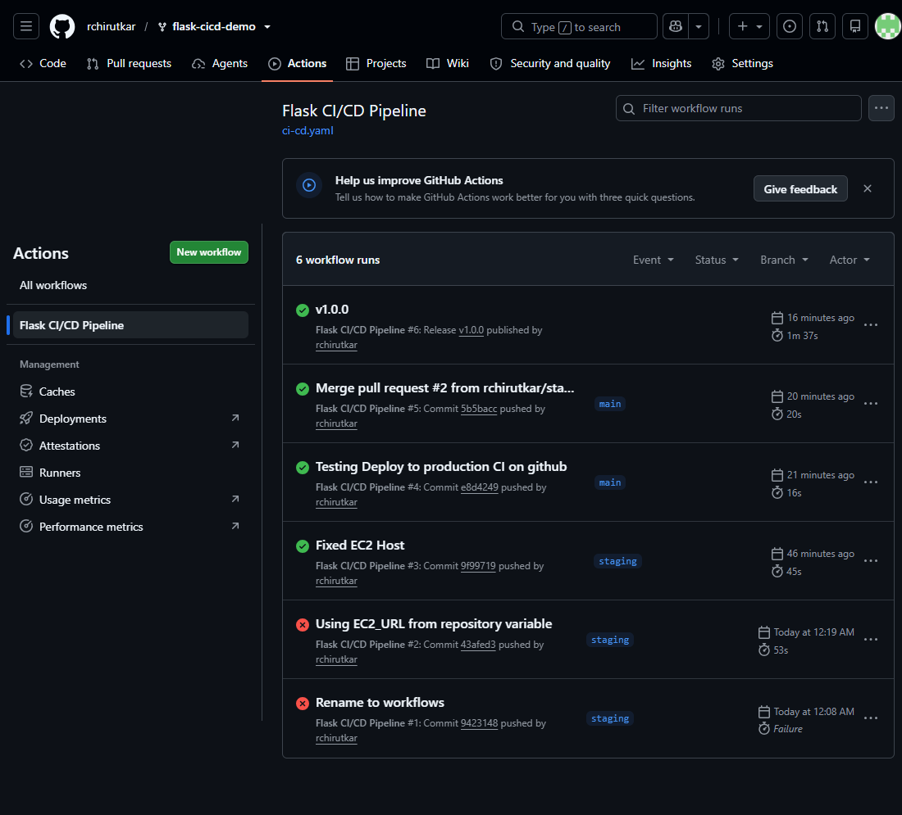
4. Environment Secrets:
- Use GitHub Secrets to store sensitive information required for deployments (e.g., deployment keys, API tokens).
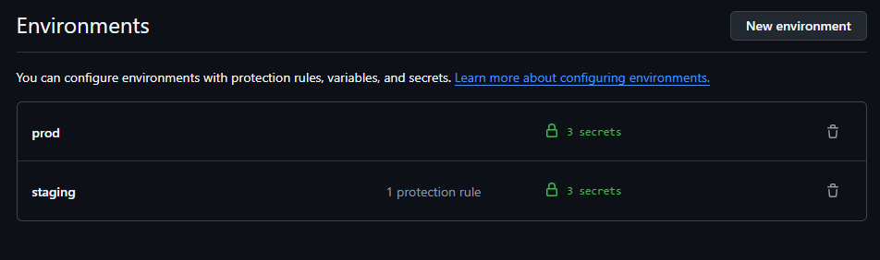
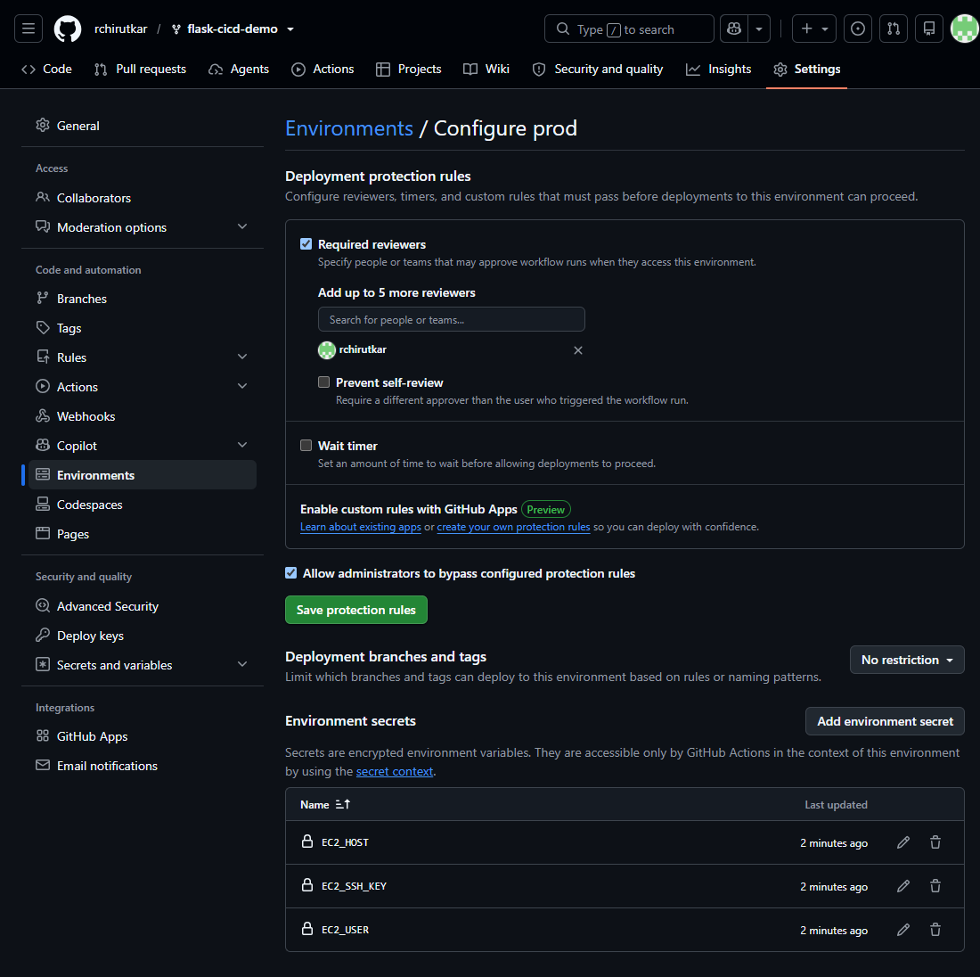
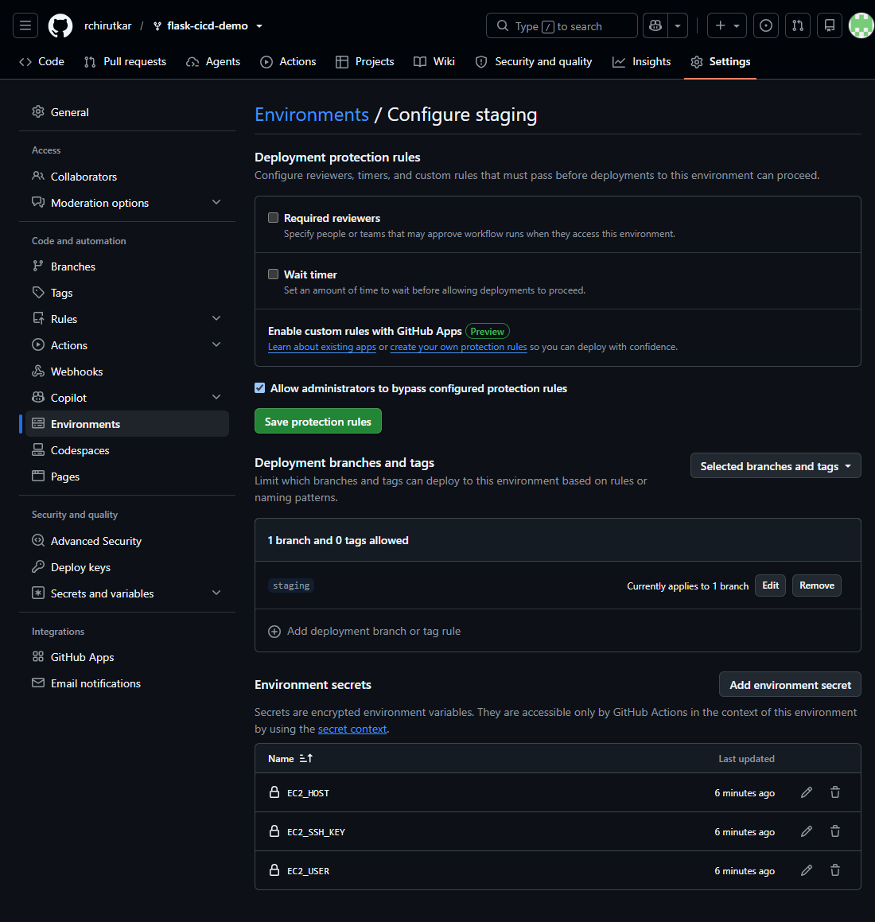
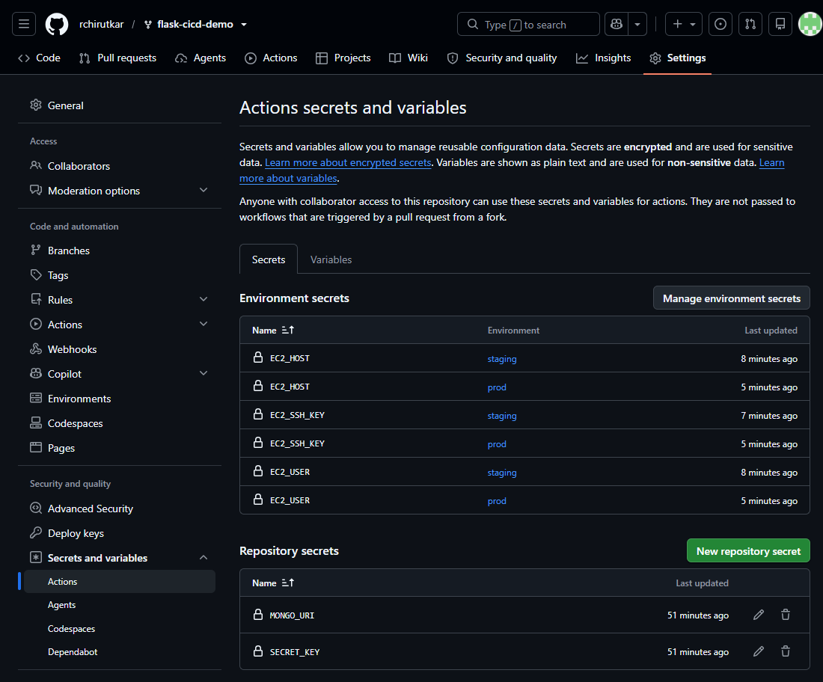
App is running in EC2 instance after deployment.
