Assignment on Deploying a MERN Application through Terraform and Ansible

AWS CLI + Terraform Backend
1. AWS CLI configured successfully.

2. aws sts get-caller-identity
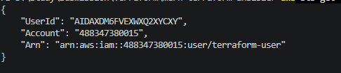

3. Terraform version.

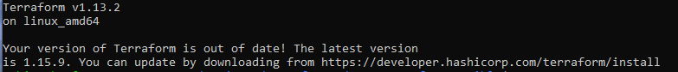

4. S3 backend bucket created.

5. terraform init successful.
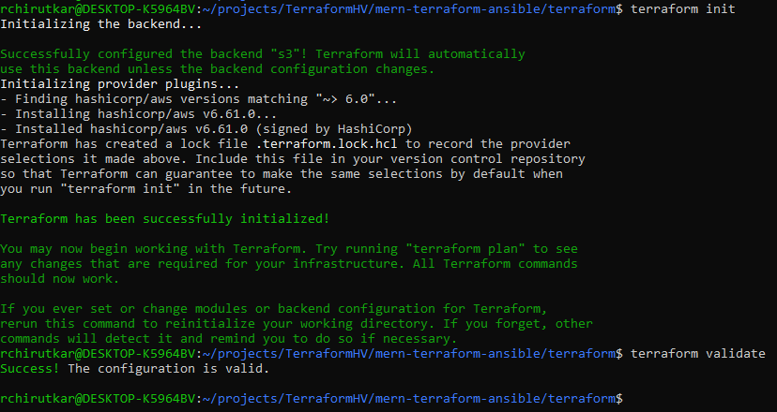

Terraform Networking (VPC + Public/Private Subnets + NAT Gateway)
- VS Code project structure with modules.

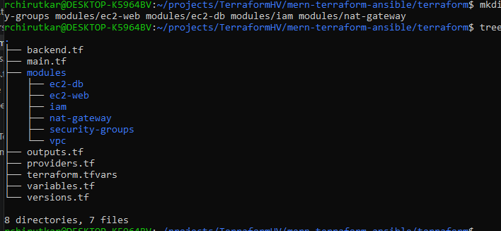
- terraform plan showing networking resources.
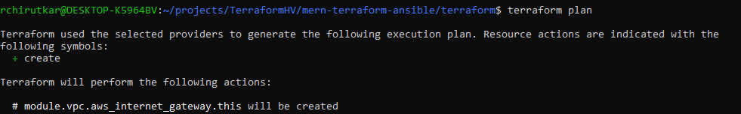
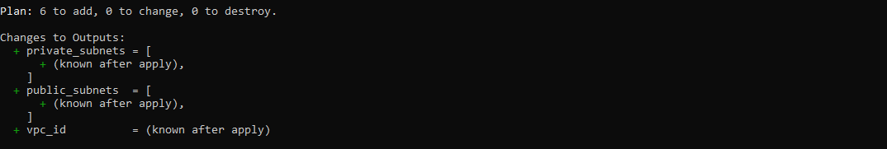

- terraform apply success.
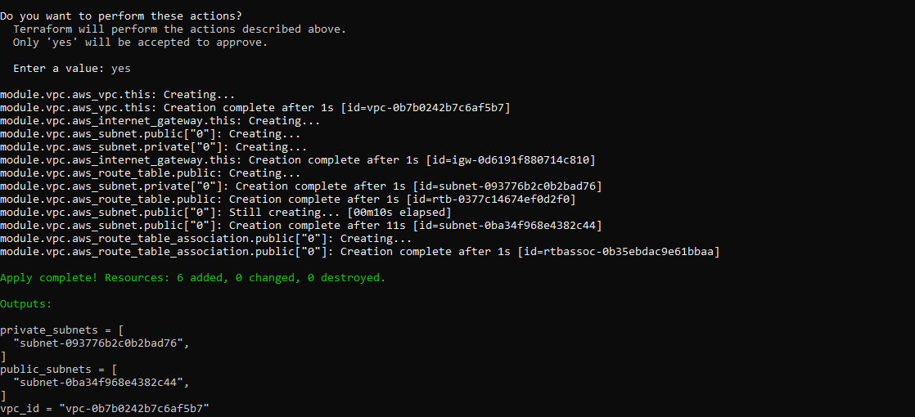

- AWS VPC dashboard.
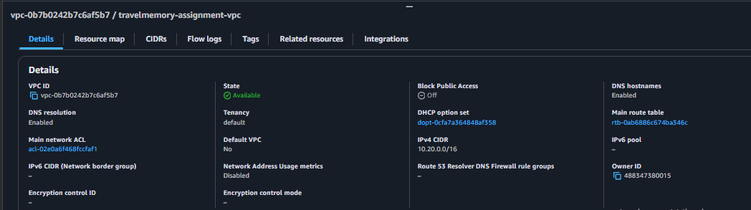

- Subnets dashboard.
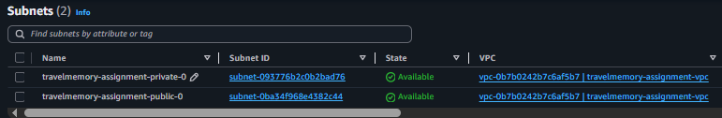

- Route Tables.
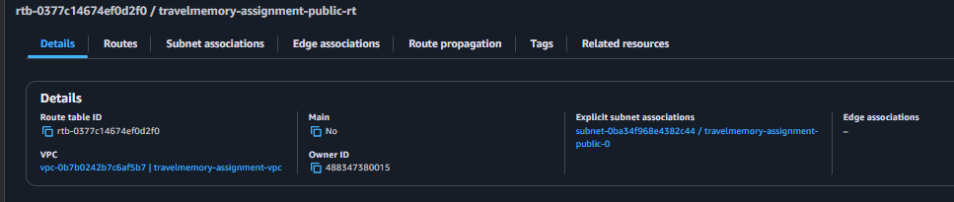
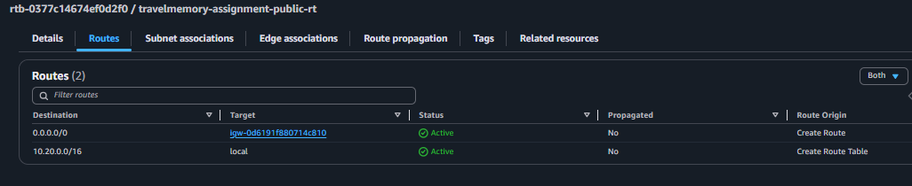
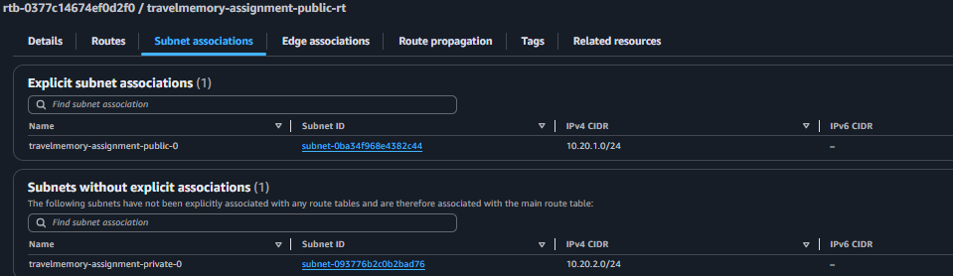

- VPC Resource Map.
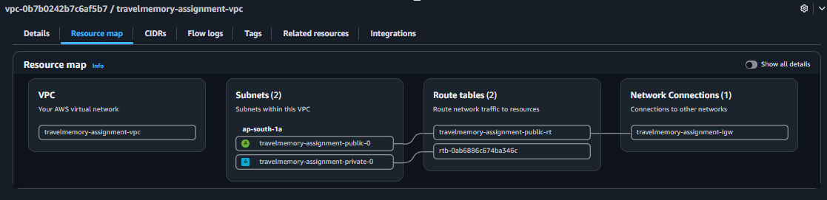

- VPC Tags
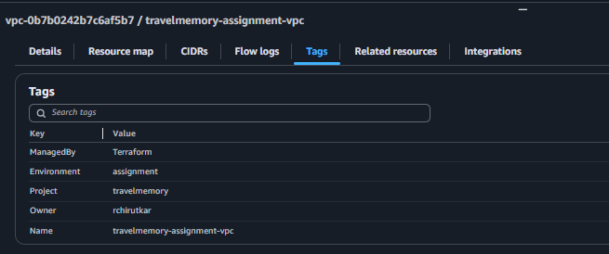
IAM + Security Groups + Web EC2 + MongoDB EC2

1. IAM Role + Instance Profile EC2 permissions
2. Web Security Group SSH + HTTP + React + API
3. MongoDB Security Group Only Web EC2 can access MongoDB
4. Web EC2 Node.js + React + Express
5. MongoDB EC2 Private MongoDB server
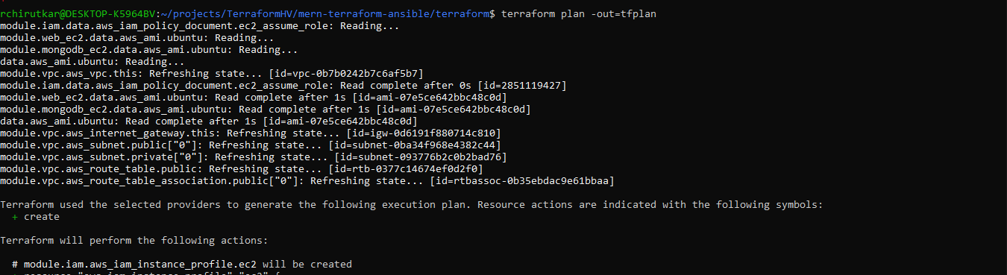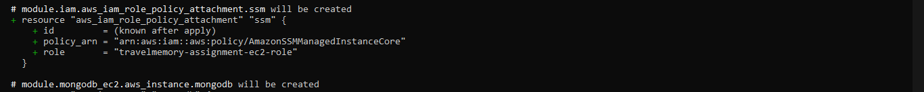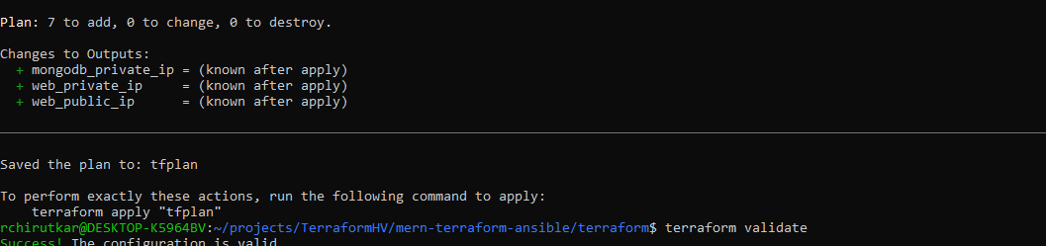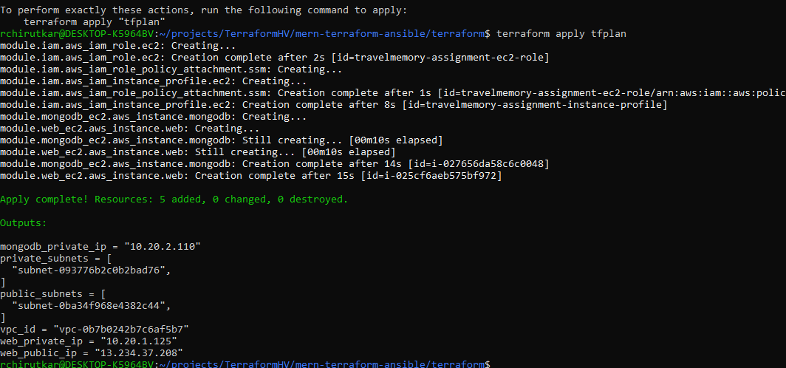
EC2 Instances
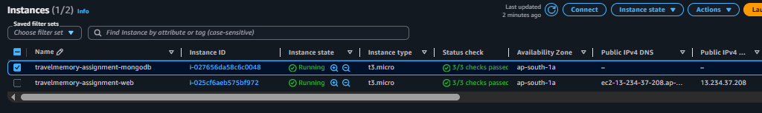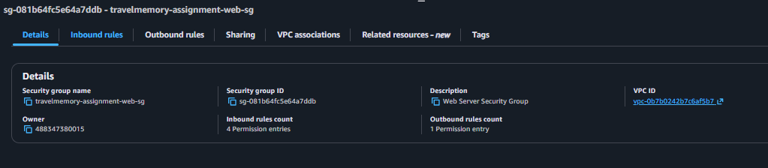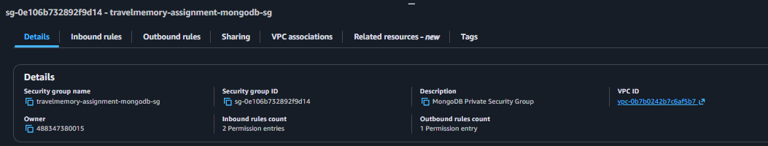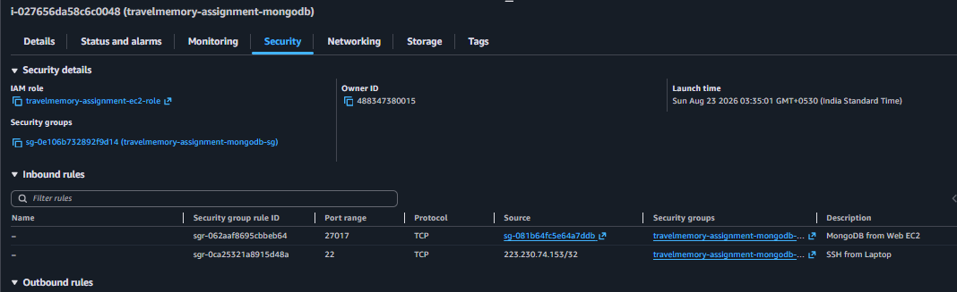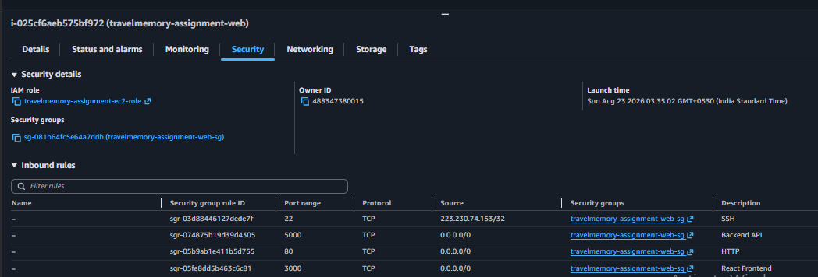

Ansible Setup
• ansible –version
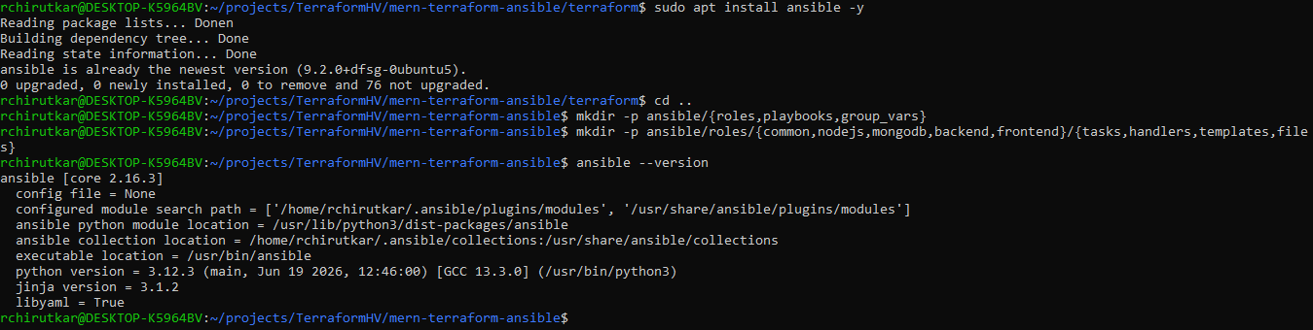

• inventory.ini
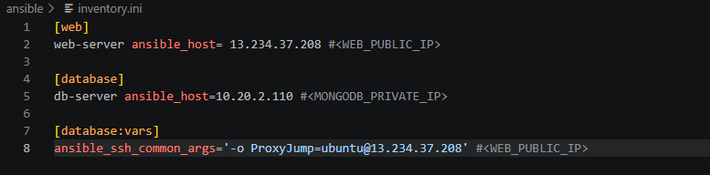

• ansible.cfg
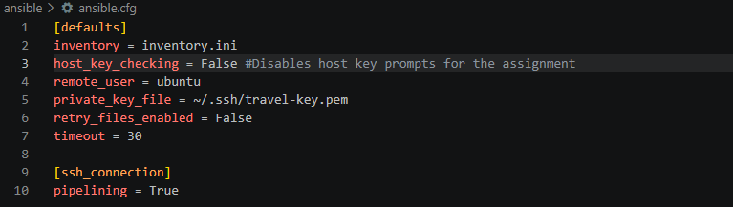

• ansible all -m ping
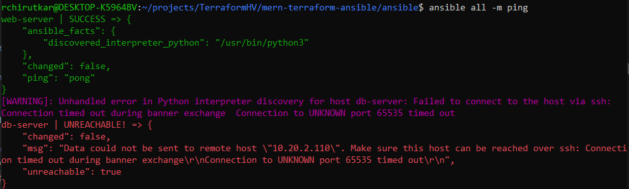

This issue is because of when using ProxyJump, SSH reaches MongoDB from the Web EC2's private IP, not from my laptop. So AWS blocks port 22.

To fix the issue updated modules/security-groups.tf as below:
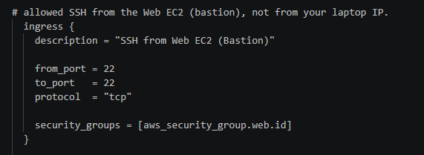

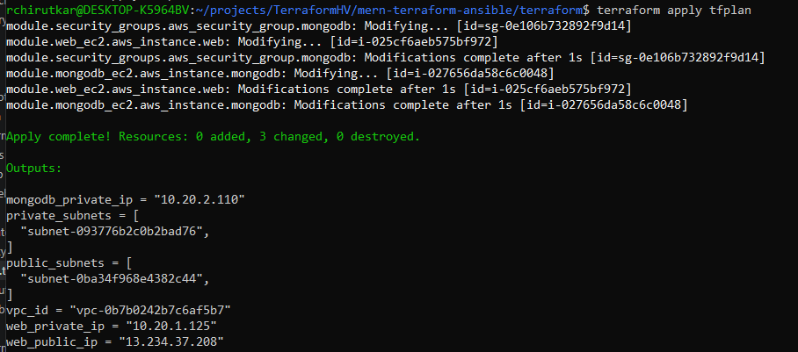

And rerun
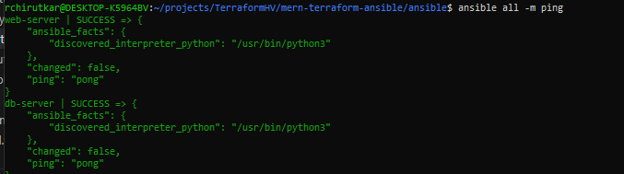

• Successful ping to Web EC2.
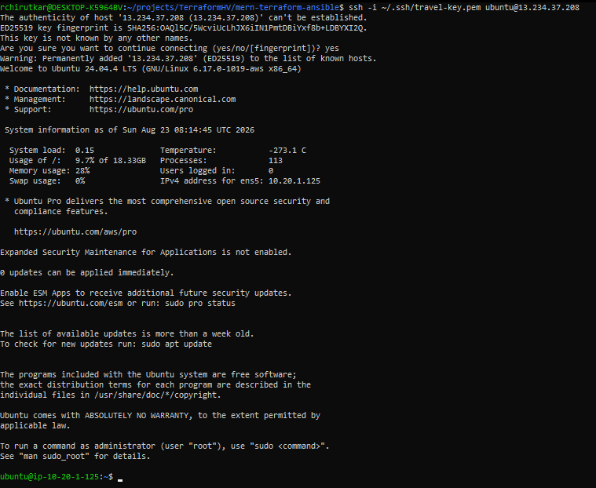
• Successful ping to MongoDB EC2 (through Web EC2).
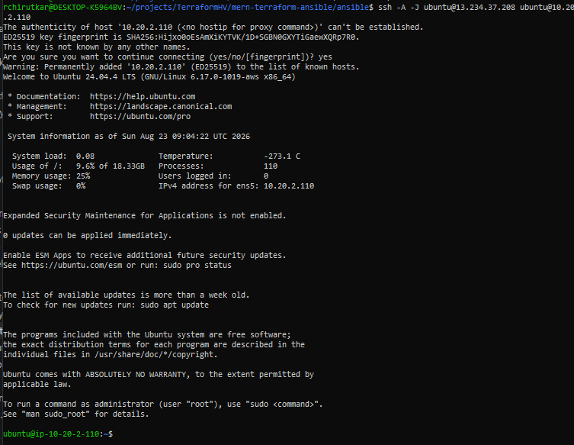

- Hop - Verify the Bastion Connection
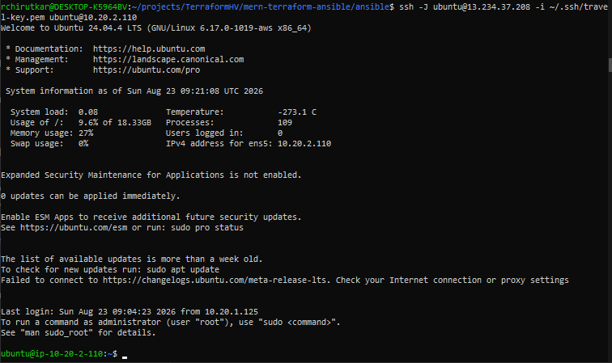

NAT Gateway
Terraform
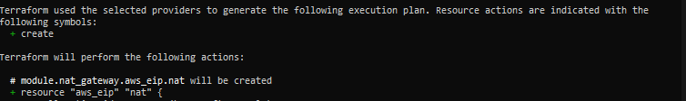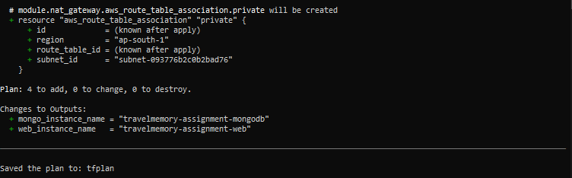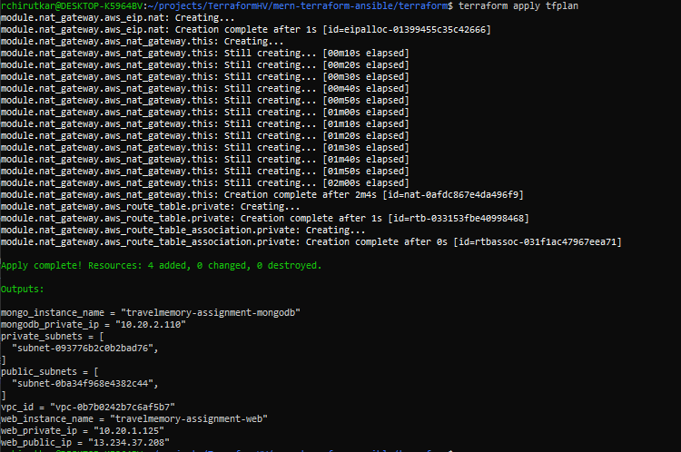

NAT Gateway dashboard
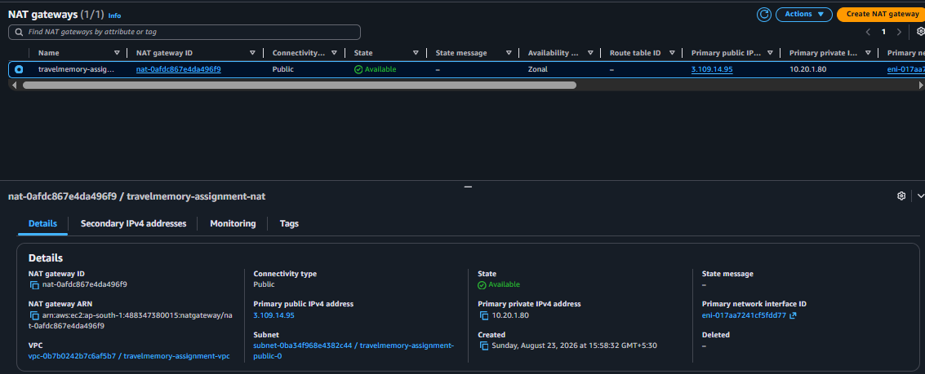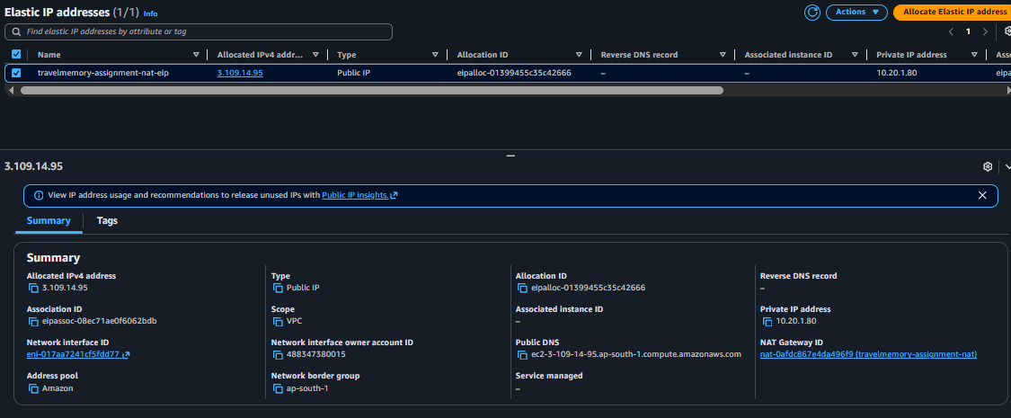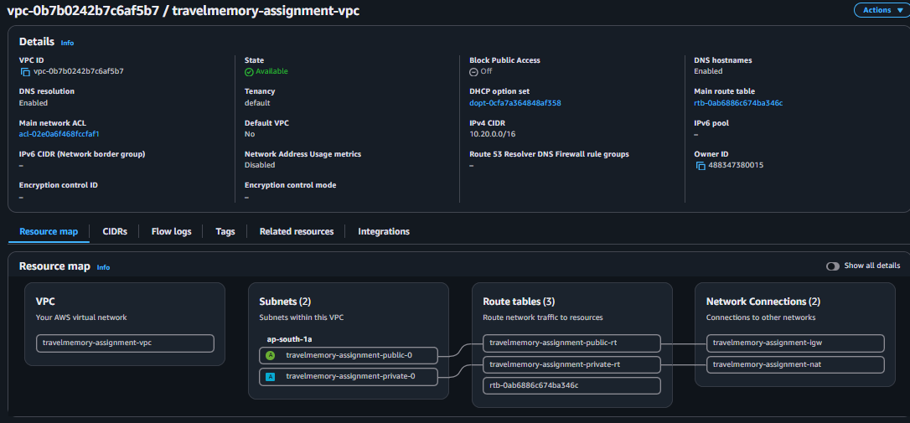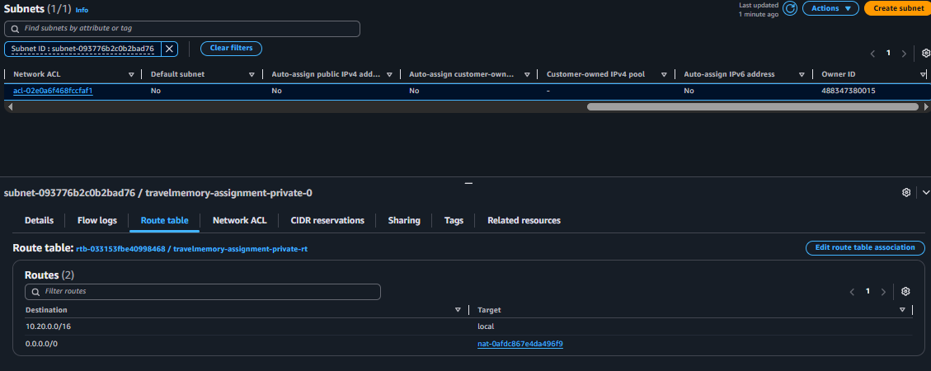
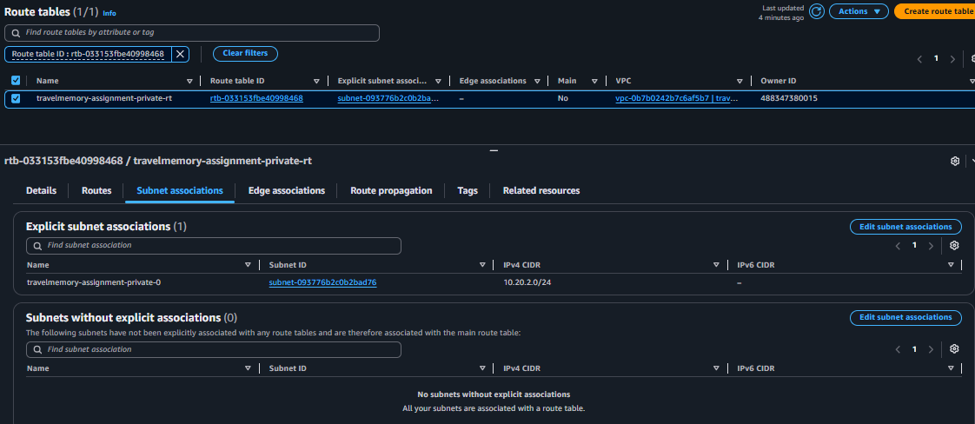
A NAT Gateway was temporarily attached to the private route table to provide outbound internet access for package installation. After MongoDB installation and validation, the NAT Gateway was destroyed to minimize AWS costs.

Install MongoDB Using Ansible
- ansible-playbook playbooks/database.yml
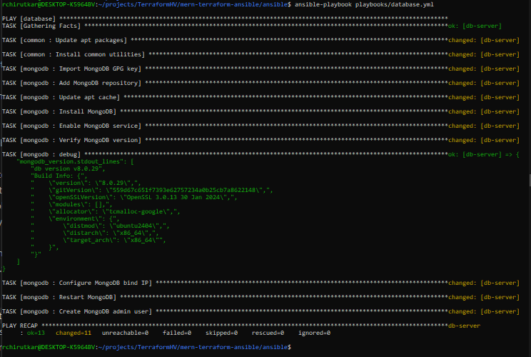
- MongoDB service running.
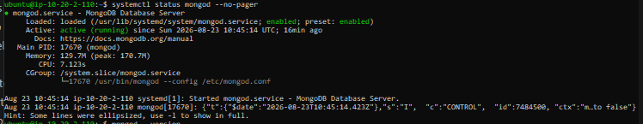
- mongod --version
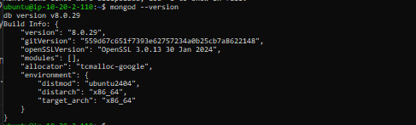
- ansible-playbook playbooks/web.yml
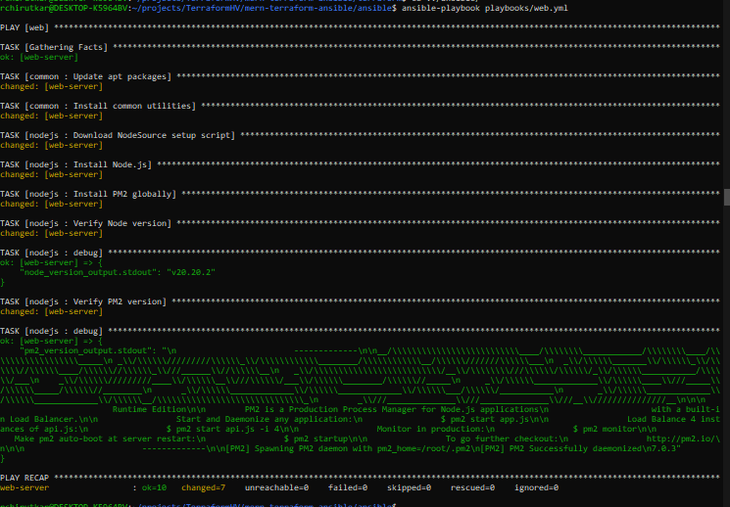
- node -v
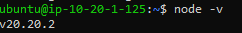
- npm -v
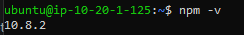
- pm2 –v
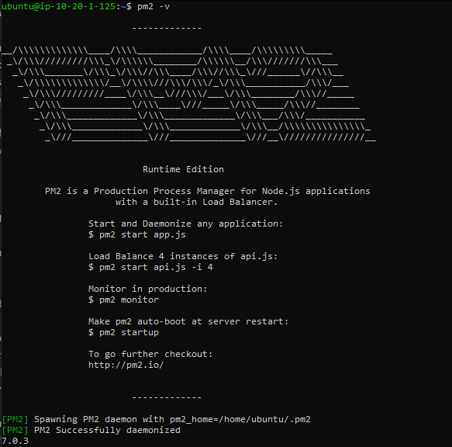

Install both database and web using single command by configuring site.yml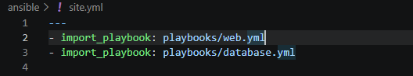
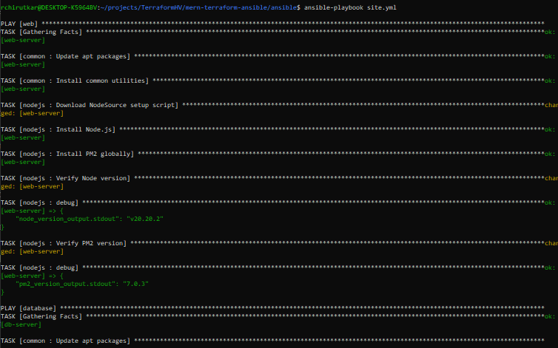

Deploy the TravelMemory MERN Application
- Git clone on Web EC2.
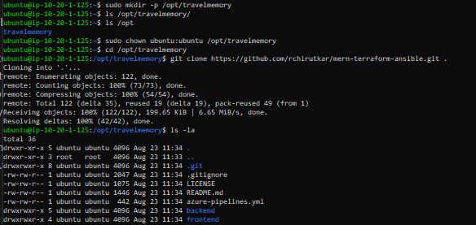
- Backend .env file.
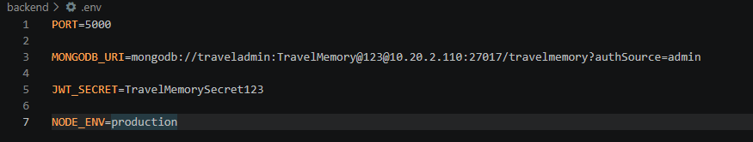
- Frontend .env file.
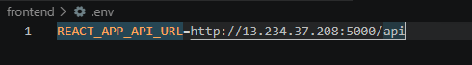
- npm install backend.
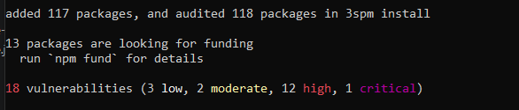
- npm install frontend.
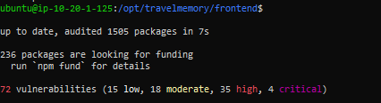

- PM2 running processes.
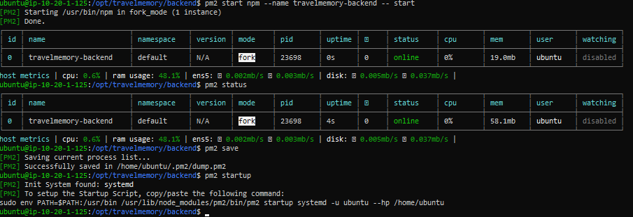
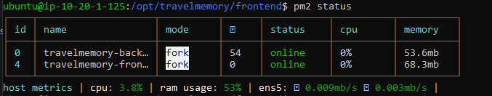
- Browser showing frontend.
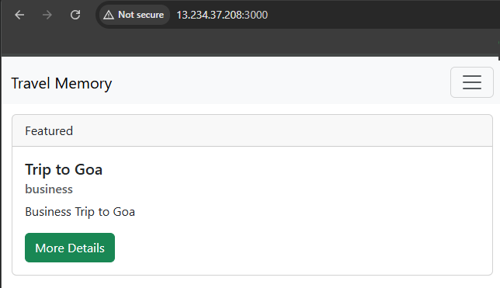
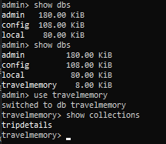
- API test successful.
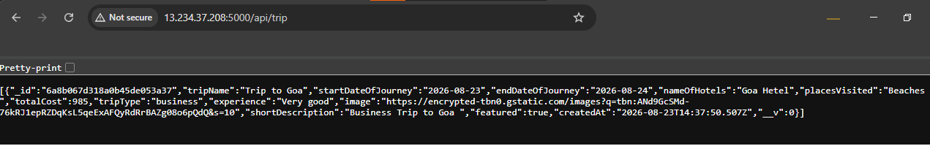
Nginx Reverse Proxy + Elastic IP + Security Hardening (Final Infrastructure)
- Nginx installed.
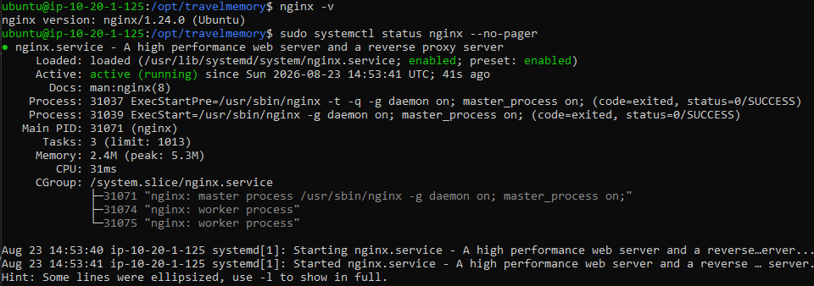

- Nginx configuration file.
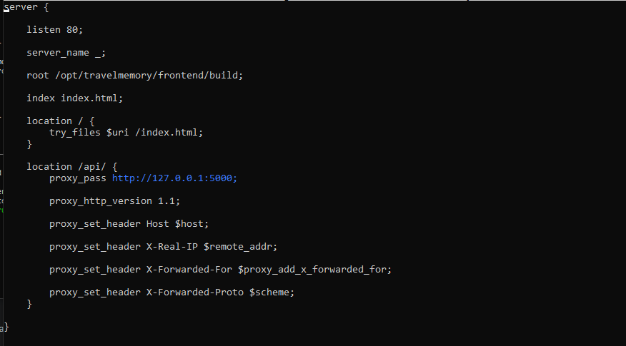

- Nginx service active.

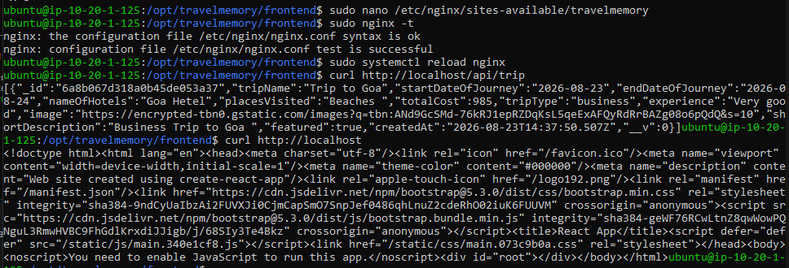

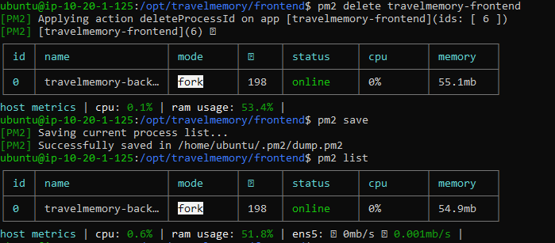

- Browser opening application on port 80.
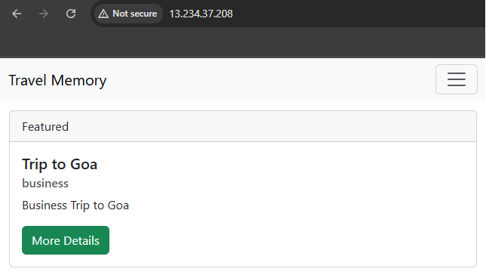

- Elastic IP attached.
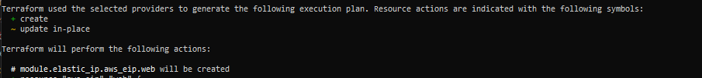
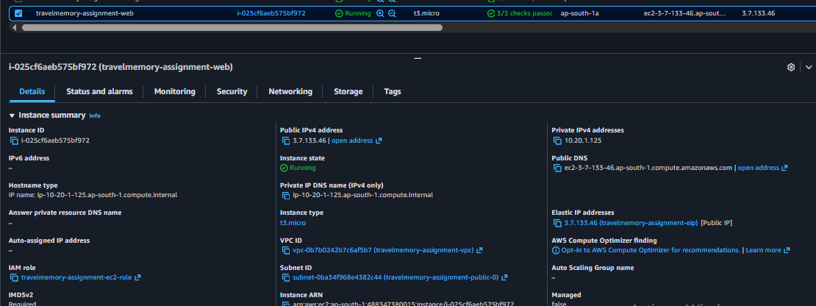
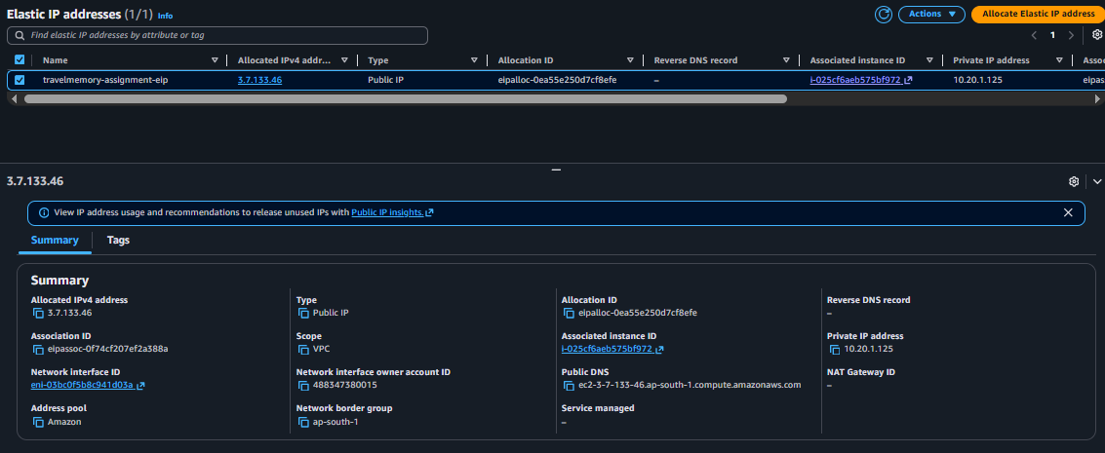

- Security Group after closing ports.
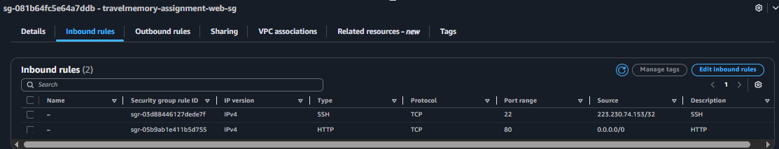
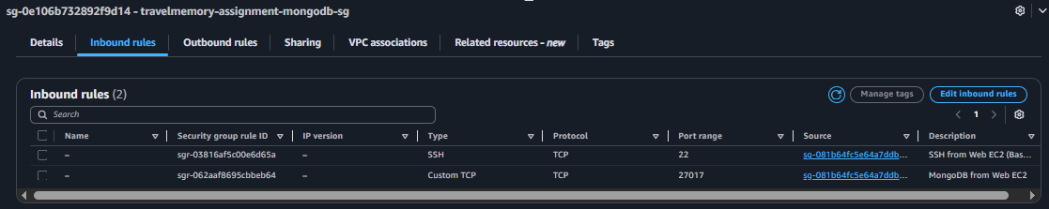

Web UI after adding elastic IP

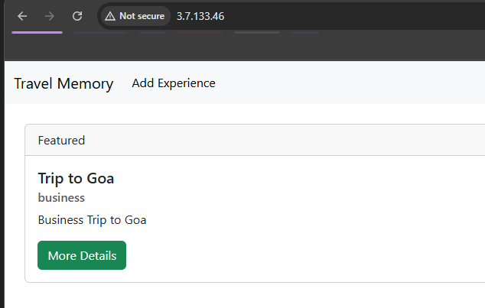
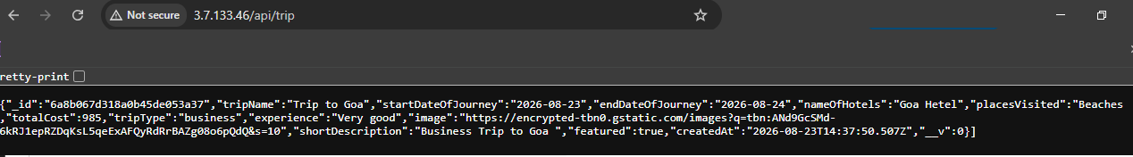

Adding new record to TripDetails from elastic IP
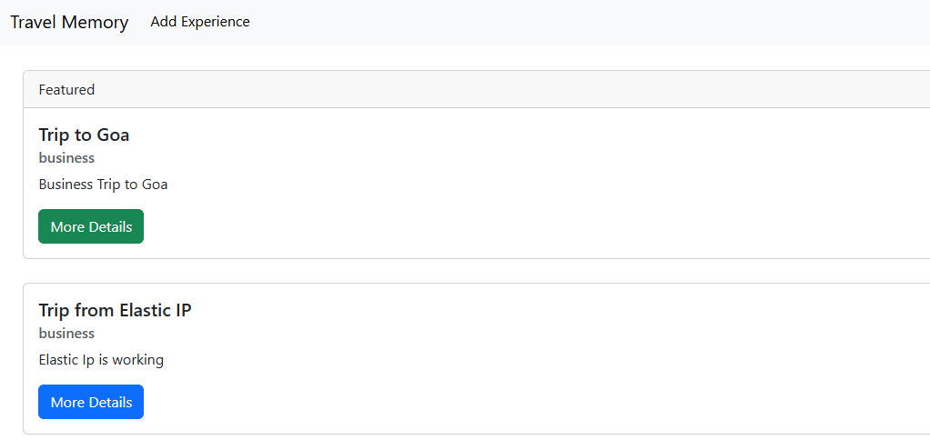
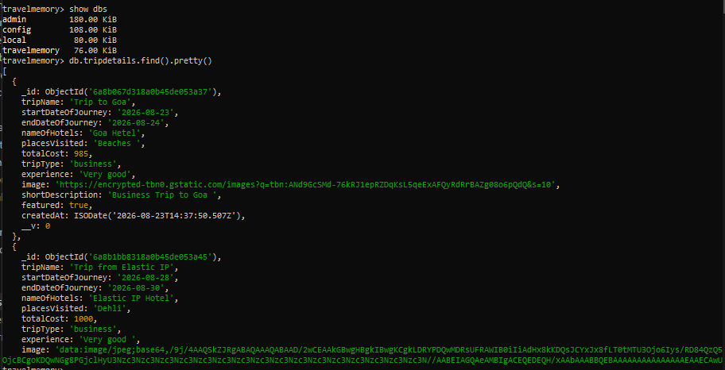
Backend is not publicly reachable.
