DevOps Assignment Report

Project: Travel Memory Application Deployment

Project Overview
This project demonstrates deployment of MERN application using AWS services with high availability, load balancing, and domain configuration.
Architecture Overview
The system is deployed across multiple availability zones using:
- AWS EC2 (2 instances)
- Application Load Balancer
- Nginx (reverse proxy)
- Node.js backend
- React frontend
- MongoDB Atlas
- Cloudflare (DNS + SSL)
Architecture Diagram:
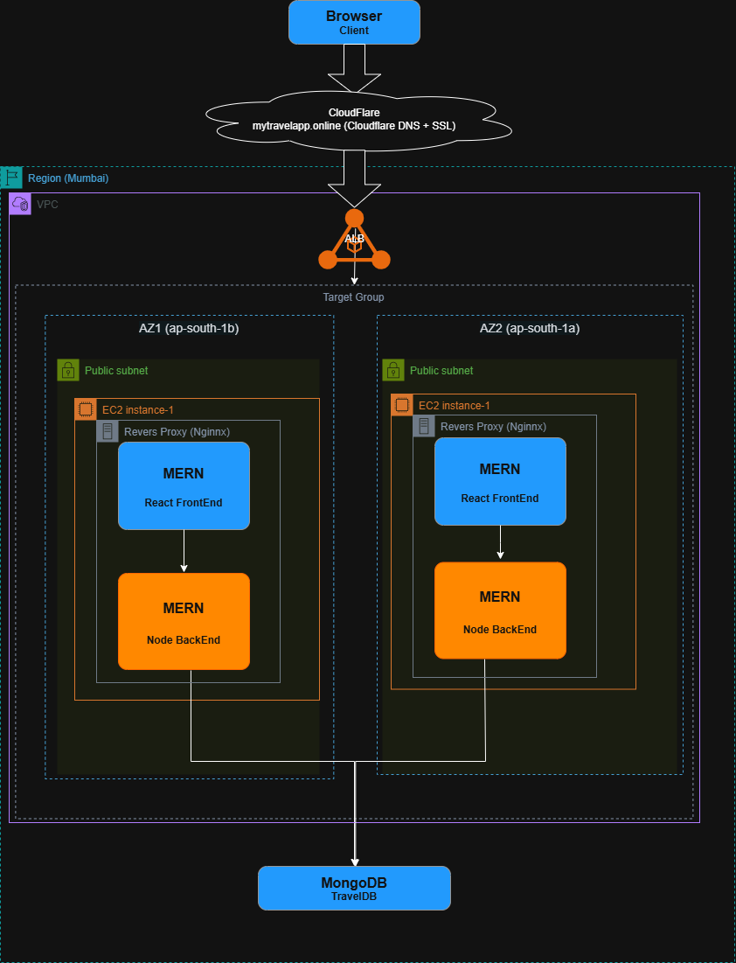
1. EC2 Setup: Created EC2 instances and configured Node.js backend and React frontend with Nginx
2. Multi-AZ Deployment: Deployed instances across multiple availability zones for high availability
3. Monitoring Methods
- Used curl for API testing
- Checked logs using: pm2 logs
- Verified service status: systemctl status nginx
- Used browser DevTools (Network tab)

• EC2 instances (both running)

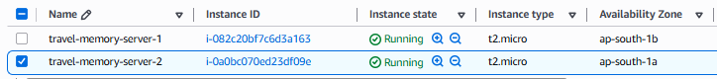

• App running on each EC2 (browser or curl)
Curl on both Instances:

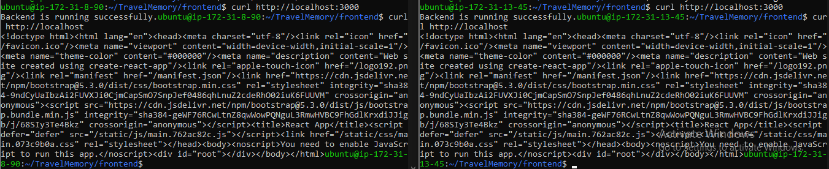

EC2 instance 1:

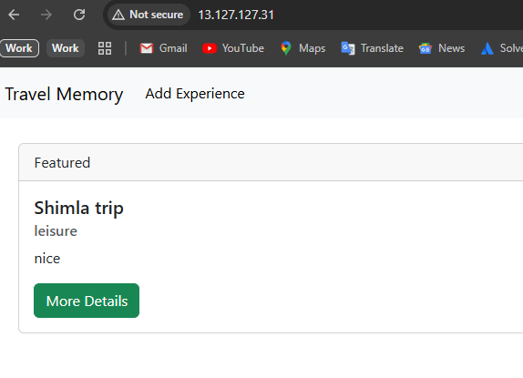

EC2 instance 2

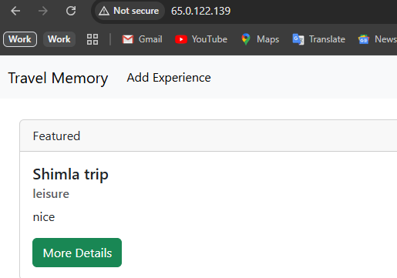

• Nginx config (terminal)

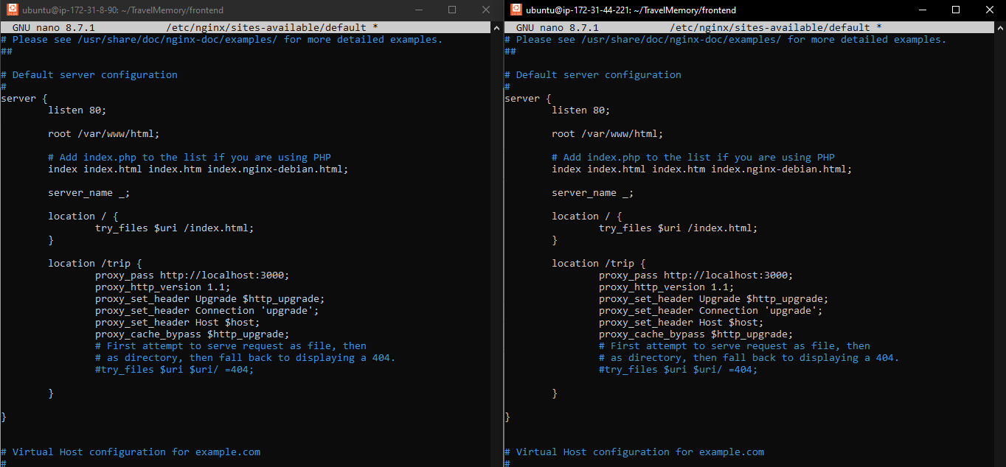

• MongoDB connection working

MongoDB Integration: Connected backend to MongoDB Atlas

MongoDB shows the data submitted over the FrontEnd.
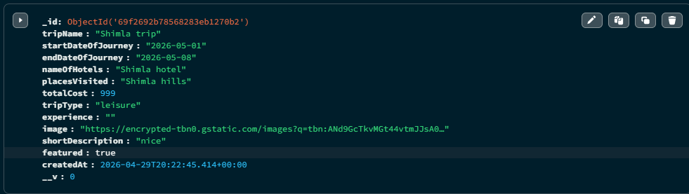

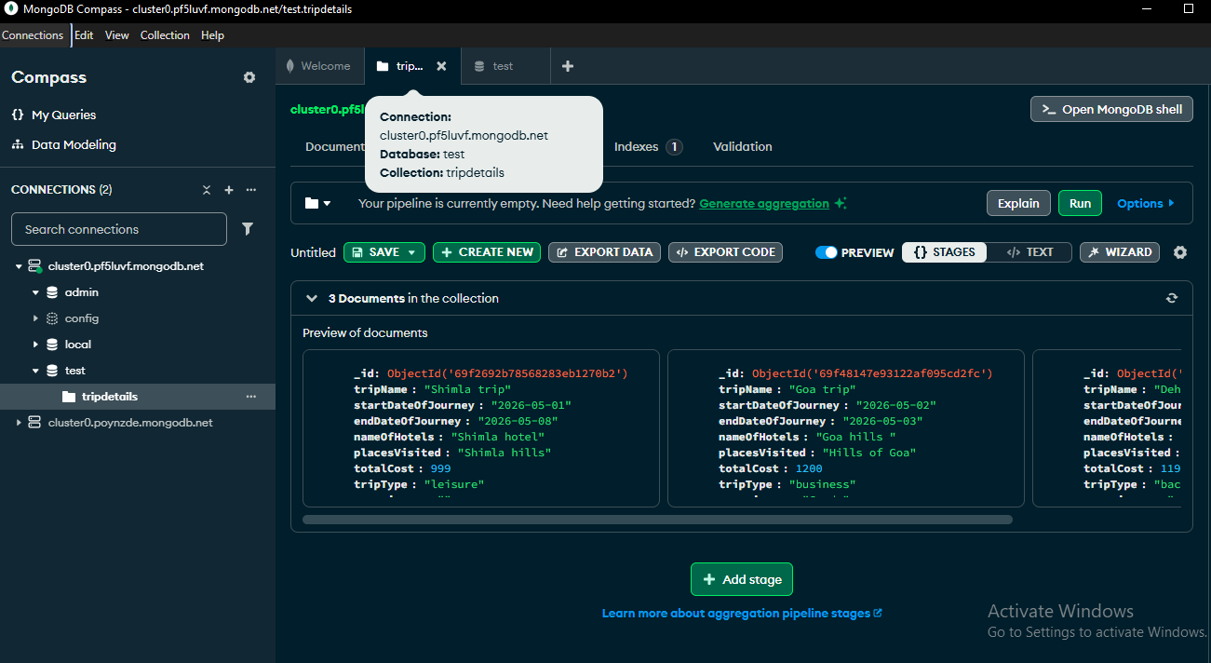
• Load Balancer dashboard
Load Balancer: Configured Application Load Balancer and target group for traffic distribution

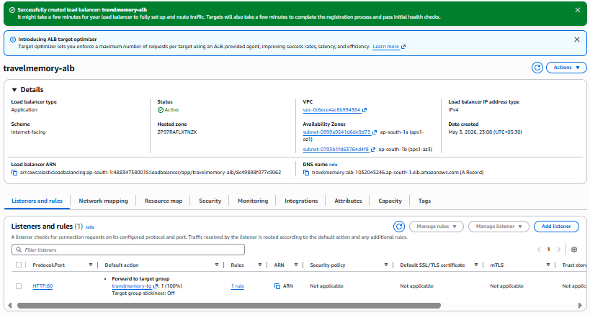

• Target group health check

Target Groups created

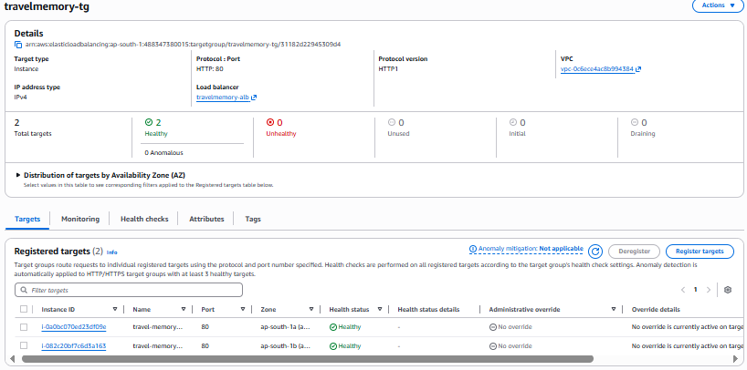
• Final app via Load Balancer DNS
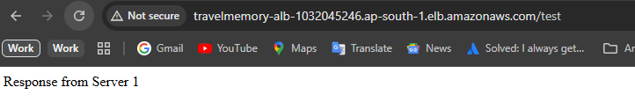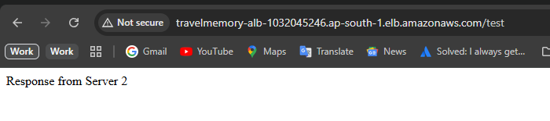
• Domain Registration:
Domain Setup: Configured domain using Cloudflare and mapped it to ALB.
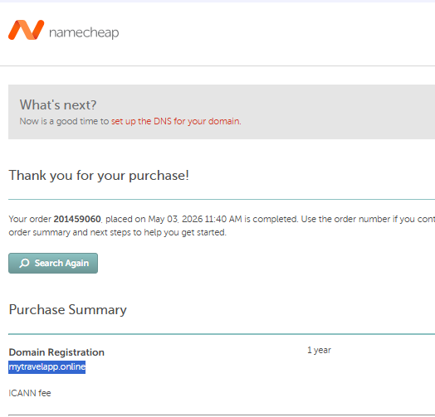

• NameServers Added to Namecheap
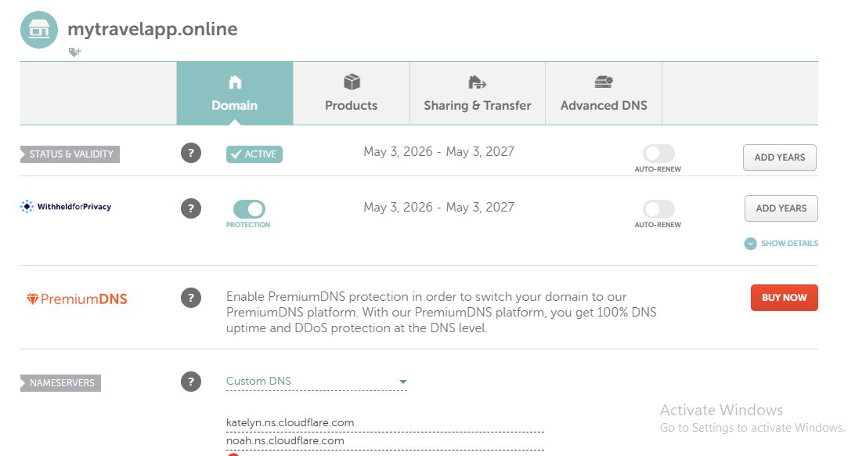
• Cloudflare shows Active
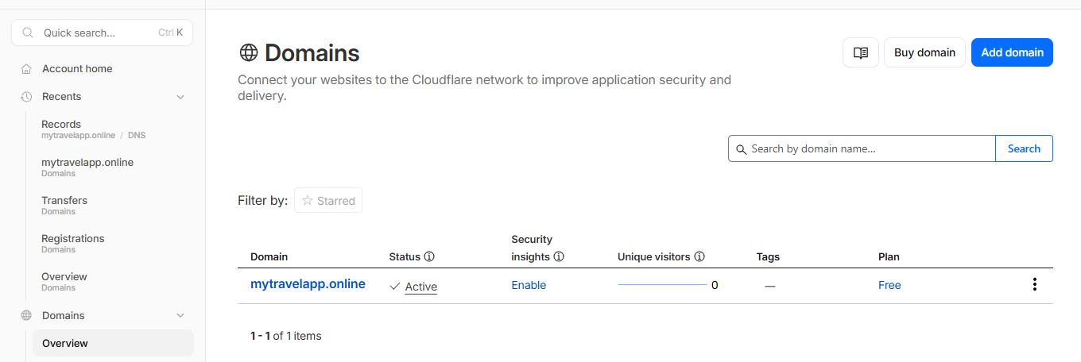

• App via Domain (Http)
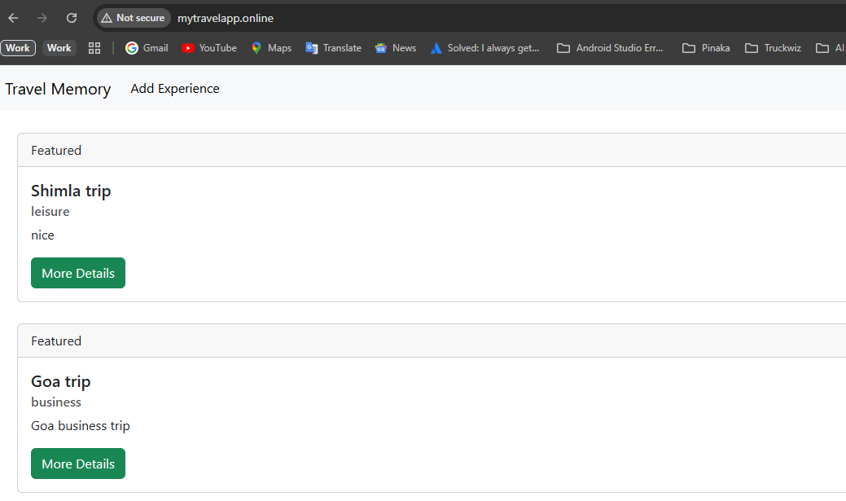
• Configure SSL (Flexible)
SSL Setup: Enabled HTTPS using Cloudflare Flexible SSL
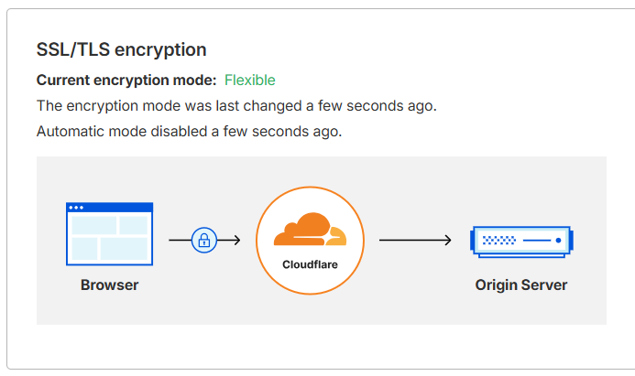

• App via Domain (Https)
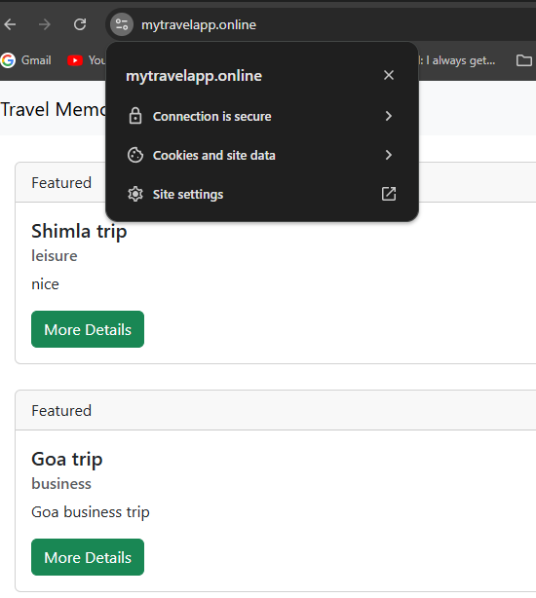

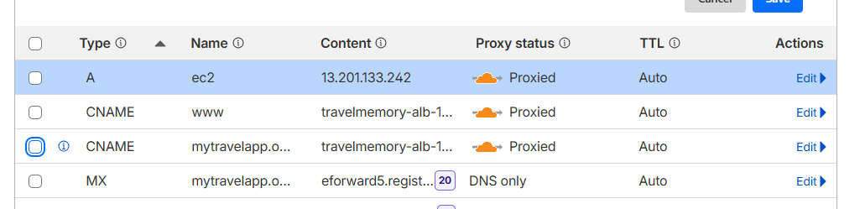
Challenges Faced (Add this — high impact)
Example:
- Nginx routing issue (/test 404)
- Backend validation (500 error)
- Load balancer routing to single instance
- DNS conflict in Cloudflare
Cloudflare DNS Conflict
Error:“A record already exists”
Duplicate DNS records:
A @ and CNAME @ (not allowed)
Fix Applied
Removed existing A/AAAA records
Added:
CNAME @ → ALB DNS

